UNITED STATES
SECURITIES AND EXCHANGE COMMISSION
Washington, D.C. 20549
SCHEDULE 14A
Proxy Statement Pursuant to Section 14(a) of the Securities
Exchange Act of 1934 (Amendment No. )
Filed by the Registrant x
Filed by a Party other than the Registrant o
Check the appropriate box:
o |  |  | Preliminary Proxy Statement
o |  |  | Confidential, for Use of the Commission Only (as permitted by Rule 14a-6(e)(2))
x |  |  | Definitive Proxy Statement
o |  |  | Definitive Additional Materials
o |  |  | Soliciting Material under §240.14a-12
Bank of Hawaii Corporation
(Name of Registrant as Specified In Its Charter)
(Name of Person(s) Filing Proxy Statement, if other than the Registrant)
Payment of Filing Fee (Check the appropriate box):
x |  |  | No fee required
o |  |  | Fee paid previously with preliminary materials
o |  |  | Fee computed on table in exhibit required by Item 25(b) per Exchange Act Rules 14a-6(i)(1) and 0-11


Notice of 2026
Annual Meeting of Shareholders
and Proxy Statement
Your VOTE is important!
Meeting Date: April 24, 2026
Bank of Hawaii Corporation
130 Merchant Street
Honolulu, Hawai‘i 96813

 |  |  |  |  |  |  |  |  | 
 |  |  | 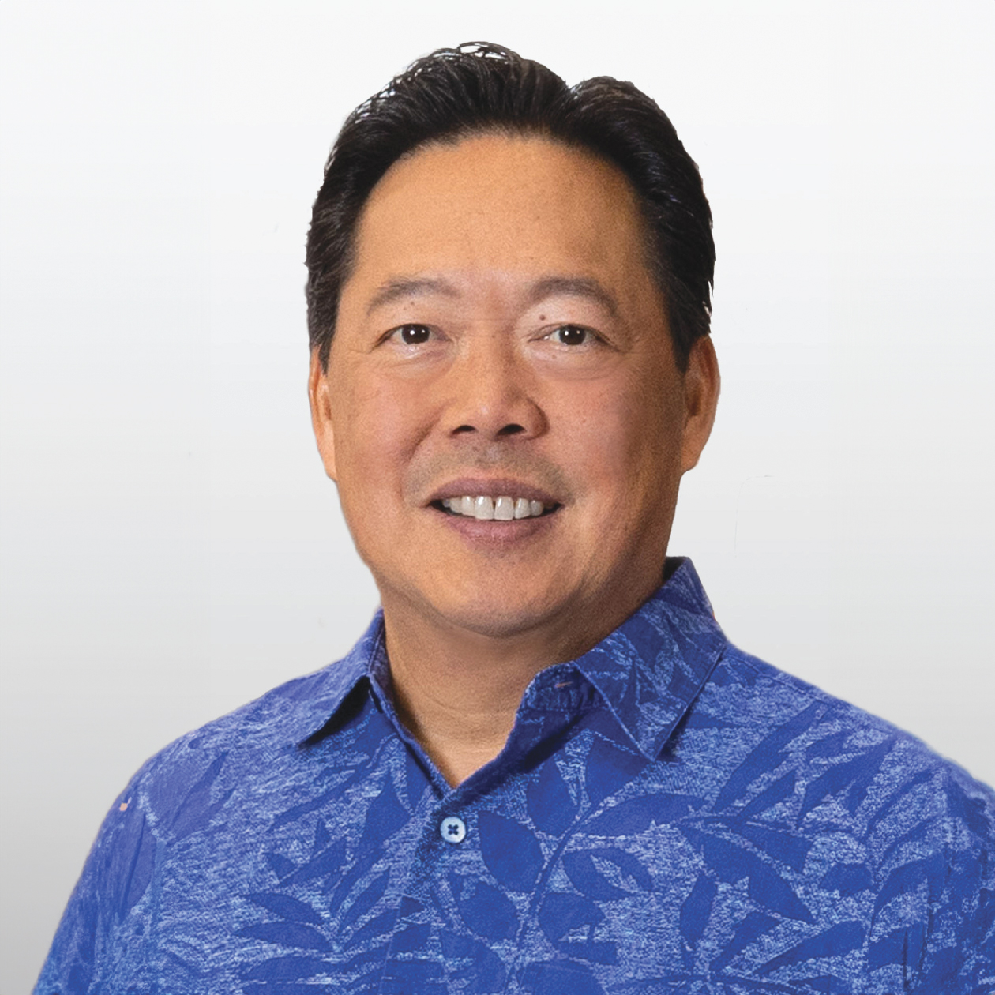  A Letter from our Chairman and Chief Executive Officer |  |  |  |  |  | Dear Fellow Shareholders,  We are pleased to invite you to attend the 2026 Annual Meeting of Shareholders of Bank of Hawaii Corporation to be held via live webcast on Friday, April 24, 2026, at 8:30 a.m. Hawai‘i Standard Time. Detailed instructions on how to attend and vote at the virtual Annual Meeting are found starting on page 5.  The Notice of Meeting and Proxy Statement accompanying this letter describe the business we will consider and vote upon at the meeting. A report to shareholders on the affairs of Bank of Hawaii Corporation also will be given and shareholders will have the opportunity to ask about matters of interest concerning the Company through the virtual meeting platform during the virtual Annual Meeting.  For reasons explained in the accompanying Proxy Statement, the Board of Directors recommends that you vote FOR Proposal 1: Election of Directors, FOR Proposal 2: Advisory Vote on Executive Compensation, and FOR Proposal 3: Ratification of the Re-Appointment of Ernst & Young LLP as the Company’s Independent Registered Public Accounting Firm for the 2026 Fiscal Year.  Your vote is very important. Please review detailed voting instructions starting on page 5. On January 30, 2026, I announced my plan to retire as Chairman and Chief Executive Officer on March 31, 2026. The Board of Directors unanimously appointed current Bank of Hawaii Corporation President and Chief Banking Officer James (“Jim”) C. Polk to succeed me as President and Chief Executive Officer, upon my retirement. Jim Polk will also join the Board of Directors on April 1, 2026. Accordingly, you will note that I am not standing for election as a director this year, and instead, Jim will be on the ballot. Additionally, Hawai‘i Pacific Health President and CEO Raymond (“Ray”) P. Vara, Jr., currently Bank of Hawaii Corporation’s Lead Independent Director, will assume the new role of Non-Executive Chair of Bank of Hawaii Corporation’s Board of Directors on April 1, 2026 and will preside as Board Chair at the April 24, 2026 Annual Meeting of Shareholders.  Serving as Chairman and Chief Executive Officer at Bank of Hawaii Corporation for the last 16 years has been the greatest honor of my professional life. I have had the privilege of leading this wonderful organization with a vision of serving our shareholders, employees, customers and communities to the fullest. Our success is built on a shared commitment to the values that unite us, and a legacy of trust and service that continues to guide us forward. I will depart confident that Bank of Hawaii Corporation is in exceptional hands under the leadership of Jim Polk and Ray Vara.  On behalf of the Board of Directors, thank you for your participation and support.  Sincerely,    PETER S. HO  Chairman of the Board and Chief Executive Officer  March 13, 2026

BANK OF HAWAI'I • 2026 PROXY STATEMENT

Notice of 2026 Annual Meeting of Shareholders
To be held April 24, 2026
To Our Shareholders:
The 2026 Annual Meeting of Shareholders of Bank of Hawaii Corporation will be held via live webcast at www.meetnow.global/MMX4PXX on Friday, April 24, 2026, at 8:30 a.m. Hawai‘i Standard Time for the following purposes:
1.To elect 12 persons to serve as directors of the Company for a term of one year each until the 2027 Annual Meeting of Shareholders and until their respective successors are duly elected and qualified, or until the director’s earlier resignation, removal, death or disqualification.
2.To hold an advisory vote on executive compensation.
3.To ratify the re-appointment of Ernst & Young LLP as the Company’s independent registered public accounting firm for the 2026 fiscal year.
These items of business are more fully described in the proxy statement accompanying this Notice, which is being mailed to shareholders on or about March 13, 2026. Shareholders of record of Bank of Hawaii Corporation common stock (NYSE: BOH) at the close of business on February 27, 2026 are entitled to attend the meeting and vote on the business brought before it. A list of such shareholders shall be open to the examination of any shareholders upon request for a period of 10 days prior to the 2026 Annual Meeting of Shareholders.
We look forward to connecting with you at the meeting. However, if you cannot attend the meeting, your shares may still be voted by telephone or via the internet, or you may complete, sign, date, and return the enclosed proxy card in the enclosed postage-paid return envelope.
By Order of the Board of Directors,
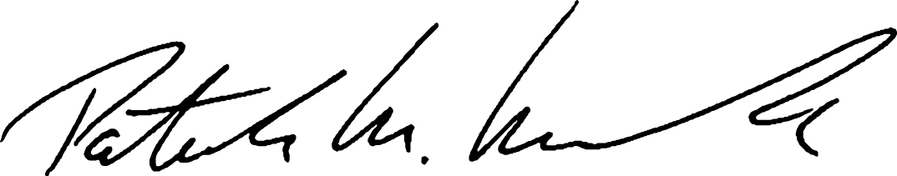
PATRICK M. McGUIRK
Vice Chair and Corporate Secretary
Bank of Hawaii Corporation
Honolulu, Hawai‘i
March 13, 2026
YOUR VOTE IS IMPORTANT!
Please promptly sign and return the enclosed proxy card, or vote by telephone or on the internet. Submitting your proxy by one of these methods will ensure your representation at the Annual Meeting regardless of whether you attend the meeting.
Thank you for your participation!
Important Notice Regarding the Availability of Proxy Materials for the 2026 Annual Meeting of Shareholders to be Held on April 24, 2026.
The Proxy Statement and the Bank of Hawaii Corporation 2025 Annual Report on Form 10-K for the year ended December 31, 2025, are available at www.edocumentview.com/boh.
We encourage you to access and review all of the information in the proxy materials before voting.

BANK OF HAWAI‘I • 2026 PROXY STATEMENT

Table of Contents
 |  |  | Page
Proxy Statement Summary |  |  | 1
General Information |  |  | 5
Questions and Answers About the Proxy Materials and the Annual Meeting |  |  | 5
Proposal 1: Election of Directors |  |  | 9
Board of Directors |  |  | 9
Beneficial Ownership |  |  | 17
Commitment to Corporate Responsibility |  |  | 19
Commitment to Effective Corporate Governance |  |  | 19
Community Stewardship |  |  | 25
Commitment to Sustainability in the Way We Do Business |  |  | 29
Board Committees and Meetings |  |  | 32
Director Compensation |  |  | 34
Director Compensation Table |  |  | 35
Proposal 2: Advisory Vote on Executive Compensation |  |  | 36
Human Resources & Compensation Committee Report |  |  | 36
Compensation Discussion and Analysis |  |  | 37
Summary Compensation Table |  |  | 60
All Other Compensation Table |  |  | 61
Nonqualified Deferred Compensation |  |  | 62
Grants of Plan-Based Awards |  |  | 64
Outstanding Equity Awards |  |  | 65
Option Exercises and Stock Vested |  |  | 66
Equity Compensation Plan Information |  |  | 66
Pension Benefits |  |  | 66
Change-in-Control, Termination, and Other Arrangements |  |  | 67
Pay Versus Performance |  |  | 69
CEO Pay Ratio |  |  | 72
Certain Relationships and Related Party Transactions |  |  | 73
Proposal 3: Ratification of the Re-appointment of Ernst & Young LLP as the Company’s Independent Registered Public Accounting Firm for the 2026 Fiscal Year |  |  | 74
Ernst & Young LLP Fees |  |  | 74
Audit Committee Report |  |  | 75
Audit Committee Pre-Approval Policies and Procedures |  |  | 76
Other Business |  |  | 76

BANK OF HAWAI‘I • 2026 PROXY STATEMENT

Proxy Statement Summary
This summary contains highlights of information contained elsewhere in our proxy statement and does not contain all information to be considered. We encourage you to read the entire proxy statement before voting.
 |  |  | 2026 ANNUAL MEETING INFORMATION
 |  |  |  |  |  |  |  |  | 
 |  |  | Date and Time |  |  | Via Webcast at |  |  | Record Date
 |  |  | Friday, April 24, 2026 |  |  | www.meetnow.global/MMX4PXX |  |  | February 27, 2026
 |  |  | at 8:30 a.m. Hawai‘i Standard Time
 |  |  | 2025 FINANCIAL HIGHLIGHTS
 |  |  | $4.63 |  |  | $205.9M |  |  | $24.2B
 |  |  | Diluted Earnings Per  Common Share |  |  | Net Income |  |  | Total Assets
 |  |  | 2025 RECOGNITIONS
 |  |  | •Newsweek  Ranked Number 12 |  |  |  |  |  | “Most Trustworthy Companies in America” |  |  | •Across Hawai‘i's major daily newspapers |  |  |  |  |  | Named “Best Bank”  By Readers
 |  |  | BANK OF HAWAI‘I • 2026 PROXY STATEMENT |  |  | 1

PROXY STATEMENT SUMMARY
OUR BOARD OF DIRECTORS |  |  |  |  |  |  |  |  | The Board unanimously recommends that stockholders vote  “FOR” the election of each of the nominees listed on page 9.

VOTING MATTERS AND BOARD RECOMMENDATIONS
Proposal |  |  | Description |  |  | Board Vote  Recommendation |  |  | Page Reference  (for more detail)
1 |  |  | Election of Directors  You are being asked to elect 12 directors. Each of the nominees standing for election will hold office until the 2027 Annual Meeting of Shareholders. The number of directors to be elected was fixed by the Board of Directors to be effective as of the date of the 2026 Annual Meeting of Shareholders. |  |  | FOR each  nominee |  |  | 9
2 |  |  | Advisory Vote on Executive Compensation  You are being asked to vote, on an advisory (non-binding) basis, to approve the Company’s executive compensation as disclosed in this proxy statement. |  |  | FOR |  |  | 36
3 |  |  | Ratification of the Re-Appointment of Ernst & Young LLP  You are being asked to ratify, on an advisory (non-binding) basis, the re-appointment of Ernst & Young LLP as the Company’s independent registered public accounting firm for fiscal year 2026. |  |  | FOR |  |  | 74
2 |  |  | BANK OF HAWAI'I • 2026 PROXY STATEMENT

PROXY STATEMENT SUMMARY
VOTING YOUR SHARES
You may vote if you are a shareholder of record as of the close of business on February 27, 2026. Each share of common stock is entitled to one vote. Shares of Series A and Series B Preferred Stocks generally are not entitled to vote. On February 27, 2026 (the “Record Date”), there were 39,725,521 shares of common stock issued and outstanding. All votes are confidential.
 |  |  | Online  Registered holders can go to www.envisionreports.com/boh and follow the instructions. For shares held in street name, please see the instruction card included by your broker or nominee.
 |  |  | By Telephone  If you live in the United States, you may submit your proxy by following the “Vote by Telephone” instruction on the proxy card. For shares held in street name, please see the instruction card included by your broker or nominee.
 |  |  | By Mail  Complete, sign, and date the proxy card and return it in the envelope that was provided in the proxy statement package. For shares held in street name, please see the instruction card included by your broker or nominee.
 |  |  | Virtual Attendance via Webcast  Register with your control number found on your proxy card, notice, or voting instruction form provided by your bank or broker and attend our virtual annual meeting. More detailed instructions on how to attend and vote are found starting on page 5.
Even if you plan to attend the Annual Meeting of Shareholders, we encourage all shareholders to vote in advance of the meeting.
 |  |  | BANK OF HAWAI‘I • 2026 PROXY STATEMENT |  |  | 3

PROXY STATEMENT SUMMARY
HIGHLIGHTS
Bank of Hawaii Corporation (“Bank of Hawaii Corporation” or the “Company”) is a Delaware corporation and a financial holding company headquartered in Honolulu, Hawai‘i. The Company’s principal subsidiary, Bank of Hawai‘i (“Bank of Hawai‘i” or the “Bank”), was founded in 1897 and provides a broad range of financial products and services to businesses, consumers and governments in Hawai‘i and the West Pacific.
Bank of Hawaii Corporation is committed to meeting high standards of ethical behavior, corporate governance, and business conduct. The first two columns in the table below summarize the Company’s governance and compensation practices, demonstrating what we do to drive performance and manage risk and is current through March 1, 2026. The third column highlights the Company’s business performance during 2025.
Corporate Governance |  |  |  |  |  | Compensation Program Best Practices |  |  |  |  |  | Business Performance
•Annual election of directors  •Majority voting in director elections with a plurality carve-out in the case of contested elections and a director resignation policy  •Independent directors comprise 92% of the Board of Directors and 100% of key committees  •33% of directors are women and 50% are ethnically diverse  •Ongoing director refreshment with 2 new directors added in the past 5 years  •Regular executive sessions of the Board of Directors without management present  •Directors actively participate in continuing education programs  •All directors attended at least 75% of the Board of Directors and committee meetings  •Annual Say-on-Pay vote  •Robust shareholder engagement process  •Effective whistleblower policy and program  •Annual Board of Directors and Committee self-evaluations  •No poison pill |  |  |  |  |  | •Pay for performance by tying a substantial portion of executive compensation to performance goals  •Significant stock ownership requirements (5x base salary for CEO, 2x for other NEOs)  •No employment or severance agreements with NEOs  •Anti-hedging and anti-pledging stock policies  •Regularly conduct assessments to identify and mitigate risk in compensation programs  •Evaluate executive compensation data and practices of our peer group companies as selected annually by the committee with guidance from the independent compensation consultant  •Double-trigger change-in-control provisions  •Independent compensation consultant  •Formalized clawback policy  •No tax gross-ups  •No excessive perquisites  •No repricing of equity incentive awards |  |  |  |  |  | •Diluted earnings per common share for the full year of 2025 were $4.63  •Loans and leases remained flat from 2024; total deposits increased 2.7% from 2024  •Asset quality, liquidity, and capital all remain strong  •Ranked Number 12 among “Most Trustworthy Companies in America” in the banking industry category by Newsweek. Bank of Hawai‘i was the only Hawai‘i business listed.  •Named Hawai‘i’s Best Bank by the readers of the major newspapers across Hawai‘i, including the Honolulu Star-Advertiser, The Garden Island, Hawaii Tribune-Herald and West Hawaii Today.
See “Commitment to Corporate Responsibility” starting on page 19, “Compensation Discussion and Analysis” starting on page 37, and “Business and Performance Overview” starting on page 39.

4 |  |  | BANK OF HAWAI'I • 2026 PROXY STATEMENT

QUESTIONS AND ANSWERS ABOUT THE PROXY MATERIALS AND THE ANNUAL MEETING
General Information
The Board of Directors (the “Board”) of Bank of Hawaii Corporation is soliciting the enclosed proxy for the Company’s 2026 Annual Meeting of Shareholders (the “Annual Meeting”). The proxy statement, proxy card, and the Company’s Annual Report to Shareholders and Annual Report on Form 10-K are being distributed to the Company’s shareholders on or about March 13, 2026.

Questions and Answers About the Proxy Materials and the Annual Meeting
Q:What is a proxy?
A:A proxy is your legal designation of another person to vote the shares you own. That other person that you designate is called a proxy and is required to vote your shares in the manner you instruct. If you designate someone as your proxy in a written document, that document also is called a proxy or a proxy card. If you vote by phone or via the internet, you will have designated Patrick M. McGuirk and/or Russell Lum to act as your proxy to vote your shares at the Annual Meeting in the manner you direct.
The Company is paying the costs of the solicitation of proxies. The Company has retained Georgeson LLC to assist in the distribution of proxy materials and the solicitation of proxies from individual shareholders as well as brokerage firms, fiduciaries, custodians, and other similar organizations representing beneficial owners of shares for the Annual Meeting. We have agreed to pay Georgeson LLC a fee of $13,000 plus variable amounts for additional proxy solicitation services and out-of-pocket expenses.
In addition to solicitations by mail, the proxy solicitor and the Company’s nominees, officers, and employees, without additional compensation, may solicit proxies on the Company’s behalf in person, by phone, or by electronic communication.
Q:How many shares must be present to hold the Annual Meeting?
A:The holders of at least one-third of the Company’s outstanding common stock on the Record Date entitled to vote at the Annual Meeting must be represented, in person or by proxy, to conduct business. That amount is called a quorum. Shares are counted as present at the meeting if a shareholder entitled to vote is present at the meeting, or has submitted a properly signed proxy in writing, or by voting by telephone or via the internet. We also count abstentions and broker non-votes as present for purposes of determining a quorum.
Q:Why did I receive a one-page notice (the “Notice”) in the mail regarding the internet availability of proxy materials instead of a full set of proxy materials?
A:The rules and regulations of the Securities and Exchange Commission (the “SEC”) allow companies to furnish proxy materials by providing access to such documents on the internet instead of mailing a printed copy of proxy materials to each shareholder of record. Shareholders who previously requested to receive printed copies of proxy materials by mail will continue to receive them by mail. Shareholders who have not previously indicated a preference for printed copies of proxy materials are receiving the Notice. The Notice provides instructions on how to access and review all of the proxy materials and how to submit your proxy via the internet. If you would like to receive a printed or e-mail copy of the proxy materials, please follow the instructions for requesting such materials in the Notice.
 |  |  | BANK OF HAWAI‘I • 2026 PROXY STATEMENT |  |  | 5

QUESTIONS AND ANSWERS ABOUT THE PROXY MATERIALS AND THE ANNUAL MEETING
Q:What are the voting procedures?
A:Under our Bylaws, directors are elected annually by majority of votes cast on the proposal (Proposal 1). This means that a director is elected if the number of votes cast for the nominee exceeds the number of votes cast against the nominee. In the event of a contested election, the election is determined by plurality vote. This means that the nominees who receive the highest number of affirmative votes are elected. Abstentions and broker non-votes do not affect the outcome of a plurality vote.
The advisory vote on executive compensation (Proposal 2), and the advisory vote on the ratification of the reappointment of our independent registered public accounting firm (Proposal 3) are also decided by a majority of votes cast on each proposal. For Proposals 1, 2 and 3, broker non-votes will be treated as not entitled to vote and will not affect the outcome. For Proposal 3, your broker, bank, trustee, or other nominee may exercise its discretion and vote. Abstentions will have the same effect as votes cast against the proposal.
Holders of our common stock are entitled to one vote per share of common stock held on the Record Date. The outstanding shares of Series A Preferred Stock and Series B Preferred Stock are not entitled to any voting rights for any current proposal.
Q:May I change my vote?
A:Yes. You may change your proxy instructions any time before the vote at the Annual Meeting. Attendance at the virtual Annual Meeting will not cause your previously granted proxy to be revoked unless you also vote at the meeting.
Q:What is a broker non-vote?
A:The New York Stock Exchange (“NYSE”) allows its member-brokers to vote shares held by them for their customers on matters the NYSE determines are routine, even though the brokers have not received voting instructions from their customers. Of the proposals anticipated to be brought at the Annual Meeting, only Proposal 3 (the ratification of the re-appointment of Ernst & Young LLP as the Company’s independent registered public accounting firm for the 2026 fiscal year) is considered by the NYSE to be a routine matter. Your broker, therefore, may vote your shares in its discretion on Proposal 3 if you do not instruct your broker how to vote. If the NYSE does not consider a matter routine, then your broker is prohibited from voting your shares on the matter unless you have given voting instructions on that matter to your broker. Therefore, your broker will need to return a proxy card without voting on these non-routine matters if you do not give voting instructions with respect to these matters. This is referred to as a “broker non-vote.” The NYSE does not consider Proposal 1 (election of Directors) and Proposal 2 (advisory vote on executive compensation) to be routine matters, so your broker may not vote on these matters in its discretion. It is important, therefore, that you provide instructions to your broker if your shares are held by a broker so that your vote is counted with respect to these non-routine matters.
Q:Why are we holding a virtual Annual Meeting?
A:The Annual Meeting will be held virtually as in prior years. We adopted a virtual meeting format in 2020, and this format has proven over the last six years to allow the same, or perhaps better, opportunity for shareholder participation. This format allows shareholders to participate from anywhere they have internet connectivity, thus allowing more shareholders to participate regardless of size, location or resources. Shareholders and the Company alike save valuable time and money with this convenient format all while reducing the carbon footprint of our activities. The Company is committed to ensuring virtual meeting participants have equivalent opportunities to those available at in-person meetings, including real-time question submission, live response during the meeting, and technical support to facilitate meaningful participation. Shareholders may view a live webcast of the Annual Meeting and submit questions digitally prior to and during the meeting at www.meetnow.global/MMX4PXX. Please refer to the “How can I attend the Annual Meeting?” section of the Proxy Statement for more details.
6 |  |  | BANK OF HAWAI'I • 2026 PROXY STATEMENT

QUESTIONS AND ANSWERS ABOUT THE PROXY MATERIALS AND THE ANNUAL MEETING
Q:How can I attend the Annual Meeting?
A:The Annual Meeting will be virtual and conducted by webcast. You are entitled to participate in the Annual Meeting only if you were a shareholder of the Company at the close of business on February 27, 2026. An in-person meeting will not be held. You will be able to attend the Annual Meeting online and submit your questions during the meeting by visiting www.meetnow.global/MMX4PXX. To participate in the Annual Meeting, you will need to review the information included on your Notice, proxy card or the instructions that accompanied your proxy materials.
The online meeting will begin promptly at 8:30 a.m. Hawai‘i Standard Time. We encourage you to access the virtual meeting website prior to the start time to leave ample time for check-in. Please follow the instructions as outlined in this proxy statement.
If you hold your shares through a bank or broker as a beneficial shareholder, and want to attend the Annual Meeting online by webcast (with the ability to ask a question and/or vote, if you choose to do so) you have two options:
1)Registration in Advance of the Annual Meeting
Submit proof of your proxy power (“Legal Proxy”) from your broker or bank reflecting your Bank of Hawaii Corporation holdings along with your name and email address to Computershare. Requests for registration must be labeled “Legal Proxy” and be received no later than 5:00 p.m. Eastern Time, on April 21, 2026. You will receive a confirmation of your registration by email after Computershare receives your registration materials. Requests for registration should be directed to Computershare at the following:
By email: Forward the email from your broker granting you a Legal Proxy, or attach an image of your Legal Proxy, to legalproxy@computershare.com
By mail: Computershare
Bank of Hawai‘i Legal Proxy
P.O. Box 43001
Providence, RI 02940-3001
2)Register at the Annual Meeting
For the 2026 proxy season, an industry solution has been agreed upon to allow beneficial shareholders to register online at the Annual Meeting to attend, ask questions and vote. We expect that the vast majority of beneficial shareholders will be able to fully participate using the control number received with their voting instruction form. Please note, however, that this option is intended to be provided as a convenience to beneficial shareholders only, and there is no guarantee this option will be available for every type of beneficial shareholder voting control number. The inability to provide this option to any or all beneficial shareholders shall in no way impact the validity of the Annual Meeting. Beneficial shareholders may choose the Register in Advance of the Annual Meeting option above, if they prefer to use this traditional, paper-based option. You may vote your shares as usual via ProxyVote.com.
In any event, please go to www.meetnow.global/MMX4PXX for more information on the available options and registration instructions.
 |  |  | BANK OF HAWAI‘I • 2026 PROXY STATEMENT |  |  | 7

QUESTIONS AND ANSWERS ABOUT THE PROXY MATERIALS AND THE ANNUAL MEETING
Q:What if I have trouble accessing the Annual Meeting virtually?
A:The virtual meeting platform is fully supported across browsers, including Edge, Chrome and Safari and devices, including tablets and cell phones. Please ensure you have a strong internet connection prior to joining the meeting virtually and join the meeting several minutes prior to the start time. There will be a link on the meeting page for further assistance if needed, or you may call:
Computershare
1-888-724-2416
1-781-575-2748
Hours: 8:30 a.m. - 6:00 p.m. Eastern Time
Q:May I propose actions for consideration at next year’s annual meeting of shareholders?
A:Yes. You may submit proposals for consideration at the 2027 Annual Meeting of Shareholders by presenting your proposal in writing to the Corporate Secretary at 130 Merchant Street, Honolulu, Hawai‘i 96813 and in accordance with the following schedule and requirements.
Proposals to be included in the proxy statement and voted on at the Annual Meeting. Proposals that shareholders wish to have included in the proxy statement for the 2027 Annual Meeting of Shareholders must be made in accordance with SEC Rule 14a-8. Proposals must be received by the Company’s Corporate Secretary on or before November 13, 2026, at the above address.
Proposals to be voted on at the Annual Meeting only. Under Section 1.12 of the Company’s Bylaws, for a shareholder to bring a proposal before the 2027 Annual Meeting, the Company must receive the written proposal not later than 80 days nor earlier than 90 days before the first anniversary of the 2026 annual meeting; in other words, not earlier than January 24, 2026, and no later than February 3, 2026. The proposal also must contain the information required in the Bylaws. If you wish to make one or more nominations for election to the Board, the required information includes, among other things, the written consent of such individual to serve as director and (i) the name, age, business address and, if known, residence address of each nominee, (ii) the principal occupation or employment of each nominee, and (iii) the number of shares of Bank of Hawaii Corporation common stock each nominee beneficially owns. These advance notice provisions are separate from the requirements a shareholder must meet to have a proposal included in the proxy statement under SEC rules. By complying with these provisions, a shareholder may present a proposal in person at the meeting, but will not be entitled to have the proposal included in the Company’s proxy statement unless they comply with the requirements described in the preceding paragraph. Persons holding proxies solicited by the Board may exercise discretionary authority to vote against such proposals. In addition to satisfying the foregoing requirements under the Company’s Bylaws, to comply with the “universal proxy rules”, shareholders who intend to solicit proxies in support of director nominees at the 2027 Annual Meeting must include the additional information required by SEC Rule 14a-19(b) including a statement that they intend to solicit 67% of outstanding voting shares.
Q:Where can I find the voting results of the Annual Meeting?
A:We plan to announce preliminary voting results at the Annual Meeting. We will publish final voting results in a report on Form 8-K within four business days of the Annual Meeting.
Q:What happens if the meeting is postponed or adjourned?
A:Your proxy will remain valid and may be voted at the postponed or adjourned meeting. You will still be able to change or revoke your proxy until it is voted.

8 |  |  | BANK OF HAWAI'I • 2026 PROXY STATEMENT

Proposal 1: Election of Directors

BOARD OF DIRECTORS
The Company’s Certificate of Incorporation requires that the Company’s Board consists of not fewer than three directors and not more than 15 directors, with the exact number to be determined by the Board. The Board fixed the number of directors for election at the annual meeting to be 12. Each of the 12 directors listed below has been nominated for a one-year term to serve until the 2027 Annual Meeting of Shareholders and until his or her successor is elected and qualified or until the director’s earlier resignation, removal, death or disqualification. In the event that any or all of the director nominees are unable to stand for election as director, the Board, upon the recommendation of the Nominating & Corporate Governance Committee, may select different nominees for election as directors.
Certain information with respect to each of the nominees is set forth below, including his or her principal occupation, qualifications, and directorships during the past five years. Each nominee has consented to serve, and all nominees are currently serving on the Company’s Board, except for Mr. Polk who will begin his service on the Board effective April 1, 2026. The nominees were each recommended to the Board by the Company’s Nominating & Corporate Governance Committee whose goal is to assemble a board that operates cohesively, encourages candid communication and discussion, and focuses on activities that help the Company create sustainable long-term growth and maximize shareholder value. The Nominating & Corporate Governance Committee also looks at the individual strengths of directors, their ability to contribute to the Board, and whether their skills and experience complement those of the other directors. A more detailed discussion on the nomination process and the criteria the Nominating & Corporate Governance Committee considers in their evaluation of director candidates is found in the Commitment to Effective Corporate Governance section which begins on page 19.
The Board of Directors recommends a vote “FOR” each of the nominees.
Name |  |  | Age |  |  |  |  |  | Year First  Elected  as Director |  |  |  |  |  | Independent |  |  |  |  |  | Other Public  Directorships  Held in Last  5 Years |  |  |  |  |  | Committee Membership
John C. Erickson |  |  | 64 |  |  |  |  |  | 2019 |  |  |  |  |  | Yes |  |  |  |  |  | 2 |  |  |  |  |  | AC, BSC, RMC, SWG
Joshua D. Feldman |  |  | 53 |  |  |  |  |  | 2019 |  |  |  |  |  | Yes |  |  |  |  |  | None |  |  |  |  |  | DAC, HRC, RMC
Michelle E. Hulst |  |  | 52 |  |  |  |  |  | 2019 |  |  |  |  |  | Yes |  |  |  |  |  | None |  |  |  |  |  | DAC, HRC, NCGC, SWG
Kent T. Lucien |  |  | 72 |  |  |  |  |  | 2006 |  |  |  |  |  | Yes |  |  |  |  |  | None |  |  |  |  |  | BSC, DAC, FIMC
Elliot K. Mills |  |  | 56 |  |  |  |  |  | 2021 |  |  |  |  |  | Yes |  |  |  |  |  | None |  |  |  |  |  | DAC, HRC, NCGC, SWG
Alicia E. Moy |  |  | 48 |  |  |  |  |  | 2017 |  |  |  |  |  | Yes |  |  |  |  |  | 1 |  |  |  |  |  | AC, BSC, FIMC, RMC
Victor K. Nichols |  |  | 69 |  |  |  |  |  | 2014 |  |  |  |  |  | Yes |  |  |  |  |  | 2 |  |  |  |  |  | AC, BSC, DAC, RMC, SWG
James C. Polk |  |  | 59 |  |  |  |  |  | 2026 |  |  |  |  |  | No |  |  |  |  |  | None |  |  |  |  |  | BSC
Dana M. Tokioka |  |  | 55 |  |  |  |  |  | 2020 |  |  |  |  |  | Yes |  |  |  |  |  | None |  |  |  |  |  | DAC, FIMC
Raymond P. Vara, Jr. |  |  | 56 |  |  |  |  |  | 2013 |  |  |  |  |  | Yes |  |  |  |  |  | None |  |  |  |  |  | AC, BSC, HRC, NCGC, RMC
Suzanne P. Vares-Lum |  |  | 58 |  |  |  |  |  | 2023 |  |  |  |  |  | Yes |  |  |  |  |  | None |  |  |  |  |  | FIMC, NCGC
Robert W. Wo |  |  | 73 |  |  |  |  |  | 2002 |  |  |  |  |  | Yes |  |  |  |  |  | None |  |  |  |  |  | FIMC, HRC, NCGC, SWG
AC - Audit Committee
BSC - Balance Sheet Committee
DAC - Digital Advisory Committee
FIMC - Fiduciary & Investment Management Committee
HRC - Human Resources & Compensation Committee
NCGC - Nominating & Corporate Governance Committee
RMC - Risk Management Committee
SWG - Succession Working Group (not an official Board Committee)
 |  |  | BANK OF HAWAI‘I • 2026 PROXY STATEMENT |  |  | 9

PROPOSAL 1: ELECTION OF DIRECTORS
As one of the largest financial institutions in Hawai‘i, finding director candidates with a deep knowledge of the focused market in which we operate is critical. The nominees’ breadth and diversity of experience, mix of qualifications, attributes, and skills strengthen our Board of Director’s effective oversight of the Company’s business. While our longer tenured directors bring a wealth of experience and deep understanding of the business, we recognize the need for fresh perspectives, have consistently added new directors, and are committed to continued board and committee diversity and refreshment.
Attributes and Skills of the Nominees
Nominees for directors are selected based on, among other criteria, their integrity, informed judgment, financial literacy, high performance standards, accomplishments and reputation in the community, experience, skill sets, ability to commit adequate time to Board and committee matters, and to act on behalf of shareholders. The criteria also includes a determination of the needs of the Board and of the individual’s personal qualities and characteristics with those of the other directors and potential directors in building a Board that is effective, collegial and responsive to the needs of the Company and its shareholders. The composition of the Board should encompass a broad range of skills, expertise, industry knowledge, diversity of background and viewpoint, and professional and community contacts relevant to the Company’s business.
12 Director Nominees: |  |  |  |  |  | Erickson |  |  | Feldman |  |  | Hulst |  |  | Lucien |  |  | Mills |  |  | Moy |  |  | Nichols |  |  | Polk |  |  | Tokioka |  |  | Vara |  |  | Vares-Lum |  |  | Wo
Experience and Skills
Finance |  |  |  |  |  | ü |  |  |  |  |  |  |  |  | ü |  |  | ü |  |  | ü |  |  | ü |  |  | ü |  |  | ü |  |  | ü
Banking |  |  |  |  |  | ü |  |  |  |  |  |  |  |  | ü |  |  |  |  |  |  |  |  | ü |  |  | ü
Technology |  |  |  |  |  |  |  |  |  |  |  | ü |  |  |  |  |  |  |  |  |  |  |  | ü |  |  |  |  |  | ü
Retail |  |  |  |  |  |  |  |  | ü |  |  |  |  |  |  |  |  | ü |  |  |  |  |  | ü |  |  |  |  |  |  |  |  |  |  |  |  |  |  | ü
Tourism |  |  |  |  |  |  |  |  |  |  |  |  |  |  |  |  |  | ü
Marketing/Communications |  |  |  |  |  |  |  |  |  |  |  | ü |  |  |  |  |  |  |  |  |  |  |  | ü |  |  |  |  |  |  |  |  |  |  |  | ü
International Experience |  |  |  |  |  | ü |  |  | ü |  |  | ü |  |  |  |  |  |  |  |  | ü |  |  | ü |  |  | ü |  |  |  |  |  |  |  |  | ü |  |  | ü
Health |  |  |  |  |  |  |  |  |  |  |  |  |  |  |  |  |  |  |  |  |  |  |  |  |  |  |  |  |  |  |  |  | ü
Education |  |  |  |  |  |  |  |  |  |  |  |  |  |  |  |  |  | ü |  |  |  |  |  | ü |  |  |  |  |  |  |  |  |  |  |  | ü
Community |  |  |  |  |  |  |  |  | ü |  |  |  |  |  | ü |  |  | ü |  |  | ü |  |  | ü |  |  | ü |  |  | ü |  |  | ü |  |  | ü |  |  | ü
Hawai‘i Market |  |  |  |  |  |  |  |  | ü |  |  |  |  |  | ü |  |  | ü |  |  | ü |  |  |  |  |  | ü |  |  | ü |  |  | ü |  |  | ü |  |  | ü
Human Resources |  |  |  |  |  |  |  |  |  |  |  |  |  |  |  |  |  |  |  |  |  |  |  | ü
Government Experience |  |  |  |  |  |  |  |  |  |  |  |  |  |  |  |  |  |  |  |  |  |  |  |  |  |  |  |  |  |  |  |  | ü |  |  | ü
Energy |  |  |  |  |  |  |  |  |  |  |  |  |  |  |  |  |  |  |  |  | ü
Risk Management |  |  |  |  |  | ü |  |  |  |  |  |  |  |  |  |  |  | ü |  |  |  |  |  | ü |  |  |  |  |  | ü |  |  | ü |  |  | ü
CEO Experience |  |  |  |  |  |  |  |  | ü |  |  |  |  |  | ü |  |  |  |  |  | ü |  |  | ü |  |  |  |  |  |  |  |  | ü |  |  | ü |  |  | ü
Background
Gender
Male |  |  |  |  |  | ü |  |  | ü |  |  |  |  |  | ü |  |  | ü |  |  |  |  |  | ü |  |  | ü |  |  |  |  |  | ü |  |  |  |  |  | ü
Female |  |  |  |  |  |  |  |  |  |  |  | ü |  |  |  |  |  |  |  |  | ü |  |  |  |  |  |  |  |  | ü |  |  |  |  |  | ü
Race
American Indian or Alaskan Native
Asian |  |  |  |  |  |  |  |  |  |  |  |  |  |  |  |  |  |  |  |  | ü |  |  |  |  |  |  |  |  | ü |  |  |  |  |  | ü |  |  | ü
Black or African American
Hispanic or Latinx
Native Hawaiian or Pacific Islander |  |  |  |  |  |  |  |  |  |  |  |  |  |  |  |  |  | ü |  |  |  |  |  |  |  |  |  |  |  |  |  |  |  |  |  | ü
White |  |  |  |  |  | ü |  |  | ü |  |  | ü |  |  | ü |  |  |  |  |  | ü |  |  | ü |  |  | ü |  |  | ü |  |  | ü |  |  | ü
Age/Tenure
Age |  |  |  |  |  | 64 |  |  | 53 |  |  | 52 |  |  | 72 |  |  | 56 |  |  | 48 |  |  | 69 |  |  | 59 |  |  | 55 |  |  | 56 |  |  | 58 |  |  | 73
Years on the Board |  |  |  |  |  | 6 |  |  | 6 |  |  | 6 |  |  | 19 |  |  | 4 |  |  | 8 |  |  | 11 |  |  | 0 |  |  | 5 |  |  | 12 |  |  | 2 |  |  | 23
10 |  |  | BANK OF HAWAI'I • 2026 PROXY STATEMENT

PROPOSAL 1: ELECTION OF DIRECTORS
Qualifications and Experience
JOHN C.  ERICKSON  Age: 64  Director since: 2019 |  |  | 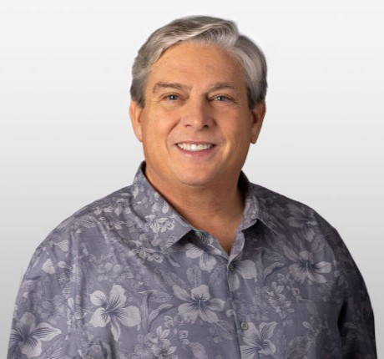 |  |  |  |  |  | JOSHUA D.  FELDMAN  Age: 53  Director since: 2019 |  |  | 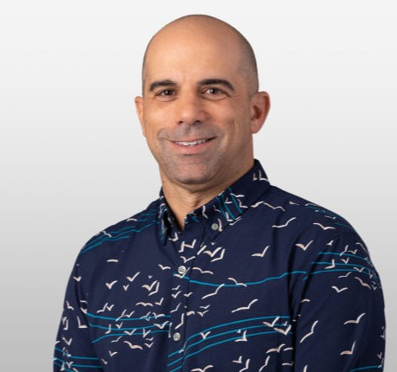
INDEPENDENT DIRECTOR  Skills: Finance, Banking, International Experience, Risk Management  Key Experience and Qualifications  A seasoned financial services executive with over 40 years in the industry, Mr. Erickson brings a wealth of strategic, operational and management experience having led a wide range of business units, including commercial lending, deposits, risk management, capital markets and wealth management. Mr. Erickson worked with Union Bank/MUFG in California until 2014, and his tenure included serving as Vice Chairman in the Chief Risk Officer and Chief Corporate Banking Officer roles. In addition, he served on the board of Zions Bancorporation, a publicly traded financial services holding company, as Chairman of the Risk Oversight Committee and as a member of the Audit Committee from 2014 to 2016. He served on the board of Luther Burbank Corporation, a publicly traded financial services holding company, from 2017 to 2024 and was a member of its Audit & Risk and Compensation Committees. In September 2023, he joined the board of National Mortgage Insurance Holdings, a publicly traded holding company, and serves on the Audit Committee as well as on the Risk Committee. Mr. Erickson’s strong banking, risk management, board and executive background qualify him to serve on our Board, the Risk Management Committee, and as Chair of the Audit Committee.  Career Highlights  •Mr. Erickson began his career at Union Bank in 1983 and served in various leadership roles including Vice Chairman, Chief Corporate Banking Officer responsible for Commercial Banking, Real Estate Industries, Global Treasury Management, Global Capital Markets, and Wealth Management, and as Vice Chairman and Chief Risk Officer responsible for enterprise-wide risk management and regulatory relations.  Other Professional Experience and Community Involvement  •Mr. Erickson served on the boards of the California Bankers Association, The Living Desert as a member of the Finance and Long Range Planning Committees, and The Music Center as its Treasurer and member of the Executive Committee.  •Mr. Erickson was a member of the Audit Committee Roundtable of Orange County, the Financial Services Board Roundtable, and the American Bankers Association Bankers Council.  Education  •Mr. Erickson received his bachelor’s degree with an emphasis in economics, and his M.B.A. with an emphasis in finance from the University of Southern California. |  |  |  |  |  |  |  |  | INDEPENDENT DIRECTOR  Skills: Retail, International Experience, Community, Hawai‘i Market, CEO Experience  Key Experience and Qualifications  Mr. Feldman is President and CEO of Tori Richard, Ltd., founded in 1956. Tori Richard, Ltd. is a Honolulu-based manufacturer, wholesaler and retailer of branded resort apparel, licensed apparel products, private label clothing and uniforms. He began his career in 1994 and was appointed President and CEO in 2004. Mr. Feldman has a solid understanding of the Hawai‘i marketplace and his accomplishments locally and globally evidence his strategic and progressive insights and operational expertise. His skills, background and experience as an innovator in the retail sector bring a valuable perspective to the Board and qualify him to serve on the Board and the Human Resources & Compensation and Risk Management Committees.  Career Highlights  •Under his leadership, the company has grown dramatically and has built a portfolio of authentic heritage brands. Mr. Feldman created Tori Richard’s retail division, TR Retail LLC, relaunched the women’s division, acquired Kahala Sportswear from Minami Sport of Japan, and formed a joint venture to provide bundled uniform services for the hospitality market. In 2025, Mr. Feldman acquired Birdwell Beach Britches, a made-in-USA heritage apparel brand founded in California in 1961.  •Tori Richard, Ltd. is a group of subsidiary branded and private label products sold in over 1,500 specialty and department store locations throughout the world. The company operates 21 company-owned stores in the state of Hawai‘i and the US Mainland and has offices in Hawai‘i, California, Florida and New York.  Other Professional Experience and Community Involvement  •Mr. Feldman is committed to the community, having served on the boards of Hawai‘i Public Radio, the Young Presidents’ Organization and as a director of Bikeshare Hawai‘i.  •He currently serves on the board of trustees of the Honolulu Museum of Art and as an advisory board member for Holomua Collective.  Education  •Mr. Feldman graduated magna cum laude with a bachelor’s degree from the University of California, San Diego.
 |  |  | BANK OF HAWAI‘I • 2026 PROXY STATEMENT |  |  | 11

PROPOSAL 1: ELECTION OF DIRECTORS
MICHELLE E.  HULST  Age: 52  Director since: 2019 |  |  | 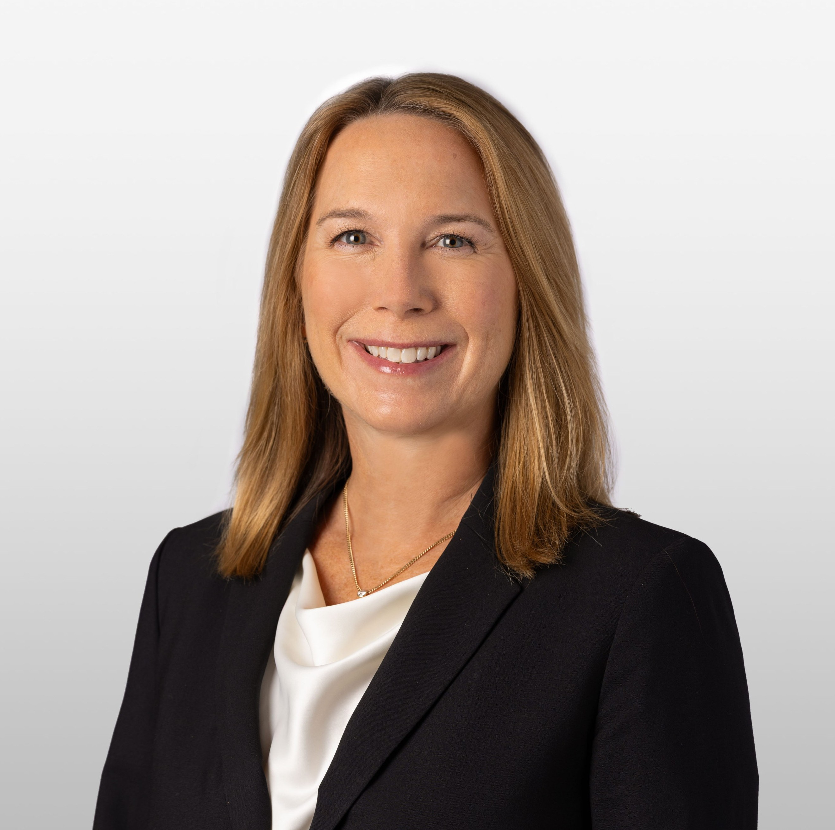 |  |  |  |  |  | KENT T.  LUCIEN  Age: 72  Director since: 2006 |  |  | 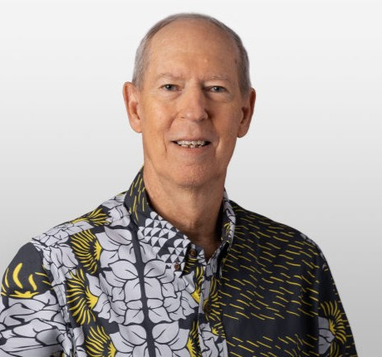
INDEPENDENT DIRECTOR  Skills: Technology, Marketing/Communications, International Experience  Key Experience and Qualifications  Ms. Hulst currently serves as Strategic Advisor at GumGum. She previously served as GumGum's President from September 2023 to March 2025 where she led GumGum’s global advertising business and drove the worldwide adoption of GumGum’s platform for the future of digital advertising.  Ms. Hulst served as Executive Vice President, Global Data & Strategy, Chief Operating Officer and Chief Data Officer at The Trade Desk, Inc. from July 2020 to July 2022. She oversaw all aspects of The Trade Desk’s operations, including client services, commercial enablement, technical account management, data partnerships and the company’s rapid geographic expansion.  Ms. Hulst also served as Group Vice President of Marketing and Strategic Partnerships at Oracle Data Cloud in San Francisco from 2015 to 2020, and was charged with developing business and data partnerships. Her expertise in digital marketing and strategic growth, developing strong alliances, and advancing key relationships are valuable skills as the Bank continues to evolve and innovate in today’s data-driven landscape. Her educational background, professional experience, and skill set qualifies her to serve on our Board, the Human Resources & Compensation and Nominating & Corporate Governance Committees.  Career Highlights  •Prior to Oracle Data Cloud, Ms. Hulst worked at Datalogix Inc., from 2006 to 2015, where she served as Senior Vice President of Strategic Partnerships and Business Development. During her tenure at Datalogix, Inc., she led the global deal team’s execution of pivotal partnerships with companies such as Facebook, Twitter, and Google, which were instrumental in the transformation of the business. She also was a member of the executive team that led the sale of Datalogix to Oracle.  Other Professional Experience and Community Involvement  •Ms. Hulst currently serves as an advisor to Conquer AI, which helps global enterprises solve complex technology challenges through cutting edge AI software. Ms. Hulst also worked at Entertainment Publications, an operating business of IAC/InterActiveCorp, where she held several positions, including Vice President. Ms. Hulst served on the boards of Ad Council, a nonprofit organization that drives the pro bono efforts of the advertising, media and tech industries and Makers, an organization that is dedicated to advancing women in the workplace.  Education  •Ms. Hulst earned a bachelor’s degree in organizational psychology from the University of Michigan and her M.B.A., with an emphasis in strategy, marketing and entrepreneurship, from Northwestern University’s Kellogg School of Management. |  |  |  |  |  |  |  |  | INDEPENDENT DIRECTOR  Skills: Finance, Banking, Community, Hawai‘i Market, CEO Experience  Key Experience and Qualifications  Mr. Lucien’s senior executive experience in major Hawai‘i businesses and strong finance and accounting background, coupled with his deep knowledge of the Company’s finances gained during his tenure with the Company makes him a valuable member of the Board and the Audit Committee.  Mr. Lucien was elected to the Board in 2006 and served as Chair of the Audit Committee prior to becoming the Company’s Chief Financial Officer in 2008.  Career Highlights  •Mr. Lucien served as Vice Chair and Chief Strategy Officer from March 2017 to April 2020 and executed the Bank’s key strategic initiatives, including the “Branch of Tomorrow” modernization project and leveraging information and technology to reshape the delivery of banking services, products and experiences with a customer focus.  •Mr. Lucien served as Vice Chair and Chief Financial Officer of the Company from April 2008 to February 2017.  Other Professional Experience and Community Involvement  •Prior to his employment with the Company, Mr. Lucien served as a Trustee for C. Brewer & Co. Ltd., (a Hawai‘i corporation engaged in agriculture, real estate and power production) and also held key executive positions at C. Brewer & Co. Ltd., including Chief Executive Officer of Operations, Controller, and Chief Financial Officer.  •He also worked for Pricewaterhouse Coopers and is a Certified Public Accountant (inactive).  •He served on the board of Wailuku Water Company LLC.  Education  •Mr. Lucien received his bachelor’s degree from Occidental College and his M.B.A. from Stanford University.

12 |  |  | BANK OF HAWAI'I • 2026 PROXY STATEMENT

PROPOSAL 1: ELECTION OF DIRECTORS
ELLIOT K.  MILLS  Age: 56  Director since: 2021 |  |  | 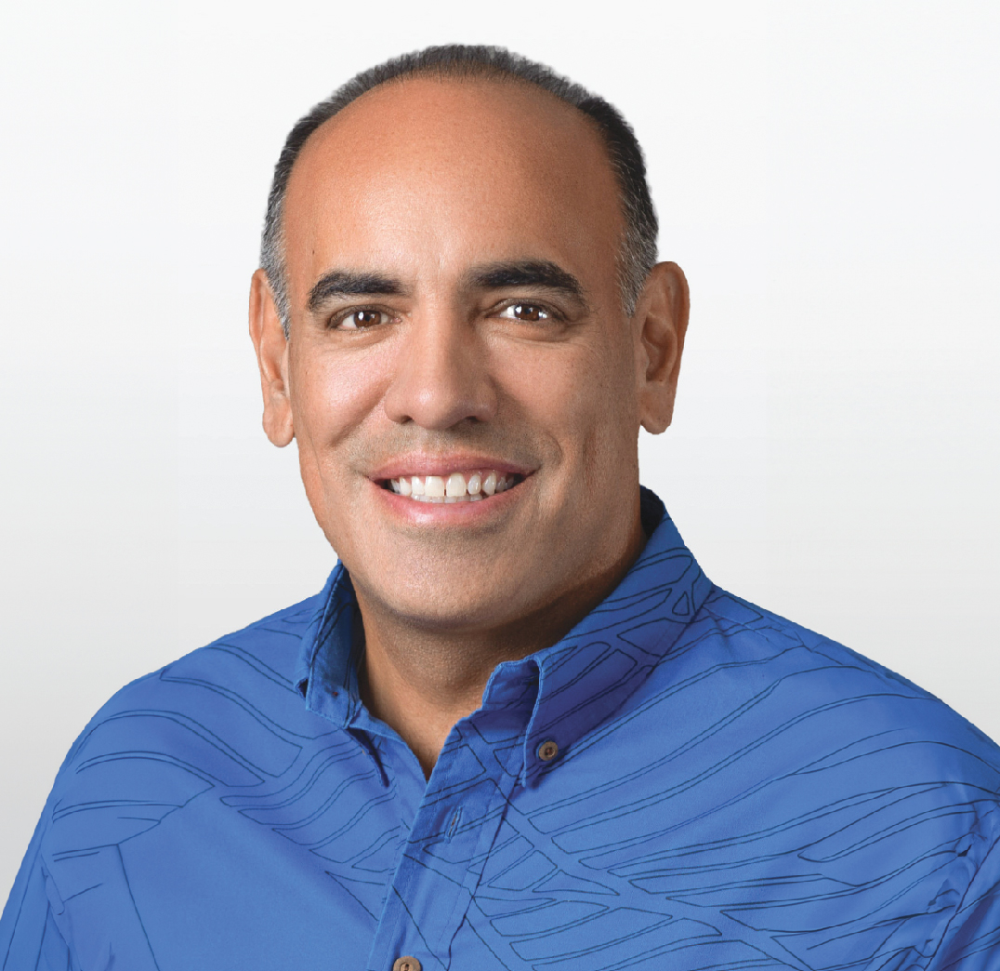 |  |  |  |  |  | ALICIA E.  MOY  Age: 48  Director since: 2017 |  |  | 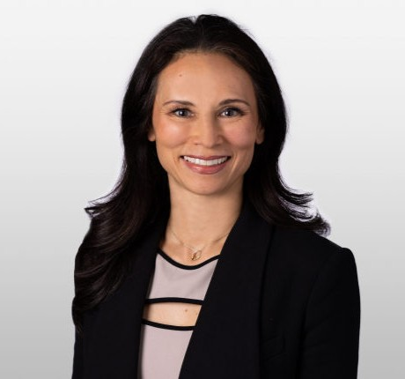
INDEPENDENT DIRECTOR  Skills: Finance, Retail, Tourism, Education, Community, Hawai‘i Market, Risk Management  Key Experience and Qualifications  Mr. Mills brings an abundance of expertise and insight of Hawai‘i’s local travel industry to Bank of Hawai‘i. His knowledge and leadership developed over 25 years in resort management brings a valuable perspective to the Board and qualifies him to serve on the Board, the Human Resources & Compensation and Nominating & Corporate Governance Committees.  Career Highlights  •Mr. Mills serves as CEO of Hawai‘i Hospitality Group. Mr. Mills previously served as Vice President of Hotel Operations for Disneyland Resort and Aulani, A Disney Resort and Spa from December 2016 to March 2025. Mr. Mills was responsible for overseeing all operations for the Disneyland Hotel, Disney’s Paradise Pier Hotel and Disney’s Grand Californian Hotel & Spa in Anaheim, California, and Aulani, A Disney Resort & Spa, in Ko Olina on O‘ahu.  •Mr. Mills had a special focus on advancing Hawaiian culture and values as the focal point for Aulani’s unique hospitality and service experience.  Other Professional Experience and Community Involvement  •Mr. Mills has held various executive and resort management positions on the islands of O‘ahu, Kaua‘i and Maui at top travel companies, including Hyatt, Marriott and Outrigger. Prior to Disney, he held the positions of General Manager at both Outrigger Hotels & Resorts on O‘ahu and at Kaua‘i Marriott Resort.  •Mr. Mills serves on a variety of boards, including Hawaii Medical Service Association, Hawai‘i Community Foundation and the Hawai‘i Visitors and Convention Bureau. He also currently serves a trustee of Kamehameha Schools.  Education  •Mr. Mills holds a degree in business administration with an emphasis in travel industry management from the University of Hawai‘i at Mānoa, and has completed the Cornell Hospitality Management General Managers Program. |  |  |  |  |  |  |  |  | INDEPENDENT DIRECTOR  Skills: Finance, International Experience, Community, Hawai‘i Market, Energy, CEO Experience  Key Experience and Qualifications  Ms. Moy’s expertise in utilities and energy has given her a unique and holistic perspective on the integrated nature of Hawai‘i’s energy ecosystem and how it is transforming to meet the state’s renewable energy and carbon neutrality goals. Given the importance of energy in Hawai‘i and how it impacts all consumers in the state, Ms. Moy’s perspective in this key segment of the markets the Bank serves brings valuable insights to the Board’s deliberations. Her leadership in this industry along with her strong executive background in finance and strategic planning qualify her to serve on the Board, the Audit Committee, and as Chair of the Risk Management Committee.  Career Highlights  •Ms. Moy has been President and Chief Executive Officer of Hawai‘i Gas since 2013, which is the state’s only government-franchised, full-service gas company. Ms. Moy also serves as President of AMF Hawai‘i Investments Holdings, LLC, the parent company of Hawai‘i Gas, as well as several other smaller businesses collectively engaged in efforts to reduce the cost and improve the reliability and sustainability of energy in Hawai‘i.  •From 2001 to 2013, Ms. Moy was Senior Vice President with Macquarie Infrastructure and Real Assets (“MIRA”), where she oversaw corporate strategy, strategic planning, funding and management of several MIRA-managed utility companies, including Hawai‘i Gas.  Other Professional Experience and Community Involvement  •Ms. Moy has served as a member of Hawai‘i Gas’s board of directors since 2011. From 1999-2001, Ms. Moy worked for Morgan Stanley in the Investment Banking division, where she was involved in corporate finance and mergers and acquisitions for private equity clients.  •Ms. Moy is a member of the Hawai‘i Business Roundtable and the Military Affairs Council. She serves on the boards of the Western Energy Institute and The Nature Conservancy of Hawai‘i. She also sits on the advisory board for Women in Renewable Energy and Holomua Collective.  Education  •Ms. Moy holds a bachelor’s degree in finance and marketing from the University of Miami and a master’s degree in finance from INSEAD.
 |  |  | BANK OF HAWAI‘I • 2026 PROXY STATEMENT |  |  | 13

PROPOSAL 1: ELECTION OF DIRECTORS
VICTOR K.  NICHOLS  Age: 69  Director since: 2014 |  |  |  |  |  |  |  |  | JAMES C. POLK  Age: 59  Appointment Effective: April 1, 2026 |  |  | 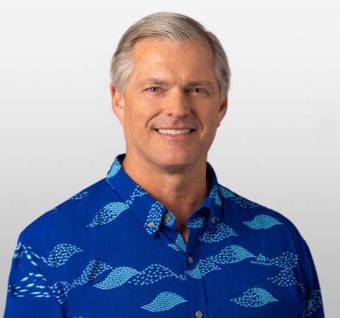
INDEPENDENT DIRECTOR  Skills: Finance, Banking, Technology, Retail, Marketing/Communications, International Experience, Education, Community, Human Resources, Risk Management, CEO Experience  Key Experience and Qualifications  Mr. Nichols’s over 40 years of executive leadership experience and knowledge in both information technology and the financial services industry, as well as his background and expertise in marketing, data analytics and strategic planning, add a valuable global perspective to the Board in understanding the increasingly important role information technology has in the financial services industry. Mr. Nichols’s background, experience, attributes and skills qualify him to serve on the Board, the Audit Committee, and the Risk Management Committee.  Career Highlights  •Mr. Nichols is the Chairman of Make-A-Wish, International, a not-for-profit foundation providing life changing wishes to ill children in 50 countries outside of the U.S., and has held that position since November 2022.  •Mr. Nichols served as an independent advisor to Harland Clarke Holdings (now named Vericast); former Chairman of Harland Clarke Holdings from January to June 2019, and previously served as its Chief Executive Officer from January 2017. As its CEO, Mr. Nichols oversaw Harland Clarke, Scantron, Retail Me Not, and Valassis. He was Chief Executive Officer of Valassis, a leader in intelligent media delivery from April 2015 through December 2016.  •Mr. Nichols previously served as Chief Executive Officer of North America, Managing Director of EMEA, and President of Global Consumer Services for Experian, the leading global information services company providing data and analytical tools to clients around the world.  •Prior to joining Experian, Mr. Nichols served as Chief Information Officer at Wells Fargo & Company.  •Mr. Nichols was President of Safeguard Business Systems and held senior positions at Bank of America in interstate banking integration, consumer loan services, and operations.  •Mr. Nichols was past President and founding partner of VICOR, Inc., an advanced technology engineering firm leading business transformation with a concentration in the financial services industry.  Other Professional Experience and Community Involvement  •Mr. Nichols was a director of Revlon, Inc. from 2019 until 2023, and served as a member of Revlon’s audit committee and later the restructuring committee. He served as a director of Zovio, an education technology services company (formerly Bridgepoint Education, Inc.) from 2014 to 2022. He served as chairman of Zovio's compensation committee and as a member of its audit committee and the merger and acquisition oversight committee. Mr. Nichols is an advisor to Trusona, a passwordless identity authentication company, and to Shield3 (aka Minty), a Web 3.0 Security start up. He has been an Advisor to Mitek, an identification technology provider, and to Bloom, a global consumer data provider.  •In addition, Mr. Nichols is a past member of the Economics Leadership Council, University of California, San Diego, served on the Leadership Council for UCI Donald Bren School of Information and Computer Sciences, and served on the Dean’s Advisory Board, University of California, Irvine Merage School.  Education  •Mr. Nichols holds a Bachelor of Science degree in economics from the University of California, San Diego, and an M.B.A. in finance from the University of California, Berkeley. |  |  |  |  |  |  |  |  | Skills: Finance, Banking, International Experience, Community, Hawai‘i Market  Key Experience and Qualifications  As recently appointed CEO, Mr. Polk is focused on the Bank’s longstanding strategy of providing financial products and services that are world-class in quality and locally coveted in the markets we serve. He understands that his commitment to the Bank’s employees and the community are important drivers of the Bank’s continued long-term success. Mr. Polk's 26-year career at Bank of Hawai‘i, serving in multiple leadership roles, overseeing many major aspects of the Company’s business, his deep knowledge of our markets, community and culture, and his 36 years of experience in the financial services industry make him well qualified for service on our Board.  Bank of Hawai‘i continues to receive industry and press recognition locally and nationally. In 2025, Bank of Hawai‘i had the largest share of deposits among all FDIC-insured financial institutions in Hawai‘i. In 2025, the Bank was ranked number 12 among the “Most Trustworthy Companies in America” in the banking industry category by Newsweek, and Bank of Hawai‘i was the only Hawai‘i business listed. Also in 2025, the Bank was named “Hawai‘i’s Best Bank” by the readers of the major newspapers across the state, including the Honolulu Star-Advertiser, The Garden Island, Hawai‘i Tribune-Herald and West Hawai‘i Today.  Career Highlights  •Mr. Polk will serve as CEO and President of the Company beginning April 1, 2026. He has served as President from July 2024 to present; Vice Chair from 2016 to 2026 and Chief Banking Officer from 2021 to 2026; Senior Executive Vice President and Manager of the Bank's Hawai‘i Commercial Banking Division from 2009 to 2016; and Executive Vice President and Pacific Islands Division Manager from 2006 to 2009.  Other Professional Experience and Community Involvement  •Mr. Polk is active in the Hawai‘i community and serves as a board member for the Hawaii Medical Service Association and After-School All-Stars Hawaii.  Education  •Mr. Polk holds a Bachelor of Science degree in economics from the University of Michigan and is a graduate of Harvard Business School's Advanced Management Program, as well as a graduate of the Pacific Coast Banking School at the University of Washington.
14 |  |  | BANK OF HAWAI'I • 2026 PROXY STATEMENT

PROPOSAL 1: ELECTION OF DIRECTORS
DANA M.  TOKIOKA  Age: 55  Director since: 2020 |  |  |  |  |  |  |  |  | RAYMOND P.  VARA, JR.  Age: 56  Director since: 2013 |  |  | 
INDEPENDENT DIRECTOR  Skills: Finance, Technology, Community, Hawai‘i Market, Risk Management  Key Experience and Qualifications  Ms. Tokioka’s strong leadership and strategic experience in IT and Finance in the insurance industry, a key segment of the markets we serve, combined with her risk management and legal background bring valuable insights to the Board’s deliberations at a time of rapidly advancing technologies and changing business models. Her professional experiences and unique skill set qualify her to serve on the Board.  Career Highlights  •Ms. Tokioka serves as President of Tradewind Group Foundation, which supports over 120 nonprofit organizations annually and Vice President of Community Engagement at Atlas Insurance Agency. Ms. Tokioka served as Vice President of Special Projects at Atlas Insurance Agency from 2010 through 2025 where she spearheaded and refined numerous initiatives, transforming the business and helping Atlas become recognized as a nationally ranked top 100 independent agency. While at Atlas, she developed and executed multiple IT initiatives, established financial reporting metrics, and engineered and directed multi-layered risk programs for financial institutions, service-based organizations, construction firms and other business enterprises.  •Prior to Atlas Insurance, Ms. Tokioka practiced both real estate and corporate law in California, representing numerous technology companies and performing due diligence for financings and M&A transactions. She negotiated terms and conditions for software, hardware, and consulting agreements and for strategic alliances with U.S. and international corporations. Ms. Tokioka also worked for Booz Allen Hamilton as an Economic Business Analyst to perform economic and cost analysis for IT systems as well as strategize financial and programmatic assessments for the U.S. Army.  Other Professional Experience and Community Involvement  •Ms. Tokioka was a member of the Board of Directors of Tradewind Capital Group, a Hawai‘i-based investment firm focused on real estate and private equity opportunities and was a board member of IC international, a surplus lines insurance broker.  •Ms. Tokioka is a dedicated supporter of the Hawai‘i nonprofit community. She currently serves on the Board of the Pacific Asian Center for Entrepreneurship at the University of Hawai‘i at Mānoa Shidler College of Business and Hawai‘i Public Radio, and on the Advisory Board for Teach for America - Hawai‘i. She previously served as Chair of the Board of Directors of the YWCA Honolulu and on the boards of Hawai‘i Theatre and Hawaii Imin Shiryo Hozon Kai, a nonprofit focused on sharing the Japanese immigrant experience in Hawai‘i.  Education  •Ms. Tokioka is a graduate of Tufts University with a Bachelor of Arts degree, cum laude, in history. She received her M.B.A. from the McDonough School of Business at Georgetown University and her Juris Doctor from the Georgetown University Law Center. |  |  |  |  |  |  |  |  | INDEPENDENT DIRECTOR  Skills: Finance, Health, Community, Hawai‘i Market, Government Experience, Risk Management, CEO Experience  Key Experience and Qualifications  Mr. Vara’s financial and operational background coupled with his senior executive and audit committee experience make him qualified to serve as Chair of the Company’s Board and its Nominating & Corporate Governance Committee. His community involvement and leadership of Hawai‘i’s largest health care provider and non-governmental employer also bring a valuable perspective of a key segment of the markets we serve.  Career Highlights  •Mr. Vara was named Hawaii Business magazine CEO of the Year 2021.  •As President and CEO of Hawai‘i Pacific Health, he oversees Hawai‘i’s largest health care provider comprised of Straub Benioff Medical Center, Kapi‘olani Medical Center for Women & Children, Pali Momi Medical Center, Wilcox Medical Center and Hawai‘i Pacific Health Medical Group with over 70 locations.  •Prior to his appointment to CEO in 2012, Mr. Vara served as its Executive Vice President and Chief Executive Officer of Operations of Hawai‘i Pacific Health since 2004.  •Mr. Vara also served as Chief Financial Officer and Chief Executive Officer for Los Alamos Medical Center in New Mexico, an integrated health care service provider.  Other Professional Experience and Community Involvement  •Prior to joining the private sector, Mr. Vara held various positions in the United States Army, including Deputy Chief Financial Officer of the Madigan Army Medical Center in Tacoma, Washington, and Assistant Administrator and Chief Financial Officer of Bassett Army Community Hospital in Fairbanks, Alaska.  •Mr. Vara is active in the Hawai‘i community and serves as a director on several boards, including Hawai‘i Executive Collaborative, Island Insurance Company, Ltd., Tradewind Capital Group, Tradewind Group, Inc., and American Heart Association-National Board, where he serves as Immediate Past-Chairman.  Education  •Mr. Vara holds a bachelor’s degree in business administration from Hawai‘i Pacific University and received his M.B.A. from the University of Alaska at Fairbanks.
 |  |  | BANK OF HAWAI‘I • 2026 PROXY STATEMENT |  |  | 15

PROPOSAL 1: ELECTION OF DIRECTORS
SUZANNE P.  VARES-LUM  Age: 58  Director since: 2023 |  |  |  |  |  |  |  |  | ROBERT W.  WO  Age: 73  Director since: 2002 |  |  | 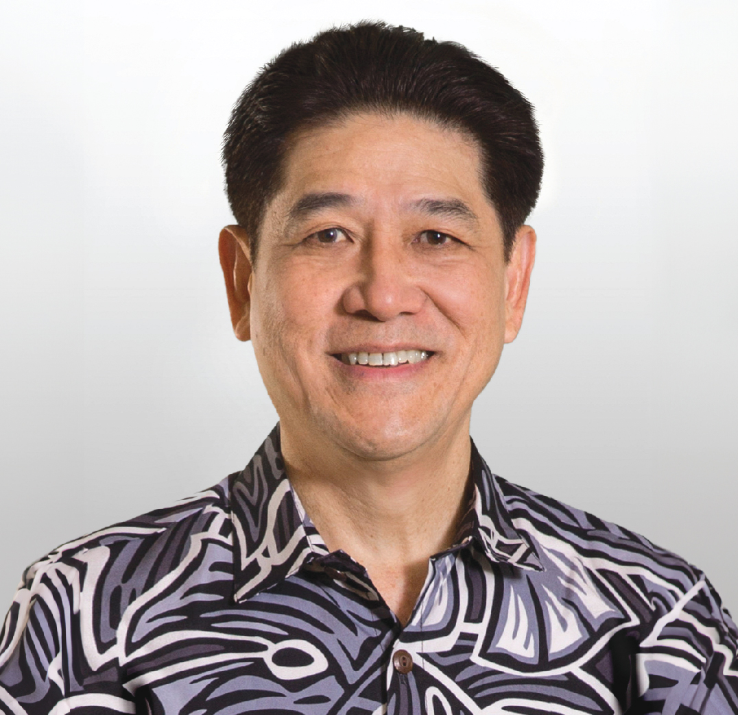
INDEPENDENT DIRECTOR  Skills: Marketing/Communications, International Experience, Education, Community, Hawai‘i Market, Government Experience, Risk Management, CEO Experience  Key Experience and Qualifications  Ms. Vares-Lum is a retired Major General in the U.S. Army. She joined the Board in 2023, and her decades of executive leadership and planning experience qualify her to serve on the Board and Nominating & Corporate Governance Committee.  Career Highlights  •Ms. Vares-Lum serves as Director of Daniel K. Inouye Asia Pacific Center for Security Studies since January 2025.  •Ms. Vares-Lum served as President of the East-West Center from January 2022 to December 2024. She is the first woman and Native Hawaiian to serve as President since the Center’s establishment in 1960. In 2022, she launched a new strategic plan that advances the Center’s mission to promote understanding and relationships among people and nations of the U.S., Asia and Pacific through cooperative study, research and dialogue.  •Ms. Vares-Lum formed Vares-Lum Indo-Pacific Consulting, LLC to provide consulting and advising on regional issues. She is an advocate for education and building bridges across the Indo-Pacific, and has led collaborative initiatives in the region.  •As a retired Major General with 34 years of service, Ms. Vares-Lum has held key roles addressing priority national security challenges in the region, with over five years serving with and advising the most senior officials at U.S. Indo-Pacific Command, where she cultivated and maintained key relationships with nations throughout the Indo-Pacific region.  Other Professional Experience and Community Involvement  •Ms. Vares-Lum serves on the Pacific International Center for High Technology Research.  •Ms. Vares-Lum is a current member of the U.S.-Japan Council and has also served on committees that promote Hawai‘i’s economic diversification, workforce development, and community dialogue on issues regarding land and water.  •In addition to her military and community awards, she is the recipient of the 2023 Girl Scouts of Hawai‘i Women of Distinction Award, and a 2017 Ellis Island Medal of Honor Awardee.  Education  •Ms. Vares-Lum received her Bachelor of Arts degree in Journalism in 1989 and her Master of Education in Teaching in 1996 from the University of Hawai‘i at Mānoa. As a graduate of the U.S. Army War College, she earned a Master of Strategic Studies degree in 2011. In 2019, she became a National Security Fellow of the Maxwell School of Citizenship and Public Affairs at Syracuse University. She is also an alumna of the Daniel K. Inouye Asia-Pacific Center for Security Studies. |  |  |  |  |  |  |  |  | INDEPENDENT DIRECTOR  Skills: Retail, International Experience, Community, Hawai‘i Market, CEO Experience  Key Experience and Qualifications  As Owner and Director of C.S. Wo & Sons, Ltd. since 1984, Mr. Wo has led this third-generation family-owned and operated business to become Hawai‘i’s largest furniture retailer, ranking it among the Top 250 companies in the state of Hawai‘i and among the Top 100 furniture retailers in the nation. Mr. Wo’s knowledge and experience in operating a business in the Company’s core market as a major employer in the State and deep involvement in the community qualify him for service on the Board, as Chair of the Human Resources & Compensation Committee and as a Member of the Nominating & Corporate Governance Committee.  Career Highlights  •Mr. Wo has been the Owner and Director of C.S. Wo & Sons, Ltd. since 1984.  Other Professional Experience and Community Involvement  •Mr. Wo is active in the community, having served on the boards of Aloha United Way, Junior Achievement of Hawaii, Rotary Club of Honolulu, Retail Merchants of Hawaii, and Hawaii Medical Service Association. He currently serves on the boards of Assets School and ‘Iolani School.  •Mr. Wo is a past member of the Hawaii Business Roundtable whose mission is to promote the overall economic vitality and social health of Hawai‘i, and continues to serve on its Education Committee.  Education  •Mr. Wo received his bachelor’s degree in economics from Stanford University and earned his M.B.A. from Harvard Business School.

16 |  |  | BANK OF HAWAI'I • 2026 PROXY STATEMENT

PROPOSAL 1: ELECTION OF DIRECTORS
BENEFICIAL OWNERSHIP
At the close of business on February 27, 2026, Bank of Hawaii Corporation had 39,725,521 shares of its common stock outstanding. As of February 27, 2026, the following table shows the amount of Bank of Hawaii Corporation common stock owned by (i) each person or entity who is known by us to beneficially own more than five percent of Bank of Hawaii Corporation’s common stock; (ii) each current director and director nominee, (iii) each of the executive officers named in the Summary Compensation Table (the “named executive officers”), and (iv) all of our directors and executive officers as a group. Unless otherwise indicated and subject to applicable community property and similar statutes, all persons listed below have sole voting and investment power over all shares of common stock beneficially owned. Share ownership has been computed in accordance with SEC rules and does not necessarily indicate beneficial ownership for any other purpose.
Name |  |  | Number of Shares Beneficially Owned |  |  |  |  |  |  |  |  | Right to Acquire Within 60 Days |  |  |  |  |  | Total |  |  |  |  |  | Percent of Outstanding Shares as of February 27, 2026
More than Five Percent Beneficial Ownership
BlackRock, Inc.  50 Hudson Yards  New York, New York 10055 |  |  | 5,825,514 |  |  | (1) |  |  |  |  |  | — |  |  |  |  |  | 5,825,514 |  |  |  |  |  | 14.66 |  | %
The Vanguard Group  100 Vanguard Blvd.  Malvern, Pennsylvania 19355 |  |  | 4,565,434 |  |  | (2) |  |  |  |  |  | — |  |  |  |  |  | 4,565,434 |  |  |  |  |  | 11.49 |  | %
State Street Corporation  1 Congress Street, Suite 1  Boston, Massachusetts 02114-2016 |  |  | 2,177,539 |  |  | (3) |  |  |  |  |  | — |  |  |  |  |  | 2,177,539 |  |  |  |  |  | 5.48 |  | %
Current Directors and Director Nominees
John C. Erickson |  |  | 9,491 |  |  | (4)(5) |  |  |  |  |  | 987 |  |  |  |  |  | 10,478 |  |  |  |  |  | *
Joshua D. Feldman |  |  | 7,096 |  |  | (4) |  |  |  |  |  | 987 |  |  |  |  |  | 8,083 |  |  |  |  |  | *
Michelle E. Hulst |  |  | 5,695 |  |  | (4) |  |  |  |  |  | 987 |  |  |  |  |  | 6,682 |  |  |  |  |  | *
Kent T. Lucien |  |  | 41,139 |  |  | (4)(5)(6) |  |  |  |  |  | 987 |  |  |  |  |  | 42,126 |  |  |  |  |  | *
Elliot K. Mills |  |  | 4,332 |  |  | (4) |  |  |  |  |  | 987 |  |  |  |  |  | 5,319 |  |  |  |  |  | *
Alicia E. Moy |  |  | 11,591 |  |  | (4) |  |  |  |  |  | 987 |  |  |  |  |  | 12,578 |  |  |  |  |  | *
Victor K. Nichols |  |  | 30,396 |  |  | (4) |  |  |  |  |  | 987 |  |  |  |  |  | 31,383 |  |  |  |  |  | *
James C. Polk |  |  | 125,367 |  |  | (5) |  |  |  |  |  | — |  |  |  |  |  | 125,367 |  |  |  |  |  | *
Dana M. Tokioka |  |  | 5,536 |  |  | (4) |  |  |  |  |  | 987 |  |  |  |  |  | 6,523 |  |  |  |  |  | *
Raymond P. Vara, Jr. |  |  | 10,987 |  |  | (4) |  |  |  |  |  | 987 |  |  |  |  |  | 11,974 |  |  |  |  |  | *
Suzanne P. Vares-Lum |  |  | 2,634 |  |  | (4) |  |  |  |  |  | 987 |  |  |  |  |  | 3,621 |  |  |  |  |  | *
Robert W. Wo |  |  | 89,727 |  |  | (4)(5) |  |  |  |  |  | 987 |  |  |  |  |  | 90,714 |  |  |  |  |  | *
Named Executive Officers
Peter S. Ho |  |  | 246,539 |  |  |  |  |  |  |  |  | — |  |  |  |  |  | 246,539 |  |  |  |  |  | *
Bradley S. Satenberg |  |  | 21,862 |  |  |  |  |  |  |  |  | — |  |  |  |  |  | 21,862 |  |  |  |  |  | *
Dean Y. Shigemura |  |  | 61,662 |  |  | (5) |  |  |  |  |  | — |  |  |  |  |  | 61,662 |  |  |  |  |  | *
S. Bradley Shairson |  |  | 49,566 |  |  |  |  |  |  |  |  | — |  |  |  |  |  | 49,566 |  |  |  |  |  | *
Marco A. Abbruzzese |  |  | 28,731 |  |  |  |  |  |  |  |  | — |  |  |  |  |  | 28,731 |  |  |  |  |  | *
Patrick M. McGuirk |  |  | 30,479 |  |  |  |  |  |  |  |  | — |  |  |  |  |  | 30,479 |  |  |  |  |  | *
All current directors, director nominees, and executive officers as a group (19 persons) |  |  | 771,927 |  |  |  |  |  |  |  |  | 10,857 |  |  |  |  |  | 782,784 |  |  |  |  |  | 1.97%
* Less than one percent
(1)According to its Schedule 13F-HR filed with the SEC on February 12, 2026, BlackRock, Inc. is a parent holding company or control person and may be deemed to have beneficial ownership as of December 31, 2025 of 5,825,514 shares of Bank of Hawaii Corporation common stock owned by its clients, none known to have more than five percent of outstanding shares except subsidiary BlackRock Fund Advisors. According to the same filing, BlackRock, Inc. has sole power to vote or to direct the vote over 5,718,569 of those shares and sole power to dispose or to direct the disposition of 5,825,514 shares.
(2)According to its Schedule 13F-HR filed with the SEC on January 29, 2026, The Vanguard Group is an investment adviser and its subsidiaries may be deemed to have beneficial ownership as of December 31, 2025, of 4,565,434 shares of Bank of Hawaii Corporation common stock owned by
 |  |  | BANK OF HAWAI‘I • 2026 PROXY STATEMENT |  |  | 17

PROPOSAL 1: ELECTION OF DIRECTORS
its clients, none known to have more than five percent of outstanding shares. According to the same filing, The Vanguard Group has shared power to vote or to direct the vote over 277,311 of those shares, and sole power to dispose or to direct the disposition of 4,565,434 shares.
(3)According to its Schedule 13F-HR filed with the SEC on February 13, 2026, State Street Corporation is a parent holding company and may be deemed to have beneficial ownership as of December 31, 2025 of 2,177,539 shares of Bank of Hawaii Corporation common stock owned by its clients. According to the same filing, State Street Corporation has sole power to vote or to direct the vote over 224,494 of those shares, shared power to vote or to direct the vote over 566 of those shares, and shared power to dispose or to direct the disposition of 2,177,539 shares.
(4)Represents common stock directly owned and restricted shares under the Director Stock Program that will be distributed within 60 days of February 27, 2026: Mr. Erickson, 987 shares; Mr. Feldman, 987 shares; Ms. Hulst, 987 shares; Mr. Lucien, 987 shares; Mr. Mills, 987 shares; Ms. Moy, 987 shares; Mr. Nichols, 987 shares; Ms. Tokioka, 987 shares; Mr. Vara, 987 shares; Ms. Vares-Lum, 987 shares and Mr. Wo, 987 shares. Also includes shares owned by directors under the Directors Deferred Compensation Plan: Messrs. Mills, 630 shares; Nichols, 14,150 shares and Wo, 34,906 shares.
(5)Includes shares held individually or jointly by family members as to which the specified director or officer may be deemed to have shared voting or investment power as follows: Mr. Erickson, 9,491 shares; Mr. Lucien, 4,500 shares; Mr. Wo, 11,873 shares; Mr. Polk, 31,749 shares, and Mr. Shigemura, 39,570 shares.
(6)Includes 1,000 shares held in a Keogh account.

18 |  |  | BANK OF HAWAI'I • 2026 PROXY STATEMENT

PROPOSAL 1: ELECTION OF DIRECTORS
COMMITMENT TO CORPORATE RESPONSIBILITY
The Company is dedicated to making corporate responsibility a part of everything we do in the communities we serve, including how we manage and develop our people, the products and services we offer, and the investments we make in creating a sustainable and resilient economy in our communities. This effort is managed by a cross-functional team of senior executives representing Corporate Communications, Marketing Community & Employee Engagement, Philanthropy, Real Estate & Facilities, Banking, People Services, Investor Relations, Legal, Risk, Vendor Management, Financial Reporting, and Cybersecurity, and all aspects of our revenue generating businesses, and ultimately reports to the Nominating & Corporate Governance Committee of the Board. Senior management and the Board remain committed to being a leader among Hawai‘i’s corporate citizens by fostering an effective and efficient risk and control environment that includes an emphasis on an ethically driven culture, sustainable growth, and ongoing investment in our employees and our community. The Company publishes an annual Impact Report, which further describes these initiatives that drive substantial shareholder value by helping to ensure the continued viability of the Company.
The Company’s Code of Business Conduct and Ethics drives a workplace and workforce that embraces the highest ethical and moral standards. We maintain strong and confidential reporting processes and procedures that support an open and honest environment in an effort to ensure that the highest principles of integrity and inclusion are maintained.
The Company believes in a work environment where teammates feel they are supported, treated fairly and able to contribute fully. As of December 31, 2025, approximately 89% of our workforce identifies as Black, Indigenous, and People of Color (“BIPOC”) and approximately 61% of our employees are female. Among our senior leaders and managers, 84% are BIPOC and 61% are female. We conduct regular external pay equity studies to evaluate compensation practices and confirm that gender pay gaps do not exist. These workforce characteristics reflect the markets we serve and support employee retention, customer trust and operational continuity in Hawai‘i and the West Pacific.

COMMITMENT TO EFFECTIVE CORPORATE GOVERNANCE
The Company is committed to effective corporate governance practices that enhance and protect shareholder rights. As of December 31, 2025, the following corporate governance practices were in place:
•Annually elected directors
•Majority voting in director elections with a plurality carve out in the case of contested elections and a director resignation policy
•Independent directors comprise 92% (11) of the Board of Directors and 100% of key committees
•33% of directors are women (4)
•50% of directors are ethnically diverse (6)
•Ongoing director refreshment with 2 new directors added in the past 5 years
•The directors are subject to Company stock ownership guidelines equal to 5 times the director annual cash retainer
•Directors actively participate in continuing education programs on corporate governance and related issues
•Each director attended at least 75% of the Board and the director’s assigned committee meetings
•The Company has adopted an annual frequency for the Say-on-Pay vote
•The Company participates in robust shareholder outreach activities
•The Company supports a whistleblower policy and program
•The Company maintains a clawback policy
•No poison pill has been adopted
 |  |  | BANK OF HAWAI‘I • 2026 PROXY STATEMENT |  |  | 19

PROPOSAL 1: ELECTION OF DIRECTORS
Corporate Governance Guidelines
The Company and the Board have adopted Corporate Governance Guidelines (“Governance Guidelines”). The Governance Guidelines are posted on the Investor Relations page of the Company’s website at www.boh.com. The Governance Guidelines address director qualification and independence standards, responsibilities of the Board, access to management and independent advisors, compensation, orientation and continuing education, Board committees, Chief Executive Officer (“CEO”) evaluation, management succession, Code of Business Conduct and Ethics, shareholder communications to the Board and the Board’s annual performance evaluation.
The Company’s leadership structure includes a CEO, who is also a director of the Company, and a separate, independent Board Chair. This governance structure provides a form of leadership that provides the Board with management's perspective, while also allowing the Board to function distinct from management, capable of objective judgment regarding management’s performance, and enables the Board to fulfill its duties effectively and efficiently. The Company’s leadership structure promotes the objectivity of the Board’s decisions and its role in reviewing the performance of management. Through its leadership and governance processes the Company seeks to establish a governance structure that provides both oversight and guidance by the Board to management regarding strategic planning, risk assessment and management, and corporate performance.
The Company’s current Board Chair, Mr. Peter S. Ho will retire from the Board on March 31, 2026. The Board appointed Mr. Raymond P. Vara, Jr. to the position of Board Chair effective April 1, 2026. The Company’s Governance Guidelines clearly define the Board Chair’s role and duties which include, but are not limited to, presiding over regularly scheduled executive sessions of the non-management directors, serving as a liaison between the non-management directors and executive management, and assisting the Board and executive management to ensure compliance with the Governance Guidelines.
The Board has determined that all of the 11 non-management director nominees for the 2026 Annual Meeting of Shareholders, including the Board Chair, are “independent” as defined by the NYSE rules. The non-management directors meet in executive session without management in attendance for regularly scheduled meetings. The non-management directors may also meet in executive session each time the full Board convenes for a meeting. In 2025, the non-management directors met ten times in executive session. The Board Chair also meets regularly on an individual basis with directors, the Company’s CEO, and other members of the executive management team.
Director Qualifications and Nomination Process
The Nominating & Corporate Governance Committee is responsible for identifying and assessing all director candidates and recommending nominees to the Board. Potential nominees are evaluated based on their independence, within the meaning of the Governance Guidelines and NYSE rules. Candidates to be nominated as a director, including those submitted by shareholders, are selected based on, among other criteria, their integrity, informed judgment, financial literacy, high performance standards, accomplishments and reputation in the community, experience, skill sets, and ability to commit adequate time to Board and committee matters and to act on behalf of shareholders. The criteria also include a determination of the needs of the Board and of the interplay between each individual’s personal qualities and characteristics and those of the other directors and potential directors in building a Board that is effective, collegial and responsive to the needs of the Company and its shareholders. In addition, Board members are expected to participate in continuing education and training opportunities to stay current on corporate governance, industry trends and issues and to enhance their understanding of the Company’s business.
The objective of the Nominating & Corporate Governance Committee is to present a combination of candidates that will result in a Board with a wide range of skills, expertise, industry knowledge, viewpoints, and backgrounds, with business and community contacts relevant to the Company’s business. To accomplish this, the Nominating & Corporate Governance Committee seeks candidates from different age groups, ethnicities, genders, industries, and experiences, in addition to the criteria described above. The Board includes directors with experience in public corporations, nonprofit organizations, and entrepreneurial individuals who have successfully run their own private enterprises. The Board also has the broad set of skills necessary for providing oversight to a financial institution, which includes proven leadership and expertise in finance, accounting, information technology, risk management, lending, investment management, digital marketing, data analytics and communications. A shareholder may submit a candidate for consideration by the Board to be included in the Board’s slate of director nominees. Candidates proposed by shareholders will be evaluated by the Nominating & Corporate Governance Committee under the same criteria that are applied to other candidates. The criteria are set forth above and in the Company’s Bylaws and Governance Guidelines. Candidates to be considered for nomination by the Nominating & Corporate Governance Committee at the 2027 Annual Meeting of Shareholders must be presented in writing to the Corporate Secretary not earlier than January 24, 2026, and no later than February 3, 2026, at 130 Merchant Street, Honolulu, Hawai‘i 96813, along with the information required by the Company's Bylaws for a shareholder nomination of directors.
20 |  |  | BANK OF HAWAI'I • 2026 PROXY STATEMENT

PROPOSAL 1: ELECTION OF DIRECTORS
Director Experience, Tenure, Diversity and Refreshment
The Board maintains a unique balance of experience, tenure, diversity, cultural and local market knowledge and broad subject matter expertise. While our longer-tenured directors carry a wealth of experience and deep understanding of the Company and our industry, the Board embraces the need for fresh perspectives and is committed to continued director refreshment. Since 2021, the Board has added three new directors. This refreshment strategy results in a membership that maintains new and contemporary perspectives, ideas and approaches.
Board and Committee Evaluations
The Nominating & Corporate Governance Committee leads and oversees the annual evaluation of the Board and Board committees. The annual evaluation includes an individual director self-assessment and an independent third party hosted survey to determine whether the Board and its committees are functioning effectively. The Nominating & Corporate Governance Committee establishes the evaluation criteria, oversees the evaluation process, discusses the results with the Board, and implements any changes that emerge from the evaluations that the Board deems appropriate to enhance Board effectiveness.
An independent consultant provides assistance with the design of the online survey instrument and administers the survey on behalf of the Nominating & Corporate Governance Committee, thereby assuring anonymity of participant responses through a secure, encrypted website. A written report of total sample data, as well as data for the Board committees, is prepared by the consultant, analyzing the closed-end questions and including the verbatim comments offered by directors at the close of each section of the survey that may provide recommendations for improvement. The report also tracks current data against results from previous surveys, where comparable. The Nominating & Corporate Governance Committee, through the same third party, distributes a survey to executive management for feedback concerning how the Board and its committees can enhance their effectiveness.
Majority Voting
The Company’s Bylaws and Governance Guidelines provide for majority voting in uncontested elections and a resignation process in the event a director nominee does not obtain a majority of votes cast. The resignation process provides the Board with discretion to accept or reject a tendered resignation if a majority vote is not obtained. If the tendered resignation is not accepted by the Board, the Board shall not nominate such director to stand for re-election at the next annual meeting of shareholders.
Communication with Directors
Shareholders and any interested parties may communicate with the Board, non-management directors, or the Board Chair by sending correspondence c/o the Company’s Corporate Secretary, 130 Merchant Street, Honolulu, Hawai‘i 96813. All appropriate communications received will be forwarded to the Board, non-management directors or the Board Chair as addressed.
 |  |  | BANK OF HAWAI‘I • 2026 PROXY STATEMENT |  |  | 21

PROPOSAL 1: ELECTION OF DIRECTORS
Code of Business Conduct and Ethics
The Company has earned its reputation as a respected leader in the communities it serves and in the financial services industry by conducting business in an ethical, responsible and professional manner. The Company is proud of the high standards of quality and service that have been its hallmark through the years. These qualities represent fundamental business practices and apply to all directors, officers and employees.
The Company and the Board have adopted a Code of Business Conduct and Ethics (the “Code”) for directors, executive officers (including the Company’s Chief Executive Officer, Chief Financial Officer, Principal Accounting Officer and Controller) and employees, which is posted on the Investor Relations page of the Company’s website at www.boh.com. The Code addresses the professional, honest and ethical conduct required of each director, officer and employee, conflicts of interest, disclosure process, compliance with laws, rules and regulations (including securities trading), corporate opportunities, confidentiality, fair dealing, protection and proper use of Company assets, and encourages the reporting of any illegal or unethical behavior through robust reporting protocols and whistleblower protections. The Company also maintains a whistleblower and anti-retaliation policy and encourages conduct reporting through several designated channels, including the Chair of the Audit Committee, Chief Ethics Officer, General Counsel and a third party hosted anonymous alert line. A waiver of any provision of the Code may be made only by the Audit Committee of the Board and must be promptly disclosed as required by SEC and NYSE rules. The Company will disclose any such waivers, as well as any amendments to the Code, on the Company’s website at www.boh.com.
Policy Prohibiting Hedging and Pledging of Company Stock
The Company has adopted a Securities Trading Policy (the “Policy”) governing transactions in Company securities by directors, officers, employees and other covered persons. A copy of the policy is incorporated by reference as Exhibit 19.1 to the Company’s 2025 Annual Report on Form 10-K for the fiscal year ended December 31, 2025.
The Policy specifically prohibits directors and executive officers from hedging the risk associated with the ownership of Bank of Hawaii Corporation’s common stock and from pledging transactions involving Company stock as collateral, including the use of a traditional margin account with a broker-dealer.
Director Independence
The Board is comprised of a majority of independent directors as defined by the NYSE listing standards. In affirmatively determining that a director is independent of the Company’s management and has no material relationship with the Company, either directly or indirectly as a partner, shareholder, or officer of an organization that has a relationship with the Company, the Board applies the following categorical standards, in addition to such other factors as the Board deems appropriate:
a)In no event shall a director be considered independent if the director is an employee, or a member of the director’s immediate family is an executive officer of the Company until three years after the end of such employment relationship. Employment as an interim Chairman of the Board, Chief Executive Officer, Chief Financial Officer or other executive officer shall not disqualify a director from being considered independent following that employment.
b)In no event shall a director be considered independent if the director receives, or a member of the director’s immediate family who serves as an executive officer of the Company receives more than $120,000 per year in direct compensation from the Company, other than director and committee fees and pension or other forms of deferred compensation for prior service (provided such compensation is not contingent in any way on continued service). A director may not be considered independent until three years after ceasing to receive such compensation.
c)In no event shall a director be considered independent if the director is a current partner or employee of the Company’s internal or external auditor, or whose immediate family member is a current partner or employee of such a firm and personally works on the Company’s audit; or was a partner or employee of such a firm and personally worked on the Company’s audit within the last three years.
d)In no event shall a director be considered independent if the director is employed, or a member of the director’s immediate family is employed, as an executive officer of another company where any of the Company’s present executives serves on that company’s compensation committee until three years after the end of such service or employment relationship.
e)In no event shall a director be considered independent if the director is an executive officer or employee, or an immediate family member of the director is an executive officer, of a company that makes payments to, or receives payments from, the Company for property or services rendered in an amount which, in any single fiscal year, exceeds the greater of $1.0 million, or 2% of such other company’s consolidated gross revenues for such year, until three years after falling below such threshold.
22 |  |  | BANK OF HAWAI'I • 2026 PROXY STATEMENT

PROPOSAL 1: ELECTION OF DIRECTORS
f)A director will not fail to be deemed independent solely as a result of the director’s and the director’s immediate family members’, or a director’s affiliated entities, banking relationship with the Company if such relationship does not violate paragraphs (a) through (e) above and is made in the ordinary course of business on substantially the same terms as those prevailing at the time for comparable transactions with persons not affiliated with the Company and, with respect to extensions of credit, is made in compliance with applicable laws, including Regulation O of the Board of Governors of the Federal Reserve System, and do not involve more than the normal risk of collectability or present other unfavorable features.
g)Audit Committee members may not receive directly or indirectly any consulting, advisory or other compensatory fee from the Company and shall otherwise meet the independence criteria of Rule 10A-3 under the Securities Exchange Act of 1934, as amended. Audit Committee members may receive directors’ fees and other in-kind consideration ordinarily available to directors, as well as regular benefits that other directors receive (including any additional such fees or consideration paid to directors with respect to service on committees of the Board).
h)Human Resources & Compensation Committee members may not receive directly or indirectly any consulting, advisory or other compensatory fee from the Company, and shall otherwise meet the independence criteria of Rule 10C-1 under the Securities Exchange Act of 1934, as amended. Human Resources & Compensation Committee members may receive directors’ fees or other in-kind consideration ordinarily available to directors, as well as regular benefits that other directors receive (including any additional such fees or consideration paid to directors with respect to service on committees of the Board).
i)If a particular commercial, industrial, banking, consulting, legal, accounting, charitable or familial relationship or transaction that is not addressed by the above standards exists between a director and the Company, the Board will determine, after taking into account all relevant facts and circumstances, whether such relationship or transaction is in the Board’s judgment material, and therefore whether the affected director is independent.
For purposes of these independence standards, an “immediate family member” includes the director’s spouse, parents, children, siblings, mothers- and fathers-in-law, sons- and daughters-in-law, brothers- and sisters-in-law, and anyone (other than a domestic employee) who shares the director’s home.
The following 11 director nominees standing for election have been determined by the Board to be independent: Messrs. Erickson, Feldman, Lucien, Mills, Nichols, Vara, and Wo, and Mmes. Hulst, Moy, Tokioka, and Vares-Lum, and accordingly, the Board has a majority of independent directors as defined by the listing standards of the NYSE and the Governance Guidelines. The Audit, Human Resources & Compensation, and Nominating & Corporate Governance Committees are each composed entirely of independent directors who also meet applicable committee independence standards. Mr. Polk is the CEO of the Company effective April 1, 2026 and is therefore not independent.
Human Resources & Compensation Committee Interlocks and Insider Participation
During fiscal year 2025, the members of the Human Resources & Compensation Committee, Messrs. Wo, Feldman, Mills, Vara, and Ms. Hulst, did not serve as an officer, former officer, or employee of the Company nor have a relationship that was required to be disclosed under “Certain Relationships and Related Party Transactions.” Further, during 2025, no executive officer of the Company served as:
•A member of the Human Resources & Compensation Committee (or equivalent) of any other entity, one of whose executive officers served as one of our directors or was an immediate family member of a director, or served on our Human Resources & Compensation Committee; or
•A director of any other entity, one of whose executive officers or their immediate family member served on our Human Resources & Compensation Committee.
Oversight of Risk
The Company’s governance, including policies, standards and procedures, has been developed with the goal of ensuring that business decisions and the execution of business processes are in compliance with legal and regulatory requirements.
 |  |  | BANK OF HAWAI‘I • 2026 PROXY STATEMENT |  |  | 23

PROPOSAL 1: ELECTION OF DIRECTORS
Authority for accepting risk exposures with appropriate limits on behalf of the Company originates from the Board. In turn, that authority is delegated through the Board-appointed Executive Committee, chaired by the CEO and comprised of executive management, and its subcommittees, including the Risk Council. The Risk Council, chaired by the Chief Risk Officer, provides the Executive Committee with a forum for the review and communication of both specific and company-wide risk issues, and serves to enhance collaboration among all areas of the Company that create and manage risk, while reinforcing executive management’s responsibility for ensuring risk is managed within established tolerances. The Asset and Liability Management Committee, a subcommittee of the Executive Committee, has responsibility for the Company's balance sheet management. There are several Company risk committees providing a forum for managing specific risks within the organization, including the ALCO Balance Sheet Risk Committee, Wealth Management Business Strategy & Risk Committee, Commercial Banking Business Strategy & Risk Committee, Information Technology Business Strategy & Risk Committee, Operational Risk & Compliance Committee, Retail Banking Business Strategy & Risk Committee and Model Risk Management Committee.
Risk management at the Company is the process for identifying, measuring, controlling and monitoring risk across the enterprise given its business as a financial institution and financial intermediary. Risk Management crosses all functions and employees and is embedded in all aspects of planning and performance measurement. The Company’s systems, information and timely reporting are designed to enable the Company to identify early warning signs to allow management to proactively address potential issues.
The Board is responsible for oversight of the Company’s enterprise risk framework. The Board implements its risk oversight function both as a whole and through delegation to various committees. The Board delegates to the Risk Management Committee primary responsibility for overseeing financial, credit, investment and operational risk exposures including regulatory and legal risk; to the Audit Committee primary responsibility for oversight of the Company's audit function and material financial risk exposure; to the Fiduciary & Investment Management Committee primary responsibility for oversight of fiduciary and investment risk of client accounts; and to the Human Resources & Compensation Committee primary responsibility for oversight of risk related to management and staff. These committees report to the full Board to ensure the Company’s overall risk exposures are understood, including risk interrelationships. The Board also oversees reputational risk.
Risk reports are provided and discussed at committee and Board meetings. In addition to detailed reports, the Board reviews an Enterprise-Wide Risk Report that reflects key risk measures and trends, including reputational risk, across the Company. Key managers responsible for risk management (Chief Risk Officer, Treasurer, Chief Compliance Officer, General Counsel, and Chief Fiduciary Officer, along with a variety of other risk specialists) regularly provide updates at the respective committee and Board meetings. In support of the Board’s risk oversight role and to ensure that potential problems are surfaced, the Audit Committee directly oversees the Company’s Internal Audit function, and the Risk Management Committee directly oversees the Company's Credit Review function.
Additionally, the Company has developed a Business Risk Executive (“BRE”) Program. The BRE program establishes senior first-line risk leaders embedded within each major business unit to ensure all risks, including compliance, credit, operational, IT, BSA/AML, vendor, model, market, and emerging risks, are properly identified, managed, and reported. BREs partner closely with second-line risk management, foster a strong risk culture, drive issue management and accountability, and support strategic execution across the Bank.
Risk Considerations in our Compensation Program
The Human Resources & Compensation Committee regularly discusses the concept of risk as it relates to our compensation program with our management team and with our compensation consultant Willis Towers Watson (“WTW”). The Human Resources & Compensation Committee does not believe the goals or the underlying philosophy of our compensation program encourage excessive risk-taking, or create risks that are reasonably likely to have a material adverse effect on the Company.
Throughout our compensation program, compensation is aligned with increases in shareholder value and long-term stockholder interests and, therefore, we believe our compensation arrangements do not encourage inappropriate risk-taking. The named executive officers’ (“NEO”) salaries are fixed in amount and typically account for approximately 34% of their total compensation. For 2025, all other total compensation (other than base salaries and perquisites) for named executive officers was determined using the balanced scorecard, which links incentive award payouts to pre-established performance targets.
The Human Resources & Compensation Committee reviews the output of the scorecard and the resulting incentive compensation to ensure that the output is consistent with the design of the plan. Additionally, a substantial portion of executive compensation is in the form of equity incentive awards, which are subject to specific pre-established performance targets, which further aligns executives’ interests with those of our stockholders. We believe these awards do not encourage excessive or inappropriate risk-taking given that the value of the awards is tied to our performance, and the awards are subject to long-term vesting schedules to help ensure that executives have significant value tie to long-term performance.
24 |  |  | BANK OF HAWAI'I • 2026 PROXY STATEMENT

PROPOSAL 1: ELECTION OF DIRECTORS
In addition to the Human Resources & Compensation Committee's annual comprehensive review, the Company's People Services Division provides the Audit Committee an analysis of potential “red flag” indicators including the existence, nature and extent of any customer complaints, regulatory complaints, legal actions, and employee feedback to determine if the variable pay plan design or implementation resulted in employee wrongdoing or customer abuse.
Compensation Program Enhancements
The Company meets with our stockholders throughout the year as part of our investor outreach, and we seek to integrate shareholder feedback into our executive compensation program design. In 2025, 95% of the votes cast by stockholders supported our Say-on-Pay proposal, expressing strong support for our executive compensation program. This follows 94% shareholder support in 2024 and 74% support in 2023.
Cybersecurity and Information Security Risk Oversight
Management of cybersecurity risks is the responsibility of the full Board. The Company, the Board, and the Risk Management Committee continue to strengthen the management and oversight of cybersecurity risks through new security system enhancements, policies, testing, identification and reporting. The Company continued its program of third-party penetration testing and ongoing analysis to identify potential vulnerabilities and need for additional enhancements. The Company also continued to support remote work that has been more prevalent as a result of the COVID-19 pandemic, which included ensuring the necessary provisions for managing the cybersecurity and information security risks associated with remote work.
The Board devotes significant time and attention to the oversight of artificial intelligence (“AI”), cybersecurity and information security risk, and benefits from the technical expertise of certain of its members. In particular, the Board and Risk Management Committee each receive regular reporting on cybersecurity and information security risk. At least quarterly, the Risk Management Committee receives an operational risk update that includes a review of cybersecurity and information security risk. Our Board reviews and approves our Information Security Policy annually and frequently receives presentations on and discusses cybersecurity and information security risks, industry trends and best practices.

COMMUNITY STEWARDSHIP
Support for Small Businesses
Bank of Hawai‘i continues to champion financial literacy and small-business growth throughout our communities, supporting expanded access and opportunities for all.
In Saipan, under Bank of Hawai‘i' Foundation's I Kinometi Para I Kumunidåt I Islå-ta small business revitalization and development grants, five grants of up to $5,000 each are awarded annually to support new and existing small businesses as a means of giving back to the community. Since its inception, $350,000 has been awarded to 70 small businesses. The 2025 recipients included Ancient Compost, a family-run company dedicated to sustainability and focused on building a zero-waste community; Magof Professional Services, a woman-owned business that provides legal support as well as notary and courier services; Marianas Churisos Company, producer of the Commonwealth of the Northern Mariana Islands’ only locally made craft sausages. Their mission is to strengthen food security and support fellow local businesses; Niao‘s Poké Deli, a local eatery known for its fresh, creative island flavors and hospitality that appeal to visitors as well as residents; and Pacific Psychiatric Care, a clinic providing compassionate mental health services for patients of all ages.
Philanthropy and Volunteering to Sustain Our Community
The Company, and its exceptional people, demonstrate their generosity and respect throughout the year by supporting many different causes. Bank of Hawai‘i, its employees, and the Foundation contributed to many community and philanthropic causes in 2025.
Kōkua for Community
Bank of Hawai‘i’s Live Kōkua Giving Campaign is the Company’s biggest annual employee-giving event. During the 2025 campaign, employees raised funds in partnership with Aloha United Way. With the theme “Now More Than Ever”, employees and retirees raised funds to support Aloha United Way's more than 300 partner nonprofits. Bank of Hawai‘i's Live Kōkua Giving Campaign has raised $9.4 million for local nonprofits since 2010.
Bank of Hawai‘i Foundation also supports hundreds of nonprofits in our local community. In addition, employee-volunteers (known as our Bankoh Blue Crew) participate in our Live Kōkua Volunteer Program for hands-on community service activities.
 |  |  | BANK OF HAWAI‘I • 2026 PROXY STATEMENT |  |  | 25

PROPOSAL 1: ELECTION OF DIRECTORS
Highlights from Bankoh Blue Crew in the Community:
•The Institute for Human Services – Each month throughout the year, a dedicated group of five volunteers returned to the Institute for Human Services Men’s Shelter to help prepare and serve hot meals, offering nourishment and connection to those in need.
•Eighteenth Annual Community Service Day — More than 150 Bankoh Blue Crew members volunteered at Kahauiki Village on O‘ahu, a community that provides long-term housing for families transitioning out of homelessness. Volunteers helped with landscaping, painting and refreshing common areas. They also completed two custom murals designed by local artist Kaelyn Okuhata depicting Hawaiian values that hold special meaning to the community: kuleana (responsibility) and lōkahi (unity). To mark the occasion, Bank of Hawai‘i Foundation provided a grant to Institute for Human Services, which operates the site.
•Goodwill Goes GLAM! —Twenty-eight employees joined forces to support Goodwill Hawaii’s signature fundraiser, which raises awareness and funds to help individuals overcome employment barriers. Bank of Hawai‘i Foundation has been the presenting sponsor for 14 years in a row.
•Interns in Action — Our summer interns contributed more than 400 volunteer hours during a one-day campus beautification at Princess Ruth Ke‘elikōlani Middle School—painting, cleaning and revitalizing spaces at the school, which is just a short walk away from our Main Branch in downtown Honolulu.
Bank of Hawai‘i Foundation
Bank of Hawai‘i Foundation supports many nonprofits in our community each year. These are some of the organizations that received funding in 2025:
•Hawai‘i Mobile Museum of Tolerance: this interactive museum promotes lessons of compassion, inclusion and human dignity to schools statewide, which began in January 2026. Using technology and engaging exhibits, the museum encourages students to stand against racism, bullying and hate.
•Holomua Collective: the collective’s Lahaina Homeowner Recovery Grant Program, along with matching funds, helps families at risk of foreclosure stay in their homes while protecting residential properties for long-term local use.
•Pacific Tsunami Museum: revitalization of the museum's Hilo facilities enhance public safety programs and plan for sustainability through expanded outreach and operations.
•Wilcox Health Foundation: innovative training technology, the first of its kind at any medical facility in Hawai‘i, and equipment that provides hands-on learning opportunities for medical professionals across Kaua‘i to refine essential skills and improve patient care.
•YMCA of Honolulu: the YMCA will construct a new facility at their flagship Honolulu headquarters featuring an early learning center, outdoor pool and expanded community spaces to support youth development and family wellness.
Continued Support for ALICE in Hawai‘i
Bank of Hawai‘i Foundation continued our investment in the Asset Limited, Income Constrained, Employed (“ALICE”) population in Hawai‘i. In response to the first 2017 ALICE Report, the ALICE Initiative was designed to find solutions toward a more resilient and affordable Hawai‘i. Bank of Hawai‘i Foundation, among other partners, has supported the ALICE Initiative.
Celebrating Employee Resources Groups
In an effort to contribute to the progress and advancement of ensuring a welcoming, collaborative and respectful workplace, Bank of Hawai‘i supports employee-led Employee Resource Groups (“ERGs”). The ERGs drive employee engagement, inclusion, leadership development, and community connection through a structured framework aligned to Culture, Career, Community, and Commerce. Our Women Inspired ERG works to empower, support and provide programming on issues important to women at work, home and in the greater community. Our RainBOH ERG celebrates coming to work with pride, encourages allies to become visible, and offers educational opportunities on issues related to the LGBTQIA+ community. Our Blue Brigade Military ERG engages in service and networking opportunities that serve the needs of service members, veterans and military families. Nā ‘Ōiwi Aloha (our Native Hawaiian ERG) creates opportunities for Native Hawaiians and allies to connect in dialogue and culture.
ERG participation has increased consistently year over year across all ERGs, reflecting sustained momentum and strong employee interest. In 2025, 23% of the workforce participated in one or more ERG, surpassing the industry “gold standard” benchmark of 20%. Notably, 61% of ERG members engaged in multiple ERGs, demonstrating meaningful cross-community involvement and allyship. ERG programming continues to drive high engagement, with ERGs collectively delivering 84 events and generating more than 2,200 employee and guest sign-ups across cultural, professional development, wellness, and community service initiatives.
26 |  |  | BANK OF HAWAI'I • 2026 PROXY STATEMENT

PROPOSAL 1: ELECTION OF DIRECTORS
The ERGs participate in the Company's bi-monthly New Employee Orientation, introducing their missions, benefits, and opportunities to new employees to foster a welcoming and inclusive culture. All of the ERG-sponsored programs aim to foster employee engagement, professional development and retention, and operate consistently with Company policies and applicable law. The ERGs were honored to select four featured beneficiaries as part of the Bank's Live Kōkua Giving Campaign, including ‘Aha Pūnana Leo, Child & Family Service, Domestic Violence Action Center, Girl Scouts of Hawai‘i, Hawai‘i Health & Harm Reduction Center, Junior Achievement of Hawaii, and U.S. VETS. These ERG-led activities raised $27,504 in charitable funds, reinforcing the Company's commitment to community investment.
Women Inspired ERG:
The Women Inspired ERG (“WIG”), over 200 members strong, fostered connection and empowerment through its “Coffee and Connect” series, a Ma‘i Movement supply drive for period kits, a dress for success clothing drive, and their annual half-day forum with a theme in 2025 of “Becoming Balanced & Bold,” featuring keynote speaker Michelle Bartell, president and CEO of Aloha United Way.
Blue Brigade Military ERG:
The Blue Brigade Military ERG with 90 members, champions veterans, service members and their families. In 2025, the group introduced a custom Blue Brigade coin to honor a military tradition while fostering advocacy and action. The ERG acknowledged military service members through events like “Heroes Among Us” for Military Appreciation Month, volunteer outreach with U.S. VETS, and cultural connection programs for military families new to Hawai‘i.
RainBOH LGBTQIA+ ERG:
The RainBOH LGBTQIA+ ERG's membership more than doubled in 2025 to over 200 participants. Members hosted quarterly “Connects,” participated in four Pride parades and festivals across the islands, and supported community causes through events like the Honolulu AIDS Walk and Rainbow Film Festival.
Nā ‘Ōiwi Aloha (Native Hawaiian ERG):
The Nā ‘Ōiwi Aloha ERG, with 105 members, hosted quarterly gatherings focused on well-being and cultural knowledge, including “Mana‘o & Māmaki” and “E ‘Ōlelo Hawai‘i Kākou Hana Hou!” featuring guest speaker Kumu Kahanuola Solatorio. Other highlights included creating a 30-foot lei for a lei-draping ceremony honoring King Kamehameha, and volunteering at Paepae o He‘eia to help with restoration of the 800-year-old fishpond.
Employee Learning
Bank of Hawai‘i continued to elevate and empower employees with new learning opportunities designed to enrich their day-to-day experience. This year, we rolled out a variety of AI-driven solutions to increase efficiency and engagement across the Bank. Access to Microsoft Copilot was expanded to all employees in the summer, marking a major step forward in productivity and innovation. To ensure a smooth and successful rollout, employees participated in training courses, followed by in-person and virtual learning labs tailored for different skill levels. Additionally, our weekly Copilot challenge encouraged employees to explore creative ways to craft effective AI prompts for potential tasks in their work.
Bank of Hawai‘i’s substantial training and career advancement programs target professional development and personal growth, which include our Fostering Workplace Excellence and other employee development programs. Bank of Hawai‘i continued to invest in people development in 2025. Employees attended over 23,400 hours of formal learning events on core employee or leadership skills development. In addition, select employees completed more than 7,500 development hours under the various professional development programs the company provides.
Our investment in learning and development remains a cornerstone of our culture. We’re dedicated to helping employees grow their careers and skills and offered many opportunities throughout the year, including our Pathways to Professional Excellence Program, Customer Experience Advocate Program, Employee Mentoring Program, Leadership Excellence Forum, Learning and Career Expo, and New Employee Orientation.
Investing in Our Employees
Our popular College Assistance Program (“CAP”) helps employees achieve their academic goal of graduating from college. In May, two employees earned their bachelor’s degrees from Chaminade University, bringing the total to 27 graduates since the program’s start. The Bank has invested over $2.4 million in employees’ tuition and educational expenses through CAP, and we look forward to celebrating the program's 10th year in 2026.
 |  |  | BANK OF HAWAI‘I • 2026 PROXY STATEMENT |  |  | 27

PROPOSAL 1: ELECTION OF DIRECTORS
We also nurture the next generation of professionals through our Summer Intern and College Mentorship Programs. This year, we had our largest intern group to date, with 47 students joining 29 departments from June through August. Our College Mentorship Program, which builds connections between employees and students from local universities, hosted eight students in the spring and 10 in the fall for real-world career insights and professional guidance.
The Company’s Tuition Assistance Program (“TAP”) is aimed at assisting employees in completing job-related courses at any accredited school. Our TAP program had 14 unique participants with $55,664 reimbursed to student employees in 2025. Another educational assistance program offered is the Professional Certification Program managed by each department for their employee certification needs.
Bank of Hawai‘i also offers a Student Loan Assistance Program for employees. Student loan debt is a significant impediment to a key demographic sector of our national community. This program provides $100 per month, up to a lifetime maximum of $10,000, for an individual employee’s student debt. At year-end 2025, we had approximately 120 employees enrolled in this program. Our employee savings product, known as the GROW Account, encourages our employees to build an emergency savings nest egg. Through these special accounts, we offer a $50 bonus to our employees when they reach $500 in savings in their GROW Account. We offer an additional $100 bonus to those employees who save an additional $500.
Our Employee Mortgage Program provides our employees with a discount of up to 1% off of prevailing market rates for their primary residences. This is an attractive retention tool for Bank of Hawai‘i given the high cost of housing on our islands.
Investing in Our Future
For the 2025 through 2026 academic year, Bank of Hawai‘i Foundation supported 21 college scholarships totaling $73,500 for children and grandchildren of Bank of Hawai‘i employees. Since 2014, the Foundation has provided $1,106,000 to fund 317 college scholarships. These scholarships reflect our commitment to help our employees and their families reduce the financial burdens of post-high school education. We believe this investment will enable a better future and the next generation of our world’s and Hawai‘i’s leaders.
Outreach to the Unbanked and Underbanked
Bank of Hawai‘i was the first local bank to offer an alternative to traditional checking accounts in Hawai‘i, beginning in 2015. EASE by Bank of Hawai‘i combines convenience and access, is FDIC-insured and is among the lowest-fee bank accounts in the U.S.
EASE by Bank of Hawai‘i received national certification from the Cities for Financial Empowerment Fund (the “CFE Fund”). The CFE Fund is dedicated to providing consumers with safe and affordable accounts that meet the Bank On National Account Standards. The CFE Fund is dedicated to providing consumers with safe and affordable accounts, and the Bank On standards were created by consumer advocates, national nonprofits, civic leaders and others to designate account features that ensure low cost, high functionality and consumer safety. Bank On’s goal is to ensure that everyone has access to a safe and affordable bank or credit union account, and EASE by Bank of Hawai‘i is one of only two deposit account products offered by a local financial institution to receive this national certification.
With no checks to return, customers do not incur overdraft fees. For a nominal fee, customers are given a Visa debit card and access to over 300 Bank of Hawai‘i and partner ATMs. With a direct deposit of any amount, the nominal monthly service fee is waived, and customers are allowed to open an account with a deposit of $25. They also receive free 24/7 Bankoh by Phone, mobile banking and e-Bankoh online banking services. We continue to see strong demand for our EASE product, and are pleased to meet the needs of unbanked and underbanked people in the communities we serve.
Assisting Communities with Their Financial Needs
Bank of Hawai‘i continues to build long-term relationships in the communities we serve through education. For the past 16 years, the Company has been offering our SmartMoney financial education seminars, which cover a variety of financial topics, such as how to save and invest and purchase a first home. Volunteers led financial literacy sessions for students at Princess Ruth Ke‘elikōlani Middle School in April and October, inspiring financial confidence among future generations. In April, our employees volunteered with Junior Achievement, teaching young students essential financial skills, including the difference between needs and wants. During tax season, six employee volunteers became certified to provide free tax preparation services for eligible taxpayers as part of the Volunteer Income Tax Assistance (VITA) program. VITA offers free tax help to those who would benefit most from tax refunds, including people with disabilities, seniors, those with limited understanding of English, and those who make approximately $66,000 or less. Our employees volunteered a combined 75 hours and prepared 86 tax returns. Their efforts resulted in approximately $78,000 returned to the community through tax refunds.
28 |  |  | BANK OF HAWAI'I • 2026 PROXY STATEMENT

PROPOSAL 1: ELECTION OF DIRECTORS
Housing for Our Community
Honolulu continues to be one of the most expensive cities in the U.S., and with a shortage of affordable rental homes across Hawai‘i, the availability of affordable and workforce housing is more important than ever.
Owning a home is more than just having a roof over your head. It’s a cornerstone of financial security and independence. In Hawai‘i, where housing costs are among the highest in the nation and inventory is limited, homeownership can feel out of reach for many families. We focus on expanding access to housing across the islands, which is an essential step toward stronger, more resilient communities.
Bank of Hawai‘i remains one of the only local lenders offering loans through the HUD 184A Native Hawaiian Housing Loan Guarantee Program, helping Department of Hawaiian Home Lands beneficiaries access financing for homeownership. We continue to invest in affordable housing solutions, financing developments that create hundreds of homes each year.
Among this year's highlights are:
Kalepa Village, Līhu‘e, Kaua‘i
On Kaua‘i, our support helped bring to life the revitalized Kalepa Village—a multi-phase affordable community just outside Līhu‘e. Currently under construction, Kalepa Village will offer a mix of one-, two-, and three-bedroom apartments that are affordable for low- to very low-income families. Bank of Hawai‘i supported the 80-unit project with a $1.3 million permanent loan.
Kaiāulu o Kupuohi, Lahaina, Maui
In Lahaina, the rebuilt Kaiāulu o Kupuohi is a place to call home following the devastating wildfires of 2023. The 89-unit complex offers one-, two-, and three-bedroom apartments for residents earning up to 60% of the Area Median Income (AMI). Each apartment is outfitted with modern conveniences, energy-efficient appliances, and balconies or patios. Financing included $8.2 million in permanent funding and $15 million in equity.
Kaiāulu o Kūku‘ia, Lahaina, Maui
Among the largest properties in our affordable housing investment is Kaiāulu o Kūku‘ia, a 200-unit permanent rental community that opened in Lahaina for low-income households. The development offers a mix of two-, three- and four-bedroom homes, built in 25 two-story, plantation-style buildings that reflect the character of Lahaina’s heritage. The property also features a community room and a picnic area. Bank of Hawai‘i supported the project with a $53-million construction loan and $27 million in equity.

COMMITMENT TO SUSTAINABILITY IN THE WAY WE DO BUSINESS
The Company pursues environmental initiatives that are designed to reduce operational risk, improve efficiency, strengthen resilience to severe weather and other physical risks, and support long-term asset values. In addition, building sound environmentally minded investments into our portfolio reduces risk and increases our value to investors by reducing our impact on the environment and thereby increasing efficiency.

Bank of Hawai‘i is constantly improving its operations to proactively find more efficient and effective ways to ensure both the long-term success of the Company and the continued vitality of the communities we serve. Through its modernization efforts, the Company is helping reduce the risk associated with climate change, such as extreme weather conditions, natural disasters and rising sea levels, which could impact long-term asset values, or otherwise impact the Company, its operations, its customers and third-party vendors upon which it relies.

 |  |  | BANK OF HAWAI‘I • 2026 PROXY STATEMENT |  |  | 29

PROPOSAL 1: ELECTION OF DIRECTORS
Financing the Future
The Company actively participates in the financing of photovoltaic/energy savings projects. The Company currently is a lender in a variety of renewable energy projects with $130.1 million committed to these initiatives as of December 31, 2025, including $101.6 million in photovoltaic loans, $4.8 million in photovoltaic leases and $23.7 million in an energy savings project. Bank of Hawai‘i continues to seek out other opportunities in this sector and is a leader in these financing initiatives.
Environmental Highlights
In 2025, Bank of Hawai‘i continued to implement Building Management Systems (“BMS”) as part of renovations or scheduled infrastructure upgrades. Through these upgrades, we are able to implement customized solutions that maximize energy conservation. Our energy initiatives to date have resulted in 75% of our building area with management systems in place.
Bank of Hawai‘i also supports Hawaiian Electric Company’s Demand Response Program at our two largest facilities. Through this participation, the Company receives incentives to reduce its usage during periods of island-wide peak demand, helping to preserve the reliability of the electrical grid and reduce the need for more electrical generation equipment.
Bank of Hawai‘i is dedicated to renewable energy. The Company now has photovoltaic installation on over 60% of owned branches and buildings. This includes three large photovoltaic systems at its main facilities and our Kahului Branch photovoltaic and battery storage system which generated 200MWh of clean energy.
Our “Branch of Tomorrow” design principles continue to be used in our renovations. These focus on more efficient use of space, portable computing platforms to allow the tellers to reach out directly with customers and reduce queue times, and upgraded ATMs that allow direct deposit of cash and checks along with simplified transaction handling. Employee lunchrooms have been outfitted with point-of-use hot water dispensers to replace water heaters, microwave ovens to replace stoves and cook-tops, as well as large-screen LED monitors that allow for remote, online meetings and training sessions, which reduce energy usage and staff travel requirements.
2025 was a landmark year for our branch network, with five major projects completed across Hawai‘i and the West Pacific. Each new or renovated Branch of Tomorrow represents an investment in all our customers and communities, combining modern design with the personalized service that defines Bank of Hawai‘i.
In May, we reopened our Lahaina Branch at Lahaina Cannery Mall, signaling a return to a community that we have served since 1930. The new 3,400 sq. ft. Branch of Tomorrow celebrates Lahaina’s history through art and design and provides personalized financial services for residents and businesses rebuilding after the 2023 wildfires.
As part of our dedication to Lahaina’s recovery, Bank of Hawai‘i Foundation contributed $100,000 to the Holomua Collective, a nonprofit organization committed to making Hawai‘i more affordable for working families.
The grant was matched by an additional $150,000 from the Federal Home Loan Bank of Des Moines, totaling $250,000 in direct community assistance to residents at risk of foreclosure.
In July, we opened our new West Pacific Regional Headquarters in Tamuning, Guam. The 18,361 sq. ft. facility unites our West Pacific operations—including The Private Bank, Commercial Banking, Dealer Indirect Lending, Mortgage, and Contact Center—under one roof. The building also includes our latest Branch of Tomorrow enhancements as part of our ongoing commitment to the region.
Three additional Branch of Tomorrow renovations were completed this year: Hāna, Maui and two Hawai‘i Island locations, Ka‘ū and Kona. Each was designed to elevate the customer experience by blending advanced technology with customized services and more private space for consultations. Work is underway on the next phase of our renovations, with KTA Puainako on Hawai‘i Island, Kaunakakai on Moloka‘i, and our Lāna‘i Branch scheduled for 2026.
Bank of Hawai‘i has continued its ability to respond to in-area natural disasters by maintaining our disaster recovery data center in the continental U.S., enabling greater data protection while reducing our carbon footprint. Our partner on the continent has been running on 100% renewable energy since January 2016 and has been recognized by the U.S. Environmental Protection Agency with the ENERGY STAR certification for superior energy efficiency.
Reducing Waste
Reducing the amount of paper used in the workplace is part of Bank of Hawai‘i’s office transformation initiative. The Company strives for optimum performance in our digital environment, and we anticipate this sustainability effort will have environmental, efficiency and cost-reduction benefits.
30 |  |  | BANK OF HAWAI'I • 2026 PROXY STATEMENT

PROPOSAL 1: ELECTION OF DIRECTORS
Encouraging Public Transportation and Bicycle Use
Bank of Hawai‘i offers a Bus Pass Benefit Program for its employees on O‘ahu, reducing the cost of a monthly bus pass from $80 to $35 (on a pre-tax basis) for participating employees 64 years and younger. Employees 65 and older receive $45 towards the purchase of a $45 senior annual bus pass. All active full-time and part-time employees who ride the bus as a primary source of transportation to and from work are eligible for the benefit. During 2025, approximately 300 employees took advantage of this benefit, resulting in an annual commitment by the Company of close to $150,000 towards reducing greenhouse gas emissions.
Bank of Hawai‘i also offers employees up to $20 per month as reimbursement for reasonable expenses if an employee uses a bicycle regularly for commuting to work. Reasonable expenses include the purchase of a bicycle as well as continuing maintenance, repair and storage.

 |  |  | BANK OF HAWAI‘I • 2026 PROXY STATEMENT |  |  | 31

PROPOSAL 1: ELECTION OF DIRECTORS
BOARD COMMITTEES AND MEETINGS
The Board met ten times during 2025. The Board’s policy is that directors should make every effort to regularly attend meetings of the Board and committees on which they serve and the Company’s Annual Meeting of Shareholders. Each director attended at least 75% of the meetings of the Board and 75% of the committee meetings on which he or she served in 2025. All of the Company’s directors attended the 2025 Annual Meeting of Shareholders.
Board Committees
The Board has three standing committees: the Audit Committee, the Human Resources & Compensation Committee, and the Nominating & Corporate Governance Committee. The charters for the respective Board committees are posted on the Investor Relations page of the Company’s website at www.boh.com.
The Board has affirmatively determined that all of the members of the Audit, Human Resources & Compensation, and Nominating & Corporate Governance Committees (collectively the “Board Committees”) meet the independence standards of the NYSE and the Company’s Governance Guidelines. The Board Committees’ charters require that each committee perform an annual evaluation of its performance and assess the adequacy of its charter. Each committee has the authority to retain consultants and advisors to assist in its duties, including the sole authority for the retention, termination and negotiation of the terms and conditions of the engagement.
Below are the members of each current standing committee as of January 23, 2026.
 |  |  | Audit |  |  | Human Resources &  Compensation |  |  | Nominating &  Corporate Governance
John C. Erickson |  |  | Chair
Joshua D. Feldman |  |  |  |  |  | ü
Michelle E. Hulst |  |  |  |  |  | ü |  |  | ü
Kent T. Lucien |  |  | ü
Elliot K. Mills |  |  |  |  |  | ü |  |  | ü
Alicia E. Moy |  |  | ü
Victor K. Nichols |  |  | ü
Dana M. Tokioka
Raymond P. Vara, Jr. |  |  | ü |  |  | ü |  |  | Chair
Suzanne P. Vares-Lum |  |  |  |  |  |  |  |  | ü
Robert W. Wo |  |  |  |  |  | Chair |  |  | ü
Audit Committee: 9 Meetings in 2025 (1 of which was an Audit & Risk Committee before the split into a separate Audit Committee and Risk Management Committee)
The Audit Committee operates under and annually reviews a charter that has been adopted by the Board. The Audit Committee’s duties include assisting the Board in its oversight of the following areas of the Company: regulatory and financial accounting and reporting; compliance with legal and regulatory requirements; the independent registered public accounting firm’s qualifications and independence; and the performance of the Company’s internal audit and independent registered public accounting firm. In addition, the Audit Committee meets in private session at the conclusion of every regularly scheduled meeting to provide a confidential forum for identification and discussion of issues of importance to the Company. The Audit Committee also meets with non-member directors on a regularly scheduled basis to brief them on the content and issues discussed at the previous meeting.
The Board has determined that Messrs. Erickson, Lucien, Nichols, Vara, and Ms. Moy meet the definition of an “audit committee financial expert” within the meaning of the SEC regulations adopted under the Sarbanes-Oxley Act of 2002. The Board has determined that all Audit Committee members meet the NYSE standard of financial literacy and have accounting or related financial management expertise.
The Audit Committee has adopted policies and procedures governing the following: pre-approval of audit and non-audit services; the receipt and treatment of complaints regarding accounting, internal controls, or auditing matters and the confidential, anonymous submission of information by employees of the Company regarding questionable accounting or audit matters; and restrictions on the Company’s hiring of certain employees of the independent registered public accounting firm. The Audit Committee Report is located on page 75.
32 |  |  | BANK OF HAWAI'I • 2026 PROXY STATEMENT

PROPOSAL 1: ELECTION OF DIRECTORS
Human Resources & Compensation Committee: 8 Meetings in 2025
The Human Resources & Compensation Committee’s duties are set forth in its charter, and include responsibility for compensation levels of directors and members of executive management and reviewing the performance of executive management. The Human Resources & Compensation Committee reviews and approves goals and objectives relevant to CEO compensation, and evaluates performance against those goals. It is also its responsibility to review the Company’s long-term and short-term incentive compensation plans, equity-based plans, and deferred compensation programs. The Human Resources & Compensation Committee also reviews management development and training programs as well as succession planning for senior and executive management. The Human Resources & Compensation Committee charter allows for the delegation of its duties to its own subcommittee as long as such delegation is in compliance with all applicable laws, rules, and listing standards. The CEO makes recommendations with respect to non-CEO executive officer compensation. The Human Resources & Compensation Committee Report is located on page 36.
Nominating & Corporate Governance Committee: 4 Meetings in 2025
The Nominating & Corporate Governance Committee’s duties are set forth in its charter and include reviewing the qualifications of all Board candidates and recommending qualified candidates for membership on the Board and the oversight of director continuing education opportunities. The Nominating & Corporate Governance Committee reviews the Board’s organization, procedures and committees and makes recommendations concerning the size and composition of the Board and its committees. The Nominating & Corporate Governance Committee makes recommendations to the Board regarding standards for determining non-management director independence and reviews the qualifications and independence of the members of the Board and its committees. The Nominating & Corporate Governance Committee also reviews and evaluates the Company’s compliance with corporate governance requirements and leads and oversees the Board and its committees’ annual performance evaluations. Further information regarding the responsibilities performed by the Nominating & Corporate Governance Committee and the Company’s corporate governance is provided in the committee charter and the Governance Guidelines.

 |  |  | BANK OF HAWAI‘I • 2026 PROXY STATEMENT |  |  | 33

PROPOSAL 1: ELECTION OF DIRECTORS
DIRECTOR COMPENSATION
Retainer Fees
The following retainer fees for the Board, Nominating & Corporate Governance Committee, Audit Committee and Human Resources & Compensation Committee, which were approved by the Board effective March 28, 2025.
•An annual retainer for service on the Board of $65,000;
•An annual retainer for the Lead Independent Director in the amount of $35,000;
•An annual retainer for the Nominating & Corporate Governance Committee members in the amount of $10,000 and annual retainer for the Chair of the Nominating & Corporate Governance Committee in the amount of $20,000;
•An annual retainer for Audit Committee members in the amount of $15,000, an annual retainer for the Chair of the Audit Committee in the amount of $28,000; and
•An annual retainer for Human Resources & Compensation Committee members in the amount of $12,000 and an annual retainer for the Chair of the Human Resources & Compensation Committee in the amount of $24,000.
In addition to these standing committees, the Board has other committees for which directors received fees in 2025. Messrs. Feldman, Lucien, Mills and Nichols and Mmes. Hulst and Tokioka are members of the Digital Advisory Committee (“DAC”). Mmes. Moy, Tokioka and Vares-Lum, and Messrs. Lucien and Wo are members of the Fiduciary Investment Management Committee (“FIMC”). Messrs. Erickson, Lucien, Nichols and Vara, and Ms. Moy are members of the Balance Sheet Committee (“BSC”). BSC members receive a $500 meeting fee and the Chair of the BSC receives a $750 meeting fee. The annual retainer for DAC members remained unchanged at $10,000 and the annual retainer for the Chair of the DAC also remained unchanged at $20,000. The annual retainer for FIMC members remained unchanged at $10,000 and the annual retainer for the Chair of the FIMC remained unchanged at $20,000. Messrs. Erickson, Feldman, Nichols, Vara, and Ms. Moy are members of the Risk Management Committee (“RMC”), with Ms. Moy serving as Chair. The Board has determined that Messrs. Erickson and Nichols meet the definition of “risk expert” under the Federal Reserve Bank rules implementing Section 16 of the Dodd-Frank Wall Street Reform and Consumer Protection Act (the “Dodd-Frank Act”) and 12 CFR 252.33(a)(4)(1). The annual retainer for RMC members is $12,000 and the annual retainer for the RMC Chair is $24,000.
The Succession Working Group (“SWG”) was established on November 8, 2024, to oversee succession planning for the Company's CEO. Messrs. Erickson, Mills, Nichols and Wo are members of the SWG and Ms. Hulst serves as the SWG Chair. SWG members receive a $500 meeting and the SWG Chair receives a $750 meeting fee. The SWG convened four times during 2025.
The Directors are reimbursed for Board-related travel expenses, and directors who reside principally on the continental U.S. receive an additional $5,000 annually to compensate them for travel time, which remains unchanged from last year.
Director Stock Plan
The shareholders approved the 2025 Director Stock Compensation Plan (the “2025 Director Stock Plan”) at the 2025 annual meeting. The purpose of the 2025 Director Stock Plan is to advance the interests of the Company by encouraging and enabling eligible non-employee members of the Board to acquire and retain throughout each member’s tenure as director a proprietary interest in the Company by owning shares of Bank of Hawaii Corporation common stock. The 2025 Director Stock Plan allows for the granting of stock options, restricted common stock, and restricted stock units. Under the 2025 Director Stock Plan, the Board has the flexibility to set the form and terms of awards. For 2025, the non-employee directors received an annual equity compensation value of $65,000. Based on the fair market value on the date of grant in April 2025, each of the non-employee Board members was given a stock award of 987 shares of restricted common stock with a vesting date of April 17, 2026. In 2025, no stock options or restricted stock units were granted under the 2025 Director Stock Plan.
For 2026, the non-employee directors elected at the Annual Meeting will receive a restricted stock award from the 2025 Director Stock Compensation Plan. As in prior years, the restricted shares will have a value of $65,000 on the grant date and be subject to vesting per the terms of the Plan and continued service.
Directors’ Deferred Compensation Plan
The Company maintains the Directors’ Deferred Compensation Plan (the “Directors’ Deferred Plan”), under which each non-employee director may participate and elect to defer the payment of all of his or her annual Board and committee retainer fees, or all of his or her annual Board retainer fees, or all of his or her annual committee retainer fees. At the director’s choice, deferred amounts under the Directors’ Deferred Plan may be payable: 1) beginning on the first day of the first month after the participating director ceases to be a director of the Company; or 2) on an anniversary date of the director’s
34 |  |  | BANK OF HAWAI'I • 2026 PROXY STATEMENT

PROPOSAL 1: ELECTION OF DIRECTORS
choosing after the director ceases to be a director; or 3) a date specified by the director (which may include a date prior to the date a director ceases to be a director). Deferred amounts are paid to the participant in a lump sum or in equal annual installments over such period of years (not exceeding 10 years) as the participant elects at the time of deferral. If a participant dies, all deferred and previously unpaid amounts will be paid in a lump sum to the participant’s beneficiary on the second day of the calendar year following the year of death. A participant’s deferred amounts are adjusted for appreciation or depreciation in value based on hypothetical investments in one or more mutual funds or in shares of Bank of Hawaii Corporation common stock, as may be directed by the participant. The Company’s obligations under the Directors’ Deferred Plan are payable from its general assets, although the Company has established a rabbi trust to assist it in meeting its liabilities under the plan. The assets of the trust are at all times subject to the claims of the Company’s general creditors.
Messrs. Lucien and Wo elected to defer all of their respective fees earned in 2025 through the Directors’ Deferred Plan. Mmes. Tokioka and Vares-Lum elected to defer all of their 2025 committee retainer fees only through the Directors’ Deferred Plan.
Director Stock Ownership Guidelines
The Board believes it is important to support an ownership culture for the Company’s directors, employees and shareholders. To ensure that linkage to shareholders occurs among the fiduciaries of the Company each non-management director is required to own a minimum amount of five times his or her annual cash retainer in Bank of Hawaii Corporation common stock. Directors are given five years from first joining the Board to achieve guideline levels of ownership. As of January 31, 2026, 10 of the 11 non-management directors standing for re-election have satisfied the ownership guidelines. The remaining director is expected to satisfy the ownership guidelines within the required five-year period.
Director Compensation
The following table presents, for the year ended December 31, 2025, information on compensation earned by or awarded to each non-employee director who served on the Board of Directors during 2025. Mr. Ho did not receive any additional compensation for services provided as a director.

Director Compensation Table
Name |  |  |  |  |  | Fees  Earned  or Paid in  Cash  ($)(1) |  |  |  |  |  | Stock  Awards  ($)(2) |  |  |  |  |  | Option  Awards  ($)(3) |  |  |  |  |  | Non-Equity  Incentive Plan  Compensation  ($) |  |  |  |  |  | Change in  Pension Value  and Non-  qualified  Deferred  Compensation  Earnings  ($) |  |  |  |  |  | All Other  Compensation ($) |  |  |  |  |  | Total  ($)
John C. Erickson |  |  |  |  |  | 112,000 |  |  |  |  |  | 65,063 |  |  |  |  |  | — |  |  |  |  |  | — |  |  |  |  |  | — |  |  |  |  |  | — |  |  |  |  |  | 177,063
Joshua D. Feldman |  |  |  |  |  | 99,000 |  |  |  |  |  | 65,063 |  |  |  |  |  | — |  |  |  |  |  | — |  |  |  |  |  | — |  |  |  |  |  | — |  |  |  |  |  | 164,063
Michelle E. Hulst |  |  |  |  |  | 105,000 |  |  |  |  |  | 65,063 |  |  |  |  |  | — |  |  |  |  |  | — |  |  |  |  |  | — |  |  |  |  |  | — |  |  |  |  |  | 170,063
Kent T. Lucien |  |  |  |  |  | 102,500 |  |  |  |  |  | 65,063 |  |  |  |  |  | — |  |  |  |  |  | — |  |  |  |  |  | — |  |  |  |  |  | — |  |  |  |  |  | 167,563
Elliot K. Mills |  |  |  |  |  | 99,000 |  |  |  |  |  | 65,063 |  |  |  |  |  | — |  |  |  |  |  | — |  |  |  |  |  | — |  |  |  |  |  | — |  |  |  |  |  | 164,063
Alicia E. Moy |  |  |  |  |  | 114,000 |  |  |  |  |  | 65,063 |  |  |  |  |  | — |  |  |  |  |  | — |  |  |  |  |  | — |  |  |  |  |  | — |  |  |  |  |  | 179,063
Victor K. Nichols |  |  |  |  |  | 114,000 |  |  |  |  |  | 65,063 |  |  |  |  |  | — |  |  |  |  |  | — |  |  |  |  |  | — |  |  |  |  |  | — |  |  |  |  |  | 179,063
Dana M. Tokioka |  |  |  |  |  | 85,000 |  |  |  |  |  | 65,063 |  |  |  |  |  | — |  |  |  |  |  | — |  |  |  |  |  | — |  |  |  |  |  | — |  |  |  |  |  | 150,063
Raymond P. Vara, Jr. |  |  |  |  |  | 159,500 |  |  |  |  |  | 65,063 |  |  |  |  |  | — |  |  |  |  |  | — |  |  |  |  |  | — |  |  |  |  |  | — |  |  |  |  |  | 224,563
Suzanne P. Vares-Lum |  |  |  |  |  | 85,000 |  |  |  |  |  | 65,063 |  |  |  |  |  | — |  |  |  |  |  | — |  |  |  |  |  | — |  |  |  |  |  | — |  |  |  |  |  | 150,063
Robert W. Wo |  |  |  |  |  | 111,000 |  |  |  |  |  | 65,063 |  |  |  |  |  | — |  |  |  |  |  | — |  |  |  |  |  | — |  |  |  |  |  | — |  |  |  |  |  | 176,063
(1)Messrs. Lucien and Wo elected to defer all of their respective fees earned in 2025. Mmes. Tokioka and Vares-Lum elected to defer all of their committee retainer fees only.
(2)The amounts in this column reflect the fair value of the restricted stock on the dates of grant. On April 25, 2025, the Company issued grants of 987 shares of restricted common stock to each of the non-management directors, each grant having an aggregate fair value of $65,063 based on the closing price of the Company’s common stock of $65.92 on the date of the grant; 100% of the grant will vest on April 17, 2026. As of December 31, 2025, each director had the following number of restricted stock awards accumulated in their accounts: Mr. Erickson, 987 shares; Mr. Feldman, 987 shares; Ms. Hulst, 987 shares; Mr. Lucien, 987 shares; Mr. Mills, 987 shares; Ms. Moy, 987 shares; Mr. Nichols, 987 shares; Ms. Tokioka, 987 shares; Mr. Vara, 987 shares; Ms. Vares-Lum 987 shares; and Mr. Wo, 19,787 shares.
(3)No option awards were granted in 2025. As of December 31, 2025, no director had outstanding options to purchase shares of the Company’s common stock.

 |  |  | BANK OF HAWAI‘I • 2026 PROXY STATEMENT |  |  | 35

Proposal 2: Advisory Vote on Executive Compensation
The Dodd-Frank Act provides shareholders the opportunity to vote, on an advisory (non-binding) basis, to approve the compensation of our named executive officers as disclosed in this proxy statement in accordance with the SEC’s compensation disclosure rules.
As an advisory vote, this proposal is not binding upon the Company. However, the Human Resources & Compensation Committee, which is responsible for designing and administering the Company’s executive compensation program, values the opinions expressed by shareholders and considers the outcome of the vote when making future compensation decisions for its executive officers. The Company currently conducts annual advisory votes on executive compensation. The Company’s shareholders approved its executive compensation at the 2025 Annual Meeting of Shareholders.
As described in the Compensation Discussion and Analysis, the primary focus of the Company’s executive compensation programs is to encourage and reward behavior that the Board believes will promote long-term sustainable growth in shareholder value, and to discourage excessive risk-taking. Our executive compensation programs are intended to balance risk and reward in relation to the Company’s overall business strategy and further align management’s interests with shareholders’ interests. The Company’s commitment to a performance culture is reflected in its strong financial performance in recent years. Accordingly, the Board of Directors recommends that shareholders approve the executive compensation programs by approving the following advisory resolution:
RESOLVED, that the shareholders of Bank of Hawaii Corporation approve, on an advisory basis, the compensation of the individuals identified in the Summary Compensation Table, as disclosed in the Company’s 2026 proxy statement pursuant to the compensation disclosure rules of the SEC, which disclosure includes the Compensation Discussion and Analysis section, the compensation tables, and the accompanying footnotes in this proxy statement.
The Board of Directors recommends a vote “FOR” the foregoing proposal.

HUMAN RESOURCES & COMPENSATION COMMITTEE REPORT
The Human Resources & Compensation Committee, composed entirely of independent directors in accordance with applicable laws, regulations, NYSE listing requirements and the Governance Guidelines, sets and administers policies that govern the Company’s executive compensation programs, and various incentive and stock programs. As members of the Human Resources & Compensation Committee, we have reviewed and discussed the Compensation Discussion and Analysis to be included in the Company’s 2026 Proxy Statement with management and, based on these discussions, recommended to the Company’s Board (and the Board subsequently approved the recommendation) that the Compensation Discussion and Analysis be included in such Proxy Statement.
As submitted by the members of the Human Resources & Compensation Committee,
Robert W. Wo, Chair
Joshua D. Feldman
Michelle E. Hulst
Elliot K. Mills
Raymond P. Vara, Jr.

36 |  |  | BANK OF HAWAI'I • 2026 PROXY STATEMENT

COMPENSATION DISCUSSION AND ANALYSIS
Compensation Discussion And Analysis
This Compensation Discussion and Analysis (“CD&A”) describes the compensation structure, process and implementation in 2025 for our Named Executive Officers (“NEOs”). The NEOs in 2025 were:
Peter S. Ho |  |  | Chairman of the Board of Directors and Chief Executive Officer
Bradley S. Satenberg |  |  | Vice Chair and Chief Financial Officer
Dean Y. Shigemura |  |  | Former Vice Chair and Chief Financial Officer
S. Bradley Shairson |  |  | Vice Chair and Chief Risk Officer
Marco A. Abbruzzese |  |  | Vice Chair and Senior Executive Director of Wealth Management
Patrick M. McGuirk |  |  | Vice Chair and Chief Administrative Officer
CD&A Table of Contents
 |  |  | Page
Overview of Compensation Program Philosophy |  |  | 38
Compensation Program Governance Summary |  |  | 39
Business and Performance Overview |  |  | 39
2025-2026 Shareholder Outreach |  |  | 43
2025 Succession Planning and Governance Highlights |  |  | 44
Compensation-Related Highlights |  |  | 45
Compensation & Risk Management |  |  | 45
Elements of a Compensation Program |  |  | 45
Executive Compensation Process & Results |  |  | 47
Review and Set Metric Targets for Balanced Scorecard Assessment |  |  | 47
Determine Peer Group to Benchmark Executive Compensation Levels |  |  | 48
Complete Performance Assessment After Year-End |  |  | 49
Calculate / Determine Annual Short-Term Incentive Amount |  |  | 53
Determine Long-Term Incentive Aware - Threshold, Target and Maximum Performance Levels |  |  | 55
Benefits & Retirement Plans Sponsored by the Company |  |  | 57
Perquisites |  |  | 57
Change-in-Control and Severance Arrangements |  |  | 57
No Excise Tax Gross-Ups |  |  | 57
Vesting of Equity Incentive Compensation on Change-in-Control (Double-Trigger) |  |  | 58
Other Matters |  |  | 58
Stock Ownership Requirements |  |  | 58
Clawback Policy |  |  | 58
Anti-Hedging and Pledging Policies |  |  | 58
Tax Considerations |  |  | 58
Delinquent Section 16(a) Reports |  |  | 59
Executive Compensation Tables |  |  | 60
Summary Compensation Table |  |  | 60
All Other Compensation Table |  |  | 61
Change-in-Control, Termination, and Other Arrangements |  |  | 67
Pay Versus Performance |  |  | 69
CEO Pay Ratio |  |  | 72

 |  |  | BANK OF HAWAI‘I • 2026 PROXY STATEMENT |  |  | 37

COMPENSATION DISCUSSION AND ANALYSIS
OVERVIEW OF COMPENSATION PROGRAM PHILOSOPHY
At Bank of Hawai‘i, we believe that executive compensation should reflect strong alignment between pay, performance and shareholders’ interests while maintaining a balanced approach to risk and reward. Compensation programs should reinforce our vision and strategy, and remain consistent with market compensation trends after taking into account the unique circumstances facing Bank of Hawai‘i in light of geographic, demographic, and economic conditions in the markets served by the Company, including the challenge of attracting and retaining top-notch executives. The Human Resources & Compensation Committee (“the Committee”) believes that compensation should recognize short- and long-term performance by including both cash and equity components, and rewarding individual performance.
The primary focus of the Company’s executive compensation program is to encourage and reward performance that supports the Company’s long-term business strategies and promotes sustainable growth in shareholder value. The Company believes that its goals are best supported by rewarding its NEOs for outstanding contributions to the Company’s success, compensating those officers competitively with similarly situated executive officers, and providing equity to encourage and motivate them to focus on the Company’s long-term growth and success.
Our executive compensation philosophy is rooted in our commitment to long-term value creation, prudent risk management, and maintaining a superior valuation relative to peers. Rather than rely solely on short-term total shareholder return (“TSR”), our compensation program is designed to reflect our strategy, and therefore rewards sustainable performance and best-in-class risk-adjusted returns over a much longer period of time.
We believe that our differentiated approach to compensation aligns with our strategic priorities and the interests of long-term shareholders. Our compensation decisions reflect the unique characteristics of our business model, a disciplined risk culture, and the challenge of recruiting and retaining qualified executives to our remote geographic footprint.
Our compensation program is guided by the following principles:
•Long-Term Value Creation: We prioritize consistent, high-quality earnings and capital, and brand strength over short-term stock price movements. Compensation is structured to incentivize behaviors that support durable performance and resilience across economic cycles.
•Risk-Adjusted Performance: Executive pay is closely tied to metrics that reflect risk-adjusted returns, including return on equity, asset quality, and metrics that reflect the strength of our brand in the communities we serve. This ensures that our leaders are rewarded with prudent decision-making and sustainable growth.
•Alignment with Shareholder Interests: While TSR is a component of our performance assessment, it is not the sole driver of compensation outcomes. We believe that focusing narrowly on TSR can encourage excessive risk-taking and short-termism, which are inconsistent with our values and long-term strategy.
•Peer-Aware, Not Peer-Driven: We benchmark compensation against a carefully selected peer group, but we remain mindful that our strategy is unique in our peer set and is therefore not easily comparable. Our goal is to maintain a compensation structure that is competitive, fair, and reflective of our unique positioning.
The Committee is responsible for developing and implementing the executive compensation program. With the support of our independent compensation consultant, Willis Towers Watson (“WTW”), the Committee has designed and implemented an executive compensation program that is structured to:
•Align executive compensation with shareholder value creation;
•Attract needed executive skillsets into a unique Hawai‘i marketplace;
•Encourage retention and growth opportunities for executives;
•Compensate executives for measurable and meaningful levels of Company performance; and
•Balance performance incentives while not encouraging excessive risk taking by executives.

38 |  |  | BANK OF HAWAI'I • 2026 PROXY STATEMENT

COMPENSATION DISCUSSION AND ANALYSIS
COMPENSATION PROGRAM GOVERNANCE SUMMARY
What we do |  |  | What we don’t do
•Maintain a robust shareholder engagement process  •Demonstrate responsiveness to shareholder concerns and general feedback  •Pay for performance by tying a substantial portion of executive compensation to performance goals, with 100% of CEO incentives being performance-based  •Evaluate executive compensation data and practices of our peer group companies as selected annually by the Committee with guidance from the independent compensation consultant  •Regularly conduct assessments to identify and mitigate risk in compensation programs  •Maintain significant stock ownership requirements (5x base salary for CEO, 2x for other NEOs)  •Maintain a clawback policy  •Engage an independent compensation consultant to evaluate and advise the Committee on executive compensation program design and pay decisions  •Maintain an independent committee |  |  | •No employment agreements with NEOs  •No single-trigger change-in-control provisions  •No tax gross-ups  •No excessive perquisites  •No hedging and pledging stock transactions by executives and directors  •No repricing of equity incentive awards

BUSINESS AND PERFORMANCE OVERVIEW
We are organized into three business segments for management reporting purposes: Consumer Banking, Commercial Banking, and Treasury and Other.
Consumer Banking offers a broad range of financial products and services, including loan and lease financing, deposit, and brokerage and insurance products; private banking and international client banking services; trust services; investment management; and institutional investment advisory services. Loan and lease products include residential mortgage loans, home equity lines of credit, automobile loans and leases, overdraft lines of credit, installment loans, small business loans and leases, and credit cards. Deposit products include checking, savings, and time deposit accounts. Brokerage and insurance offerings include equities, mutual funds, life insurance, and annuity products. Private banking (including international client banking) and Trust groups assist individuals and families in building and preserving their wealth by providing investment, credit, and trust services to high-net-worth individuals. The investment management group manages portfolios utilizing a variety of investment products and the institutional client services group offers investment advice to corporations, government entities, and foundations. Products and services from Consumer Banking are delivered to customers through 51 branch locations and 320 ATMs throughout Hawai‘i and the West Pacific, and online and mobile banking services.
Commercial Banking offers products including commercial and industrial loans, commercial real estate loans, commercial lease financing, auto dealer financing, deposit products and cash management services. Commercial lending and lease financing, deposit products, and cash management are offered to middle-market and large companies in Hawai‘i and the West Pacific. Commercial Banking also offers lease financing and deposit products to government entities in Hawai‘i. Commercial real estate mortgages focus on investors, developers, and builders predominantly domiciled in Hawai‘i. Commercial Banking includes international banking which services Japanese, Korean, and Chinese commercial businesses owned by a foreign individual or entity, a U.S. corporate subsidiary of a foreign owner, or businesses where management prefers to speak a foreign language.
Treasury consists of corporate asset and liability management activities, including interest rate risk management and a foreign currency exchange business. This segment’s assets and liabilities (and related interest income and expense) consist of interest-bearing deposits, investment securities, federal funds sold and purchased, and short and long-term borrowings. The primary sources of noninterest income are from bank-owned life insurance, net gains from the sale of investment securities, and foreign exchange income related to customer-driven currency requests from merchants and island visitors.
 |  |  | BANK OF HAWAI‘I • 2026 PROXY STATEMENT |  |  | 39

COMPENSATION DISCUSSION AND ANALYSIS
The net residual effect of the transfer pricing of assets and liabilities is included in Treasury and Other, along with the elimination of intercompany transactions.
We concluded 2025 with solid financial performance, with the Company continuing to execute on its strategy of delivering consistent, superior risk-adjusted returns over time. Total loans and leases were $14.1 billion at December 31, 2025, flat from 2024. Our deposit balances increased to $21.2 billion, up 2.7% from 2024. Asset quality and capital and liquidity ratios remain strong. The return on average common equity for the year was 13.29%, return on average assets was 0.87%, and our efficiency ratio was 61.84%. Diluted earnings per common share was $4.63 for the full year of 2025, compared with $3.46 in 2024. Net income for the year was $205.9 million, compared with $150.0 million in the previous year.
The hallmark of the Company is to strive to produce superior, risk-adjusted returns, over time. To do this, we run a conservative business, apply strict credit underwriting standards, and do business only with customers we know in geographies we understand. We believe this level of prudence is apparent in the quality of our assets – our non-performing assets level was 0.10% of total loans and leases and foreclosed real estate as of December 31, 2025 and our net charge-off rate was 0.10% for the year ended December 31, 2025. The steady nature of our business is also apparent in our performance over time, with our ROCE consistently landing in the top-quartile relative to peers, and our TSR over the last seventeen years outpacing the market, all proving the Company’s long-term value proposition.
In 2025, the Company continued to return value to its shareholders through dividends and resumed share repurchases. The Company maintained the quarterly dividend of $0.70 per share throughout 2025. In the fourth quarter of 2025, the Company repurchased 76,547 shares at a total cost of $5.0 million. Total shareholders’ equity was $1.9 billion at December 31, 2025, up from $1.7 billion in 2024.
40 |  |  | BANK OF HAWAI'I • 2026 PROXY STATEMENT

COMPENSATION DISCUSSION AND ANALYSIS
Deposit and Loan Growth
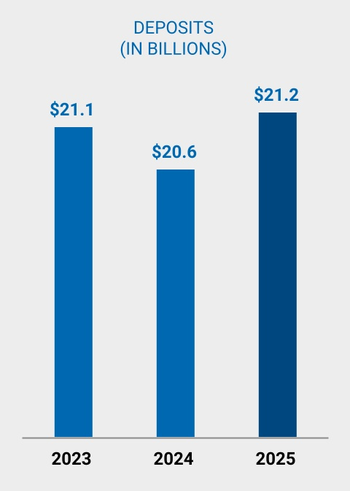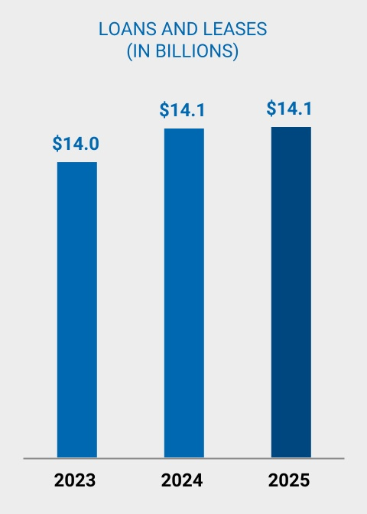
Strong Credit Risk Profile
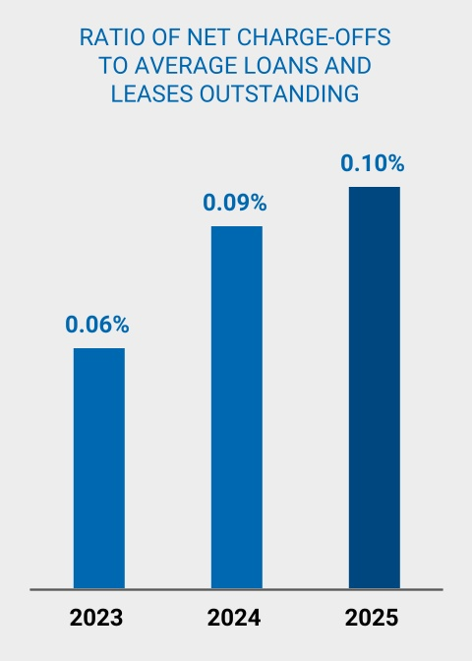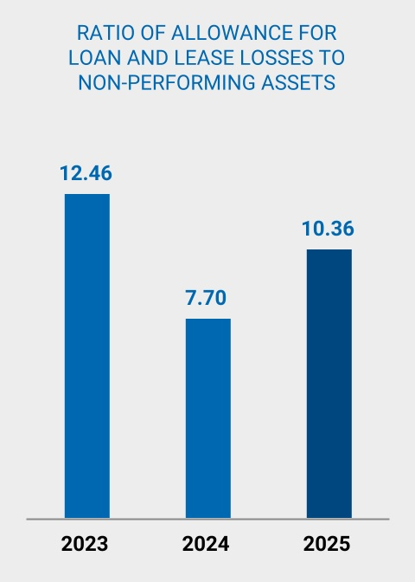
 |  |  | BANK OF HAWAI‘I • 2026 PROXY STATEMENT |  |  | 41

COMPENSATION DISCUSSION AND ANALYSIS
A Balanced Approach to Capital Return
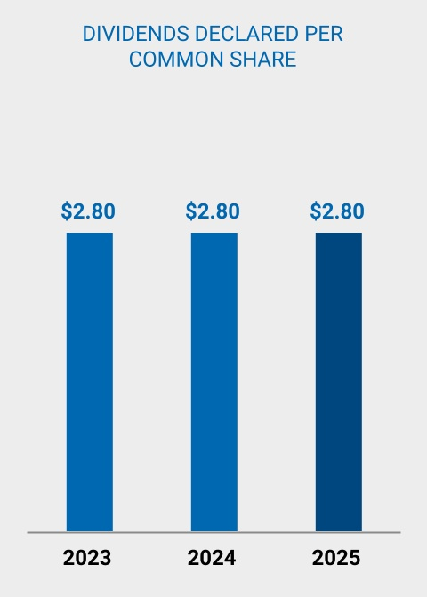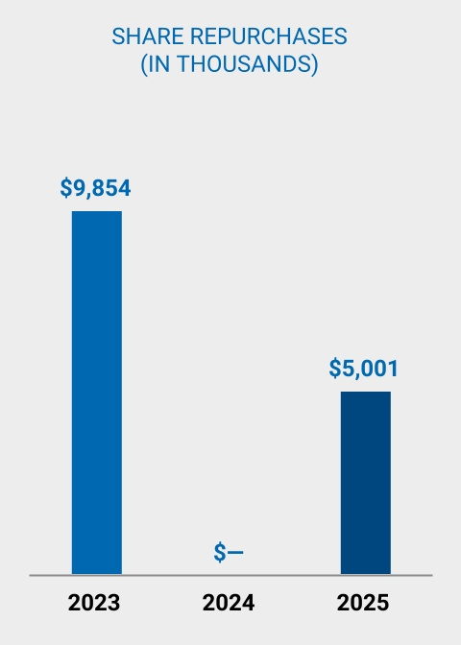

42 |  |  | BANK OF HAWAI'I • 2026 PROXY STATEMENT

COMPENSATION DISCUSSION AND ANALYSIS
2025 SHAREHOLDER OUTREACH

In 2025 and into 2026, the Company continued its ongoing effort to communicate with shareholders and solicit feedback on matters of importance, including our compensation philosophy and plan.

As part of this effort, we solicited feedback from our 30 largest shareholders, representing voting authority for approximately 63% of shares outstanding. We received interest from four shareholders representing approximately 32% of shares outstanding, including our top three shareholders. The meetings that took place were led by the Chair of our Human Resources & Compensation Committee and included the Company’s Chief Administrative Officer and Investor Relations team.

The main topics of conversation during our shareholder meetings this year included: a review of Company strategy and performance; governance changes at the board and committee level; an update on CFO succession and deep dive on the Board-directed process to determine the next CEO of the Company; and the performance of the Company as it relates to the balanced scorecard used to determine short term incentives for 2025.

The shareholders we met with voiced strong support for the Company’s strategy, performance and the changes made to our compensation plan in response to shareholder feedback. They were also highly complimentary of the robust process undertaken by the Board to ensure a smooth succession to our incoming CEO, James C. Polk.

Feedback from these discussions informed continued emphasis on performance-based pay, objective metric calibration and incentive caps, and reinforced the Committee's focus on risk adjusted performance.

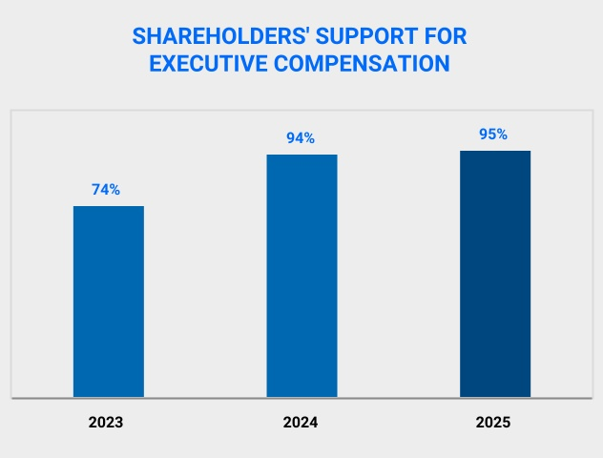
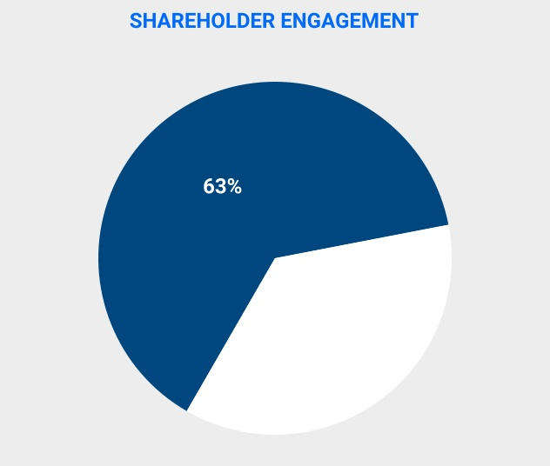
Contacted our top 30 shareholders,
representing voting authority for
approximately 63% of total shares
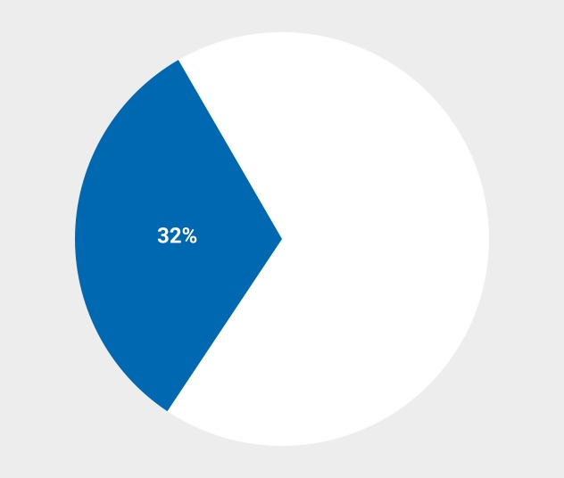
Received interest from 4
shareholders, representing voting
authority for approximately 32% of
total shares

 |  |  | BANK OF HAWAI‘I • 2026 PROXY STATEMENT |  |  | 43

COMPENSATION DISCUSSION AND ANALYSIS
2025 SUCCESSION PLANNING AND GOVERNANCE HIGHLIGHTS
Succession Planning
The Company has a long track record of both attracting senior executives at the highest level, and also developing the next generation of leadership internally over time. The process of succession planning is guided by the Company’s Board of Directors, and during the past year several highlights and milestones were achieved.

In July 2025, Bradley S. Satenberg was promoted to Vice Chair and Chief Financial Officer (“CFO”), replacing long-time CFO Dean Y. Shigemura upon his retirement. Mr. Shigemura had been CFO since 2017, and with the Company for 26 years. In preparation for Mr. Shigemura’s retirement, the Company hired Mr. Satenberg as Deputy CFO in July 2024, allowing him to season into the role for a year before becoming CFO. Mr. Satenberg is now responsible for planning and forecasting, financial accounting and reporting, corporate taxation, treasury and investor relations.

In 2023, anticipating the eventual retirement of Chairman & CEO Peter S. Ho, the Board began the succession process and, in 2024, formed a Succession Working Group (the “SWG”), consisting of five independent directors reporting to the Human Resources & Compensation Committee (the “HRC”). The goal of the SWG was to ensure stability and continuity for the 128-year old Company by executing a comprehensive and thoughtful CEO succession plan well in advance of Mr. Ho’s retirement.

Over time, and with the assistance of external executive search consultant Spencer Stuart, the SWG developed a set of criteria and qualities that any successor CEO candidate should meet and possess. Then the SWG conducted an extensive table-top review of nearly 100 internal and external CEO candidates, measuring all against the agreed upon criteria and qualities. In early 2025, the SWG concluded and recommended to the HRC that the most appropriate candidate for the CEO position was James C. Polk, President and Chief Banking Officer. The Board then set goals for Mr. Polk pursuant to a development plan and provided him executive coaching, all to help prepare him to be Mr. Ho’s eventual successor.

Mr. Polk joined the Bank in 1999, and has since served in multiple leadership roles, overseeing many major areas, including Commercial Banking, Retail Lending, Deposits, Mortgage Banking, The Private Bank and Branch Banking. In 2006, Mr. Polk was promoted to Executive Vice President and Pacific Islands Division Manager, overseeing the Bank’s West Pacific region. In 2009, he advanced to Senior Executive Vice President and Manager of the Bank’s Hawai‘i Commercial Banking Division, and was also named a member of the Bank’s Executive Committee. In 2016, Mr. Polk was promoted to Vice Chair and in 2021 to Chief Banking Officer. As part of the succession plan, Mr. Polk was named President in July 2024, becoming responsible for all of the Bank’s revenue-generating businesses: Commercial Banking, Merchant Services, Cash Management, Wealth Management and Retail Banking (including Branch Banking and the Contact Center).

It was because of this thoughtful, long-term succession planning that, when Mr. Ho announced to the Board on January 30, 2026 that after 16 years as CEO, he planned to retire on March 31, 2026, the Board had a qualified and ready successor in Mr. Polk, who was named CEO and a director of the Company, all effective April 1, 2026. Upon assuming the CEO role, Mr. Polk’s salary will be increased to $825,000 and he will become eligible to participate in the short- and long-term incentive plans that are generally available to the Company CEO and more fully described below.

With his well-earned retirement, Mr. Ho concludes a 33-year career with the Company, the last 16 of which he served as Chairman and CEO. During his decades of unwavering leadership and dedication, the Company consistently delivered solid results, receiving multiple accolades for its financial performance, including being named one of “America’s Best Banks” by Forbes magazine for 15 consecutive years, and listed among “America’s Most Trustworthy Companies” by Newsweek magazine for the last four years in a row.

To ensure a smooth leadership transition, Mr. Ho plans to serve as a consultant to the Company through the end of 2027.

Governance
The Company has historically operated with a combined Audit & Risk Committee, comprised of independent directors. In January 2025 the Board decided to create a separate Audit Committee and a Risk Management Committee. This division of duty permits added director focus upon each of these important oversight disciplines. Both committees consist entirely of independent directors who possess the necessary risk and financial expertise to guide the Company.

As part of the CEO succession process, the Board also tasked Spencer Stuart with examining Board composition and structure, in particular weighing the Company’s traditional model of an executive Board Chair (the CEO) plus a Lead Independent Director against a non-executive Chair model. Based on Spencer Stuart’s recommendation, the Board determined that upon Mr. Ho’s retirement, the Board would move to a non-executive Chair model. Accordingly, also on January 30, 2026, the Board voted Raymond P. Vara, Jr. Chair of the Board, effective April 1, 2026. Mr. Vara, who is President and CEO of Hawaii Pacific Health, the state’s largest hospital system, has been a member of the Board since 2013 and currently serves as the Lead Independent Director.

44 |  |  | BANK OF HAWAI'I • 2026 PROXY STATEMENT

COMPENSATION DISCUSSION AND ANALYSIS
COMPENSATION-RELATED HIGHLIGHTS
2025 Compensation Program
•CEO Short-Term Incentive (“STI”) is based on a balanced scorecard measuring profitability, asset quality, financial returns, a strategic measure, and individual performance in 2025, each weighted 20%.
•Long-Term Incentive (“LTI”) metrics were ROCE (weighted 70%) and TSR (weighted 30%).
•Approximately 82% of our CEO’s total compensation (salary, STI, LTI and all other compensation) is performance-based. This is a much higher percentage compared to other regional banks in our peer group where, on average, the peer CEOs receive 42.5% of their LTI in time-based RSUs.
Peer Group |  |  |  |  |  | Percentage of Total CEO Compensation  That Is Performance-Based
25th Percentile |  |  |  |  |  | 47%
Median |  |  |  |  |  | 56%
75th Percentile |  |  |  |  |  | 61%
BOH |  |  |  |  |  | 82%
•Individual performance measured against strategic goals
•The same scorecard drives other NEO STI payouts, with a greater emphasis placed on individual contribution within their line of sight and sphere of influence

COMPENSATION & RISK MANAGEMENT
Compensation risks are assessed and managed in the context of the Company’s business strategies. The Committee monitors the Company’s financial and non-financial performance throughout the year as well as the Company’s risk profile and risk management processes to ensure that the Company’s compensation policies do not promote inappropriate conduct, or unnecessary or excessive risks that may threaten the value of the Company (see “Risk Considerations in our Compensation Program” on page 24). Several areas are reviewed by the Committee including, but not limited to, how risk management is built into incentive compensation for the Company’s executive management, the specific risk profile for a community bank as it relates to loans and investment securities, the controlled and disciplined approach in the compensation structure of the Company, the implementation of new processes with regard to qualitative versus quantitative measures of management performance, and the refinement of best practices.
The Committee also believes that compensation should recognize short- and long-term performance, and may include both cash and equity components, some of which may be awarded throughout the year to recognize essential executives' extraordinary performance. The composition of components may vary from year to year based on individual, market and other factors. The Committee does not adhere to a specific formula when determining the mix of pay elements, or the allocation between cash and non-cash compensation or among non-cash forms of pay.
Referring to the following Elements of the Compensation Program section, neither total compensation nor any element of cash and non-cash compensation is formally benchmarked against a peer group of companies, although the Committee uses the peer group data as a reference. In making compensation decisions, the Committee considers individual performance, experience in the position, breadth of duties, and pay parity among positions of comparable responsibility. The Committee also reviews market data to verify that compensation is competitive and within market ranges, with the understanding that the remoteness and high cost of living of the Hawai‘i marketplace create attraction and retention challenges for the Company that are not experienced by our peers.

 |  |  | BANK OF HAWAI‘I • 2026 PROXY STATEMENT |  |  | 45

COMPENSATION DISCUSSION AND ANALYSIS
ELEMENTS OF A COMPENSATION PROGRAM
In order to ensure compensation is tightly linked to long-term shareholder value creation, the Board and the Committee have implemented an executive compensation program that seeks to balance short-term financial results with long-term value through sustainable business growth in our market. To that end, the compensation program uses a number of short- and long-term forms of executive compensation, each specifically structured to incentivize one or more aspects of Company performance the Committee believes are critical to driving long-term shareholder value.
Each NEO receives a balance of variable and fixed compensation. The following describes the various forms of compensation:
2025 Base Salary
Base salary is driven by each NEO’s responsibilities. The Committee also considered competitive compensation data provided by WTW. Base salaries are generally established in connection with recruiting or retaining qualified executive officers. The Committee reviews salary levels as part of the Company’s annual performance review process, as well as upon promotion or other changes in job responsibility. Merit-based increases to salaries for executive officers other than the CEO are determined by the Committee and include the CEO’s assessment of individual performance and his recommendation.
In recommending base salaries, the CEO considers, among other factors, the needs of the Company, internal pay parity among positions of comparable responsibility, talent retention and individual performance and contribution to the Company. The Committee also looks at market survey data to verify that salaries are competitive and within market ranges.
Based upon the foregoing, including peer group analysis, market data and recommendations by WTW, the Committee approved, effective April 1, 2025, the following NEO base salaries:
Name |  |  |  |  |  | Base Salary Effective  April 1, 2025 ($)
Peter S. Ho |  |  |  |  |  | 925,000
Bradley S. Satenberg |  |  |  |  |  | 460,000
Dean Y. Shigemura(1) |  |  |  |  |  | 500,000
S. Bradley Shairson |  |  |  |  |  | 460,000
Marco A. Abbruzzese |  |  |  |  |  | 460,000
Patrick M. McGuirk |  |  |  |  |  | 462,000
(1)Mr. Shigemura received a base salary increase in lieu of 2025 participation in the Executive Incentive Plan as part of his transition to Strategic Consultant when Mr. Satenberg was promoted to Chief Financial Officer effective June 27, 2025.
2025 Short-Term Incentive Compensation
The CEO and other NEOs (other than Mr. Shigemura) participate in the Executive Incentive Plan (the “EIP”), the Company’s short-term cash incentive plan for executives. The EIP is a 100% performance-based short-term incentive plan. Refer to the Executive Compensation Process and Results sections for details on the EIP design.
2025 Long-Term Incentive Compensation
The Company’s long-term incentive program is also largely performance-based and awarded in the form of performance units with a three-year cliff vesting schedule. Time-based units can be awarded strategically for retention and to recognize extraordinary performance. Refer to the Executive Compensation Process and Results sections for details on the long-term incentive program design.

46 |  |  | BANK OF HAWAI'I • 2026 PROXY STATEMENT

COMPENSATION DISCUSSION AND ANALYSIS
EXECUTIVE COMPENSATION PROCESS & RESULTS
The Committee’s annual process for setting NEOs’ compensation begins in the fourth quarter of each year when the Company’s senior management team sets operating and financial goals for the coming year. Using data and analysis provided by an independent compensation consultant, WTW, and considering senior management’s operating and financial goals, as well as the market environment, the Committee establishes compensation levels and challenging performance goals for the year.
The Committee is responsible for retaining WTW, and for determining the terms and conditions of that engagement, including fees to be paid. The Committee determines whether WTW's services are performed objectively. WTW reports directly to the Committee, takes instructions solely from the Committee, and performs no other services for the Company. The Committee Chair pre-approves all compensation consulting engagements, including the nature, scope and fees of assignments. In 2025, the Committee considered the factors delineated by the SEC in Rule 10C-1 and determined that WTW was an independent compensation consultant and that the firm’s work did not raise a conflict of interest with the Company.
WTW helped to ensure that the Company’s executive compensation practices were competitive, appropriately designed, and were aimed at linking executive compensation to the business and strategic objectives of the Company. WTW also provided the Committee with market data and an analysis of competitive compensation for the NEOs.
The compensation program is designed and implemented as follows:
1.Review and Set Metric Targets for Balanced Scorecard Assessment
2.Determine Peer Group to benchmark executive compensation levels and practices
3.Complete Performance Assessment
4.Calculate/Determine Short-Term Incentive Amount
5.Determine Long-Term Incentive Award

1.Review and Set Metric Targets for Balanced Scorecard Assessment
Company performance objectives are subject to a robust goal-setting process in which the Committee considers business-driven bottom-up and corporate top-down budgets and market projections. In setting each NEO's total compensation, the Committee considers among other factors, Company performance, shareholder value creation, the competitive marketplace, and the awards given to NEOs in past years.
The below chart shows graphically the Company’s short- and long-term incentive program metrics:
Performance  Category |  |  |  |  |  | 2025 |  |  |  |  |  |  |  |  |  |  |  |  |  |  |  |  |  | Weighting
 |  |  |  |  |  | STI |  |  |  |  |  | LTI |  |  |  |  |  | Measurement |  |  |  |  |  | STI |  |  |  |  |  | LTI
Profitability |  |  |  |  |  | Pre- Provision  Net Revenue |  |  |  |  |  |  |  |  |  |  |  | Absolute |  |  |  |  |  | 20%
Asset Quality |  |  |  |  |  | Non-Performing Assets |  |  |  |  |  |  |  |  |  |  |  | Relative |  |  |  |  |  | 20%
Financial Returns |  |  |  |  |  | ROCE |  |  |  |  |  | ROCE |  |  |  |  |  | Relative |  |  |  |  |  | 20% |  |  |  |  |  | 70%
Shareholder Returns |  |  |  |  |  |  |  |  |  |  |  | Total Shareholder Return |  |  |  |  |  | Relative |  |  |  |  |  |  |  |  |  |  |  | 30%
Strategic Measure |  |  |  |  |  | Customer  Experience |  |  |  |  |  |  |  |  |  |  |  | Absolute |  |  |  |  |  | 20%
Individual |  |  |  |  |  | Individual |  |  |  |  |  |  |  |  |  |  |  | Absolute |  |  |  |  |  | 20%

 |  |  | BANK OF HAWAI‘I • 2026 PROXY STATEMENT |  |  | 47

COMPENSATION DISCUSSION AND ANALYSIS
2.Determine Peer Group to Benchmark Executive Compensation Levels
Each year, the Committee identifies companies to include in a peer group for purposes of benchmarking executive compensation levels and practices. The Committee selects peer companies with the support of WTW. For 2025, the Committee selected a bank peer group, consisting of regional banks that the Company competes against for capital and talent. Companies selected for the peer groups are:
•Possible sources of, or destinations for, talent.
•Comparable in:
•Size
•Complexity and organizational structure; and
•Compensation practices and structures.
•In some cases, peers of our peer companies.
48 |  |  | BANK OF HAWAI'I • 2026 PROXY STATEMENT

COMPENSATION DISCUSSION AND ANALYSIS
Peer Group Companies*
 |  |  | Market  Capitalization |  |  |  |  |  | Revenue |  |  |  |  |  | Total Assets |  |  |  |  |  | Employee  Population  (FTE)**
Bank Peers (dollars in millions)
Associated Banc-Corp |  |  | $4,213.4 |  |  |  |  |  | $1,433.5 |  |  |  |  |  | $45,202.6 |  |  |  |  |  | 4,000
Banner Corporation |  |  | $2,135.8 |  |  |  |  |  | $647.7 |  |  |  |  |  | $16,354.5 |  |  |  |  |  | 1,906
Cathay General Bancorp |  |  | $3,292.3 |  |  |  |  |  | $745.3 |  |  |  |  |  | $24,229.6 |  |  |  |  |  | 1,266
Commerce Bancshares, Inc. |  |  | $7,277.1 |  |  |  |  |  | $1,711.7 |  |  |  |  |  | $32,915.1 |  |  |  |  |  | 4,667
Community Financial System, Inc. |  |  | $3,024.9 |  |  |  |  |  | $796.9 |  |  |  |  |  | $17,303.3 |  |  |  |  |  | 2,824
CVB Financial Corp. |  |  | $2,544.6 |  |  |  |  |  | $519.0 |  |  |  |  |  | $15,631.1 |  |  |  |  |  | 1,089
First Financial Bancorp. |  |  | $2,465.2 |  |  |  |  |  | $861.8 |  |  |  |  |  | $21,129.4 |  |  |  |  |  | 2,164
First Hawaiian, Inc. |  |  | $3,130.1 |  |  |  |  |  | $853.6 |  |  |  |  |  | $23,955.3 |  |  |  |  |  | 1,997
Fulton Financial Corporation |  |  | $3,490.9 |  |  |  |  |  | $1,277.4 |  |  |  |  |  | $32,118.4 |  |  |  |  |  | 3,400
Glacier Bancorp, Inc. |  |  | $5,723.9 |  |  |  |  |  | $961.8 |  |  |  |  |  | $31,978.1 |  |  |  |  |  | 4,087
Hancock Whitney Corporation |  |  | $5,324.5 |  |  |  |  |  | $1,464.0 |  |  |  |  |  | $35,472.8 |  |  |  |  |  | 3,627
Home Bancshares, Inc. (Conway, AR) |  |  | $5,456.6 |  |  |  |  |  | $1,070.0 |  |  |  |  |  | $22,881.9 |  |  |  |  |  | 2,552
International Bancshares Corporation |  |  | $4,130.2 |  |  |  |  |  | $821.7 |  |  |  |  |  | $16,551.4 |  |  |  |  |  | 2,220
Pacific Premier Bancorp, Inc. |  |  | $2,375.3 |  |  |  |  |  | $584.3 |  |  |  |  |  | $17,783.2 |  |  |  |  |  | 1,325
Banc of California, Inc. |  |  | $2,998.5 |  |  |  |  |  | $1,048.9 |  |  |  |  |  | $34,797.4 |  |  |  |  |  | 1,903
Prosperity Bancshares, Inc. |  |  | $6,430.5 |  |  |  |  |  | $1,249.8 |  |  |  |  |  | $38,463.4 |  |  |  |  |  | 3,941
Renasant Corporation |  |  | $3,346.7 |  |  |  |  |  | $878.4 |  |  |  |  |  | $26,751.4 |  |  |  |  |  | 2,200
Texas Capital Bancshares, Inc. |  |  | $4,132.6 |  |  |  |  |  | $1,200.8 |  |  |  |  |  | $31,540.3 |  |  |  |  |  | 1,785
Trustmark Corporation |  |  | $2,335.4 |  |  |  |  |  | $798.0 |  |  |  |  |  | $18,925.2 |  |  |  |  |  | 2,543
UMB Financial Corporation |  |  | $8,737.8 |  |  |  |  |  | $2,497.8 |  |  |  |  |  | $73,094.1 |  |  |  |  |  | 3,698
United Bankshares, Inc. |  |  | $5,379.4 |  |  |  |  |  | $1,202.2 |  |  |  |  |  | $33,660.3 |  |  |  |  |  | 2,740
WaFd, Inc. |  |  | $2,448.2 |  |  |  |  |  | $734.5 |  |  |  |  |  | $27,285.7 |  |  |  |  |  | 1,979
75th Percentile |  |  | $5,365.7 |  |  |  |  |  | $1,237.9 |  |  |  |  |  | $33,474.0 |  |  |  |  |  | 3,570
Median |  |  | $3,418.8 |  |  |  |  |  | $920.1 |  |  |  |  |  | $27,018.6 |  |  |  |  |  | 2,382
25th Percentile |  |  | $2,658.1 |  |  |  |  |  | $797.2 |  |  |  |  |  | $19,476.3 |  |  |  |  |  | 1,924
Average for Bank Peer Group |  |  | $4,108.8 |  |  |  |  |  | $1,061.8 |  |  |  |  |  | $29,001.1 |  |  |  |  |  | 2,632
Bank of Hawaii Corporation |  |  | $2,685.2 |  |  |  |  |  | $705.1 |  |  |  |  |  | $24,176.4 |  |  |  |  |  | 1,877
Bank of Hawaii Corporation, Percent Rank |  |  | 25P |  |  |  |  |  | 13P |  |  |  |  |  | 42P |  |  |  |  |  | 18P
(1)Pacific Premier Bancorp, Inc. was acquired by Colombia Banking System, with its last trading day on August 29, 2025. Accordingly, the market data reflects value as of the last trading day (August 29, 2025).
*Peer data provided by WTW Executive Compensation Consultants as of December 31, 2025, or earlier, based on available data as of February 18, 2026.
**FTE represents Full-Time Equivalent Employees

 |  |  | BANK OF HAWAI‘I • 2026 PROXY STATEMENT |  |  | 49

COMPENSATION DISCUSSION AND ANALYSIS
3.Complete Performance Assessment After Year-End
Commencing in February of each year, the Committee reviews the annual results of the Company compared to the business plan and uses this review as the basis for the annual evaluation of the CEO. The Committee reviews the relative and absolute performance for the quantitative performance metrics. The CEO does not attend executive sessions of the Committee when his own compensation is being reviewed or determined. The Committee’s evaluation is discussed with the full Board, excluding the CEO, and communicated to the CEO by the Lead Independent Director.
Based on similar factors and individual objectives, including an assessment of effective risk management, the CEO annually reviews the performance of each of the other NEOs. The conclusions and recommendations based on those reviews, including any recommendations for salary adjustments, annual awards and equity components, are presented to the Committee for consideration.
The Committee believes that retaining discretion to assess the qualitative performance of the CEO and other NEOs gives the Committee members the ability to more accurately reflect individual contributions that cannot be quantified.
The following table displays the 2025 targets and 2025 actual results for each individual metric considered in the Committee’s scorecard assessment. The scorecard was designed based on both quantitative and qualitative metrics, and all metrics are equally weighted (20%). The Committee implemented a cap of 250% for the CEO and 200% for the other NEOs on achievement level of each individual metric in addition to an aggregate cap on compensation. A score above 20% implies a payout above the target level and a score of 50% implies a maximum payout. The final score for the CEO was 250% based on the following results:
•Non-Performing Assets of only 0.10% of total loans and leases and foreclosed real estate, which was top quartile relative to peers and reflects the Company's conservative credit culture
•Return on Common Equity of 13.29%, which was in the top quartile relative to peers
•Pre-Provision Net Revenue as measured against the Company’s 2025 budget exceeded its target coming in at more than 5% above budget
•The Customer Experience score was 78, exceeding the target of 73, and achieving a rating of Outstanding for this metric
•The Committee rated the CEO's individual performance Outstanding for his achievements in pursuing the Company's strategic initiatives, enhancing community presence and reputation, and executing on the Company's succession plan
Metrics |  |  |  |  |  | Weight |  |  |  |  |  | Target |  |  |  |  |  | Actual |  |  |  |  |  | Score
Pre-Provision Net Revenue |  |  |  |  |  | 20% |  |  |  |  |  | Budget |  |  |  |  |  | +5%Budget |  |  |  |  |  | 50%
Non-Performing Assets vs. Peers |  |  |  |  |  | 20% |  |  |  |  |  | 2nd Quartile |  |  |  |  |  | Best Quartile |  |  |  |  |  | 50%
Return on Common Equity vs. Peers |  |  |  |  |  | 20% |  |  |  |  |  | 3rd Quartile |  |  |  |  |  | Top Quartile |  |  |  |  |  | 50%
Customer Experience |  |  |  |  |  | 20% |  |  |  |  |  | 73% |  |  |  |  |  | 78% |  |  |  |  |  | 50%
Community Presence and Reputation, Leadership Development & Succession Planning, Strategic Initiatives |  |  |  |  |  | 20% |  |  |  |  |  |  |  |  |  |  |  | Outstanding |  |  |  |  |  | 50%
TOTAL |  |  |  |  |  | 100% |  |  |  |  |  |  |  |  |  |  |  |  |  |  |  |  |  | 250%
50 |  |  | BANK OF HAWAI'I • 2026 PROXY STATEMENT

COMPENSATION DISCUSSION AND ANALYSIS
Key Performance Metrics
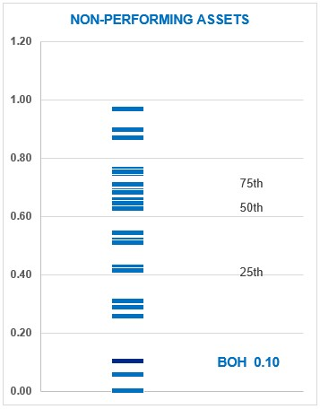 |  |  |  |  |  | 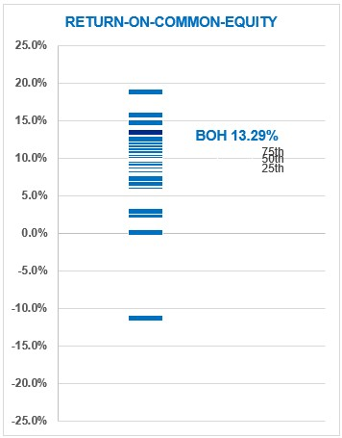
"Non-performing assets" shall be measured as of  December 31 of such year |  |  |  |  |  | "Return-on-Common-Equity" shall be measured as of  December 31 of such year
CX Score |  |  | Rating |  |  | PPNR as % of Target |  |  | Rating
78 |  |  | BOH |  |  | > = +5.0% |  |  | BOH
> = 78 |  |  | Outstanding |  |  | > = +5.0% |  |  | Outstanding
77 |  |  | Exceeds |  |  | +5.0% |  |  | Exceeds
76 |  |  |  |  |  | +4.5%
75 |  |  |  |  |  | +4.0%
74 |  |  |  |  |  | +3.5%
73 |  |  |  |  |  | +3.0%
72 |  |  |  |  |  | +2.5%
71 |  |  | Meets |  |  | +2.0%
70 |  |  |  |  |  | +1.5%
69 |  |  |  |  |  | +1.0%
68 |  |  |  |  |  | Target |  |  | Meets
67 |  |  |  |  |  | -1.0%
66 |  |  |  |  |  | -1.5%
65 |  |  | Below |  |  | -2.0%
64 |  |  |  |  |  | -2.5%
< 64 |  |  |  |  |  | < - 2.5% |  |  | Below
 |  |  | BANK OF HAWAI‘I • 2026 PROXY STATEMENT |  |  | 51

COMPENSATION DISCUSSION AND ANALYSIS
The following table describes the Short-Term Incentive Plan’s disciplined other short-term metrics and achievements of the CEO and NEOs for 2025:
2025 Disciplined Other Short-Term Metrics - 20% Weighting *
Strategic Initiatives |  |  | Community Presence/Reputation |  |  | Leadership Development/Succession
Total loans and leases were $14.1 billion at December 31, 2025  •Overall asset quality remained strong  Efficiency ratio was 61.84%  •Delivered strong, disciplined execution across core strategic priorities, demonstrating accountability, sound governance and a consistent focus on sustainable long-term value creation  •Performance was characterized by transparent reporting, timely course correction where needed and notable achievements in workforce modernization, client retention and core business momentum  •Strengthen & Broaden Risk Management  •Successfully implemented key phases of the new risk platform, retiring legacy systems and stabilizing core credit risk functionality  •Improved governance rigor by refining metrics to better reflect the workload and risk reduction progress  •Fortify the Balance Sheet  •Selected and approved a next generation enterprise platform to modernize capabilities, strengthening long-term balance sheet and profitability management  •Established a clear governance and implementation roadmap, with anticipated material cost efficiencies once fully implemented  •Cultivating a Modern Workforce  •Exceeded workforce engagement and development targets, including outreach activity, goal setting adoption, and training participation  •Achieved high participation in training programs, reinforcing a strong performance and learning culture  •Strengthened leadership continuity, with identified successors in place for over 90% of critical leadership roles  •Organic Revenue Expansion  •Delivered exceptional client outcomes during the Wealth Management platform conversion, achieving client retention with minimal disruption  •Advanced readiness for the Center for Family Businesses & Entrepreneurs, with disciplined timing decisions supporting a strong 2026 launch  •Exceeded Commercial Banking growth targets, driven by strong fee performance and new account growth  •Progressed Mass Affluent retail strategy with appropriate reprioritization to align resources with highest value initiatives |  |  | •CEO continued to be active in the community in 2025 serving on 10 local boards and in a leadership role guiding Hawai‘i  •High levels of industry and press recognition:  •TIME magazine named BOH among “America’s Best Midsize Companies of 2025”  •Newsweek recognized BOH as one of:  •“America's Best Regional Banks & Credit Unions”, earned the highest 5-star rating, and is among the Top 500 regional banks in the U.S  •“Most Trustworthy Companies in America”, ranked 12 of 25 in the U.S. banking industry and the only Hawai‘i business to appear on the list for the fourth consecutive year  •“World's Most Trustworthy Companies”, ranked 28 of 47 banks globally and is the only Hawai‘i bank to appear on the list  •“America's Most Admired Workplace” among 750 national companies and is the only Hawai‘i bank to appear on the list  •“America's Greatest Workplaces in Financial Services”  •“America's Greatest Workplaces by State”, earning the highest 5-star rating  •“America's Greatest Workplaces for Gen Z”  •“America's Greatest Workplaces for Hispanics & Latinos” (inaugural list)  •Strong commitment to the communities we serve  •Supports our communities with the use of investment, philanthropic and human capital to expand access to economic opportunity within such communities  •Advances sustainable development through financing solutions that generate positive impacts  •Significant charitable/community activity:  •Bank of Hawai‘i, its Foundation and employees contributed significantly to the community including the following worthy causes:  •Alice Initiative (Aloha United Way)  •Aloha United Way  •Hawai‘i Mobile Museum of Tolerance  •Holomua Collective  •YMCA of Honolulu  •Pacific Tsunami Museum  •Many local nonprofits by the Live Kōkua Giving Campaign  •Bank of Hawai‘i Scholarship Fund awarded 21 scholarships to children and grandchildren of Bank of Hawai‘i employees  •More than 1,100 Bankoh Blue Crew volunteers donated more than 3,300 hours to special causes |  |  | •Leadership Succession  James C. Polk appointed CEO of the Company effective April 1, 2026; Current CEO demonstrated effective leadership in advancing succession planning, executive development, and organizational alignment. Succession planning achieved near full coverage across senior leadership tiers, supporting continuity and long-term enterprise readiness. Proactively managed leadership transitions, balancing internal promotions with selective external hires to strengthen bench strength, reinforced governance, and aligned leadership capabilities with strategic priorities across business and control functions. Collectively, these actions reflect disciplined talent stewardship, sound judgment, and a focus on sustaining organizational effectiveness and future performance  •Strong commitment to a modern workplace  Committed to attracting, retaining and developing diverse talent and investing in employees through education, learning development, compensation and benefits, and workplace excellence. Supported higher education through the Tuition Reimbursement Program and College Assistance Program  •Talent Landscape  Completed talent review and succession planning across the organization  •Development Programs  Offered a variety of development programs to include a Summer Intern Program, Leadership Development Program, Manager Excellence Forum, new Leadership Council Orientation and Pathways to Profession Excellence  •Mentorship Programs  Allows leaders to sharpen their skills and give back to the community by mentoring college students or small business owners
*20% represents CEO weighting. The table details the CEO individual contribution.

52 |  |  | BANK OF HAWAI'I • 2026 PROXY STATEMENT

COMPENSATION DISCUSSION AND ANALYSIS
4. Calculate / Determine Annual Short-Term Incentive Amount
The CEO and other NEOs participate in the Executive Incentive Plan (the “EIP”), the Company’s short-term incentive plan for executives. The EIP is a 100% performance-based short-term incentive plan.
The Committee determines the CEO’s STI award based upon a balanced scorecard that equally measures profitability, asset quality, financial returns, a strategic measure, and individual performance. Each of these measures are given equal weighting in determining the CEO’s cash bonus. Accordingly, PPNR is measured against a target set prior to the beginning of the year and is designed to encourage budget discipline throughout the year. Making sure that a conservative credit culture drives behavior, the level of non-performing assets is measured relative to peers. ROCE is a key measure of the Company’s financial health, and is measured against peers. Inasmuch as the Company’s brand is a differentiator in our marketplace, a focus on customer experience is a key strategic initiative, so the strategic measure for 2025 remained our Customer Experience score, as measured by the proprietary framework developed by Forrester, a global research company. Finally, the CEO’s individual contribution is determined based on an assessment of strategic initiatives, community presence and reputation, and leadership development and succession. NEO personal contributions are determined relative to the achievement in their respective managerial spheres of influence.
Annually, the Committee approves the EIP maximum incentive pool. For 2025, the EIP maximum incentive pool was approved at 3% of the Company’s net income before taxes for the fiscal year. At the beginning of the performance period, each participating executive is allocated a maximum percentage of the incentive pool. For 2025, the Committee allocated a maximum percentage of 35% to Mr. Ho, 16% to Mr. Polk and 11% to the other NEOs. The Company has set a target award of 100% of base salary for the CEO, with a threshold or minimum payout of 50% and maximum payout of 250% of target. Company performance below third quartile results in forfeiture of the entire weighted opportunity for each of the relative quantitative measures. The Company has set a target award of 90% of base salary for the President; the other NEOs have a target award of 80% of base salary. Their threshold or minimum payout is 50% of target and maximum payout is 200% of target.
In evaluating CEO performance and resulting EIP payment, the Committee employed a balanced scoring system based upon achievement of the performance metrics referenced above. The Committee reviewed and discussed the CEO’s performance against the EIP metrics and objectives, then determined the final EIP award based upon the results. The Committee reviewed and discussed in detail the evidence supporting the CEO’s individual contributions against pre-defined objectives established at the start of the year and rated his performance “Outstanding” in the areas of community presence, reputation, leadership development, succession planning and strategic initiatives.
In evaluating the other NEOs, the Committee considered the recommendations of the CEO, and reviewed and discussed the other NEOs’ performance against the EIP metrics and objectives, as well as their individual contributions and achievements in their respective managerial spheres of influence.
Marco A. Abbruzzese
Mr. Abbruzzese joined the Company as Vice Chair and Senior Executive Director of Wealth Management in January 2022. He is responsible for overseeing the wealth management areas of Trust Services Group, Bankoh Advisors, and The Private Bank. In addition, he is a member of the Bank’s Executive Committee.

The Committee discussed Mr. Abbruzzese’s contributions to the Company in 2025, including his leadership of the Wealth Management organization and execution of key elements of a multi-year strategic plan to strengthen and grow the business. Under his direction, the organization completed several important strategic initiatives, including the transition of Bankoh Advisors to a new advisory platform, adding key leaders for our Trust Services business and Business Succession services, and the implementation of a consistent, advice-led discovery process across Wealth and Advisory teams. Meaningful progress was also made in refining the Wealth value proposition through customer segmentation actions, enhanced financial planning capabilities, and deepening collaboration with shared clients of the Commercial bank. These efforts improved client experience, increased organizational focus on High Net Worth and Ultra High Net Worth clients, and strengthened collaboration across the Company. The Wealth Management organization also continued to invest in talent, technology, and process improvements, while maintaining a strong focus on risk management, including enhancements to governance and oversight within the Trust business. Mr. Abbruzzese is the Executive Sponsor of the Bank of Hawai‘i Blue Brigade Employee Resource Group for military veterans and allies and serves as a trustee and Board Chair for the Trust for Public Land Hawai‘i Chapter, as well as Board Chair of the McInerny Foundation and a board member of the Barstow Foundation.

 |  |  | BANK OF HAWAI‘I • 2026 PROXY STATEMENT |  |  | 53

COMPENSATION DISCUSSION AND ANALYSIS
Bradley S. Satenberg
Mr. Satenberg was appointed Vice Chair and Chief Financial Officer in July 2025, after joining Bank of Hawai‘i in July 2024 as Senior Executive Vice President and Deputy Chief Financial Officer. He is responsible for developing and implementing the Company’s financial strategies, overseeing Treasury, Financial Reporting, Accounting, and Tax functions, as well as the Company’s budgeting and forecasting processes. Additionally, he serves as a member of the Company’s Executive Committee.
The Committee highlighted Mr. Satenberg’s significant contributions in 2025, including the successful execution of financial initiatives and the effective daily management of both balance sheet and market-related risks. In addition, he played a crucial role in maximizing the Company’s profitability while navigating a dynamic interest rate and economic environment. In particular, the Committee noted his leadership in financial planning, maintaining a strong liquidity position and enhancing key capital and profitability metrics. As Chair of the Asset and Liability Management Committee in 2025, a position he continues to hold, Mr. Satenberg oversaw balance sheet structure, market risk, liquidity, and investment strategies. He also made substantial contributions to the Company’s capital markets efforts throughout the year. In addition, Mr. Satenberg successfully recruited several key finance leaders, further strengthening and enhancing the Company’s finance function.
Dean Y. Shigemura
Mr. Shigemura is the former Vice Chair and Chief Financial Officer. He is currently in a strategic consultant role through June 2026.
S. Bradley Shairson
Mr. Shairson serves as Vice Chair and Chief Risk Officer of the Bank and is a member of the Company’s Executive Committee. Mr. Shairson joined the Company in May 2023.
As Chief Risk Officer, Mr. Shairson has responsibility for the Bank’s enterprise risk management framework, including oversight of credit, market, liquidity, interest rate, operational, model, and strategic risks. He is responsible for establishing and maintaining risk policies, limits, and governance processes designed to ensure that the Bank’s risk profile is consistent with its strategic objectives, capital adequacy, and regulatory requirements. Under Mr. Shairson’s leadership, the Bank’s risk management program has been strengthened and broadened, including the implementation of a comprehensive financial risk management framework overseeing capital, market, and liquidity risk, as well as the Bank’s interest rate risk management and hedging program. He has also enhanced the Bank’s enterprise risk management, model risk management, and operational risk management functions and supported investments in operational efficiency and expanded risk reporting.
Mr. Shairson regularly reports to the Risk Management Committee of the Board of Directors and has direct access to the full Board as appropriate. He works closely with executive management to promote a strong risk culture across the organization and serves as a principal point of contact with regulatory agencies on matters related to risk management, safety and soundness, and supervisory oversight.
Patrick M. McGuirk
Mr. McGuirk is Vice Chair and Chief Administrative Officer, General Counsel and Corporate Secretary, and has been with the Company since November 2020. He is a member of the Company’s Executive Committee and has overall responsibility for the Legal and Administration Division, which comprises business units that are key to protecting our brand and maintaining the safety and security of our customers and employees, including: Legal, Legal & Custody, Corporate Secretary, Corporate Security, Corporate Insurance, Corporate Real Estate and Facilities, Enterprise Strategic Sourcing, Business Continuity and Corporate Communications. He is also chair of the Company’s Environmental, Social and Governance Committee.

The Committee discussed Mr. McGuirk's contributions in his area of responsibilities in 2025. He demonstrated disciplined management of legal exposure and expenses, including implementing an artificial intelligence initiative to increase efficiency and reduce cost. His stewardship of the Company’s physical assets resulted in the building or renovation of five branches, including the new Lahaina Branch and the Company’s West Pacific Regional Headquarters Branch in Tamuning, Guam. Mr. McGuirk’s commitment to good governance and the highest ethical standards were reflected in his assistance with the Company succession plan and revamp of the Board committee structure. In 2025, Mr. McGuirk’s responsibilities were expanded to include oversight of the Business Continuity function.

54 |  |  | BANK OF HAWAI'I • 2026 PROXY STATEMENT

COMPENSATION DISCUSSION AND ANALYSIS
The Committee emphasizes that incentive outcomes are governed by pre-established metrics and are subject to both individual metric and aggregate caps. The Committee retains negative discretion to reduce payouts based on risk outcomes, compliance considerations or other factors that may not be fully captured in formulaic results. The Committee did not apply upward discretion in 2025. Taking into consideration the weighted performance assessment score, and overall company performance, the Committee awarded the following:
Name |  |  |  |  |  | Annual Base  Salary as of  December 31, 2025  ($) |  |  |  |  |  | Target Annual  Incentive |  |  |  |  |  | Final Incentive  Payout  (% of Annual Base Salary) |  |  |  |  |  | Final Incentive  Award ($)
Peter S. Ho |  |  |  |  |  | 925,000 |  |  |  |  |  | 100% |  |  |  |  |  | 250% |  |  |  |  |  | 2,312,500
Bradley S. Satenberg |  |  |  |  |  | 460,000 |  |  |  |  |  | 80% |  |  |  |  |  | 92% |  |  |  |  |  | 425,000
S. Bradley Shairson |  |  |  |  |  | 460,000 |  |  |  |  |  | 80% |  |  |  |  |  | 92% |  |  |  |  |  | 425,000
Marco A. Abbruzzese |  |  |  |  |  | 460,000 |  |  |  |  |  | 80% |  |  |  |  |  | 92% |  |  |  |  |  | 425,000
Patrick M. McGuirk |  |  |  |  |  | 462,000 |  |  |  |  |  | 80% |  |  |  |  |  | 87% |  |  |  |  |  | 400,000

5.Determine Long-Term Incentive Award - Threshold, Target and Maximum Performance Levels
2025 LTI Design Elements
•Three-year plan
•Three-year sustained performance period
•Three-year cliff vesting
•100% quantitative performance metrics
•Two performance metrics set at challenging levels relative to peers* weighted as follows:
▪Return-on-Common-Equity (70%); and
▪Total Shareholder Return (30%).
•To achieve maximum payout of 200%, top quartile performance in Return-on-Common-Equity and Total Shareholder Return must occur
•To achieve any payout, top three quartile performance must occur with the actual payout determined by performance and metric weighting

•Time-based LTI grants used strategically for retention and to recognize extraordinary performance
*2025 KBW Regional Banking Index as of January 2, 2025
The terms “Return-on-Common-Equity” (generally defined as the net income available to common shareholders as a percent of average common equity, but as determined by the Committee) and Total Shareholder Return shall be measured as of December 31 of such year, measured against the banks that comprise the KBW Regional Bank Index. With respect to the given Financial Performance Criteria, the “Three Year Average Percentile” shall mean the Company’s percentile level on the KBW Regional Bank Index for the average of the numerical measures over the three years 2025, 2026, and 2027 that comprise the January 2, 2025, KBW Regional Bank Index.
The Company has set a target award of 100% of the performance units to be awarded under the 2025 long-term incentive plan with a threshold or minimum award of 50% of target and maximum award of 200% of target. To achieve any performance unit award, top three quartile performance must occur with the actual award determined by performance and metric weighting. Company performance below 25th percentile results in forfeiture of the entire weighted opportunity for each of the performance measures. The period of restriction terminates based upon the level of achievement of the specified financial performance criteria (Return-on-Common-Equity, weighted at 70% and Total Shareholder Return, weighted at 30%). In this regard, the Period of Restriction terminates with respect to the “Applicable Vesting Percentages,” based upon the Company’s achievement of the respective Financial Performance Criteria with a maximum payout of 200% at the 75th percentile that is interpolated downward to the 25th percentile, below which point there is no payout.
In setting the CEO’s and other NEOs’ long-term incentive compensation, the Committee considered, among other factors, Company performance, shareholder value creation, the competitive marketplace, the awards given in past years, peer group analysis and other market factors. In applying these factors, the Committee determined the number of performance units to
 |  |  | BANK OF HAWAI‘I • 2026 PROXY STATEMENT |  |  | 55

COMPENSATION DISCUSSION AND ANALYSIS
be awarded under the long-term incentive plan to the CEO and other NEOs. Refer to the Grants of Plan-Based Awards on page 64.
Substantial ‘at risk’ and variable compensation: Approximately 82% of CEO total compensation, which includes salary, bonus, stock awards (long-term incentives), non-equity incentive plan compensation (short-term incentives), and all other compensation, is variable and impacted by pre-established Company performance metrics.
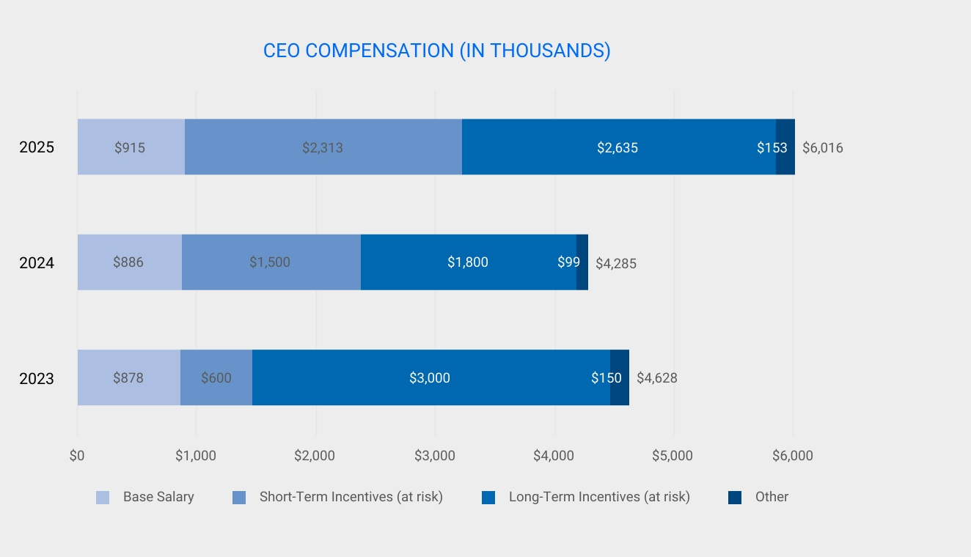

56 |  |  | BANK OF HAWAI'I • 2026 PROXY STATEMENT

COMPENSATION DISCUSSION AND ANALYSIS
BENEFITS & RETIREMENT PLANS SPONSORED BY THE COMPANY
Executive officers are eligible to participate in health and insurance plans, retirement plans, and other benefits generally available to full-time employees. This is consistent with the Company’s belief in offering employees comprehensive health and retirement benefits that are competitive in our markets. The retirement programs assist employees in planning for their retirement income needs. Benefits under the qualified health and retirement plans are not directly tied to specific Company performance. Employees who meet service requirements are eligible to participate in the Company-sponsored Retirement Savings Plan (“RSP”), a tax-qualified defined contribution pension plan. Benefits are reviewed on a regular basis, and appropriate changes are made to ensure our program continues to be effective and competitive.
The Committee has adopted the Bank of Hawaii Corporation Executive Deferred Compensation Program (the “Deferred Compensation Program”), a program that offers senior management (including the NEOs) the ability to defer up to 80% of base salary and 100% of incentive amounts under the Executive Incentive Plan in order to allow executives to defer, along with the receipt of the compensation, the income tax liability on such payments (including any appreciation in value as a result of the deemed investment of such amounts) until receipt. This program allows participants to manage their cash flow and estate planning needs.
The Company also maintains the Bank of Hawaii Retirement Savings Excess Benefit Plan (the “Excess Benefit Plan”), a nonqualified supplemental retirement benefit plan that compensates participants for benefits that would otherwise be payable under the Company’s Retirement Savings Plan but for certain Internal Revenue Code (“IRC”) limitations. The Committee believes that this plan is important to ensure equitability in retirement funding amounts between those that fall below and above the IRC limitations.
Gains from long-term incentive compensation are not included in the determination of nonqualified deferred compensation benefits.

Perquisites
The Company offers and provides perquisites to NEOs that the Committee believes are competitive, yet reasonable in attracting and retaining a strong executive team. The Committee believes perquisites should be limited in scope and value.

Change-in-Control and Severance Arrangements
The Committee believes that an essential component of protecting and enhancing the best interests of the Company and its shareholders is to provide for the protection of its executive team in the event of a change-in-control of the Company. Change-in-control benefits play an important role in attracting and retaining key executives. The payment of such benefits ensures a smooth transition in management following a change-in-control by giving an executive the incentive to remain with the Company through the transition period, and, in the event the executive’s employment is terminated as part of the transition, by compensating the executive with a degree of financial and personal security during a period in which he or she is likely to be unemployed.
The Change-in-Control Retention Plan (the “Retention Plan”), provides benefits only in the event that a participant’s employment is terminated by the Company without cause or by the participant for “good reason” within 24 months following a change-in-control. The Committee believes that this encourages executives to remain with the Company upon a change-in-control. The key provisions of the Retention Plan for NEOs, are:
•Severance benefit - a “two times base salary and bonus” payment which is payable in the month following termination of employment.
•Payment for non-competition - an additional “one times base salary and bonus” payment that is payable only if the executive complies with the 12-month non-competition restrictions specified under the Retention Plan.
•In addition to non-competition restrictions, the Retention Plan imposes non-disclosure, non-solicitation and non-disparagement restrictions on participants.
Each of the NEOs participates in the Retention Plan. See the discussion under “Change-in-Control, Termination, and Other Arrangements” on page 67 for additional information.

No Excise Tax Gross-Ups
The Retention Plan does not permit the Company to pay any tax gross up payments to executives in connection with any payment or benefit under the Plan. In addition, the Retention Plan limits any payment or benefit under the plan to an amount that would not be subject to Excise Tax even if the benefits would be substantially eliminated as a result of this limit.

 |  |  | BANK OF HAWAI‘I • 2026 PROXY STATEMENT |  |  | 57

COMPENSATION DISCUSSION AND ANALYSIS
Vesting of Equity Incentive Compensation on Change-in-Control (Double-Trigger)
The terms of the Company’s 2025 Stock and Incentive Compensation Plan provide for full acceleration of vesting of restricted stock, restricted stock units, and stock options upon the occurrence of a change-in-control of the Company (as defined in the Retention Plan, which requires, among other things, a double-trigger termination for vesting to occur). The Committee believes that it is generally appropriate to fully vest equity and incentive-based awards to employees in a change-in-control transaction because such a transaction may often cut short or reduce the employee’s ability to realize value with respect to such awards. Similarly, the Executive Incentive Plan provides that incentive awards will, upon a change-in-control of the Company, be prorated as though the applicable performance period ended on the change-in-control date and will be calculated as an amount equal to two times a participant’s incentive allocation for the prorated performance period.

OTHER MATTERS

Stock Ownership Requirements
The Committee believes that significant ownership of our common stock by our executives directly aligns their interest with those of our shareholders and also helps balance the incentives for risk-taking inherent in equity-based awards. Under the Company’s executive stock ownership guidelines, the CEO must own Company common stock having a market value equal to at least five times base salary and vice chairs must own Company stock having a market value equal to at least two times base salary. Stock ownership includes the value of vested stock options, restricted stock, restricted stock units from qualified plans, and other stock held by the executive. The guidelines require the CEO to comply with the stock ownership levels within five years of the date hired or promoted to such position within the Company; for all other NEOs the attainment period is three years. As of December 31, 2025, all of the NEOs satisfied the stock ownership guidelines.
Officer |  |  |  |  |  | Stockholding Guideline  (multiple of base salary)
Chairman and CEO |  |  |  |  |  | 5x
Vice Chairs |  |  |  |  |  | 2x

Clawback Policy
To the extent permitted by law, this policy requires the Company to reasonably promptly recover incentive-based compensation if the Human Resources & Compensation Committee determines that it was erroneously awarded or received by an executive officer based on any Accounting Restatement. If this policy is triggered, in determining whether to recover such payment, the Committee will take into account whatever it considers appropriate, including whether the expense of recovering the recoverable amount would exceed the amount to be recovered after making a reasonable attempt of recovery or the assertion of a claim may violate applicable law. If the Human Resources & Compensation Committee determines either of these situations is present documentation must be provided to the New York Stock Exchange.
Further, following a restatement of the Bank’s financial statements, the Human Resources & Compensation Committee shall instigate recovery of any compensation that is required to be recovered by Section 10D-1 of the Securities Exchange Act of 1934.

Anti-Hedging and Pledging Policies
The Company's Securities Trading Policy specifically prohibits directors and executive officers from hedging the risk associated with the ownership of Bank of Hawaii Corporation’s common stock and from pledging transactions involving Company stock as collateral, including the use of a traditional margin account with a broker-dealer. No directors and executive officers are parties to transactions involving the hedging or pledging of Company stock.

58 |  |  | BANK OF HAWAI'I • 2026 PROXY STATEMENT

COMPENSATION DISCUSSION AND ANALYSIS
Tax Considerations
Section 162(m) of the Internal Revenue Code (“Section 162(m)”) generally disallows a tax deduction to a public corporation for compensation over $1,000,000 paid in any year to a company’s chief executive officer or other designated executive officers. To maintain flexibility in compensating executive officers, the Committee does not require all compensation to be awarded in a tax deductible manner and compensation payable to our executive officers may exceed the Section 162(m) deductible limit at times. However, it is the intent of the Committee that executive compensation be deductible under the provisions of Section 162(m) to the fullest extent possible and consistent with overall corporate goals. Approximately $7.0 million of compensation paid in 2025 was not deductible by the Company pursuant to Section 162(m).

Delinquent Section 16(a) Reports
Section 16(a) of the Exchange Act requires our directors and executive officers, and holders of more than 10 percent of a registered class of the Company's equity securities, to file with the SEC reports regarding their ownership and changes in ownership of Common Stock and other equity securities of the Company. Directors, officers, and greater than 10 percent shareholders are required by the regulations of the SEC to furnish the Company with copies of all Section 16(a) forms they file. Based solely on a review of such reports furnished to the Company and written representations, we believe all Section 16(a) reports during fiscal year 2025 were timely filed, except for one Form 4 report relating to common stock held in trust, of which the reporting person, Robert W. Wo, became a co-trustee on September 13, 2019. These shares were inadvertently omitted from prior filings.

 |  |  | BANK OF HAWAI‘I • 2026 PROXY STATEMENT |  |  | 59

COMPENSATION DISCUSSION AND ANALYSIS
EXECUTIVE COMPENSATION TABLES

Summary Compensation Table
The following table summarizes the total compensation paid to or earned by our named executive officers for each of the fiscal years indicated.
Name and  Principal Position |  |  |  |  |  | Year |  |  |  |  |  | Salary  ($)(1) |  |  |  |  |  | Bonus  ($)(2) |  |  |  |  |  | Stock Awards  ($)(3) |  |  |  |  |  | Option Awards  ($) |  |  |  |  |  | Non-Equity Incentive Plan Compensation  ($) |  |  |  |  |  | Change in Pension Value and Nonqualified Deferred Compensation Earnings  ($)(4) |  |  |  |  |  | All Other Compensation  ($)(5) |  |  |  |  |  | Total  ($)
PETER S. HO |  |  |  |  |  | 2025 |  |  |  |  |  | 915,308 |  |  |  |  |  | — |  |  |  |  |  | 2,635,463 |  |  |  |  |  | — |  |  |  |  |  | 2,312,500 |  |  |  |  |  | 949 |  |  |  |  |  | 151,786 |  |  |  |  |  | 6,016,006
Chairman of the Board, |  |  |  |  |  | 2024 |  |  |  |  |  | 885,800 |  |  |  |  |  | — |  |  |  |  |  | 1,800,014 |  |  |  |  |  | — |  |  |  |  |  | 1,500,000 |  |  |  |  |  | 1,215 |  |  |  |  |  | 98,272 |  |  |  |  |  | 4,285,301
Chief Executive Officer |  |  |  |  |  | 2023 |  |  |  |  |  | 878,258 |  |  |  |  |  | — |  |  |  |  |  | 3,000,067 |  |  |  |  |  | — |  |  |  |  |  | 600,000 |  |  |  |  |  | 365 |  |  |  |  |  | 149,228 |  |  |  |  |  | 4,627,918
BRADLEY S. SATENBERG |  |  |  |  |  | 2025 |  |  |  |  |  | 445,165 |  |  |  |  |  | 100,000 |  |  |  |  |  | 435,038 |  |  |  |  |  | — |  |  |  |  |  | 425,000 |  |  |  |  |  | — |  |  |  |  |  | 40,938 |  |  |  |  |  | 1,446,141
Vice Chair, |  |  |  |  |  | 2024 |  |  |  |  |  | — |  |  |  |  |  | — |  |  |  |  |  | — |  |  |  |  |  | — |  |  |  |  |  | — |  |  |  |  |  | — |  |  |  |  |  | — |  |  |  |  |  | —
Chief Financial Officer |  |  |  |  |  | 2023 |  |  |  |  |  | — |  |  |  |  |  | — |  |  |  |  |  | — |  |  |  |  |  | — |  |  |  |  |  | — |  |  |  |  |  | — |  |  |  |  |  | — |  |  |  |  |  | —
DEAN Y. SHIGEMURA |  |  |  |  |  | 2025 |  |  |  |  |  | 474,168 |  |  |  |  |  | — |  |  |  |  |  | — |  |  |  |  |  | — |  |  |  |  |  | — |  |  |  |  |  | — |  |  |  |  |  | 49,545 |  |  |  |  |  | 523,713
Former Vice Chair, |  |  |  |  |  | 2024 |  |  |  |  |  | 448,050 |  |  |  |  |  | — |  |  |  |  |  | 335,009 |  |  |  |  |  | — |  |  |  |  |  | 360,000 |  |  |  |  |  | — |  |  |  |  |  | 46,122 |  |  |  |  |  | 1,189,181
Chief Financial Officer |  |  |  |  |  | 2023 |  |  |  |  |  | 444,235 |  |  |  |  |  | — |  |  |  |  |  | 600,059 |  |  |  |  |  | — |  |  |  |  |  | 360,000 |  |  |  |  |  | — |  |  |  |  |  | 55,587 |  |  |  |  |  | 1,459,881
S. BRADLEY SHAIRSON (5) |  |  |  |  |  | 2025 |  |  |  |  |  | 457,527 |  |  |  |  |  | — |  |  |  |  |  | 977,758 |  |  |  |  |  | — |  |  |  |  |  | 425,000 |  |  |  |  |  | — |  |  |  |  |  | 58,896 |  |  |  |  |  | 1,919,181
Vice Chair, |  |  |  |  |  | 2024 |  |  |  |  |  | 406,154 |  |  |  |  |  | — |  |  |  |  |  | 600,005 |  |  |  |  |  | — |  |  |  |  |  | 600,000 |  |  |  |  |  | — |  |  |  |  |  | 22,154 |  |  |  |  |  | 1,628,313
Chief Risk Officer |  |  |  |  |  | 2023 |  |  |  |  |  | 189,231 |  |  |  |  |  | 150,000 |  |  |  |  |  | 1,400,110 |  |  |  |  |  | — |  |  |  |  |  | 400,000 |  |  |  |  |  | — |  |  |  |  |  | 65,000 |  |  |  |  |  | 2,204,341
MARCO A. ABBRUZZESE |  |  |  |  |  | 2025 |  |  |  |  |  | 454,313 |  |  |  |  |  | — |  |  |  |  |  | 977,758 |  |  |  |  |  | — |  |  |  |  |  | 425,000 |  |  |  |  |  | — |  |  |  |  |  | 65,813 |  |  |  |  |  | 1,922,884
Vice Chair |  |  |  |  |  | 2024 |  |  |  |  |  | 430,767 |  |  |  |  |  | — |  |  |  |  |  | 335,009 |  |  |  |  |  | — |  |  |  |  |  | 325,000 |  |  |  |  |  | — |  |  |  |  |  | 41,588 |  |  |  |  |  | 1,132,364
Senior Executive Director |  |  |  |  |  | 2023 |  |  |  |  |  | 408,492 |  |  |  |  |  | — |  |  |  |  |  | 500,074 |  |  |  |  |  | — |  |  |  |  |  | 265,000 |  |  |  |  |  | — |  |  |  |  |  | 44,769 |  |  |  |  |  | 1,218,335
of Wealth Management
PATRICK M. MCGUIRK |  |  |  |  |  | 2025 |  |  |  |  |  | 462,000 |  |  |  |  |  | — |  |  |  |  |  | 727,735 |  |  |  |  |  | — |  |  |  |  |  | 400,000 |  |  |  |  |  | — |  |  |  |  |  | 68,425 |  |  |  |  |  | 1,658,160
Vice Chair, |  |  |  |  |  | 2024 |  |  |  |  |  | 462,000 |  |  |  |  |  | — |  |  |  |  |  | 335,009 |  |  |  |  |  | — |  |  |  |  |  | 325,000 |  |  |  |  |  | — |  |  |  |  |  | 44,280 |  |  |  |  |  | 1,166,289
Chief Administrative |  |  |  |  |  | 2023 |  |  |  |  |  | 420,031 |  |  |  |  |  | — |  |  |  |  |  | 400,014 |  |  |  |  |  | — |  |  |  |  |  | 300,000 |  |  |  |  |  | — |  |  |  |  |  | 78,016 |  |  |  |  |  | 1,198,061
Officer
(1) Mr. Ho received no fees or compensation for his services on the Board of Directors. The Company pays on a bi-weekly basis. Mr. Shigemura served as our Vice Chair and Chief Financial Officer through July 1, 2025. He continues as an employee in a non-executive officer capacity through June 2026. For 2025, this column represents compensation earned by Mr. Shigemura for services in all capacities.
(2) For 2025, Mr. Satenberg received a signing bonus of $100,000. For 2023, Mr. Shairson received a signing bonus of $150,000.
(3) This column represents the aggregate grant date fair value of restricted stock and restricted stock units granted to each of the NEOs in accordance with Accounting Standards Codification (“ASC”) Topic 718, “Compensation - Stock Compensation.” Time-based and Performance-based awards were valued using the closing stock price on the grant date. Market-based awards tied to TSR were valued using a Monte Carlo simulation model.
(4)This column represents the annual change in the actuarial present value of accumulated benefits under the Employees’ Retirement Plan of Bank of Hawai‘i. Mr. Ho is the only NEO who is a participant of this plan, which was frozen at the end of 1995. For 2025, Mr. Ho’s pension value increased by $949 from the prior measurement date primarily due to the passage of time. There are also slight increases due to the change in the discount rate from 5.67% to 5.40% and change in lump sum mortality, and a small decrease due to the update in the lump sum segment rates. Note, lump sums are assumed to be paid 90% of the time when it is less than $25,000. For 2024, Mr. Ho’s pension value increased by $1,215 from the prior measurement date primarily due to the passage of time. There is also a small increase due to the change in discount rate from 5.44% to 5.67% and a small decrease due to the increase in the lump sum segment rates which reduces the lump that is payable. Note, lump sums are assumed to be paid 90% of the time when it is less than $25,000. For 2023, Mr. Ho’s pension value increased by $365. For 2023, the increase in value of the pension benefits from the prior measurement date is primarily due to the passage of time. There is also a small increase due to the change in the discount rate from 5.51% to 5.44% and a small decrease due to the increase in the lump sum segment rates which reduces the lump sum that is payable. Note, lump sums are assumed to be paid 90% of the time when it is less than $25,000.
The Company has not provided above-market or preferential earnings on any nonqualified deferred compensation and, accordingly, no such amounts are reflected in this column.
(5)The All Other Compensation Table that follows provides additional detail regarding the amounts in this column.
60 |  |  | BANK OF HAWAI'I • 2026 PROXY STATEMENT

COMPENSATION DISCUSSION AND ANALYSIS

All Other Compensation Table
The following table sets forth a breakdown of All Other Compensation paid to or earned by our NEOs for each of the fiscal years indicated.
Name |  |  |  |  |  | Year |  |  |  |  |  | Retirement  Savings Plan  401(k)  Matching  Contribution  ($)(1) |  |  |  |  |  | Value  Sharing  Funding  ($)(2) |  |  |  |  |  | Excess Plan  Value  Sharing  Funding  ($)(3) |  |  |  |  |  | Retirement  Savings Plan  Company  Fixed  Contribution  ($)(4) |  |  |  |  |  | Excess Plan  Company  Fixed  Contribution  ($)(4) |  |  |  |  |  | Executive  Deferred  Compensation  Contribution  ($)(5) |  |  |  |  |  | Other  Compensation  ($)(6) |  |  |  |  |  | Total All Other  Compensation  ($)
Peter S. Ho |  |  |  |  |  | 2025 |  |  |  |  |  | 14,000 |  |  |  |  |  | 4,121 |  |  |  |  |  | 24,715 |  |  |  |  |  | — |  |  |  |  |  | — |  |  |  |  |  | 73,469 |  |  |  |  |  | 35,481 |  |  |  |  |  | 151,786
 |  |  |  |  |  | 2024 |  |  |  |  |  | 13,800 |  |  |  |  |  | 3,450 |  |  |  |  |  | 11,408 |  |  |  |  |  | — |  |  |  |  |  | — |  |  |  |  |  | 44,574 |  |  |  |  |  | 25,040 |  |  |  |  |  | 98,272
 |  |  |  |  |  | 2023 |  |  |  |  |  | 13,200 |  |  |  |  |  | 3,495 |  |  |  |  |  | 26,992 |  |  |  |  |  | — |  |  |  |  |  | — |  |  |  |  |  | 86,348 |  |  |  |  |  | 19,193 |  |  |  |  |  | 149,228
Bradley S. Satenberg |  |  |  |  |  | 2025 |  |  |  |  |  | — |  |  |  |  |  | 2,851 |  |  |  |  |  | — |  |  |  |  |  | — |  |  |  |  |  | — |  |  |  |  |  | 7,265 |  |  |  |  |  | 30,822 |  |  |  |  |  | 40,938
 |  |  |  |  |  | 2024 |  |  |  |  |  | — |  |  |  |  |  | — |  |  |  |  |  | — |  |  |  |  |  | — |  |  |  |  |  | — |  |  |  |  |  | — |  |  |  |  |  | — |  |  |  |  |  | —
 |  |  |  |  |  | 2023 |  |  |  |  |  | — |  |  |  |  |  | — |  |  |  |  |  | — |  |  |  |  |  | — |  |  |  |  |  | — |  |  |  |  |  | — |  |  |  |  |  | — |  |  |  |  |  | —
Dean Y. Shigemura |  |  |  |  |  | 2025 |  |  |  |  |  | 14,000 |  |  |  |  |  | 4,121 |  |  |  |  |  | 5,898 |  |  |  |  |  | — |  |  |  |  |  | — |  |  |  |  |  | 25,526 |  |  |  |  |  | — |  |  |  |  |  | 49,545
 |  |  |  |  |  | 2024 |  |  |  |  |  | 13,800 |  |  |  |  |  | 3,450 |  |  |  |  |  | 2,024 |  |  |  |  |  | — |  |  |  |  |  | — |  |  |  |  |  | 26,848 |  |  |  |  |  | — |  |  |  |  |  | 46,122
 |  |  |  |  |  | 2023 |  |  |  |  |  | 13,200 |  |  |  |  |  | 3,495 |  |  |  |  |  | 1,940 |  |  |  |  |  | — |  |  |  |  |  | — |  |  |  |  |  | 36,952 |  |  |  |  |  | — |  |  |  |  |  | 55,587
S. Bradley Shairson |  |  |  |  |  | 2025 |  |  |  |  |  | 14,000 |  |  |  |  |  | 4,121 |  |  |  |  |  | 8,274 |  |  |  |  |  | — |  |  |  |  |  | — |  |  |  |  |  | 32,501 |  |  |  |  |  | — |  |  |  |  |  | 58,896
 |  |  |  |  |  | 2024 |  |  |  |  |  | 11,077 |  |  |  |  |  | 2,769 |  |  |  |  |  | — |  |  |  |  |  | — |  |  |  |  |  | — |  |  |  |  |  | 8,308 |  |  |  |  |  | — |  |  |  |  |  | 22,154
 |  |  |  |  |  | 2023 |  |  |  |  |  | — |  |  |  |  |  | — |  |  |  |  |  | — |  |  |  |  |  | — |  |  |  |  |  | — |  |  |  |  |  | — |  |  |  |  |  | 65,000 |  |  |  |  |  | 65,000
Marco A. Abbruzzese |  |  |  |  |  | 2025 |  |  |  |  |  | 14,000 |  |  |  |  |  | 4,121 |  |  |  |  |  | 5,250 |  |  |  |  |  | — |  |  |  |  |  | — |  |  |  |  |  | 23,876 |  |  |  |  |  | 18,566 |  |  |  |  |  | 65,813
 |  |  |  |  |  | 2024 |  |  |  |  |  | 13,800 |  |  |  |  |  | 3,450 |  |  |  |  |  | 3,497 |  |  |  |  |  | — |  |  |  |  |  | — |  |  |  |  |  | 20,841 |  |  |  |  |  | — |  |  |  |  |  | 41,588
 |  |  |  |  |  | 2023 |  |  |  |  |  | 13,200 |  |  |  |  |  | 3,495 |  |  |  |  |  | 4,742 |  |  |  |  |  | — |  |  |  |  |  | — |  |  |  |  |  | 23,332 |  |  |  |  |  | — |  |  |  |  |  | 44,769
Patrick M. McGuirk |  |  |  |  |  | 2025 |  |  |  |  |  | 14,000 |  |  |  |  |  | 4,121 |  |  |  |  |  | 5,093 |  |  |  |  |  | — |  |  |  |  |  | — |  |  |  |  |  | 24,405 |  |  |  |  |  | 20,806 |  |  |  |  |  | 68,425
 |  |  |  |  |  | 2024 |  |  |  |  |  | 13,800 |  |  |  |  |  | 3,450 |  |  |  |  |  | 3,935 |  |  |  |  |  | — |  |  |  |  |  | — |  |  |  |  |  | 23,095 |  |  |  |  |  | — |  |  |  |  |  | 44,280
 |  |  |  |  |  | 2023 |  |  |  |  |  | 13,200 |  |  |  |  |  | 3,495 |  |  |  |  |  | 5,167 |  |  |  |  |  | — |  |  |  |  |  | — |  |  |  |  |  | 25,640 |  |  |  |  |  | 30,514 |  |  |  |  |  | 78,016
(1)This column represents the Company Match of an individual’s salary deferral contributions to the RSP, a qualified defined contribution pension plan, subject to the Internal Revenue Code prescribed limit (which in 2025 was limited to $350,000 of eligible compensation), and is available to all eligible employees. The Company makes a matching contribution of $1.25 for each dollar of employee contribution up to 2% of eligible compensation, and a $0.50 matching contribution for every dollar of employee contribution above 2% and up to 5% of eligible compensation.
(2)For 2025, the total profit-sharing funding, or “Value Sharing Funding,” equaled 1.18% of eligible compensation. The funding is allocated in the following manner and made available to all eligible employees: 1) a portion of the funding is allocated in cash, 2) to the extent permitted by IRS ($350,000 of eligible compensation in 2025) and RSP provisions, a portion is contributed to the RSP, and 3) any Value Sharing Funding on eligible compensation in excess of IRS limits are contributed to the Excess Benefit Plan (column 3). This column represents the sum of the cash portion and the portion contributed to the RSP. For 2025, the cash portion and the portion contributed to the RSP were $829 and $3,292 respectively, for each of the NEOs, other than Mr. Satenberg who received a pro-rated contribution.
(3)This column represents the Company’s Value Sharing Funding based on 1.18% of eligible compensation in excess of the Internal Revenue Code prescribed limit ($350,000 of eligible compensation in 2025) that is contributed to the Excess Benefit Plan, and is available to all eligible employees. Mr. Shairson was not eligible for any company contributions in 2023 and participated on a pro-rated basis in 2024. Mr. Satenberg participated on a pro-rated basis in 2025.
(4)A Special Fixed Bonus was paid in lieu of the Company Fixed Contribution to the RSP and the Excess Benefit Plan. The Special Fixed Bonus equaled 3.00% of Eligible Compensation and is reflected in the Executive Deferred Compensation Contribution column. Mr. Shairson was not eligible for any company contributions in 2023 and participated on a pro-rated basis in 2024. Mr. Satenberg participated on a pro-rated basis in 2025.
(5)These amounts include the Special Fixed Bonus Contribution made in lieu of the Company Fixed Contributions to the RSP and the RSP Excess Plan, and Value Sharing and Company Fixed restoration contributions. Refer to section “Nonqualified Deferred Compensation” for additional information. Mr. Shairson was not eligible for the Restoration Benefit Contributions nor Special Fixed Bonus in 2023. Mr. Satenberg was not eligible for the Restoration Benefit Contributions nor Special Fixed Bonus in 2025.
(6)For 2025, this column includes the value of perquisites for Messrs. Ho, Abbruzzese, and McGuirk, which include club membership dues, fitness, group term life insurance, and spousal travel. For 2025, the amount for Mr. Satenberg reflects a vacation payout of $29,856 and group term life insurance. For 2024, this column includes the value of perquisites for Mr. Ho, which include club membership dues, fitness, group term life insurance, and spousal travel. In 2023, Mr. Shairson received a relocation allowance necessary to entice him to join the Company.

 |  |  | BANK OF HAWAI‘I • 2026 PROXY STATEMENT |  |  | 61

COMPENSATION DISCUSSION AND ANALYSIS
Nonqualified Deferred Compensation
Executive Deferred Compensation Program
The Company’s Executive Deferred Compensation Program (the “Deferred Compensation Program”) is a nonqualified deferred compensation plan that allows senior management (including the named executive officers) to defer up to 80% of their base salary earned for a specified year through the Executive Base Salary Deferral Plan (the “Salary Deferral Plan”), and to defer up to 100% of incentive payments under the Executive Incentive Plan.
For each Plan Year beginning in 2012, with respect to the deferred amount, a Deferred Compensation Program participant who is eligible for the Company Fixed Contribution and discretionary Value Sharing Contribution under the Company’s qualified retirement plan, the Bank of Hawaii Retirement Savings Plan (“Retirement Savings Plan”), will receive an amount, referred to as “Restoration Contribution,” equal to the sum of: (a) the “Fixed Contribution Percentage” as described in the Retirement Savings Plan for the immediately preceding Plan Year multiplied by the Elective Deferral Amount; plus (b) the “Value Sharing Allocation Percentage” as determined by the Company for purposes of the Retirement Savings Plan for the immediately preceding Plan Year multiplied by the Elective Deferral Amount. For plan years 2023, 2024 and 2025, a Special Fixed Bonus was paid in lieu of the Company Fixed Contribution to the RSP and the Excess Benefit Plan. The Special Fixed Bonus was contributed to the participant’s Executive Base Salary Deferral Plan account.
A participant is always 100% vested in his or her deferred amounts. Deferred amounts under the Deferred Compensation Program are subject to adjustment for appreciation or depreciation in value based on hypothetical investments in one or more investment funds or vehicles permitted by the Committee and chosen by the participant. A participant’s deferred amounts are generally payable beginning on the earliest to occur of the following: (a) a specified time chosen by the participant, or if none, the date that is six months following a separation from service, (b) the participant’s death, (c) the participant’s disability or (d) an “unforeseeable emergency” (generally, a severe financial hardship resulting from the illness of the participant or his or her spouse or dependent, or other extraordinary and unforeseeable circumstances arising from events beyond the control of the participant). Distributions in the event of an unforeseeable emergency are subject to restrictions and are limited to an amount that is reasonably necessary to satisfy the emergency need. For distributions upon a separation from service or at a specified time chosen by a participant, the participant may choose to receive deferred amounts as a lump sum cash payment or in annual installments over a period not to exceed five years. The amount of each installment will be calculated using the “declining balance method,” under which each installment payment is determined by dividing a participant’s aggregate unpaid balance by the remaining years in the payment period. For distributions resulting from all other events, payment will be made as a lump sum cash payment.
The Company’s obligations with respect to deferred amounts under the Salary Deferral Plan and the Executive Incentive Plan are payable from its general assets, although the Company has established a rabbi trust to assist it in meeting its liabilities under the plans. The assets of the trust are at all times subject to the claims of the Company’s general creditors.
Retirement Savings Excess Benefit Plan
The Retirement Savings Excess Benefit Plan (the “Excess Benefit Plan”) is a nonqualified supplemental retirement benefits plan that compensates participants for the amount of benefits that would otherwise be payable under the Company’s Retirement Savings Plan but for limitations under Internal Revenue Code Sections 415 and 401(a)(17) as to the amount of annual contributions to, and annual benefits payable under, the Retirement Savings Plan. A participant’s accrued benefits under the Excess Benefit Plan are hypothetically invested in one or more funds permitted by the Plan and chosen by the participant, and are adjusted for appreciation or depreciation in value attributable to such hypothetical investments.
For an individual who became a participant in the Excess Benefit Plan after May 19, 2006, the plan provides that benefits are payable upon a separation from service according to a distribution schedule that is determined by reference to the total amount accrued for the individual under the plan. A participant with:
•$100,000 or less in deferred amounts will receive a lump sum payment six months after separation from service;
•more than $100,000 but no more than $300,000 in deferred amounts will receive distributions in two installments;
•more than $300,000 but no more than $500,000 in deferred amounts will receive distributions in three installments; and
•more than $500,000 in deferred amounts will receive distributions in five installments.
In each case, the first installment will be paid on the first day of the seventh month following separation from service and subsequent installments will be paid in each subsequent January. An individual who first became a participant in the Excess Benefit Plan on or prior to May 19, 2006 will receive benefits upon the participant’s separation from service and may have elected to be paid as follows: (a) according to the distribution schedule applicable to individuals who become participants after May 19, 2006, (b) in a lump sum on the first day of the seventh month following separation from service, or (c) in annual installments (not to exceed five) commencing on the first day of the seventh month following separation from
62 |  |  | BANK OF HAWAI'I • 2026 PROXY STATEMENT

COMPENSATION DISCUSSION AND ANALYSIS
service or commencing on an anniversary of the participant’s separation from service (not later than the fifth anniversary). The amount of each installment will be calculated using the declining balance method. If a participant dies prior to the full distribution of his or her deferred amounts, any unpaid amounts remaining will be distributed in a lump sum to the participant's beneficiary.
The Company’s obligations under the Excess Benefit Plan are payable from its general assets, although the Company has established a rabbi trust to assist it in meeting its liabilities under the plan. The assets of the trust are at all times subject to the claims of the Company’s general creditors.
Set forth below is information regarding the amounts deferred by or for the benefit of the named executive officers in 2025.
Nonqualified Deferred Compensation Table
Name |  |  |  |  |  | Executive Contributions in 2025  ($)(1) |  |  |  |  |  | Registrant Contributions in 2025  ($)(2) |  |  |  |  |  | Aggregate Earnings in 2025  ($) |  |  |  |  |  | Aggregate Withdrawals or Distributions in 2025  ($)(3) |  |  |  |  |  | Aggregate Balance at December 31, 2025  ($)(4)
Peter S. Ho |  |  |  |  |  | — |  |  |  |  |  | 98,184 |  |  |  |  |  | 201,065 |  |  |  |  |  | 1,219,309 |  |  |  |  |  | 2,429,453
Bradley S. Satenberg |  |  |  |  |  | — |  |  |  |  |  | 7,265 |  |  |  |  |  | — |  |  |  |  |  | — |  |  |  |  |  | —
Dean Y. Shigemura |  |  |  |  |  | — |  |  |  |  |  | 31,423 |  |  |  |  |  | 942,260 |  |  |  |  |  | — |  |  |  |  |  | 7,172,896
Marco A. Abbruzzese |  |  |  |  |  | — |  |  |  |  |  | 29,127 |  |  |  |  |  | 7,369 |  |  |  |  |  | — |  |  |  |  |  | 61,409
S. Bradley Shairson |  |  |  |  |  | 22,006 |  |  |  |  |  | 40,776 |  |  |  |  |  | 2,663 |  |  |  |  |  | — |  |  |  |  |  | 32,340
Patrick M. McGuirk |  |  |  |  |  | 22,212 |  |  |  |  |  | 29,498 |  |  |  |  |  | 39,318 |  |  |  |  |  | — |  |  |  |  |  | 283,453
(1)During 2025, Messrs. Shairson and McGuirk deferred $22,006 and $22,212, respectively, under the Base Salary Deferral Program. The table below shows the Vanguard funds available under the Deferred Compensation Program and their annual rate of return for the calendar year ended December 31, 2025.
(2)These amounts represent Excess Benefit Plan and Restoration Contributions by the Company for fiscal year 2025 which were paid in 2026 and accordingly are not included in the Aggregate Balance as of Last Fiscal Year-End column. See columns, 3, 5 and 6 of the All Other Compensation Table for additional details.
(3)For Mr. Ho, this column represents a scheduled distribution made during the fiscal year 2025.
(4)A portion of each amount listed in this column has been reported in the “Summary Compensation Table” in current and prior years' proxy statements for the years in which the named executive officer appeared in these proxy statements.
Name of Fund |  |  |  |  |  | Rate of Return |  |  |  |  |  | Name of Fund |  |  |  |  |  | Rate of Return
Vanguard Emerging Markets Stock Index Admiral |  |  |  |  |  | 24.75% |  |  |  |  |  | Vanguard Target Retirement 2035 Fund |  |  |  |  |  | 17.54%
Vanguard Explorer Adm |  |  |  |  |  | 7.23% |  |  |  |  |  | Vanguard Target Retirement 2040 Fund |  |  |  |  |  | 18.16%
Vanguard Extended Market Index Instl |  |  |  |  |  | 11.42% |  |  |  |  |  | Vanguard Target Retirement 2045 Fund |  |  |  |  |  | 19.99%
Vanguard Federal Money Market Investor |  |  |  |  |  | 4.22% |  |  |  |  |  | Vanguard Target Retirement 2050 Fund |  |  |  |  |  | 21.41%
Vanguard High-Yield Corporate Adm |  |  |  |  |  | 9.46% |  |  |  |  |  | Vanguard Target Retirement 2055 Fund |  |  |  |  |  | 21.43%
Vanguard Instl Index Instl Plus |  |  |  |  |  | 17.86% |  |  |  |  |  | Vanguard Target Retirement 2060 Fund |  |  |  |  |  | 21.42%
Vanguard International Growth Adm |  |  |  |  |  | 20.21% |  |  |  |  |  | Vanguard Target Retirement 2065 Fund |  |  |  |  |  | 21.43%
Vanguard Mid Cap Growth Inv |  |  |  |  |  | 8.98% |  |  |  |  |  | Vanguard Target Retirement 2070 Fund |  |  |  |  |  | 21.42%
Vanguard Selected Value Inv |  |  |  |  |  | 10.98% |  |  |  |  |  | Vanguard Target Retirement Income Fund |  |  |  |  |  | 11.31%
Vanguard Short Term Federal Adm |  |  |  |  |  | 5.93% |  |  |  |  |  | Vanguard Total Bond Market Index Instl |  |  |  |  |  | 7.17%
Vanguard Target Retirement 2020 Fund |  |  |  |  |  | 12.15% |  |  |  |  |  | Vanguard US Growth Admiral |  |  |  |  |  | 15.68%
Vanguard Target Retirement 2025 Fund |  |  |  |  |  | 14.60% |  |  |  |  |  | Vanguard Wellington Adm |  |  |  |  |  | 16.57%
Vanguard Target Retirement 2030 Fund |  |  |  |  |  | 16.14% |  |  |  |  |  | Vanguard Windsor Admiral |  |  |  |  |  | 13.42%

 |  |  | BANK OF HAWAI‘I • 2026 PROXY STATEMENT |  |  | 63

COMPENSATION DISCUSSION AND ANALYSIS
Grants of Plan-Based Awards
The following table summarizes the equity-based awards granted in 2025 to the named executive officers in the Summary Compensation Table.
 |  |  |  |  |  |  |  |  |  |  |  | Estimated Future Payouts  Under Non-Equity  Incentive Plan Awards |  |  |  |  |  |  |  |  |  |  |  | Estimated Future Payouts  Under Equity  Incentive Plan Awards
Name |  |  |  |  |  | Type of  Award(1) |  |  | Grant Date |  |  | Threshold  ($) |  |  | Target  ($) |  |  | Maximum  ($) |  |  |  |  |  | Threshold  (#) |  |  | Target  (#) |  |  | Maximum  (#) |  |  | All Other Stock Awards; Number of Shares of Stock or Units  (#) |  |  | All Other Option Awards: Number of Securities Underlying Options  (#) |  |  | Exercise or Base Price of Option Awards  ($/Sh) |  |  | Grant Date Fair Value of Stock and Option Awards  ($) |  |  | Grant Date Fair Value of Maximum Stock and Option Awards  ($)
Peter S. Ho |  |  | (2) |  |  | PSU |  |  | 2/27/2025 |  |  | — |  |  | — |  |  | — |  |  |  |  |  | — |  |  | 33,581 |  |  | 67,162 |  |  | — |  |  | — |  |  | — |  |  | 2,635,463 |  |  | 4,315,509
Bradley S. Satenberg |  |  | (4) |  |  | PSU |  |  | 2/27/2025 |  |  | — |  |  | — |  |  | — |  |  |  |  |  | — |  |  | 6,087 |  |  | 6,087 |  |  | — |  |  | — |  |  | — |  |  | 435,038 |  |  | 435,038
S. Bradley Shairson |  |  | (3) |  |  | RSU |  |  | 1/24/2025 |  |  | — |  |  | — |  |  | — |  |  |  |  |  | — |  |  | — |  |  | — |  |  | 7,032 |  |  | — |  |  | — |  |  | 500,046 |  |  | 500,046
 |  |  | (2) |  |  | PSU |  |  | 2/27/2025 |  |  | — |  |  | — |  |  | — |  |  |  |  |  | — |  |  | 6,087 |  |  | 12,174 |  |  | — |  |  | — |  |  | — |  |  | 477,712 |  |  | 782,245
Marco A. Abbruzzese |  |  | (3) |  |  | RSU |  |  | 1/24/2025 |  |  | — |  |  | — |  |  | — |  |  |  |  |  | — |  |  | — |  |  | — |  |  | 7,032 |  |  | — |  |  | — |  |  | 500,046 |  |  | 500,046
 |  |  | (2) |  |  | PSU |  |  | 2/27/2025 |  |  | — |  |  | — |  |  | — |  |  |  |  |  | — |  |  | 6,087 |  |  | 12,174 |  |  | — |  |  | — |  |  | — |  |  | 477,712 |  |  | 782,245
Patrick M. McGuirk |  |  | (3) |  |  | RSU |  |  | 1/24/2025 |  |  | — |  |  | — |  |  | — |  |  |  |  |  | — |  |  | — |  |  | — |  |  | 3,516 |  |  | — |  |  | — |  |  | 250,023 |  |  | 250,023
 |  |  | (2) |  |  | PSU |  |  | 2/27/2025 |  |  | — |  |  | — |  |  | — |  |  |  |  |  | — |  |  | 6,087 |  |  | 12,174 |  |  | — |  |  | — |  |  | — |  |  | 477,712 |  |  | 782,245
(1)Types of Awards: PSU - Performance-Based Restricted Stock Unit Grant
RSU - Service-Based Restricted Stock Unit Grant
(2)Performance-based restricted stock was granted, of which 70% are First Category Units and 30% are Second Category Units, which vests once the Committee has certified the Three Year Average Percentiles for each of the performance metrics, provided employment and performance criteria are met. Vesting is conditioned upon the Company’s three year (for the years 2025, 2026, and 2027) average percentile ranking in the KBW Regional Bank Index and the grantee must remain an employee of the Company through the vesting date. The KBW Regional Bank Index was determined as of January 2, 2025. The First Category Units will vest 200% of target if the three year average percentile ranking for Return-on-Common Equity is in the top quartile of the KBW Regional Bank Index, 100% will vest if the Company’s ranking is at the median, 50% will vest if the Company’s ranking is at the 25th percentile, units will forfeit if the Company’s ranking is below the 25th percentile. The Second Category Units will vest 200% of target if the three year average percentile ranking for Total Shareholder Return is in the top quartile of the KBW Regional Bank Index, 100% will vest if the Company’s ranking is at the median, 50%will vest if the Company’s ranking is at the 25th percentile, units will forfeit if the Company’s ranking is below the 25th percentile.
(3)Service-based restricted stock was granted on January 24, 2025, of which 50% will vest for continuous service through December 13, 2027 and 50%will vest for continuous service through December 13, 2028 once the Company's People Services has certified the grantee remained an employee of the Company through each vesting date.
(4)Performance-based restricted stock was granted, of which 50% are First Category Shares and 50% are Second Category Shares, which vests once the Committee has certified the Three Year Average Percentiles for each of the performance metrics, provided service and performance criteria are met. Vesting is conditioned upon the Company’s three year (for the years 2025, 2026, and 2027) average percentile ranking in the KBW Regional Bank Index (less banks with assets greater than $50 billion) and the grantee must remain an employee of the Company through the vesting date. The KBW Regional Bank Index was determined as of January 2 of the calendar year that includes the Grant Date). The First Category Shares will vest 100% if the three year average percentile ranking for Return-on-Common-Equity is in the top quartile of the KBW Regional Bank Index, 75% will vest if the Company’s ranking is at least in the 62.5th and not more than 74.99th percentile, 50% will vest if the Company’s ranking is at least in the 50th percentile and not more than 62.49th percentile, shares will forfeit if the Company’s ranking is below the 50th percentile. The Second Category Shares will vest 100% if the three year average percentile ranking for Stock Price-to-Book Ratio is in the top quartile of the KBW Regional Bank Index, 75% will vest if the Company’s ranking is at least in the 62.5th and not more than 74.99th percentile, 50% will vest if the Company’s ranking is at least in the 50th percentile and not more than 62.49th percentile, shares will forfeit if the Company’s ranking is below the 50th percentile.
Policies and Practices Related to the Grant of Certain Equity Awards Close in Time to the Release of Material Nonpublic Information
The Company does not have any formal policy that requires the Company to grant, or avoid granting, equity-based compensation to its executive officers at certain times. Consistent with its annual compensation cycle, the Human Resources & Compensation Committee has for several years granted annual equity awards to its executive officers approximately forty-five days after the Company’s fiscal year end. The timing of any equity grants to executive officers in connection with new hires, promotions, or other non-routine grants is tied to the event giving rise to the award (such as an executive officer’s commencement of employment or promotion effective date). As a result, in all cases, the timing of grants of equity awards, including stock options, occurs independent of the release of any material nonpublic information, and the
64 |  |  | BANK OF HAWAI'I • 2026 PROXY STATEMENT

COMPENSATION DISCUSSION AND ANALYSIS
Company does not time the disclosure of material nonpublic information for the purpose of affecting the value of equity-based compensation.
No stock options were issued to executive officers in 2025 during any period beginning four business days before the filing of a periodic report or current report disclosing material non-public information and ending one business day after the filing or furnishing of such report with the SEC.

Outstanding Equity Awards
The following table presents a summary of unexercised stock options and restricted stock and unit awards held as of December 31, 2025, by the named executive officers in the Summary Compensation Table.
 |  |  | Option Awards |  |  |  |  |  |  |  |  |  |  |  |  |  |  |  |  |  |  |  |  |  |  |  |  |  |  |  |  |  | Stock Awards
Name |  |  | Number of  Securities  Underlying  Unexercised  Options  Exercisable  (#) |  |  |  |  |  | Number of  Securities  Underlying  Unexercised  Options  Unexercisable  (#) |  |  |  |  |  | Equity Incentive  Plan Awards:  Number of  Securities  Underlying  Unexercised  Unearned  Options  (#) |  |  |  |  |  | Option  Exercise  Price  ($) |  |  |  |  |  | Option  Expiration  Date |  |  |  |  |  | Number of  Shares or  Units of Stock  That Have Not  Vested  (#) |  |  |  |  |  | Market Value  of Shares or  Units of Stock  That Have Not  Vested  ($) |  |  |  |  |  | Equity  Incentive Plan  Awards:  Number of  Unearned  Shares, Units  or Other  Rights That  Have Not  Vested  (#) |  |  |  |  |  | Equity  Incentive Plan  Awards:  Market or  Payout Value  of Unearned  Shares, Units  or Other Rights  That Have Not  Vested  ($)(7)
Peter S. Ho |  |  | — |  |  |  |  |  | — |  |  |  |  |  | — |  |  |  |  |  | — |  |  |  |  |  | — |  |  |  |  |  | — |  |  |  |  |  | — |  |  |  |  |  | 39,937 |  |  | (1) |  |  | 2,730,493
 |  |  | — |  |  |  |  |  | — |  |  |  |  |  | — |  |  |  |  |  | — |  |  |  |  |  | — |  |  |  |  |  | — |  |  |  |  |  | — |  |  |  |  |  | 29,412 |  |  | (2) |  |  | 2,010,898
 |  |  | — |  |  |  |  |  | — |  |  |  |  |  | — |  |  |  |  |  | — |  |  |  |  |  | — |  |  |  |  |  | — |  |  |  |  |  | — |  |  |  |  |  | 33,581 |  |  | (3) |  |  | 2,295,933
Bradley S. Satenberg |  |  | — |  |  |  |  |  | — |  |  |  |  |  | — |  |  |  |  |  | — |  |  |  |  |  | — |  |  |  |  |  | — |  |  |  |  |  | — |  |  |  |  |  | 4,459 |  |  | (2) |  |  | 304,862
 |  |  | — |  |  |  |  |  | — |  |  |  |  |  | — |  |  |  |  |  | — |  |  |  |  |  | — |  |  |  |  |  | — |  |  |  |  |  | — |  |  |  |  |  | 6,087 |  |  | (3) |  |  | 416,168
 |  |  | — |  |  |  |  |  | — |  |  |  |  |  | — |  |  |  |  |  | — |  |  |  |  |  | — |  |  |  |  |  | 2,973 |  |  | (5) |  |  | 203,264 |  |  |  |  |  | — |  |  |  |  |  | —
Dean Y. Shigemura |  |  | — |  |  |  |  |  | — |  |  |  |  |  | — |  |  |  |  |  | — |  |  |  |  |  | — |  |  |  |  |  | — |  |  |  |  |  | — |  |  |  |  |  | 7,988 |  |  | (1) |  |  | 546,140
 |  |  | — |  |  |  |  |  | — |  |  |  |  |  | — |  |  |  |  |  | — |  |  |  |  |  | — |  |  |  |  |  | — |  |  |  |  |  | — |  |  |  |  |  | 10,737 |  |  | (4) |  |  | 734,089
 |  |  | — |  |  |  |  |  | — |  |  |  |  |  | — |  |  |  |  |  | — |  |  |  |  |  | — |  |  |  |  |  | — |  |  |  |  |  | — |  |  |  |  |  | 5,474 |  |  | (2) |  |  | 374,257
S. Bradley Shairson |  |  | — |  |  |  |  |  | — |  |  |  |  |  | — |  |  |  |  |  | — |  |  |  |  |  | — |  |  |  |  |  | — |  |  |  |  |  | — |  |  |  |  |  | 10,461 |  |  | (1) |  |  | 715,219
 |  |  | — |  |  |  |  |  | — |  |  |  |  |  | — |  |  |  |  |  | — |  |  |  |  |  | — |  |  |  |  |  | — |  |  |  |  |  | — |  |  |  |  |  | 9,804 |  |  | (2) |  |  | 670,299
 |  |  | — |  |  |  |  |  | — |  |  |  |  |  | — |  |  |  |  |  | — |  |  |  |  |  | — |  |  |  |  |  | — |  |  |  |  |  | — |  |  |  |  |  | 6,087 |  |  | (3) |  |  | 416,168
 |  |  | — |  |  |  |  |  | — |  |  |  |  |  | — |  |  |  |  |  | — |  |  |  |  |  | — |  |  |  |  |  | 7,032 |  |  | (6) |  |  | 480,778 |  |  |  |  |  | — |  |  |  |  |  | —
Marco A. Abbruzzese |  |  | — |  |  |  |  |  | — |  |  |  |  |  | — |  |  |  |  |  | — |  |  |  |  |  | — |  |  |  |  |  | — |  |  |  |  |  | — |  |  |  |  |  | 6,657 |  |  | (1) |  |  | 455,139
 |  |  | — |  |  |  |  |  | — |  |  |  |  |  | — |  |  |  |  |  | — |  |  |  |  |  | — |  |  |  |  |  | — |  |  |  |  |  | — |  |  |  |  |  | 5,474 |  |  | (2) |  |  | 374,257
 |  |  | — |  |  |  |  |  | — |  |  |  |  |  | — |  |  |  |  |  | — |  |  |  |  |  | — |  |  |  |  |  | — |  |  |  |  |  | — |  |  |  |  |  | 6,087 |  |  | (3) |  |  | 416,168
 |  |  | — |  |  |  |  |  | — |  |  |  |  |  | — |  |  |  |  |  | — |  |  |  |  |  | — |  |  |  |  |  | 7,032 |  |  | (6) |  |  | 480,778 |  |  |  |  |  | — |  |  |  |  |  | —
Patrick M. McGuirk |  |  | — |  |  |  |  |  | — |  |  |  |  |  | — |  |  |  |  |  | — |  |  |  |  |  | — |  |  |  |  |  | — |  |  |  |  |  | — |  |  |  |  |  | 5,325 |  |  | (1) |  |  | 364,070
 |  |  | — |  |  |  |  |  | — |  |  |  |  |  | — |  |  |  |  |  | — |  |  |  |  |  | — |  |  |  |  |  | — |  |  |  |  |  | — |  |  |  |  |  | 5,474 |  |  | (2) |  |  | 374,257
 |  |  | — |  |  |  |  |  | — |  |  |  |  |  | — |  |  |  |  |  | — |  |  |  |  |  | — |  |  |  |  |  | — |  |  |  |  |  | — |  |  |  |  |  | 6,087 |  |  | (3) |  |  | 416,168
 |  |  | — |  |  |  |  |  | — |  |  |  |  |  | — |  |  |  |  |  | — |  |  |  |  |  | — |  |  |  |  |  | 3,516 |  |  | (6) |  |  | 240,389 |  |  |  |  |  | — |  |  |  |  |  | —
(1)These are performance-based restricted stock in which the performance targets were achieved and vested on February 20, 2026.
(2)These are performance-based restricted stock unit, which will vest in stock on the date of certification of achievement of service and performance targets by the Committee in 2027.
(3)These are performance-based restricted stock unit, which will vest in stock on the date of certification of achievement of service and performance targets by the Committee in 2028.
(4)These are performance-based restricted stock with a vest date of March 31, 2026.
(5)These are service-based restricted stock unit. One-half of the grant vested on July 21, 2025 and the remaining one-half with vest date of July 20, 2026.
(6)These are service-based restricted stock unit. One-half of the grant with vest date of December 13, 2027 and the remaining one-half with vest date of December 13, 2028.
(7)The amounts in these columns are based on the closing market stock price of the Company’s common stock on December 31, 2025 of $68.37.

 |  |  | BANK OF HAWAI‘I • 2026 PROXY STATEMENT |  |  | 65

COMPENSATION DISCUSSION AND ANALYSIS
Option Exercises and Stock Vested
The following table includes values realized for stock options exercised, the vesting of restricted stock, and the payouts on performance-based restricted stock units in 2025. For further information on the vesting criteria for these restricted stock awards see the table “Outstanding Equity Awards.”
 |  |  | Option Awards |  |  |  |  |  |  |  |  |  |  |  | Stock Awards
Name |  |  | Number of  Shares  Acquired on  Exercise  (#) |  |  |  |  |  | Value Realized  on Exercise  ($)(1) |  |  |  |  |  | Number of  Shares  Acquired on  Vesting  (#) |  |  |  |  |  | Value Realized  on Vesting  ($)(2)
Peter S. Ho |  |  | — |  |  |  |  |  | — |  |  |  |  |  | 34,373 |  |  |  |  |  | 2,456,638
Bradley S. Satenberg |  |  | — |  |  |  |  |  | — |  |  |  |  |  | 2,972 |  |  |  |  |  | 200,877
Dean Y. Shigemura |  |  | — |  |  |  |  |  | — |  |  |  |  |  | 8,021 |  |  |  |  |  | 573,261
S. Bradley Shairson |  |  | — |  |  |  |  |  | — |  |  |  |  |  | 10,461 |  |  |  |  |  | 702,456
Marco A, Abbruzzese |  |  | — |  |  |  |  |  | — |  |  |  |  |  | 4,399 |  |  |  |  |  | 296,449
Patrick M. McGuirk |  |  | — |  |  |  |  |  | — |  |  |  |  |  | 4,583 |  |  |  |  |  | 327,547
(1)Value determined by subtracting the exercise price per share from the closing market price per share of the Company's common stock on the date of exercise and multiplying the difference by the number of shares acquired on exercise.
(2)Value determined by multiplying the number of vested shares by the closing market price per share of the Company's common stock on the vesting date or on the next business day in the event the vesting date was not on a business day.

Equity Compensation Plan Information
The following table contains information with respect to all of the Company’s compensation plans (including individual compensation arrangements) under which securities are authorized for issuance as of December 31, 2025.
Plan Category |  |  | Number of Securities  to be issued upon  exercise of  outstanding options,  warrants and rights  (#) |  |  |  |  |  | Weighted average  exercise price of  outstanding options,  warrants and rights  ($) |  |  |  |  |  | Number of securities  remaining available for  future issuance  under equity compensation plans (excluding securities reflected in column  (#)
Equity compensation plans approved by security holders |  |  | — |  |  |  |  |  | — |  |  |  |  |  | 1,289,988

Pension Benefits
The Employees’ Retirement Plan of Bank of Hawai‘i (the “Retirement Plan”) provides retirement benefits for eligible employees based on the employee’s years of service and average annual salary during the 60 consecutive months resulting in the highest average salary (excluding overtime, incentive plan payouts, and discretionary cash awards). The Retirement Plan was frozen as of December 31, 1995, except that for the five-year period commencing January 1, 1996, benefits for certain eligible participants were increased in proportion to the increase in the participant’s average annual salary. As of December 31, 2000, the benefits under the Retirement Plan were completely frozen and not subject to increase for any additional years of service or increase in average annual salary. Mr. Ho is the only named executive officer who is a participant in the Retirement Plan. A summary of his benefits is listed below:
Name |  |  |  |  |  | Plan Name |  |  |  |  |  | Number of  Years of  Credited Service  (#) |  |  |  |  |  | Present Value of  Accumulated  Benefits ($) |  |  |  |  |  | Payments  During Last  Fiscal Year ($)
Peter S. Ho |  |  |  |  |  | Employees’ Retirement Plan of Bank of Hawai‘i |  |  |  |  |  | 2 |  |  |  |  |  | 16,368 |  |  |  |  |  | —

66 |  |  | BANK OF HAWAI'I • 2026 PROXY STATEMENT

COMPENSATION DISCUSSION AND ANALYSIS
CHANGE-IN-CONTROL, TERMINATION, AND OTHER ARRANGEMENTS
Bank of Hawai‘i’s Change-in-Control Retention Plan (the “Retention Plan”) provides a participant with benefits in the event of a change-in-control of the Company. The Retention Plan includes a “Double-Trigger” payout requirement; there must be a change-in-control of the Company, and a termination of the participant’s employment with the Company either by the Company without cause or by the participant for “good reason” in each case within 24 months following the change-in-control. All of the current named executive officers are participants in the Retention Plan. Two levels of benefits are payable to participants in the Retention Plan, with executives holding the position of Vice Chair or above being eligible for the higher tier of benefits. All NEOs are eligible for the higher tier of benefits (described in the table below). In consideration of the benefits payable under the Retention Plan, participants are, for 12 months following termination of employment, subject to non-disclosure, non-competition (generally with respect to any other financial institution doing business in Hawai‘i), non-solicitation of business and employees, and non-disparagement restrictions.
The Retention Plan limits any payment or benefit under the Plan to an amount that would not be subject to Excise Tax even if the benefits would be substantially eliminated as a result of this limit, and prohibits the payment under the Plan of any tax gross up payments to executives in connection with any payment or benefit under the Plan.
Under the Retention Plan, a “change-in-control” will be deemed to have occurred if:
•any person or group becomes the beneficial owner of 25% or more of the combined voting power of the Company’s securities that are entitled to vote for the election of directors;
•a reorganization, merger or consolidation of the Company or the sale of substantially all of its assets occurs (excluding a transaction in which beneficial owners of the Company immediately prior to the transaction continue to own more than 60% of the total outstanding stock of the resulting entity and of the combined voting power of the entity’s securities that are entitled to vote for the election of directors); or
•individuals who constituted the Board of Directors as of April 30, 2004, cease to constitute a majority of the Board, including as a result of actual or threatened election contests or through consents by or on behalf of a party other than the Board (but disregarding directors whose nomination or election was approved by at least a majority of the directors as of April 30, 2004, or other directors approved by them).
A participant is deemed to have “good reason” if one or more of the following occur after a change-in-control without the participant’s written consent:
•a material reduction in the participant’s base salary, authority, duties or responsibilities, or in the budget over which the participant has authority;
•a material reduction in the authority, duties or responsibilities of the participant’s supervisor;
•the participant is required to relocate to a different Hawaiian Island for employment or to a place more than 50 miles from the participant’s base of employment immediately prior to the change-in-control; or
•any other action or inaction that constitutes a material breach by the Company of the Retention Plan or the participant’s employment agreement.
The terms of the Company’s 2024 Stock and Incentive Compensation Plan provide for full acceleration of vesting of restricted stock, restricted stock units, and stock options upon the occurrence of a change-in-control of the Company. We believe that it is generally appropriate to fully vest equity and incentive-based awards to employees in a change-in-control transaction because such a transaction may often cut short or reduce the employee’s ability to realize value with respect to such awards. All restricted stock, restricted stock units and stock option agreements which, by their terms, provide for acceleration of vesting in the event of a change-in-control, require a “Double-Trigger” for acceleration to occur, as provided in the Retention Plan. The Executive Incentive Plan provides that incentive awards will, upon a change-in-control of the Company, be prorated as though the applicable performance period ended on the change-in-control date, and will be calculated as an amount equal to two times a participant’s incentive allocation for the prorated performance period.
 |  |  | BANK OF HAWAI‘I • 2026 PROXY STATEMENT |  |  | 67

COMPENSATION DISCUSSION AND ANALYSIS
The table below sets forth the benefits that would have been payable to each of the named executive officers had a qualifying termination occurred under the terms of the Retention Plan or plans with change-in-control provisions on December 31, 2025.
Name |  |  |  |  |  | Base Salary  and Bonus  Payment  ($)(1)(8) |  |  |  |  |  | Executive  Incentive  Plan  Payment  ($)(2)(8) |  |  |  |  |  | Health  Benefits  ($)(3) |  |  |  |  |  | Outplacement  ($)(4) |  |  |  |  |  | Relocation  Payment  ($)(5) |  |  |  |  |  | Acceleration  of Restricted  Stock  ($)(6)(8) |  |  |  |  |  | Non-  competition  Payment  ($)(7) |  |  |  |  |  | Total ($)
Peter S. Ho |  |  |  |  |  | 3,700,000 |  |  |  |  |  | 1,850,000 |  |  |  |  |  | 61,293 |  |  |  |  |  | 31,355 |  |  |  |  |  | 150,000 |  |  |  |  |  | 7,037,324 |  |  |  |  |  | 1,850,000 |  |  |  |  |  | 14,679,972
Bradley S. Satenberg |  |  |  |  |  | 1,656,000 |  |  |  |  |  | 736,000 |  |  |  |  |  | 46,551 |  |  |  |  |  | 31,355 |  |  |  |  |  | 150,000 |  |  |  |  |  | 348,791 |  |  |  |  |  | 828,000 |  |  |  |  |  | 3,796,697
S. Bradley Shairson |  |  |  |  |  | 1,656,000 |  |  |  |  |  | 736,000 |  |  |  |  |  | 60,816 |  |  |  |  |  | 31,355 |  |  |  |  |  | 150,000 |  |  |  |  |  | 1,803,057 |  |  |  |  |  | 828,000 |  |  |  |  |  | 5,265,228
Marco A. Abbruzzese |  |  |  |  |  | 1,656,000 |  |  |  |  |  | 736,000 |  |  |  |  |  | 57,487 |  |  |  |  |  | 31,355 |  |  |  |  |  | 150,000 |  |  |  |  |  | 1,547,306 |  |  |  |  |  | 828,000 |  |  |  |  |  | 5,006,148
Patrick M. McGuirk |  |  |  |  |  | 1,663,200 |  |  |  |  |  | 739,200 |  |  |  |  |  | 61,293 |  |  |  |  |  | 31,355 |  |  |  |  |  | 150,000 |  |  |  |  |  | 967,409 |  |  |  |  |  | 831,600 |  |  |  |  |  | 4,444,057
(1)Under the Retention Plan, participants who hold the position of Vice Chair or above would be entitled to the sum of (a) two times the participant’s highest annual base salary in the three fiscal years preceding termination of employment (the “Highest Base Salary”), and (b) two times the product of the participant’s annual bonus target percentage under the Executive Incentive Plan in the year of termination and the participant’s Highest Base Salary. Amounts would be payable in a lump sum in the month following termination unless the participant is a “key employee” as defined in Treasury Regulation Section 416(i)(1)(A)(i), (ii) or (iii), in which case amounts would be payable in a lump sum on the first day of the seventh month following termination.
(2)The Executive Incentive Plan provides that upon a change-in-control of the Company, a participant who would otherwise be entitled to a final award for a performance period ending after the date of the change-in-control will be entitled to an amount equal to two times the participant’s annual bonus target percentage under the plan (calculated based on the participant’s annualized salary), prorated to the number of months elapsed in the applicable performance period. The final award would be paid within ten days after the end of the shortened performance period.
(3)In lieu of Company-paid health benefits, Retention Plan participants who hold the position of Vice Chair or above would be entitled to an amount equal to three times the cost of annual COBRA premiums for the medical, dental and vision plan coverage that was provided to the participant immediately prior to termination (or coverage provided to employees generally if the participant was not covered by the Company’s health plans prior to termination). Amounts would be payable in a lump sum as described in (1) above.
(4)Under the Retention Plan, participants who hold the position of Vice Chair or above would be entitled to reimbursement for outplacement expenses not to exceed $20,000 (adjusted for inflation after 2007).
(5)For participants who hold the position of Vice Chair or above, the Retention Plan provides for reimbursement of reasonable moving expenses incurred by the participant within 24 months following a qualifying termination (to the extent not reimbursed by another employer). The maximum reimbursement for real estate transaction expenses shall not exceed $100,000 and the maximum reimbursement for all other reasonable moving expenses shall not exceed $50,000.
(6)Under the 2014 and 2024 Stock and Incentive Plan, a change-in-control would accelerate the lapsing of restrictions applicable to any restricted stock, restricted stock units, and stock options granted under such plan. All restricted stock, restricted stock units and stock option agreements which, by their terms, provide for acceleration of vesting in the event of a change-in-control, require a “Double-Trigger” for acceleration to occur, as provided in the Retention Plan.
(7)Under the Retention Plan, a participant who holds the position of Vice Chair or above is eligible to receive an amount equal to the sum of (a) one times the participant’s Highest Base Salary, and (b) the product of the participant’s annual bonus target percentage under the Executive Incentive Plan in the year of termination and the participant’s Highest Base Salary, provided that the participant refrains from competing against the Company (generally with respect to any other financial institution doing business in Hawai‘i) and also complies with the non-solicitation, non-disclosures and non-disparagement provisions of the plan for twelve months following the date of termination. The payment described in this section would be paid in a lump sum in the thirteenth month following termination.
(8)In 2009, the Company amended the Retention Plan to limit any payment or benefit under the plan to an amount that would not be subject to Excise Tax even if the benefits would be substantially eliminated as a result of this limit. Under the terms of the Retention Plan, if it is determined that any payment or benefit would be subject to Excise Tax, then the benefit payments will be reduced first from equity compensation and then from salary and bonus to the extent that the value of the reduced benefit payments will not be subject to any Excise Tax.

68 |  |  | BANK OF HAWAI'I • 2026 PROXY STATEMENT

COMPENSATION DISCUSSION AND ANALYSIS
PAY VERSUS PERFORMANCE
In accordance with the SEC’s disclosure requirements regarding Pay Versus Performance (“PVP”), this section presents the SEC-defined Compensation Actually Paid (“CAP”). Also required by the SEC, this section compares CAP to various measures used to gauge performance.
Value of Initial Fixed $100
Investment Based On:
Year |  |  | Summary  Compensation  Table Total for  PEO  ($) (1) |  |  |  |  |  | Compensation  Actually Paid to  PEO  ($) (1) |  |  |  |  |  | Average Summary  Compensation  Table Total for  Non-PEO Named  Executive Officers  ($) (2) |  |  |  |  |  | Average  Compensation  Actually Paid to  Non-PEO Named  Executive Officers  ($) (2) |  |  |  |  |  | Total  Shareholder  Return  ($) |  |  |  |  |  | Peer Group  Total  Shareholder Return  ($) (3) |  |  |  |  |  | Net Income  ($) |  |  |  |  |  | Return-on-  Common Equity  (%) (4)
2025 |  |  | 6,016,006 |  |  |  |  |  | 6,677,585 |  |  |  |  |  | 1,494,016 |  |  |  |  |  | 1,910,093 |  |  |  |  |  | 109 |  |  |  |  |  | 153 |  |  |  |  |  | 205,902,000 |  |  |  |  |  | 13.29%
2024 |  |  | 4,285,301 |  |  |  |  |  | 4,360,536 |  |  |  |  |  | 1,384,490 |  |  |  |  |  | 919,052 |  |  |  |  |  | 109 |  |  |  |  |  | 143 |  |  |  |  |  | 149,994,000 |  |  |  |  |  | 10.85%
2023 |  |  | 4,627,918 |  |  |  |  |  | 4,381,686 |  |  |  |  |  | 1,540,927 |  |  |  |  |  | 1,701,848 |  |  |  |  |  | 106 |  |  |  |  |  | 127 |  |  |  |  |  | 171,202,000 |  |  |  |  |  | 13.89%
2022 |  |  | 6,056,524 |  |  |  |  |  | 5,674,791 |  |  |  |  |  | 2,661,358 |  |  |  |  |  | 2,487,102 |  |  |  |  |  | 108 |  |  |  |  |  | 127 |  |  |  |  |  | 225,804,000 |  |  |  |  |  | 17.83%
2021 |  |  | 7,339,234 |  |  |  |  |  | 8,082,521 |  |  |  |  |  | 3,143,609 |  |  |  |  |  | 3,227,437 |  |  |  |  |  | 113 |  |  |  |  |  | 137 |  |  |  |  |  | 253,372,000 |  |  |  |  |  | 17.92%
(1)Reflects compensation for our Chairman and Chief Executive Officer, Peter S. Ho, who served as our Principal Executive Officer (PEO) in 2021, 2022, 2023. 2024, and 2025.
(2)Reflects compensation for Dean Y. Shigemura, Sharon M. Crofts, James C. Polk, and Mary E. Sellers in 2021; Dean Y. Shigemura, Marco A. Abbruzzese, James C. Polk, and Mary E. Sellers in 2022; Dean Y. Shigemura, Marco A. Abbruzzese, Matthew K.M. Emerson, and S. Bradley Shairson in 2023; Dean Y. Shigemura, Patrick M. McGuirk, S. Bradley Shairson, and James C. Polk in 2024; Bradley S. Satenberg, Dean Y. Shigemura, S. Bradley Shairson, Marco A. Abbruzzese and Patrick M. McGuirk in 2025, as shown in the Summary Compensation Table for each respective year.
(3)Peer Group used for TSR comparisons reflects the KBW Regional Bank Index.
(4)Return-on-Common-Equity is generally defined as the net income available to common shareholders as a percent of average common equity.
To calculate Compensation Actually Paid for our CEO and other NEOs, the following adjustments were made to the Summary Compensation Table total pay.
 |  |  |  |  |  | PEO ($) |  |  |  |  |  |  |  |  |  |  |  |  |  |  |  |  |  |  |  |  |  |  |  |  |  |  |  |  |  | Other NEO Average ($)
Adjustments (1) |  |  |  |  |  | 2025 |  |  |  |  |  | 2024 |  |  |  |  |  | 2023 |  |  |  |  |  | 2022 |  |  |  |  |  | 2021 |  |  |  |  |  | 2025 |  |  |  |  |  | 2024 |  |  |  |  |  | 2023 |  |  |  |  |  | 2022 |  |  |  |  |  | 2021
Summary Compensation Table Total |  |  |  |  |  | 6,016,006 |  |  |  |  |  | 4,285,301 |  |  |  |  |  | 4,627,918 |  |  |  |  |  | 6,056,524 |  |  |  |  |  | 7,339,234 |  |  |  |  |  | 1,494,016 |  |  |  |  |  | 1,384,490 |  |  |  |  |  | 1,540,927 |  |  |  |  |  | 2,661,358 |  |  |  |  |  | 3,143,609
Deduction for amount reported in “Stock Awards” column of the Summary Compensation Table |  |  |  |  |  | (2,635,463) |  |  |  |  |  | (1,800,014) |  |  |  |  |  | (3,000,067) |  |  |  |  |  | (3,000,075) |  |  |  |  |  | (4,211,668) |  |  |  |  |  | (623,658) |  |  |  |  |  | (442,514) |  |  |  |  |  | (750,079) |  |  |  |  |  | (1,350,055) |  |  |  |  |  | (2,003,242)
Addition of fair value at fiscal year (FY) end, of equity awards granted during the FY that remained outstanding |  |  |  |  |  | 2,396,471 |  |  |  |  |  | 2,095,311 |  |  |  |  |  | 2,893,835 |  |  |  |  |  | 2,665,970 |  |  |  |  |  | 3,959,251 |  |  |  |  |  | 671,136 |  |  |  |  |  | 501,939 |  |  |  |  |  | 916,492 |  |  |  |  |  | 1,190,982 |  |  |  |  |  | 1,824,565
Change in fair value at FY end versus prior FY end for awards granted in prior FY that remained outstanding |  |  |  |  |  | 605,410 |  |  |  |  |  | (90,658) |  |  |  |  |  | (389,222) |  |  |  |  |  | (449,810) |  |  |  |  |  | 389,023 |  |  |  |  |  | 314,454 |  |  |  |  |  | (417,227) |  |  |  |  |  | (59,815) |  |  |  |  |  | (139,071) |  |  |  |  |  | 96,406
Change in fair value at vesting date versus prior FY end for awards granted in prior FY that vested during the FY |  |  |  |  |  | 7,906 |  |  |  |  |  | (418,611) |  |  |  |  |  | (75,927) |  |  |  |  |  | 102,798 |  |  |  |  |  | 327,875 |  |  |  |  |  | (13,534) |  |  |  |  |  | (206,040) |  |  |  |  |  | (9,017) |  |  |  |  |  | 18,085 |  |  |  |  |  | 79,758
Addition in respect of any dividends or other earnings paid during applicable FY prior to vesting date of underlying award |  |  |  |  |  | 288,204 |  |  |  |  |  | 290,422 |  |  |  |  |  | 325,514 |  |  |  |  |  | 299,384 |  |  |  |  |  | 278,806 |  |  |  |  |  | 67,679 |  |  |  |  |  | 98,404 |  |  |  |  |  | 63,340 |  |  |  |  |  | 105,803 |  |  |  |  |  | 86,341
Deduction for values reported in the “Change in Pension Value and Nonqualified Deferred Compensation Earnings” column of the Summary Compensation Table |  |  |  |  |  | (949) |  |  |  |  |  | (1,215) |  |  |  |  |  | (365) |  |  |  |  |  | - |  |  |  |  |  | - |  |  |  |  |  | - |  |  |  |  |  | - |  |  |  |  |  | - |  |  |  |  |  | - |  |  |  |  |  | -
Compensation Actually Paid |  |  |  |  |  | 6,677,585 |  |  |  |  |  | 4,360,536 |  |  |  |  |  | 4,381,686 |  |  |  |  |  | 5,674,791 |  |  |  |  |  | 8,082,521 |  |  |  |  |  | 1,910,093 |  |  |  |  |  | 919,052 |  |  |  |  |  | 1,701,848 |  |  |  |  |  | 2,487,102 |  |  |  |  |  | 3,227,437
(1)Measurement date equity fair values are calculated with assumptions derived on a basis consistent with those used for grant date fair value purposes.
 |  |  | BANK OF HAWAI‘I • 2026 PROXY STATEMENT |  |  | 69

COMPENSATION DISCUSSION AND ANALYSIS
Compensation Actually Paid Versus Company Performance:
The graphs below reflect the relationship between the PEO and Average Non-PEO NEO CAP with 1) the Company’s and the peer group’s total shareholder return (assuming an initial fixed investment of $100), 2) the Company’s Net Income, and 3) the Company’s return on common equity for the fiscal years 2021, 2022, 2023, 2024, and 2025.
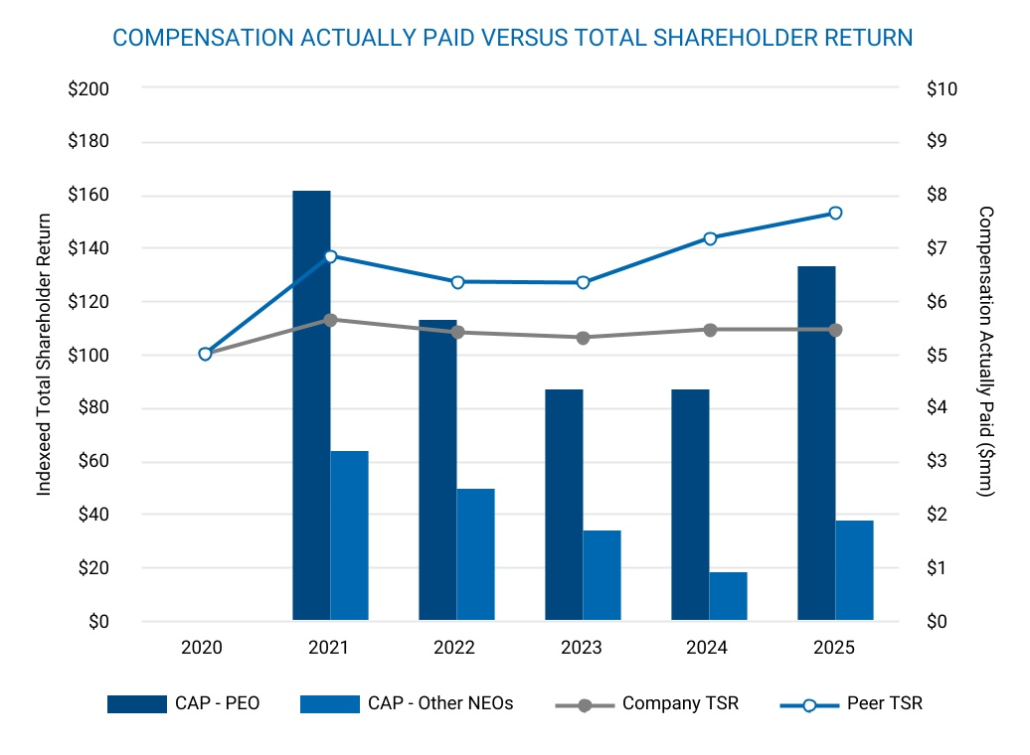
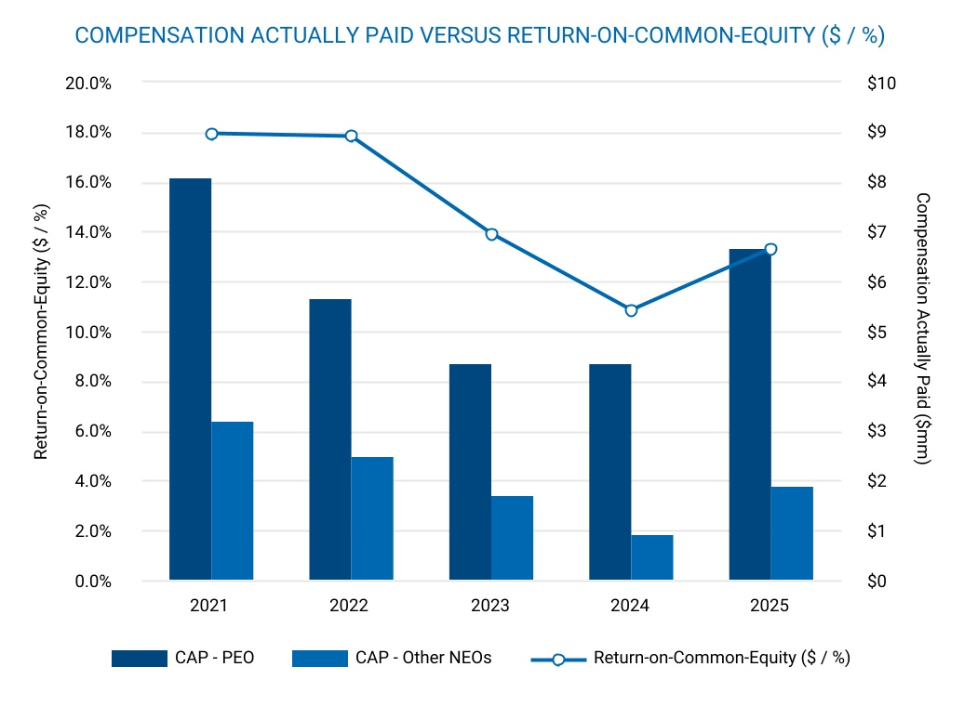
70 |  |  | BANK OF HAWAI'I • 2026 PROXY STATEMENT

COMPENSATION DISCUSSION AND ANALYSIS
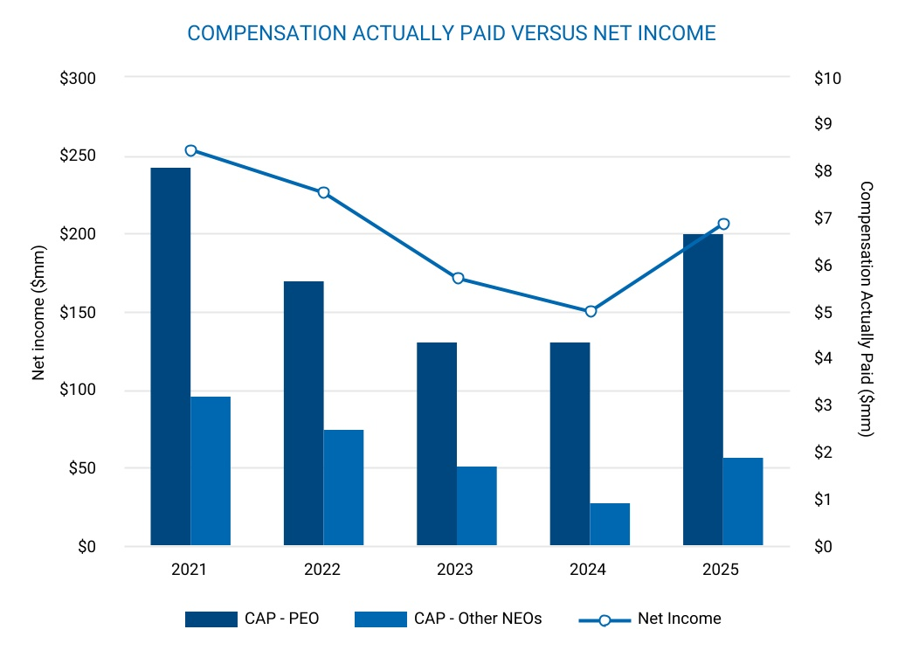
Tabular List of Company Performance Measures
The four items listed below represent the performance measures we believe are most important in linking compensation actually paid to company performance during 2025.
1.Non-Performing Assets
2.Pre-Provision Net Revenue
3.Relative Total Shareholder Return
4.Return on Common Equity

 |  |  | BANK OF HAWAI‘I • 2026 PROXY STATEMENT |  |  | 71

COMPENSATION DISCUSSION AND ANALYSIS
CEO PAY RATIO
As required by Section 953(b) of the Dodd-Frank Wall Street Reform and Consumer Protection Act and Item 402(u) of Regulation S-K, we are providing the ratio of the annual total compensation of our Chief Executive Officer to the annual total compensation of our median employee for fiscal year 2025.
Identification of the Median Employee
•For fiscal year 2025, we identified our median employee using Form W-2 Box 5 wages for all U.S. employees employed as of December 31, 2025. This population included 1,873 full-time, part-time, temporary, and seasonal employees. As permitted by SEC rules, we excluded 17 employees located in Palau and Japan under the de minimis exemption, representing less than 1% of our total U.S. and non-U.S. population of 1,890 employees. We did not annualize compensation for employees who worked only part of the year.
•In prior years, we identified the median employee based on total earnings as reported on Form W-2 plus nontaxable earnings from our payroll records, and we annualized compensation for full-time and part-time permanent employees who were employed as of the first pay period in October but did not work the entire year. We did not make full-time equivalent adjustments for part-time employees.
•For 2025, we transitioned to using Form W-2 Box 5 wages as of December 31 to simplify the process and to align the identification date with year-end payroll reporting. This methodology also improves consistency across reporting periods by using final payroll data already subject to IRS reporting requirements.
•After evaluating the effect of this change, we determined that the revised methodology did not materially change the identity of the median employee. This update reflects an administrative improvement to enhance accuracy and efficiency and does not represent any change to our compensation programs or pay practices.
CEO and Median Employee Compensation
 |  |  | 2025 Annual Total Compensation*
Chief Executive Officer |  |  | $6,016,006
Median Employee |  |  | $78,614
Pay Ratio |  |  | 77:1

*CEO: amount reported in the “Total” column of our 2025 Summary Compensation Table, prepared in accordance with requirements of Item 402(c)(2)(x) of Regulation S-K.
Median employee: Total compensation calculated in accordance with Item 402(c)(2)(x) of Regulation S-K.

72 |  |  | BANK OF HAWAI'I • 2026 PROXY STATEMENT

Certain Relationships and Related Party Transactions
The Company has written ethics and business conduct policies and procedures to monitor and approve related party transactions, including procedures related to any loans the Company makes to executive officers and directors. The Company also conducts ethics training for its officers and directors. In accordance with applicable NYSE listing standards, each related party transaction is reviewed and evaluated by an appropriate group, generally the Audit Committee, to determine whether a particular relationship serves the best interest of the Company and its shareholders and whether the relationship should be continued. The Company also has adopted a written Code of Business Conduct and Ethics (the “Code”) for all directors, officers and employees to address, among other topics, possible conflicts of interest, corporate opportunities, compliance responsibilities, and reporting and accountability. The Code stresses personal accountability. Directors, officers, or employees who become aware of conflicts of interest or are concerned that a conflict might develop are required to disclose the matter promptly.
In accordance with the applicable NYSE listing standards and the Code, any material transactions or relationships involving a director or executive officer that could reasonably be expected to give rise to a conflict of interest must be approved or ratified by the Audit Committee and a list of those approvals and ratifications must be submitted semi-annually to the Board of Directors. The Audit Committee approves or ratifies material transactions or relationships involving a director or executive officer based on the facts and circumstances of each case. In addition to self-reporting, information about potential conflicts of interest is obtained as part of the annual questionnaire process. In response to the annual Directors’ and Officers’ Questionnaire, each director and executive officer submits to the Corporate Secretary a description of any current or proposed related party transactions. These transactions are presented to the Audit Committee for review and approval or ratification.
The Company and its subsidiaries are also subject to extensive federal regulations regarding certain transactions, including banking regulations relating to the extension of credit by subsidiary banks to insiders, such as executive officers and directors, as well as entities in which these individuals have specified control positions.
During 2025, the Company and its banking and investment subsidiaries engaged in transactions in the ordinary course of business with one or more of the Company’s directors and executive officers, members of their immediate families, corporations and organizations of which one or more of them was a beneficial owner of 10% or more of a class of equity securities, certain of their associates and affiliates, and certain trusts and estates of which one or more of them was a trustee or beneficiary. All loans to such persons were made in the ordinary course of business, were made on substantially the same terms, including interest rates and collateral, as those prevailing at the time for comparable loans with persons not related to the Company, and did not involve more than the normal risk of collectability or present other unfavorable features.
Ms. Dana M. Tokioka, a current director and director nominee, serves as a vice president of Atlas Insurance Agency, Inc. (“Atlas”), a Honolulu-based insurance agency which has provided insurance brokerage services to the Company since July 2009, predating Ms. Tokioka’s appointment to the Board. In 2025, the Company paid Atlas insurance brokerage fees in the amount of $512,290, relating to professional liability, property, casualty and other insurance related products and services. The above-mentioned transactions were made in the ordinary course of business and on terms and conditions comparable to contracts with other vendors not related to the Company.

 |  |  | BANK OF HAWAI‘I • 2026 PROXY STATEMENT |  |  | 73

Proposal 3: Ratification of the Re-Appointment of Ernst & Young LLP as the Company’s Independent Registered Public Accounting Firm for the 2026 Fiscal Year
The Audit Committee has appointed Ernst & Young LLP as the Company’s independent registered public accounting firm for the 2026 fiscal year. The Board recommends that the shareholders ratify this appointment. Ernst & Young LLP has been the Company’s independent registered public accounting firm since its incorporation in 1971. We expect representatives of Ernst & Young LLP to attend the annual meeting. Ernst & Young LLP has indicated that they will have no statement to make but will be available to respond to questions. If this Proposal does not pass, the appointment of the independent registered public accounting firm will be reconsidered by the Audit Committee.
The Board of Directors recommends a vote “FOR” the foregoing proposal.

ERNST & YOUNG LLP FEES
Ernst & Young LLP’s fees for professional services rendered for 2025 and 2024 were as follows:
Service |  |  | 2025 |  |  |  |  |  | 2024
Audit Fees |  |  | $2,604,175 |  |  |  |  |  | $2,441,400
Audit-Related Fees |  |  | 335,360 |  |  |  |  |  | 319,700
Tax Fees |  |  | 226,897 |  |  |  |  |  | 181,048
All Other Fees |  |  | — |  |  |  |  |  | —
Total |  |  | $3,166,432 |  |  |  |  |  | $2,942,148
Audit Fees
The audit fees represent fees and administrative expenses for professional services rendered for the audit of the Company’s annual consolidated financial statements, the review of our quarterly financial statements included in our Quarterly Reports on Form 10-Q, and the audit of our internal control over financial reporting. Audit fees also represent fees for professional services rendered for statutory and subsidiary audits, attestation services required by statute or regulation, and accounting and financial reporting consultations and research work necessary to comply with U.S. generally accepted accounting principles. Audit fees also include professional services related to consents and assistance with review of documents filed with the SEC.
Audit-Related Fees
The audit-related fees represent fees for employee benefit plan audits, services with respect to Statement on Standards for Attestation Engagements No. 18 related to the Company’s trust operations and mortgage compliance, and other attestation reports.
Tax Fees
The tax fees represent fees for tax advisory and compliance services.
All Other Fees
The all other fees represent fees for non-tax related advisory and consulting services.

74 |  |  | BANK OF HAWAI'I • 2026 PROXY STATEMENT

PROPOSAL 3: RATIFICATION OF THE RE-APPOINTMENT OF ERNST & YOUNG LLP AS THE COMPANY’S INDEPENDENT REGISTERED PUBLIC ACCOUNTING FIRM FOR THE 2026 FISCAL YEAR
Audit Committee Report
As members of the Audit Committee, we review the Company’s financial reporting process on behalf of the Board of Directors. The Audit Committee Charter, which outlines the Committee’s responsibilities, is available on the Company’s website at www.boh.com. Management has the primary responsibility for the financial statements and the reporting process, including the systems of internal controls and disclosure controls. In this context, we have met and held discussions with management and the independent registered public accounting firm. Management represented to us that the Company’s consolidated financial statements were prepared in accordance with U.S. generally accepted accounting principles, and we have reviewed and discussed the audited financial statements and related disclosures with management and the independent registered public accounting firm, including a review of the significant management judgments underlying the financial statements and disclosures.
The independent registered public accounting firm reports to us. We have sole authority to appoint and to terminate the engagement of the independent registered public accounting firm. As a matter of best practice, we submit the appointment of the independent registered public accounting firm to shareholders for ratification.
We have discussed with the independent registered public accounting firm the matters required to be discussed by the Public Company Accounting Oversight Board’s (“PCAOB”) Accounting Standard No. 1301, “Communications with Audit Committees,” including the quality, not just the acceptability, of the accounting principles, the reasonableness of significant judgments, and the clarity of the disclosures in the financial statements. In addition, we have received the written disclosures and the letter from the independent registered public accounting firm required by applicable requirements of the PCAOB regarding communications with the audit committee concerning independence, and have discussed with the independent registered public accounting firm its independence from the Company and its management. In concluding that the independent registered public accounting firm is independent, we determined, among other things, that the audit and non-audit services provided by Ernst & Young LLP were compatible with its independence. Consistent with the requirements of the Sarbanes-Oxley Act of 2002, the Audit Committee has adopted policies to avoid compromising the independence of the independent registered public accounting firm, such as prior committee approval of audit, non-audit, tax, and all other services, and required audit partner rotation.
We discussed with the Company’s internal auditors and independent registered public accounting firm the overall scope and plans for their respective audits, including internal control testing under Section 404 of the Sarbanes-Oxley Act of 2002. We met with our internal auditors and independent registered public accounting firm, with and without management present, and in private sessions with members of senior management to discuss the results of their examinations, their evaluations of the Company’s internal controls, and the overall quality of the Company’s financial reporting. We also periodically met in executive session.
In reliance on the reviews and discussions referred to above, as members of the Audit Committee, we recommended to the Board of Directors (and the Board of Directors subsequently approved the recommendation) that the audited consolidated financial statements be included in the Company’s annual report on Form 10-K for the year ended December 31, 2025, for filing with the Securities and Exchange Commission. We have also appointed the Company’s independent registered public accounting firm for the 2026 fiscal year.
As submitted by the members of the Audit Committee,
John C. Erickson, Chair
Kent T. Lucien
Alicia E. Moy
Victor K. Nichols
Raymond P. Vara, Jr.

 |  |  | BANK OF HAWAI‘I • 2026 PROXY STATEMENT |  |  | 75

PROPOSAL 3: RATIFICATION OF THE RE-APPOINTMENT OF ERNST & YOUNG LLP AS THE COMPANY’S INDEPENDENT REGISTERED PUBLIC ACCOUNTING FIRM FOR THE 2026 FISCAL YEAR
Audit Committee Pre-Approval Policies and Procedures
On an annual basis, the Audit Committee pre-approves all auditing and permitted non-audit services to be provided by Ernst & Young LLP, except that the Audit Committee need not pre-approve any permitted non-audit services that meet the requirements of any de minimis exception established by SEC rules. The pre-approved list of services consists of audit services, audit-related services, and tax services. The Audit Committee or its designee, the Committee Chair, must specifically approve any type of service that is not included on the pre-approved list of services, provided that any such pre-approval by the Committee Chair is presented to the full Audit Committee at its next meeting. Any proposed service that is included on the list of pre-approved services but will cause the pre-approved fee level to be exceeded also requires specific pre-approval by the Audit Committee or its designee, the Committee Chair, provided that any such pre-approval by the Committee Chair is presented to the full Audit Committee at its next meeting.
All of the services provided by, and fees paid to, Ernst & Young LLP in 2025 were pre-approved by the Audit Committee, and there were no services for which the de minimis exception permitted in certain circumstances under SEC rules was utilized.

Other Business
The Board of Directors knows of no other business for consideration at the annual meeting. However, if other matters properly come before the meeting or any adjournment, the person or persons voting your shares pursuant to instructions by proxy card, telephone, or the Internet will vote as they deem in the best interests of Bank of Hawaii Corporation.
A copy of the Company’s Annual Report on Form 10-K, including the related consolidated financial statements and schedules filed with the SEC, is available without charge to any shareholder who requests a copy in writing. Any exhibit to Form 10-K is also available upon written request at a reasonable charge for copying and mailing. Written requests should be made to the Corporate Secretary at 130 Merchant Street, Honolulu, Hawai‘i 96813.

76 |  |  | BANK OF HAWAI'I • 2026 PROXY STATEMENT



