UNITED STATES
SECURITIES AND EXCHANGE COMMISSION
Washington, D. C. 20549
FORM 8-K
CURRENT REPORT
PURSUANT TO SECTION 13 OR 15(d) OF THE SECURITIES EXCHANGE ACT OF 1934
Date of Report |  |  | July 27, 2026
(Date of earliest event reported)
BANK OF HAWAII CORPORATION
(Exact name of registrant as specified in its charter)
Delaware |  |  | 1-6887 |  |  | 99-0148992
(State of Incorporation) |  |  | (Commission File Number) |  |  | (IRS Employer Identification No.)
130 Merchant Street |  |  | Honolulu |  |  | Hawaii |  |  | 96813
(Address of principal executive offices) |  |  | (City) |  |  | (State) |  |  | (Zip Code)
(888) 643-3888
(Registrant's telephone number, including area code)
Not Applicable
(Former name or former address, if changed since last report)
Securities registered pursuant to Section 12(b) of the Act:
Title of each class |  |  |  |  |  | Trading Symbol(s) |  |  |  |  |  | Name of each exchange on which registered
Common Stock, par value $0.01 per share |  |  |  |  |  | BOH |  |  |  |  |  | New York Stock Exchange
Depository Shares, Each Representing 1/40th Interest in a Share of 4.375% Fixed Rate Non-Cumulative Perpetual Preferred Stock, Series A |  |  |  |  |  | BOH.PRA |  |  |  |  |  | New York Stock Exchange
Depository Shares, Each Representing 1/40th Interest in a Share of 8.000% Fixed Rate Non-Cumulative Perpetual Preferred Stock, Series B |  |  |  |  |  | BOH.PRB |  |  |  |  |  | New York Stock Exchange
Check the appropriate box below if the Form 8-K filing is intended to simultaneously satisfy the filing obligation of the registrant under any of the following provisions:
☐ |  |  | Written communications pursuant to Rule 425 under the Securities Act (17 CFR 230.425)
☐ |  |  | Soliciting material pursuant to Rule 14a-12 under the Exchange Act (17 CFR 240.14a-12)
☐ |  |  | Pre-commencement communications pursuant to Rule 14d-2(b) under the Exchange Act (17 CFR 240.14d-2(b))
☐ |  |  | Pre-commencement communications pursuant to Rule 13e-4(c) under the Exchange Act (17 CFR 240.13e-4 (c))
Indicate by check mark whether the registrant is an emerging growth company as defined in Rule 405 of the Securities Act of 1933 (§230.405 of this chapter) or Rule 12b-2 of the Securities Exchange Act of 1934 (§240.12b-2 of this chapter).
Emerging growth company ☐
If an emerging growth company, indicate by check mark if the registrant has elected not to use the extended transition period for complying with any new or revised financial accounting standards provided pursuant to Section 13(a) of the Exchange Act. ☐

Item 2.02.Results of Operations and Financial Condition.
On July 27, 2026, Bank of Hawaii Corporation announced its results of operations for the quarter ended June 30, 2026. The public announcement was made by means of a press release, the text of which is furnished as Exhibit 99.1 hereto and incorporated herein by reference.

Item 9.01.Financial Statements and Exhibits.
(d)Exhibits
Exhibit No.
99.1 |  |  |  |  |  | July 27, 2026 Press Release: Bank of Hawaii Corporation Second Quarter 2026 Financial Results. Any internet addresses provided in this release are for informational purposes only and are not intended to be hyperlinks. Furnished herewith.
99.2 |  |  |  |  |  | Bank of Hawaii Corporation Second Quarter 2026 Financial Report
104 |  |  |  |  |  | Cover Page Interactive Data File (embedded within the Inline XBRL document)

Signatures
Pursuant to the requirements of the Securities Exchange Act of 1934, the Registrant has duly caused this report to be signed on its behalf by the undersigned hereunto duly authorized.
Date: July 27, 2026 |  |  | Bank of Hawaii Corporation
 |  |  | By: |  |  | /s/ Patrick M. McGuirk
 |  |  |  |  |  | Patrick M. McGuirk
 |  |  |  |  |  | Vice Chair and Chief Administrative Officer

Exhibit 99.1

Bank of Hawai‘i Corporation Second Quarter 2026 Financial Results

•Diluted Earnings Per Common Share of $1.47
•Net Income of $63.8 Million
•Net Interest Margin Increased to 2.78%
•Share Repurchases of $17.0 Million

FOR IMMEDIATE RELEASE

HONOLULU, HI (July 27, 2026) -- Bank of Hawai‘i Corporation (NYSE: BOH) (the “Company”) today reported diluted earnings per common share of $1.47 for the second quarter of 2026, compared with $1.30 during the linked quarter. Net income for the quarter was $63.8 million, up 11.1% from the linked quarter. The return on average common equity for the second quarter of 2026 was 15.47% compared with 13.90% during the linked quarter.

“Bank of Hawai‘i delivered solid second quarter results reflecting steady execution and disciplined balance sheet management,” said Jim Polk, President and CEO. “Net interest margin expanded for the ninth consecutive quarter, supported by the ongoing repricing of cash flows. Total loans and leases increased from the prior quarter, while average total deposits were modestly lower during a seasonally lower period. Credit quality remained strong, and we continued to maintain a disciplined approach to expenses.”

Financial Highlights
Net interest income for the second quarter of 2026 was $153.6 million, an increase of 1.7% from the linked quarter. The increase was primarily driven by a 5 basis point increase in earning asset yield as fixed-rate assets rolled off and were reinvested at higher rates (fixed asset repricing), partially offset by a shift from noninterest-bearing deposits and interest-bearing deposits yielding less than 10 basis points to higher yielding interest-bearing deposits accounts (deposit mix shift) and higher deposit costs.

Net interest margin was 2.78% in the second quarter of 2026, an increase of 4 basis points from the linked quarter, reflecting the same asset yield and deposit cost dynamics as previously mentioned.

The average yield on total earning assets was 4.08% and the average yield on loans and leases was 4.79% in the second quarter of 2026, up 5 basis points and 4 basis points, respectively, from the linked quarter. The increase in loan yield from the linked quarter was primarily driven by fixed asset repricing and additional loan production at higher current rates. Loan originations of all loans, including floating rate loans, during the quarter were originated at an average rate of 5.90%.
- more -
Bank of Hawai‘i Corporation Second Quarter 2026 Financial Results |  |  | Page 2

The average rate of interest-bearing deposits was 1.73% and the average quarterly rate of total deposits, including noninterest-bearing deposits, was 1.27%, both up 1 basis point from the linked quarter. The increase in the rate on total deposits was primarily driven by deposit mix shift and higher rates on interest-bearing demand and savings deposits, partially offset by maturing time deposits renewing at lower rates. The deposit beta for the downward rate cycle was 35.5% as of the second quarter of 2026.

Noninterest income was $43.3 million in the second quarter of 2026, an increase of 4.8% from the linked quarter. Noninterest income included a $0.4 million and a $0.2 million charge related to a Visa Class B share conversion ratio change in the second quarter of 2026 and linked quarter, respectively. Adjusted for these items, noninterest income for the second quarter of 2026 was up 5.3% from the linked quarter. The increase was primarily due to increases in trust and asset management fees and commissions earned on our annuity and insurance business.

Noninterest expense was $111.2 million in the second quarter of 2026, a decrease of 4.2% from the linked quarter. Noninterest expense in the second quarter included a $0.5 million net benefit related to the forfeiture of restricted stock awards. Noninterest expense in the linked quarter included $3.5 million in expenses related to the accelerated vesting of restricted stock awards pursuant to the retirement provision of performance-based restricted stock granted in 2024 and 2025 and $0.7 million in separation expenses. Adjusted for these items, noninterest expense for the second quarter of 2026 decreased by 0.2% from the linked quarter.

The effective tax rate for the second quarter of 2026 was 22.31% compared to 22.91% during the linked quarter. The lower effective tax rate in the current quarter as compared to the linked quarter was primarily due to higher benefits from certain tax advantaged investments and an increase in tax benefits from discrete items.

Asset Quality

The Company’s overall asset quality remained strong during the second quarter of 2026. Provision for credit losses for the second quarter of 2026 was $3.6 million, up $1.9 million from the linked quarter. This increase was primarily driven by higher net loan and lease charge-offs during the second quarter of 2026 as compared to the linked quarter, which included a $1.6 million recovery on a single commercial mortgage loan.

Total non-performing assets were $11.5 million at June 30, 2026, down $0.6 million from March 31, 2026. Non-performing assets as a percentage of total loans and leases and foreclosed real estate were 0.08% at the end of the quarter, a decrease of 1 basis point from the linked quarter.

Net loan and lease charge-offs during the second quarter of 2026 were $3.4 million or 10 basis points annualized of total average loans and leases outstanding. Gross charge-offs of $4.7 million were partially offset by gross recoveries of $1.3 million. Compared to the linked quarter, net loan and lease charge-offs increased by $2.3 million or 7 basis points annualized on total average loans and leases outstanding.

The allowance for credit losses on loans and leases was $147.0 million at June 30, 2026, unchanged from March 31, 2026. The ratio of the allowance for credit losses to total loans and leases outstanding was 1.03% at the end of the quarter, a decrease of 1 basis point from March 31, 2026.

Balance Sheet

Total assets were $23.8 billion at June 30, 2026, a decrease of 1.4% from December 31, 2025. The decrease from December 31, 2025 was primarily due to decreases in cash and cash equivalents and held-to-maturity securities, partially offset by increases in loans and leases and available-for-sale securities.

- more -
Bank of Hawai‘i Corporation Second Quarter 2026 Financial Results |  |  | Page 3
The investment securities portfolio was $7.7 billion at June 30, 2026, a decrease of 0.9% from December 31, 2025. The decrease was primarily due to portfolio runoff, including maturities and paydowns, partially offset by purchases in available-for-sale securities. The investment securities portfolio remains largely comprised of securities issued by U.S. government agencies and U.S. government-sponsored enterprises.

Total loans and leases were $14.3 billion at June 30, 2026, an increase of 1.5% from December 31, 2025. Total commercial loans were $6.2 billion at June 30, 2026, an increase of 2.6% from December 31, 2025. The increase was primarily due to commercial mortgage and commercial and industrial production. Total consumer loans were $8.0 billion at June 30, 2026, an increase of 0.6% from December 31, 2025. The increase was primarily due to increased production in the residential mortgage portfolio, partially offset by amortization and paydowns.

Total deposits were $20.9 billion at June 30, 2026, a decrease of 1.4% from December 31, 2025. Noninterest-bearing deposits made up 26.7% of total deposit balances at June 30, 2026, down from 27.2% at December 31, 2025. Average total deposits were $20.8 billion for the second quarter of 2026, down 0.7% from December 31, 2025.

Capital and Dividends

The Company’s capital levels remain well above regulatory well-capitalized minimums.

The Tier 1 Capital Ratio was 14.45% at June 30, 2026 compared with 14.49% at December 31, 2025. The decrease from December 31, 2025 was due to an increase in risk-weighted assets and share repurchases, as discussed below, partially offset by an increase in retained earnings. The Tier 1 Leverage Ratio was 8.70% at June 30, 2026, compared with 8.57% at December 31, 2025. The increase from December 31, 2025 was due to a decline in average assets and an increase in retained earnings.

The Company repurchased 216 thousand shares of common stock at a total cost of $17.0 million under the share repurchase program in the second quarter of 2026. Total remaining buyback authority under the share repurchase program was $88.9 million at June 30, 2026.

The Company’s Board of Directors declared a quarterly cash dividend of $0.70 per share on the Company’s outstanding common shares. The dividend will be payable on September 15, 2026 to shareholders of record at the close of business on August 31, 2026.

On July 6, 2026, the Company announced that the Board of Directors declared a quarterly dividend payment of $10.94 per share, equivalent to $0.2735 per depositary share, of Fixed Rate Non-Cumulative Perpetual Preferred Stock, Series A, and a quarterly dividend payment of $20.00 per share, equivalent to $0.5000 per depositary share, of Fixed Rate Non-Cumulative Perpetual Preferred Stock, Series B. The depositary shares representing the Series A Preferred Stock and Series B Preferred Stock are traded on the NYSE under the symbol “BOH.PRA” and “BOH.PRB”, respectively. The dividends on the Series A Preferred Stock and Series B Preferred Stock will be payable on August 3, 2026 to shareholders of record of the preferred stock as of the close of business on July 17, 2026.
- more -
Bank of Hawai‘i Corporation Second Quarter 2026 Financial Results |  |  | Page 4

Conference Call Information
The Company will review its second quarter financial results today at 8:00 a.m. Hawai‘i Time (2:00 p.m. Eastern Time). The live call, including a slide presentation, will be accessible on the investor relations link of Bank of Hawai‘i Corporation's website, www.boh.com. The webcast can be accessed via the link: https://register-conf.media-server.com/register/BIbf819fb4b2824119b0496adf4c769c13. A replay of the conference call will be available for one year beginning at approximately 11:00 a.m. Hawai‘i Time on Monday, July 27, 2026. The replay will be available on the Company's website, www.boh.com.
Investor Announcements
Investors and others should note that the Company intends to announce financial and other information to the Company’s investors using the Company’s investor relations website at https://ir.boh.com, social media channels, press releases, SEC filings and public conference calls and webcasts, all for purposes of complying with the Company’s disclosure obligations under Regulation FD. Accordingly, investors should monitor these channels, as information is updated, and new information is posted.

Forward-Looking Statements

This news release, and other statements made by the Company in connection with it may contain "forward-looking statements" (as defined in the Private Securities Litigation Reform Act of 1995) that involve risks and uncertainties that could cause results to be materially different from expectations. Forecasts of our financial results and condition, expectations for our operations and business prospects, and our assumptions used in those forecasts and expectations are examples of certain of these forward-looking statements. Do not unduly rely on forward-looking statements. Actual results might differ significantly from our forecasts and expectations because of a variety of factors. More information about these factors is contained in Bank of Hawai‘i Corporation's Annual Report on Form 10-K for the year ended December 31, 2025, which was filed with the U.S. Securities and Exchange Commission. These forward-looking statements are not guarantees of future performance and speak only as of the date made, and, except as required by law, the Company undertakes no obligation to update or revise any forward-looking statements to reflect subsequent events, new information or future circumstances.

Bank of Hawai‘i Corporation is an independent regional financial services company serving businesses, consumers, and governments in Hawai‘i and the West Pacific. The Company's principal subsidiary, Bank of Hawai‘i, was founded in 1897. For more information about Bank of Hawai‘i Corporation, see the Company’s website, www.boh.com. Bank of Hawai‘i Corporation is a trade name of Bank of Hawaii Corporation.
# # # #

Bank of Hawai‘i Corporation and Subsidiaries
Financial Highlights |  |  |  |  |  |  |  |  |  |  |  |  |  |  |  |  |  |  |  |  |  |  |  |  |  |  |  |  |  | Table 1
 |  |  |  |  |  | Three Months Ended |  |  |  |  |  |  |  |  |  |  |  |  |  |  |  |  |  | Six Months Ended
(dollars in thousands, except per share amounts) |  |  |  |  |  | June 30, 2026 |  |  |  |  |  | March 31, 2026 |  |  |  |  |  | June 30, 2025 |  |  |  |  |  | June 30, 2026 |  |  |  |  |  | June 30, 2025
For the Period:
Operating Results
Net Interest Income |  |  |  |  |  | $ | 153,604 |  |  |  |  | $ | 150,990 |  |  |  |  | $ | 129,683 |  |  |  |  | $ | 304,594 |  |  |  |  | $ | 255,490
Provision for Credit Losses |  |  |  |  |  | 3,600 |  |  |  |  |  | 1,750 |  |  |  |  |  | 3,250 |  |  |  |  |  | 5,350 |  |  |  |  |  | 6,500
Total Noninterest Income |  |  |  |  |  | 43,299 |  |  |  |  |  | 41,332 |  |  |  |  |  | 44,795 |  |  |  |  |  | 84,631 |  |  |  |  |  | 88,853
Total Noninterest Expense |  |  |  |  |  | 111,186 |  |  |  |  |  | 116,071 |  |  |  |  |  | 110,783 |  |  |  |  |  | 227,257 |  |  |  |  |  | 221,242
Pre-Provision Net Revenue |  |  |  |  |  | 85,717 |  |  |  |  |  | 76,251 |  |  |  |  |  | 63,695 |  |  |  |  |  | 161,968 |  |  |  |  |  | 123,101
Net Income |  |  |  |  |  | 63,799 |  |  |  |  |  | 57,432 |  |  |  |  |  | 47,637 |  |  |  |  |  | 121,231 |  |  |  |  |  | 91,622
Net Income Available to Common Shareholders |  |  |  |  |  | 58,530 |  |  |  |  |  | 52,163 |  |  |  |  |  | 42,368 |  |  |  |  |  | 110,693 |  |  |  |  |  | 81,084
Basic Earnings Per Common Share |  |  |  |  |  | 1.48 |  |  |  |  |  | 1.32 |  |  |  |  |  | 1.07 |  |  |  |  |  | 2.80 |  |  |  |  |  | 2.05
Diluted Earnings Per Common Share |  |  |  |  |  | 1.47 |  |  |  |  |  | 1.30 |  |  |  |  |  | 1.06 |  |  |  |  |  | 2.78 |  |  |  |  |  | 2.03
Dividends Declared Per Common Share |  |  |  |  |  | 0.70 |  |  |  |  |  | 0.70 |  |  |  |  |  | 0.70 |  |  |  |  |  | 1.40 |  |  |  |  |  | 1.40
Performance Ratios
Return on Average Assets |  |  |  |  |  | 1.07 |  | % |  |  |  | 0.97 |  | % |  |  |  | 0.81 |  | % |  |  |  | 1.02 |  | % |  |  |  | 0.78 |  | %
Return on Average Shareholders' Equity |  |  |  |  |  | 13.74 |  |  |  |  |  | 12.47 |  |  |  |  |  | 11.21 |  |  |  |  |  | 13.11 |  |  |  |  |  | 10.93
Return on Average Common Equity |  |  |  |  |  | 15.47 |  |  |  |  |  | 13.90 |  |  |  |  |  | 12.50 |  |  |  |  |  | 14.69 |  |  |  |  |  | 12.16
Efficiency Ratio 1 |  |  |  |  |  | 56.47 |  |  |  |  |  | 60.35 |  |  |  |  |  | 63.49 |  |  |  |  |  | 58.39 |  |  |  |  |  | 64.25
Net Interest Margin 2 |  |  |  |  |  | 2.78 |  |  |  |  |  | 2.74 |  |  |  |  |  | 2.39 |  |  |  |  |  | 2.76 |  |  |  |  |  | 2.36
Dividend Payout Ratio 3 |  |  |  |  |  | 47.30 |  |  |  |  |  | 53.03 |  |  |  |  |  | 65.42 |  |  |  |  |  | 50.00 |  |  |  |  |  | 68.29
Average Shareholders' Equity to Average Assets |  |  |  |  |  | 7.81 |  |  |  |  |  | 7.81 |  |  |  |  |  | 7.22 |  |  |  |  |  | 7.81 |  |  |  |  |  | 7.16
Average Balances
Average Loans and Leases |  |  |  |  |  | $ | 14,218,951 |  |  |  |  | $ | 14,083,875 |  |  |  |  | $ | 14,049,025 |  |  |  |  | $ | 14,151,786 |  |  |  |  | $ | 14,055,563
Average Assets |  |  |  |  |  | 23,861,848 |  |  |  |  |  | 23,915,334 |  |  |  |  |  | 23,596,955 |  |  |  |  |  | 23,888,444 |  |  |  |  |  | 23,617,398
Average Deposits |  |  |  |  |  | 20,826,923 |  |  |  |  |  | 20,915,443 |  |  |  |  |  | 20,699,694 |  |  |  |  |  | 20,870,939 |  |  |  |  |  | 20,684,700
Average Shareholders' Equity |  |  |  |  |  | 1,862,499 |  |  |  |  |  | 1,867,165 |  |  |  |  |  | 1,704,415 |  |  |  |  |  | 1,864,819 |  |  |  |  |  | 1,690,073
Per Share of Common Stock
Book Value |  |  |  |  |  | $ | 38.81 |  |  |  |  | $ | 38.10 |  |  |  |  | $ | 35.16 |  |  |  |  | $ | 38.81 |  |  |  |  | $ | 35.16
Tangible Book Value |  |  |  |  |  | 38.01 |  |  |  |  |  | 37.31 |  |  |  |  |  | 34.37 |  |  |  |  |  | 38.01 |  |  |  |  |  | 34.37
Market Value
Closing |  |  |  |  |  | 81.49 |  |  |  |  |  | 74.25 |  |  |  |  |  | 67.53 |  |  |  |  |  | 81.49 |  |  |  |  |  | 67.53
High |  |  |  |  |  | 83.18 |  |  |  |  |  | 80.61 |  |  |  |  |  | 71.35 |  |  |  |  |  | 83.18 |  |  |  |  |  | 76.00
Low |  |  |  |  |  | 70.07 |  |  |  |  |  | 67.04 |  |  |  |  |  | 57.45 |  |  |  |  |  | 67.04 |  |  |  |  |  | 57.45
 |  |  |  |  |  | June 30, 2026 |  |  |  |  |  | March 31, 2026 |  |  |  |  |  | December 31, 2025 |  |  |  |  |  | June 30, 2025
As of Period End:
Balance Sheet Totals
Loans and Leases |  |  |  |  |  | $ | 14,286,625 |  |  |  |  | $ | 14,192,811 |  |  |  |  | $ | 14,082,050 |  |  |  |  | $ | 14,002,178
Total Assets |  |  |  |  |  | 23,842,940 |  |  |  |  |  | 23,909,933 |  |  |  |  |  | 24,176,364 |  |  |  |  |  | 23,709,752
Total Deposits |  |  |  |  |  | 20,892,775 |  |  |  |  |  | 20,957,930 |  |  |  |  |  | 21,188,495 |  |  |  |  |  | 20,798,914
Other Debt |  |  |  |  |  | 508,124 |  |  |  |  |  | 558,150 |  |  |  |  |  | 558,176 |  |  |  |  |  | 558,226
Total Shareholders' Equity |  |  |  |  |  | 1,875,467 |  |  |  |  |  | 1,854,563 |  |  |  |  |  | 1,851,212 |  |  |  |  |  | 1,743,107
Asset Quality
Non-Performing Assets |  |  |  |  |  | $ | 11,478 |  |  |  |  | $ | 12,090 |  |  |  |  | $ | 14,171 |  |  |  |  | $ | 17,881
Allowance for Credit Losses - Loans and Leases |  |  |  |  |  | 146,995 |  |  |  |  |  | 146,962 |  |  |  |  |  | 146,766 |  |  |  |  |  | 148,543
Allowance to Loans and Leases Outstanding 4 |  |  |  |  |  | 1.03 |  | % |  |  |  | 1.04 |  | % |  |  |  | 1.04 |  | % |  |  |  | 1.06 |  | %
Capital Ratios 5
Common Equity Tier 1 Capital Ratio 6 |  |  |  |  |  | 12.12 |  | % |  |  |  | 12.06 |  | % |  |  |  | 12.14 |  | % |  |  |  | 11.81 |  | %
Tier 1 Capital Ratio |  |  |  |  |  | 14.45 |  |  |  |  |  | 14.40 |  |  |  |  |  | 14.49 |  |  |  |  |  | 14.17
Total Capital Ratio |  |  |  |  |  | 15.48 |  |  |  |  |  | 15.44 |  |  |  |  |  | 15.54 |  |  |  |  |  | 15.23
Tier 1 Leverage Ratio |  |  |  |  |  | 8.70 |  |  |  |  |  | 8.62 |  |  |  |  |  | 8.57 |  |  |  |  |  | 8.46
Total Shareholders' Equity to Total Assets |  |  |  |  |  | 7.87 |  |  |  |  |  | 7.76 |  |  |  |  |  | 7.66 |  |  |  |  |  | 7.35
Tangible Common Equity to Tangible Assets 7 |  |  |  |  |  | 6.30 |  |  |  |  |  | 6.19 |  |  |  |  |  | 6.11 |  |  |  |  |  | 5.77
Tangible Common Equity to Risk-Weighted Assets 7 |  |  |  |  |  | 10.38 |  |  |  |  |  | 10.28 |  |  |  |  |  | 10.35 |  |  |  |  |  | 9.62
Non-Financial Data
Full-Time Equivalent Employees |  |  |  |  |  | 1,910 |  |  |  |  |  | 1,866 |  |  |  |  |  | 1,877 |  |  |  |  |  | 1,921
Branches |  |  |  |  |  | 52 |  |  |  |  |  | 52 |  |  |  |  |  | 51 |  |  |  |  |  | 51
ATMs |  |  |  |  |  | 315 |  |  |  |  |  | 319 |  |  |  |  |  | 320 |  |  |  |  |  | 317
1 Efficiency ratio is defined as noninterest expense divided by total revenue (net interest income and total noninterest income).
2 Net interest margin is defined as net interest income, on a taxable-equivalent basis, as a percentage of average earning assets.
3 Dividend payout ratio is defined as dividends declared per common share divided by basic earnings per common share.
4 The numerator comprises the Allowance for Credit Losses - Loans and Leases.
5 Regulatory capital ratios as of June 30, 2026 are preliminary.
6 Capital Ratio as of December 31, 2025 has been updated to reflect final reported ratio.
7 Tangible common equity to tangible assets and tangible common equity to risk-weighted assets are Non-GAAP financial measures. Tangible common equity is defined by the Company as common shareholders' equity minus goodwill. See Table 8 “Reconciliation of Non-GAAP Financial Measures”.

Bank of Hawai‘i Corporation and Subsidiaries
Consolidated Statements of Income |  |  |  |  |  |  |  |  |  |  |  |  |  |  |  |  |  |  |  |  |  |  |  |  |  |  |  |  |  | Table 2
 |  |  |  |  |  | Three Months Ended |  |  |  |  |  |  |  |  |  |  |  |  |  |  |  |  |  | Six Months Ended
(dollars in thousands, except per share amounts) |  |  |  |  |  | June 30, 2026 |  |  |  |  |  | March 31, 2026 |  |  |  |  |  | June 30, 2025 |  |  |  |  |  | June 30, 2026 |  |  |  |  |  | June 30, 2025
Interest Income
Interest and Fees on Loans and Leases |  |  |  |  |  | $ | 168,624 |  |  |  |  | $ | 164,469 |  |  |  |  | $ | 166,779 |  |  |  |  | $ | 333,093 |  |  |  |  | $ | 329,861
Income on Investment Securities
Available-for-Sale |  |  |  |  |  | 36,397 |  |  |  |  |  | 34,575 |  |  |  |  |  | 27,007 |  |  |  |  |  | 70,972 |  |  |  |  |  | 51,375
Held-to-Maturity |  |  |  |  |  | 18,056 |  |  |  |  |  | 18,541 |  |  |  |  |  | 19,835 |  |  |  |  |  | 36,597 |  |  |  |  |  | 40,126
Cash and Cash Equivalents |  |  |  |  |  | 1,726 |  |  |  |  |  | 3,329 |  |  |  |  |  | 3,817 |  |  |  |  |  | 5,055 |  |  |  |  |  | 9,277
Other |  |  |  |  |  | 1,313 |  |  |  |  |  | 1,293 |  |  |  |  |  | 1,097 |  |  |  |  |  | 2,606 |  |  |  |  |  | 2,182
Total Interest Income |  |  |  |  |  | 226,116 |  |  |  |  |  | 222,207 |  |  |  |  |  | 218,535 |  |  |  |  |  | 448,323 |  |  |  |  |  | 432,821
Interest Expense
Deposits |  |  |  |  |  | 65,804 |  |  |  |  |  | 64,886 |  |  |  |  |  | 82,476 |  |  |  |  |  | 130,690 |  |  |  |  |  | 164,168
Securities Sold Under Agreements to Repurchase |  |  |  |  |  | 491 |  |  |  |  |  | 486 |  |  |  |  |  | 491 |  |  |  |  |  | 977 |  |  |  |  |  | 1,235
Other Debt |  |  |  |  |  | 6,217 |  |  |  |  |  | 5,845 |  |  |  |  |  | 5,885 |  |  |  |  |  | 12,062 |  |  |  |  |  | 11,928
Total Interest Expense |  |  |  |  |  | 72,512 |  |  |  |  |  | 71,217 |  |  |  |  |  | 88,852 |  |  |  |  |  | 143,729 |  |  |  |  |  | 177,331
Net Interest Income |  |  |  |  |  | 153,604 |  |  |  |  |  | 150,990 |  |  |  |  |  | 129,683 |  |  |  |  |  | 304,594 |  |  |  |  |  | 255,490
Provision for Credit Losses |  |  |  |  |  | 3,600 |  |  |  |  |  | 1,750 |  |  |  |  |  | 3,250 |  |  |  |  |  | 5,350 |  |  |  |  |  | 6,500
Net Interest Income After Provision for Credit Losses |  |  |  |  |  | 150,004 |  |  |  |  |  | 149,240 |  |  |  |  |  | 126,433 |  |  |  |  |  | 299,244 |  |  |  |  |  | 248,990
Noninterest Income
Trust and Asset Management |  |  |  |  |  | 13,712 |  |  |  |  |  | 12,445 |  |  |  |  |  | 12,097 |  |  |  |  |  | 26,157 |  |  |  |  |  | 23,838
Fees, Exchange, and Other Service Charges |  |  |  |  |  | 11,127 |  |  |  |  |  | 10,928 |  |  |  |  |  | 14,383 |  |  |  |  |  | 22,055 |  |  |  |  |  | 28,820
Service Charges on Deposit Accounts |  |  |  |  |  | 8,353 |  |  |  |  |  | 8,440 |  |  |  |  |  | 8,119 |  |  |  |  |  | 16,793 |  |  |  |  |  | 16,378
Bank-Owned Life Insurance |  |  |  |  |  | 3,923 |  |  |  |  |  | 4,147 |  |  |  |  |  | 3,714 |  |  |  |  |  | 8,070 |  |  |  |  |  | 7,325
Annuity and Insurance |  |  |  |  |  | 2,017 |  |  |  |  |  | 1,469 |  |  |  |  |  | 1,437 |  |  |  |  |  | 3,486 |  |  |  |  |  | 2,992
Mortgage Banking |  |  |  |  |  | 839 |  |  |  |  |  | 876 |  |  |  |  |  | 849 |  |  |  |  |  | 1,715 |  |  |  |  |  | 1,837
Investment Securities Losses, Net |  |  |  |  |  | (1,287) |  |  |  |  |  | (1,272) |  |  |  |  |  | (1,126) |  |  |  |  |  | (2,559) |  |  |  |  |  | (2,733)
Other |  |  |  |  |  | 4,615 |  |  |  |  |  | 4,299 |  |  |  |  |  | 5,322 |  |  |  |  |  | 8,914 |  |  |  |  |  | 10,396
Total Noninterest Income |  |  |  |  |  | 43,299 |  |  |  |  |  | 41,332 |  |  |  |  |  | 44,795 |  |  |  |  |  | 84,631 |  |  |  |  |  | 88,853
Noninterest Expense
Salaries and Benefits |  |  |  |  |  | 62,642 |  |  |  |  |  | 68,457 |  |  |  |  |  | 61,308 |  |  |  |  |  | 131,099 |  |  |  |  |  | 124,192
Net Occupancy |  |  |  |  |  | 10,868 |  |  |  |  |  | 10,782 |  |  |  |  |  | 10,499 |  |  |  |  |  | 21,650 |  |  |  |  |  | 21,058
Net Equipment |  |  |  |  |  | 10,604 |  |  |  |  |  | 10,611 |  |  |  |  |  | 9,977 |  |  |  |  |  | 21,215 |  |  |  |  |  | 20,169
Data Processing |  |  |  |  |  | 5,463 |  |  |  |  |  | 5,581 |  |  |  |  |  | 5,456 |  |  |  |  |  | 11,044 |  |  |  |  |  | 10,723
Professional Fees |  |  |  |  |  | 5,276 |  |  |  |  |  | 4,226 |  |  |  |  |  | 4,263 |  |  |  |  |  | 9,502 |  |  |  |  |  | 8,527
FDIC Insurance |  |  |  |  |  | 2,978 |  |  |  |  |  | 2,719 |  |  |  |  |  | 3,640 |  |  |  |  |  | 5,697 |  |  |  |  |  | 5,282
Other |  |  |  |  |  | 13,355 |  |  |  |  |  | 13,695 |  |  |  |  |  | 15,640 |  |  |  |  |  | 27,050 |  |  |  |  |  | 31,291
Total Noninterest Expense |  |  |  |  |  | 111,186 |  |  |  |  |  | 116,071 |  |  |  |  |  | 110,783 |  |  |  |  |  | 227,257 |  |  |  |  |  | 221,242
Income Before Provision for Income Taxes |  |  |  |  |  | 82,117 |  |  |  |  |  | 74,501 |  |  |  |  |  | 60,445 |  |  |  |  |  | 156,618 |  |  |  |  |  | 116,601
Provision for Income Taxes |  |  |  |  |  | 18,318 |  |  |  |  |  | 17,069 |  |  |  |  |  | 12,808 |  |  |  |  |  | 35,387 |  |  |  |  |  | 24,979
Net Income |  |  |  |  |  | $ | 63,799 |  |  |  |  | $ | 57,432 |  |  |  |  | $ | 47,637 |  |  |  |  | $ | 121,231 |  |  |  |  | $ | 91,622
Preferred Stock Dividends |  |  |  |  |  | 5,269 |  |  |  |  |  | 5,269 |  |  |  |  |  | 5,269 |  |  |  |  |  | 10,538 |  |  |  |  |  | 10,538
Net Income Available to Common Shareholders |  |  |  |  |  | $ | 58,530 |  |  |  |  | $ | 52,163 |  |  |  |  | $ | 42,368 |  |  |  |  | $ | 110,693 |  |  |  |  | $ | 81,084
Basic Earnings Per Common Share |  |  |  |  |  | $ | 1.48 |  |  |  |  | $ | 1.32 |  |  |  |  | $ | 1.07 |  |  |  |  | $ | 2.80 |  |  |  |  | $ | 2.05
Diluted Earnings Per Common Share |  |  |  |  |  | $ | 1.47 |  |  |  |  | $ | 1.30 |  |  |  |  | $ | 1.06 |  |  |  |  | $ | 2.78 |  |  |  |  | $ | 2.03
Dividends Declared Per Common Share |  |  |  |  |  | $ | 0.70 |  |  |  |  | $ | 0.70 |  |  |  |  | $ | 0.70 |  |  |  |  | $ | 1.40 |  |  |  |  | $ | 1.40
Basic Weighted Average Common Shares |  |  |  |  |  | 39,513,447 |  |  |  |  |  | 39,568,000 |  |  |  |  |  | 39,622,998 |  |  |  |  |  | 39,540,239 |  |  |  |  |  | 39,588,916
Diluted Weighted Average Common Shares |  |  |  |  |  | 39,734,782 |  |  |  |  |  | 39,981,356 |  |  |  |  |  | 39,895,093 |  |  |  |  |  | 39,839,337 |  |  |  |  |  | 39,888,294

Bank of Hawai‘i Corporation and Subsidiaries
Consolidated Statements of Condition |  |  |  |  |  |  |  |  |  |  |  |  |  |  |  |  |  |  |  |  |  |  |  | Table 3
(dollars in thousands, except per share amounts) |  |  |  |  |  | June 30, 2026 |  |  |  |  |  | March 31, 2026 |  |  |  |  |  | December 31, 2025 |  |  |  |  |  | June 30, 2025
Assets
Cash and Cash Equivalents |  |  |  |  |  | $ | 452,814 |  |  |  |  | $ | 425,080 |  |  |  |  | $ | 946,520 |  |  |  |  | $ | 768,683
Investment Securities
Available-for-Sale |  |  |  |  |  | 3,618,515 |  |  |  |  |  | 3,722,405 |  |  |  |  |  | 3,510,652 |  |  |  |  |  | 3,111,504
Held-to-Maturity (Fair Value of $3,452,980; $3,549,687; $3,651,966; and $3,754,794) |  |  |  |  |  | 4,070,908 |  |  |  |  |  | 4,163,261 |  |  |  |  |  | 4,245,681 |  |  |  |  |  | 4,441,353
Loans Held for Sale |  |  |  |  |  | 5,089 |  |  |  |  |  | 3,609 |  |  |  |  |  | 4,369 |  |  |  |  |  | 1,867
Loans and Leases |  |  |  |  |  | 14,286,625 |  |  |  |  |  | 14,192,811 |  |  |  |  |  | 14,082,050 |  |  |  |  |  | 14,002,178
Allowance for Credit Losses |  |  |  |  |  | (146,995) |  |  |  |  |  | (146,962) |  |  |  |  |  | (146,766) |  |  |  |  |  | (148,543)
Net Loans and Leases |  |  |  |  |  | 14,139,630 |  |  |  |  |  | 14,045,849 |  |  |  |  |  | 13,935,284 |  |  |  |  |  | 13,853,635
Premises and Equipment, Net |  |  |  |  |  | 223,463 |  |  |  |  |  | 215,859 |  |  |  |  |  | 199,747 |  |  |  |  |  | 192,221
Operating Lease Right-of-Use Assets |  |  |  |  |  | 84,519 |  |  |  |  |  | 82,244 |  |  |  |  |  | 83,424 |  |  |  |  |  | 83,594
Accrued Interest Receivable |  |  |  |  |  | 70,646 |  |  |  |  |  | 70,555 |  |  |  |  |  | 69,899 |  |  |  |  |  | 67,204
Mortgage Servicing Rights |  |  |  |  |  | 16,626 |  |  |  |  |  | 17,036 |  |  |  |  |  | 17,455 |  |  |  |  |  | 18,362
Goodwill |  |  |  |  |  | 31,517 |  |  |  |  |  | 31,517 |  |  |  |  |  | 31,517 |  |  |  |  |  | 31,517
Bank-Owned Life Insurance |  |  |  |  |  | 508,869 |  |  |  |  |  | 499,681 |  |  |  |  |  | 499,795 |  |  |  |  |  | 488,028
Other Assets |  |  |  |  |  | 620,344 |  |  |  |  |  | 632,837 |  |  |  |  |  | 632,021 |  |  |  |  |  | 651,784
Total Assets |  |  |  |  |  | $ | 23,842,940 |  |  |  |  | $ | 23,909,933 |  |  |  |  | $ | 24,176,364 |  |  |  |  | $ | 23,709,752
Liabilities
Deposits
Noninterest-Bearing Demand |  |  |  |  |  | $ | 5,575,291 |  |  |  |  | $ | 5,653,265 |  |  |  |  | $ | 5,755,371 |  |  |  |  | $ | 5,424,471
Interest-Bearing Demand |  |  |  |  |  | 4,075,694 |  |  |  |  |  | 3,884,305 |  |  |  |  |  | 3,910,952 |  |  |  |  |  | 3,855,120
Savings |  |  |  |  |  | 8,705,102 |  |  |  |  |  | 8,683,875 |  |  |  |  |  | 8,741,090 |  |  |  |  |  | 8,481,328
Time |  |  |  |  |  | 2,536,688 |  |  |  |  |  | 2,736,485 |  |  |  |  |  | 2,781,082 |  |  |  |  |  | 3,037,995
Total Deposits |  |  |  |  |  | 20,892,775 |  |  |  |  |  | 20,957,930 |  |  |  |  |  | 21,188,495 |  |  |  |  |  | 20,798,914
Securities Sold Under Agreements to Repurchase |  |  |  |  |  | 50,000 |  |  |  |  |  | 50,000 |  |  |  |  |  | 50,000 |  |  |  |  |  | 50,000
Other Debt |  |  |  |  |  | 508,124 |  |  |  |  |  | 558,150 |  |  |  |  |  | 558,176 |  |  |  |  |  | 558,226
Operating Lease Liabilities |  |  |  |  |  | 93,568 |  |  |  |  |  | 91,213 |  |  |  |  |  | 92,402 |  |  |  |  |  | 92,381
Retirement Benefits Payable |  |  |  |  |  | 25,496 |  |  |  |  |  | 25,686 |  |  |  |  |  | 20,139 |  |  |  |  |  | 23,528
Accrued Interest Payable |  |  |  |  |  | 16,390 |  |  |  |  |  | 19,757 |  |  |  |  |  | 22,370 |  |  |  |  |  | 26,732
Other Liabilities |  |  |  |  |  | 381,120 |  |  |  |  |  | 352,634 |  |  |  |  |  | 393,570 |  |  |  |  |  | 416,864
Total Liabilities |  |  |  |  |  | 21,967,473 |  |  |  |  |  | 22,055,370 |  |  |  |  |  | 22,325,152 |  |  |  |  |  | 21,966,645
Shareholders’ Equity
Preferred Stock (Series A, $.01 par value; authorized 180,000 shares issued and outstanding) |  |  |  |  |  | 180,000 |  |  |  |  |  | 180,000 |  |  |  |  |  | 180,000 |  |  |  |  |  | 180,000
Preferred Stock (Series B, $.01 par value; authorized 165,000 shares issued and outstanding) |  |  |  |  |  | 165,000 |  |  |  |  |  | 165,000 |  |  |  |  |  | 165,000 |  |  |  |  |  | 165,000
Common Stock ($.01 par value; authorized 500,000,000 shares; issued / outstanding: June 30, 2026 - 59,020,336 / 39,439,677; March 31, 2026 - 59,000,929 / 39,620,563; December 31, 2025 - 58,780,253 / 39,725,698 and June 30, 2025 - 58,775,870 / 39,765,375) |  |  |  |  |  | 590 |  |  |  |  |  | 590 |  |  |  |  |  | 587 |  |  |  |  |  | 587
Capital Surplus |  |  |  |  |  | 675,654 |  |  |  |  |  | 672,584 |  |  |  |  |  | 664,781 |  |  |  |  |  | 655,479
Accumulated Other Comprehensive Loss |  |  |  |  |  | (243,475) |  |  |  |  |  | (247,217) |  |  |  |  |  | (244,438) |  |  |  |  |  | (299,194)
Retained Earnings |  |  |  |  |  | 2,260,152 |  |  |  |  |  | 2,229,539 |  |  |  |  |  | 2,205,707 |  |  |  |  |  | 2,158,450
Treasury Stock, at Cost (Shares: June 30, 2026 - 19,580,659; March 31, 2026 - 19,380,366; December 31, 2025 - 19,054,555; and June 30, 2025 - 19,010,495) |  |  |  |  |  | (1,162,454) |  |  |  |  |  | (1,145,933) |  |  |  |  |  | (1,120,425) |  |  |  |  |  | (1,117,215)
Total Shareholders’ Equity |  |  |  |  |  | 1,875,467 |  |  |  |  |  | 1,854,563 |  |  |  |  |  | 1,851,212 |  |  |  |  |  | 1,743,107
Total Liabilities and Shareholders’ Equity |  |  |  |  |  | $ | 23,842,940 |  |  |  |  | $ | 23,909,933 |  |  |  |  | $ | 24,176,364 |  |  |  |  | $ | 23,709,752

Bank of Hawai‘i Corporation and Subsidiaries
Average Balances and Interest Rates - Taxable-Equivalent Basis 1 |  |  |  |  |  |  |  |  |  |  |  |  |  |  |  |  |  |  |  |  |  |  |  |  |  |  |  |  |  | Table 4a
 |  |  | Three Months Ended June 30, 2026 |  |  |  |  |  |  |  |  |  |  |  | Three Months Ended March 31, 2026 |  |  |  |  |  |  |  |  |  |  |  | Three Months Ended June 30, 2025
(dollars in millions) |  |  | Average Balance |  |  | Income/Expense 2 |  |  | Yield/Rate |  |  |  |  |  | Average Balance |  |  | Income/Expense 2 |  |  | Yield/Rate |  |  |  |  |  | Average Balance |  |  | Income/Expense 2 |  |  | Yield/Rate
Earning Assets
Cash and Cash Equivalents |  |  | $ | 196.2 |  | $ | 1.7 |  | 3.48 |  | % |  |  |  | $ | 372.5 |  | $ | 3.3 |  | 3.58 |  | % |  |  |  | $ | 353.7 |  | $ | 3.8 |  | 4.27 |  | %
Investment Securities
Available-for-Sale
Taxable |  |  | 3,669.5 |  |  | 36.1 |  |  | 3.93 |  |  |  |  |  | 3,598.1 |  |  | 34.2 |  |  | 3.82 |  |  |  |  |  | 2,987.2 |  |  | 26.7 |  |  | 3.58
Non-Taxable |  |  | 31.7 |  |  | 0.4 |  |  | 5.08 |  |  |  |  |  | 32.1 |  |  | 0.4 |  |  | 5.07 |  |  |  |  |  | 27.4 |  |  | 0.4 |  |  | 5.85
Held-to-Maturity
Taxable |  |  | 4,091.6 |  |  | 17.9 |  |  | 1.75 |  |  |  |  |  | 4,175.4 |  |  | 18.4 |  |  | 1.76 |  |  |  |  |  | 4,462.1 |  |  | 19.7 |  |  | 1.77
Non-Taxable |  |  | 33.4 |  |  | 0.2 |  |  | 2.10 |  |  |  |  |  | 33.5 |  |  | 0.2 |  |  | 2.10 |  |  |  |  |  | 34.0 |  |  | 0.2 |  |  | 2.10
Total Investment Securities |  |  | 7,826.2 |  |  | 54.6 |  |  | 2.79 |  |  |  |  |  | 7,839.1 |  |  | 53.2 |  |  | 2.72 |  |  |  |  |  | 7,510.7 |  |  | 47.0 |  |  | 2.50
Loans Held for Sale |  |  | 2.7 |  |  | 0.0 |  |  | 6.20 |  |  |  |  |  | 3.6 |  |  | 0.1 |  |  | 5.22 |  |  |  |  |  | 2.2 |  |  | 0.0 |  |  | 5.66
Loans and Leases 3
Commercial Mortgage |  |  | 4,314.9 |  |  | 55.7 |  |  | 5.17 |  |  |  |  |  | 4,220.6 |  |  | 54.1 |  |  | 5.19 |  |  |  |  |  | 4,025.2 |  |  | 53.7 |  |  | 5.35
Commercial and Industrial |  |  | 1,624.6 |  |  | 19.5 |  |  | 4.83 |  |  |  |  |  | 1,583.4 |  |  | 18.7 |  |  | 4.79 |  |  |  |  |  | 1,668.1 |  |  | 21.1 |  |  | 5.07
Construction |  |  | 209.7 |  |  | 3.3 |  |  | 6.30 |  |  |  |  |  | 215.7 |  |  | 3.4 |  |  | 6.46 |  |  |  |  |  | 366.2 |  |  | 6.7 |  |  | 7.30
Commercial Lease Financing |  |  | 84.6 |  |  | 0.9 |  |  | 4.26 |  |  |  |  |  | 86.9 |  |  | 0.9 |  |  | 4.29 |  |  |  |  |  | 93.4 |  |  | 1.0 |  |  | 4.07
Residential Mortgage |  |  | 4,812.6 |  |  | 48.9 |  |  | 4.06 |  |  |  |  |  | 4,781.9 |  |  | 47.8 |  |  | 4.00 |  |  |  |  |  | 4,626.5 |  |  | 45.6 |  |  | 3.95
Home Equity |  |  | 2,085.3 |  |  | 24.1 |  |  | 4.63 |  |  |  |  |  | 2,103.1 |  |  | 23.6 |  |  | 4.55 |  |  |  |  |  | 2,141.5 |  |  | 23.3 |  |  | 4.37
Automobile |  |  | 677.4 |  |  | 9.5 |  |  | 5.65 |  |  |  |  |  | 684.6 |  |  | 9.4 |  |  | 5.57 |  |  |  |  |  | 730.1 |  |  | 9.4 |  |  | 5.19
Other |  |  | 409.9 |  |  | 7.9 |  |  | 7.74 |  |  |  |  |  | 407.7 |  |  | 7.8 |  |  | 7.76 |  |  |  |  |  | 398.0 |  |  | 7.5 |  |  | 7.53
Total Loans and Leases |  |  | 14,219.0 |  |  | 169.8 |  |  | 4.79 |  |  |  |  |  | 14,083.9 |  |  | 165.7 |  |  | 4.75 |  |  |  |  |  | 14,049.0 |  |  | 168.3 |  |  | 4.80
Other |  |  | 82.8 |  |  | 1.4 |  |  | 6.34 |  |  |  |  |  | 81.9 |  |  | 1.3 |  |  | 6.31 |  |  |  |  |  | 65.2 |  |  | 1.1 |  |  | 6.72
Total Earning Assets |  |  | 22,326.9 |  |  | 227.5 |  |  | 4.08 |  |  |  |  |  | 22,381.0 |  |  | 223.6 |  |  | 4.03 |  |  |  |  |  | 21,980.8 |  |  | 220.2 |  |  | 4.01
Non-Earning Assets |  |  | 1,534.9 |  |  |  |  |  |  |  |  |  |  |  | 1,534.3 |  |  |  |  |  |  |  |  |  |  |  | 1,616.2
Total Assets |  |  | $ | 23,861.8 |  |  |  |  |  |  |  |  |  |  | $ | 23,915.3 |  |  |  |  |  |  |  |  |  |  | $ | 23,597.0
Interest-Bearing Liabilities
Interest-Bearing Deposits
Demand |  |  | $ | 3,781.7 |  | $ | 7.4 |  | 0.78 |  | % |  |  |  | $ | 3,839.0 |  | $ | 6.6 |  | 0.69 |  | % |  |  |  | $ | 3,705.5 |  | $ | 7.6 |  | 0.82 |  | %
Savings |  |  | 8,750.0 |  |  | 39.9 |  |  | 1.83 |  |  |  |  |  | 8,668.4 |  |  | 38.7 |  |  | 1.81 |  |  |  |  |  | 8,578.6 |  |  | 48.1 |  |  | 2.25
Time |  |  | 2,707.6 |  |  | 18.5 |  |  | 2.75 |  |  |  |  |  | 2,753.6 |  |  | 19.6 |  |  | 2.89 |  |  |  |  |  | 3,050.0 |  |  | 26.8 |  |  | 3.52
Total Interest-Bearing Deposits |  |  | 15,239.3 |  |  | 65.8 |  |  | 1.73 |  |  |  |  |  | 15,261.0 |  |  | 64.9 |  |  | 1.72 |  |  |  |  |  | 15,334.1 |  |  | 82.5 |  |  | 2.16
Securities Sold Under Agreements to Repurchase |  |  | 50.0 |  |  | 0.5 |  |  | 3.88 |  |  |  |  |  | 50.0 |  |  | 0.5 |  |  | 3.89 |  |  |  |  |  | 50.0 |  |  | 0.5 |  |  | 3.88
Other Debt |  |  | 593.3 |  |  | 6.2 |  |  | 4.20 |  |  |  |  |  | 560.9 |  |  | 5.8 |  |  | 4.23 |  |  |  |  |  | 558.3 |  |  | 5.9 |  |  | 4.23
Total Interest-Bearing Liabilities |  |  | 15,882.6 |  |  | 72.5 |  |  | 1.83 |  |  |  |  |  | 15,871.9 |  |  | 71.2 |  |  | 1.82 |  |  |  |  |  | 15,942.4 |  |  | 88.9 |  |  | 2.24
Net Interest Income |  |  |  |  |  | $ | 155.0 |  |  |  |  |  |  |  |  |  |  | $ | 152.4 |  |  |  |  |  |  |  |  |  |  | $ | 131.3
Interest Rate Spread |  |  |  |  |  |  |  |  | 2.25 |  | % |  |  |  |  |  |  |  |  |  | 2.21 |  | % |  |  |  |  |  |  |  |  |  | 1.77 |  | %
Net Interest Margin |  |  |  |  |  |  |  |  | 2.78 |  | % |  |  |  |  |  |  |  |  |  | 2.74 |  | % |  |  |  |  |  |  |  |  |  | 2.39 |  | %
Noninterest-Bearing Demand Deposits |  |  | 5,587.6 |  |  |  |  |  |  |  |  |  |  |  | 5,654.4 |  |  |  |  |  |  |  |  |  |  |  | 5,365.6
Other Liabilities |  |  | 529.1 |  |  |  |  |  |  |  |  |  |  |  | 521.8 |  |  |  |  |  |  |  |  |  |  |  | 584.6
Shareholders' Equity |  |  | 1,862.5 |  |  |  |  |  |  |  |  |  |  |  | 1,867.2 |  |  |  |  |  |  |  |  |  |  |  | 1,704.4
Total Liabilities and Shareholders' Equity |  |  | $ | 23,861.8 |  |  |  |  |  |  |  |  |  |  | $ | 23,915.3 |  |  |  |  |  |  |  |  |  |  | $ | 23,597.0
1Due to rounding, the amounts presented in this table may not tie to other amounts presented elsewhere in this report.
2Interest income includes taxable-equivalent basis adjustments, based upon a federal statutory tax rate of 21%, of $1.4 million, $1.4 million, and $1.6 million for the three months ended June 30, 2026, March 31, 2026, and June 30, 2025, respectively.
3Non-performing loans and leases are included in the respective average loan and lease balances.

Bank of Hawai‘i Corporation and Subsidiaries
Average Balances and Interest Rates - Taxable-Equivalent Basis 1 |  |  |  |  |  |  |  |  |  |  |  |  |  |  |  |  |  |  |  |  | Table 4b
 |  |  | Six Months Ended June 30, 2026 |  |  |  |  |  |  |  |  |  |  |  | Six Months Ended June 30, 2025
(dollars in millions) |  |  | Average Balance |  |  | Income/Expense 2 |  |  | Yield/Rate |  |  |  |  |  | Average Balance |  |  | Income/Expense 2 |  |  | Yield/Rate
Earning Assets
Cash and Cash Equivalents |  |  | $ | 283.8 |  | $ | 5.1 |  | 3.54 |  | % |  |  |  | $ | 426.4 |  | $ | 9.3 |  | 4.33 |  | %
Investment Securities
Available-for-Sale
Taxable |  |  | 3,634.0 |  |  | 70.3 |  |  | 3.88 |  |  |  |  |  | 2,889.3 |  |  | 50.8 |  |  | 3.53
Non-Taxable |  |  | 31.9 |  |  | 0.8 |  |  | 5.08 |  |  |  |  |  | 24.3 |  |  | 0.7 |  |  | 5.77
Held-to-Maturity
Taxable |  |  | 4,133.2 |  |  | 36.3 |  |  | 1.76 |  |  |  |  |  | 4,505.1 |  |  | 39.8 |  |  | 1.77
Non-Taxable |  |  | 33.5 |  |  | 0.4 |  |  | 2.10 |  |  |  |  |  | 34.1 |  |  | 0.4 |  |  | 2.10
Total Investment Securities |  |  | 7,832.6 |  |  | 107.8 |  |  | 2.76 |  |  |  |  |  | 7,452.8 |  |  | 91.7 |  |  | 2.47
Loans Held for Sale |  |  | 3.1 |  |  | 0.1 |  |  | 5.65 |  |  |  |  |  | 2.2 |  |  | 0.1 |  |  | 5.87
Loans and Leases 3
Commercial Mortgage |  |  | 4,268.0 |  |  | 109.7 |  |  | 5.18 |  |  |  |  |  | 4,020.3 |  |  | 106.2 |  |  | 5.33
Commercial and Industrial |  |  | 1,604.1 |  |  | 38.2 |  |  | 4.81 |  |  |  |  |  | 1,685.8 |  |  | 42.3 |  |  | 5.06
Construction |  |  | 212.7 |  |  | 6.7 |  |  | 6.38 |  |  |  |  |  | 352.4 |  |  | 12.7 |  |  | 7.26
Commercial Lease Financing |  |  | 85.7 |  |  | 1.8 |  |  | 4.27 |  |  |  |  |  | 92.3 |  |  | 1.8 |  |  | 3.95
Residential Mortgage |  |  | 4,797.3 |  |  | 96.8 |  |  | 4.03 |  |  |  |  |  | 4,621.6 |  |  | 90.5 |  |  | 3.91
Home Equity |  |  | 2,094.2 |  |  | 47.7 |  |  | 4.59 |  |  |  |  |  | 2,147.9 |  |  | 45.8 |  |  | 4.30
Automobile |  |  | 681.0 |  |  | 18.9 |  |  | 5.61 |  |  |  |  |  | 741.3 |  |  | 18.8 |  |  | 5.10
Other |  |  | 408.8 |  |  | 15.7 |  |  | 7.75 |  |  |  |  |  | 394.0 |  |  | 14.6 |  |  | 7.47
Total Loans and Leases |  |  | 14,151.8 |  |  | 335.5 |  |  | 4.77 |  |  |  |  |  | 14,055.6 |  |  | 332.7 |  |  | 4.76
Other |  |  | 82.5 |  |  | 2.6 |  |  | 6.33 |  |  |  |  |  | 65.2 |  |  | 2.1 |  |  | 6.70
Total Earning Assets |  |  | 22,353.8 |  |  | 451.1 |  |  | 4.05 |  |  |  |  |  | 22,002.2 |  |  | 435.9 |  |  | 3.98
Non-Earning Assets |  |  | 1,534.6 |  |  |  |  |  |  |  |  |  |  |  | 1,615.2
Total Assets |  |  | $ | 23,888.4 |  |  |  |  |  |  |  |  |  |  | $ | 23,617.4
Interest-Bearing Liabilities
Interest-Bearing Deposits
Demand |  |  | $ | 3,810.2 |  | $ | 14.0 |  | 0.74 |  | % |  |  |  | $ | 3,739.2 |  | $ | 14.7 |  | 0.79 |  | %
Savings |  |  | 8,709.4 |  |  | 78.6 |  |  | 1.82 |  |  |  |  |  | 8,561.7 |  |  | 95.2 |  |  | 2.24
Time |  |  | 2,730.5 |  |  | 38.1 |  |  | 2.82 |  |  |  |  |  | 3,043.7 |  |  | 54.3 |  |  | 3.60
Total Interest-Bearing Deposits |  |  | 15,250.1 |  |  | 130.7 |  |  | 1.73 |  |  |  |  |  | 15,344.6 |  |  | 164.2 |  |  | 2.16
Securities Sold Under Agreements to Repurchase |  |  | 50.0 |  |  | 1.0 |  |  | 3.89 |  |  |  |  |  | 63.3 |  |  | 1.2 |  |  | 3.88
Other Debt |  |  | 577.2 |  |  | 12.0 |  |  | 4.21 |  |  |  |  |  | 568.2 |  |  | 11.9 |  |  | 4.23
Total Interest-Bearing Liabilities |  |  | 15,877.3 |  |  | 143.7 |  |  | 1.83 |  |  |  |  |  | 15,976.1 |  |  | 177.3 |  |  | 2.24
Net Interest Income |  |  |  |  |  | $ | 307.4 |  |  |  |  |  |  |  |  |  |  | $ | 258.6
Interest Rate Spread |  |  |  |  |  |  |  |  | 2.22 |  | % |  |  |  |  |  |  |  |  |  | 1.74 |  | %
Net Interest Margin |  |  |  |  |  |  |  |  | 2.76 |  | % |  |  |  |  |  |  |  |  |  | 2.36 |  | %
Noninterest-Bearing Demand Deposits |  |  | 5,620.8 |  |  |  |  |  |  |  |  |  |  |  | 5,340.1
Other Liabilities |  |  | 525.5 |  |  |  |  |  |  |  |  |  |  |  | 611.1
Shareholders’ Equity |  |  | 1,864.8 |  |  |  |  |  |  |  |  |  |  |  | 1,690.1
Total Liabilities and Shareholders’ Equity |  |  | $ | 23,888.4 |  |  |  |  |  |  |  |  |  |  | $ | 23,617.4
1.Due to rounding, the amounts presented in this table may not tie to other amounts presented elsewhere in this report.
2.Interest income includes taxable-equivalent basis adjustments, based upon a federal statutory tax rate of 21%, of $2.8 million and $3.1 million for the six months ended June 30, 2026 and June 30, 2025, respectively.
3.Non-performing loans and leases are included in the respective average loan and lease balances.

Bank of Hawai‘i Corporation and Subsidiaries
Loan and Lease Portfolio Balances |  |  |  |  |  |  |  |  |  |  |  |  |  |  |  |  |  |  |  |  |  |  |  |  |  |  | Table 5
(dollars in thousands) |  |  | June 30,  2026 |  |  |  |  |  | March 31,  2026 |  |  |  |  |  | December 31,  2025 |  |  |  |  |  | September 30,  2025 |  |  |  |  |  | June 30,  2025
Commercial
Commercial Mortgage |  |  | $ | 4,319,221 |  |  |  |  | $ | 4,341,448 |  |  |  |  | $ | 4,205,791 |  |  |  |  | $ | 4,040,711 |  |  |  |  | $ | 4,038,956
Commercial and Industrial |  |  | 1,676,535 |  |  |  |  |  | 1,575,207 |  |  |  |  |  | 1,584,245 |  |  |  |  |  | 1,581,232 |  |  |  |  |  | 1,597,560
Construction |  |  | 164,504 |  |  |  |  |  | 204,993 |  |  |  |  |  | 208,584 |  |  |  |  |  | 380,944 |  |  |  |  |  | 374,768
Lease Financing |  |  | 85,338 |  |  |  |  |  | 84,651 |  |  |  |  |  | 88,303 |  |  |  |  |  | 92,213 |  |  |  |  |  | 92,842
Total Commercial |  |  | 6,245,598 |  |  |  |  |  | 6,206,299 |  |  |  |  |  | 6,086,923 |  |  |  |  |  | 6,095,100 |  |  |  |  |  | 6,104,126
Consumer
Residential Mortgage |  |  | 4,864,875 |  |  |  |  |  | 4,800,256 |  |  |  |  |  | 4,775,502 |  |  |  |  |  | 4,685,214 |  |  |  |  |  | 4,637,014
Home Equity |  |  | 2,079,127 |  |  |  |  |  | 2,095,521 |  |  |  |  |  | 2,114,809 |  |  |  |  |  | 2,129,599 |  |  |  |  |  | 2,139,025
Automobile |  |  | 674,899 |  |  |  |  |  | 680,570 |  |  |  |  |  | 690,376 |  |  |  |  |  | 699,244 |  |  |  |  |  | 715,688
Other |  |  | 422,126 |  |  |  |  |  | 410,165 |  |  |  |  |  | 414,440 |  |  |  |  |  | 412,422 |  |  |  |  |  | 406,325
Total Consumer |  |  | 8,041,027 |  |  |  |  |  | 7,986,512 |  |  |  |  |  | 7,995,127 |  |  |  |  |  | 7,926,479 |  |  |  |  |  | 7,898,052
Total Loans and Leases |  |  | $ | 14,286,625 |  |  |  |  | $ | 14,192,811 |  |  |  |  | $ | 14,082,050 |  |  |  |  | $ | 14,021,579 |  |  |  |  | $ | 14,002,178

Deposits
(dollars in thousands) |  |  | June 30,  2026 |  |  |  |  |  | March 31,  2026 |  |  |  |  |  | December 31,  2025 |  |  |  |  |  | September 30,  2025 |  |  |  |  |  | June 30,  2025
Consumer |  |  | $ | 10,454,082 |  |  |  |  | $ | 10,530,223 |  |  |  |  | $ | 10,466,617 |  |  |  |  | $ | 10,393,932 |  |  |  |  | $ | 10,429,271
Commercial |  |  | 8,167,262 |  |  |  |  |  | 8,340,279 |  |  |  |  |  | 8,597,265 |  |  |  |  |  | 8,348,396 |  |  |  |  |  | 8,243,898
Public and Other |  |  | 2,271,431 |  |  |  |  |  | 2,087,428 |  |  |  |  |  | 2,124,613 |  |  |  |  |  | 2,338,341 |  |  |  |  |  | 2,125,745
Total Deposits |  |  | $ | 20,892,775 |  |  |  |  | $ | 20,957,930 |  |  |  |  | $ | 21,188,495 |  |  |  |  | $ | 21,080,669 |  |  |  |  | $ | 20,798,914

Average Deposits
 |  |  | Three Months Ended
(dollars in thousands) |  |  | June 30,  2026 |  |  |  |  |  | March 31,  2026 |  |  |  |  |  | December 31,  2025 |  |  |  |  |  | September 30,  2025 |  |  |  |  |  | June 30,  2025
Consumer |  |  | $ | 10,474,385 |  |  |  |  | $ | 10,461,004 |  |  |  |  | $ | 10,373,200 |  |  |  |  | $ | 10,387,715 |  |  |  |  | $ | 10,435,867
Commercial |  |  | 8,436,028 |  |  |  |  |  | 8,431,519 |  |  |  |  |  | 8,478,592 |  |  |  |  |  | 8,504,078 |  |  |  |  |  | 8,316,893
Public and Other |  |  | 1,916,510 |  |  |  |  |  | 2,022,920 |  |  |  |  |  | 2,128,407 |  |  |  |  |  | 2,176,493 |  |  |  |  |  | 1,946,933
Total Deposits |  |  | $ | 20,826,923 |  |  |  |  | $ | 20,915,443 |  |  |  |  | $ | 20,980,199 |  |  |  |  | $ | 21,068,286 |  |  |  |  | $ | 20,699,693

Bank of Hawai‘i Corporation and Subsidiaries
Non-Performing Assets and Accruing Loans and Leases Past Due 90 Days or More |  |  |  |  |  |  |  |  |  |  |  |  |  |  |  |  |  |  |  |  |  |  |  |  |  |  | Table 6
(dollars in thousands) |  |  | June 30,  2026 |  |  |  |  |  | March 31,  2026 |  |  |  |  |  | December 31,  2025 |  |  |  |  |  | September 30,  2025 |  |  |  |  |  | June 30,  2025
Non-Performing Assets
Non-Accrual Loans and Leases
Commercial
Commercial Mortgage |  |  | $ | - |  |  |  |  | $ | - |  |  |  |  | $ | 2,085 |  |  |  |  | $ | 2,498 |  |  |  |  | $ | 2,566
Commercial and Industrial |  |  | 1,734 |  |  |  |  |  | 1,860 |  |  |  |  |  | 1,940 |  |  |  |  |  | 3,506 |  |  |  |  |  | 3,744
Total Commercial |  |  | 1,734 |  |  |  |  |  | 1,860 |  |  |  |  |  | 4,025 |  |  |  |  |  | 6,004 |  |  |  |  |  | 6,310
Consumer
Residential Mortgage |  |  | 5,348 |  |  |  |  |  | 5,410 |  |  |  |  |  | 5,382 |  |  |  |  |  | 5,628 |  |  |  |  |  | 5,842
Home Equity |  |  | 4,225 |  |  |  |  |  | 4,525 |  |  |  |  |  | 4,469 |  |  |  |  |  | 5,107 |  |  |  |  |  | 5,387
Total Consumer |  |  | 9,573 |  |  |  |  |  | 9,935 |  |  |  |  |  | 9,851 |  |  |  |  |  | 10,735 |  |  |  |  |  | 11,229
Total Non-Accrual Loans and Leases |  |  | 11,307 |  |  |  |  |  | 11,795 |  |  |  |  |  | 13,876 |  |  |  |  |  | 16,739 |  |  |  |  |  | 17,539
Foreclosed Real Estate |  |  | 171 |  |  |  |  |  | 295 |  |  |  |  |  | 295 |  |  |  |  |  | 125 |  |  |  |  |  | 342
Total Non-Performing Assets |  |  | $ | 11,478 |  |  |  |  | $ | 12,090 |  |  |  |  | $ | 14,171 |  |  |  |  | $ | 16,864 |  |  |  |  | $ | 17,881
Accruing Loans and Leases Past Due 90 Days or More
Consumer
Residential Mortgage |  |  | $ | 8,887 |  |  |  |  | $ | 10,733 |  |  |  |  | $ | 8,834 |  |  |  |  | $ | 7,456 |  |  |  |  | $ | 9,070
Home Equity |  |  | 3,503 |  |  |  |  |  | 1,556 |  |  |  |  |  | 2,152 |  |  |  |  |  | 2,765 |  |  |  |  |  | 1,867
Automobile |  |  | 763 |  |  |  |  |  | 672 |  |  |  |  |  | 520 |  |  |  |  |  | 525 |  |  |  |  |  | 680
Other |  |  | 965 |  |  |  |  |  | 764 |  |  |  |  |  | 753 |  |  |  |  |  | 578 |  |  |  |  |  | 630
Total Consumer |  |  | 14,118 |  |  |  |  |  | 13,725 |  |  |  |  |  | 12,259 |  |  |  |  |  | 11,324 |  |  |  |  |  | 12,247
Total Accruing Loans and Leases Past Due 90 Days or More |  |  | $ | 14,118 |  |  |  |  | $ | 13,725 |  |  |  |  | $ | 12,259 |  |  |  |  | $ | 11,324 |  |  |  |  | $ | 12,247
Total Loans and Leases |  |  | $ | 14,286,625 |  |  |  |  | $ | 14,192,811 |  |  |  |  | $ | 14,082,050 |  |  |  |  | $ | 14,021,579 |  |  |  |  | $ | 14,002,178
Ratio of Non-Accrual Loans and Leases to Total Loans and Leases |  |  | 0.08 |  | % |  |  |  | 0.08 |  | % |  |  |  | 0.10 |  | % |  |  |  | 0.12 |  | % |  |  |  | 0.13 |  | %
Ratio of Non-Performing Assets to Total Loans and Leases and Foreclosed Real Estate |  |  | 0.08 |  | % |  |  |  | 0.09 |  | % |  |  |  | 0.10 |  | % |  |  |  | 0.12 |  | % |  |  |  | 0.13 |  | %
Ratio of Non-Performing Assets to Total Assets |  |  | 0.05 |  | % |  |  |  | 0.05 |  | % |  |  |  | 0.06 |  | % |  |  |  | 0.07 |  | % |  |  |  | 0.08 |  | %
Ratio of Commercial Non-Performing Assets to Total Commercial Loans and Leases and Commercial Foreclosed Real Estate |  |  | 0.03 |  | % |  |  |  | 0.03 |  | % |  |  |  | 0.07 |  | % |  |  |  | 0.10 |  | % |  |  |  | 0.10 |  | %
Ratio of Consumer Non-Performing Assets to Total Consumer Loans and Leases and Consumer Foreclosed Real Estate |  |  | 0.12 |  | % |  |  |  | 0.13 |  | % |  |  |  | 0.13 |  | % |  |  |  | 0.14 |  | % |  |  |  | 0.15 |  | %
Ratio of Non-Performing Assets and Accruing Loans and Leases Past Due 90 Days or More to Total Loans and Leases and Foreclosed Real Estate |  |  | 0.18 |  | % |  |  |  | 0.18 |  | % |  |  |  | 0.19 |  | % |  |  |  | 0.20 |  | % |  |  |  | 0.22 |  | %

Bank of Hawai‘i Corporation and Subsidiaries
Reserve for Credit Losses |  |  |  |  |  |  |  |  |  |  |  |  |  |  |  |  |  | Table 7
 |  |  | Three Months Ended |  |  |  |  |  |  |  |  |  |  |  | Six Months Ended
(dollars in thousands) |  |  | June 30, 2026 |  |  | March 31, 2026 |  |  | June 30, 2025 |  |  |  |  |  | June 30, 2026 |  |  | June 30, 2025
Balance at Beginning of Period |  |  | $ | 149,078 |  | $ | 148,403 |  | $ | 149,496 |  |  |  |  | $ | 148,403 |  | $ | 150,649
Loans and Leases Charged-Off
Commercial
Commercial and Industrial |  |  | (385) |  |  | (230) |  |  | (206) |  |  |  |  |  | (615) |  |  | (1,605)
Consumer
Residential Mortgage |  |  | — |  |  | (15) |  |  | — |  |  |  |  |  | (15) |  |  | —
Home Equity |  |  | (219) |  |  | (6) |  |  | (155) |  |  |  |  |  | (225) |  |  | (230)
Automobile |  |  | (1,735) |  |  | (1,417) |  |  | (1,253) |  |  |  |  |  | (3,152) |  |  | (3,004)
Other |  |  | (2,400) |  |  | (2,394) |  |  | (2,397) |  |  |  |  |  | (4,794) |  |  | (4,881)
Total Loans and Leases Charged-Off |  |  | (4,739) |  |  | (4,062) |  |  | (4,011) |  |  |  |  |  | (8,801) |  |  | (9,720)
Recoveries on Loans and Leases Previously Charged-Off
Commercial
Commercial Mortgage |  |  | — |  |  | 1,617 |  |  | — |  |  |  |  |  | 1,617 |  |  | —
Commercial and Industrial |  |  | 72 |  |  | 53 |  |  | 78 |  |  |  |  |  | 125 |  |  | 155
Consumer
Residential Mortgage |  |  | 22 |  |  | 11 |  |  | 11 |  |  |  |  |  | 33 |  |  | 22
Home Equity |  |  | 77 |  |  | 137 |  |  | 180 |  |  |  |  |  | 214 |  |  | 308
Automobile |  |  | 626 |  |  | 579 |  |  | 557 |  |  |  |  |  | 1,205 |  |  | 1,190
Other |  |  | 540 |  |  | 590 |  |  | 567 |  |  |  |  |  | 1,130 |  |  | 1,024
Total Recoveries on Loans and Leases |  |  | 1,337 |  |  | 2,987 |  |  | 1,393 |  |  |  |  |  | 4,324 |  |  | 2,699
Net Charged-Off - Loans and Leases |  |  | (3,402) |  |  | (1,075) |  |  | (2,618) |  |  |  |  |  | (4,477) |  |  | (7,021)
Provision for Credit Losses:
Loans and Leases |  |  | 3,435 |  |  | 1,271 |  |  | 3,454 |  |  |  |  |  | 4,706 |  |  | 7,036
Unfunded Commitments |  |  | 165 |  |  | 479 |  |  | (204) |  |  |  |  |  | 644 |  |  | (536)
Total Provision for Credit Losses |  |  | 3,600 |  |  | 1,750 |  |  | 3,250 |  |  |  |  |  | 5,350 |  |  | 6,500
Balance at End of Period |  |  | $ | 149,276 |  | $ | 149,078 |  | $ | 150,128 |  |  |  |  | $ | 149,276 |  | $ | 150,128
Components
Allowance for Credit Losses - Loans and Leases |  |  | $ | 146,995 |  | $ | 146,962 |  | $ | 148,543 |  |  |  |  | $ | 146,995 |  | $ | 148,543
Reserve for Unfunded Commitments |  |  | 2,281 |  |  | 2,116 |  |  | 1,585 |  |  |  |  |  | 2,281 |  |  | 1,585
Total Reserve for Credit Losses |  |  | $ | 149,276 |  | $ | 149,078 |  | $ | 150,128 |  |  |  |  | $ | 149,276 |  | $ | 150,128
Average Loans and Leases Outstanding |  |  | $ | 14,218,951 |  | $ | 14,083,875 |  | $ | 14,049,025 |  |  |  |  | $ | 14,151,786 |  | $ | 14,055,563
Ratio of Net Loans and Leases Charged-Off to Average Loans and Leases Outstanding (annualized) |  |  | 0.10 |  | % | 0.03 |  | % | 0.07 |  | % |  |  |  | 0.06 |  | % | 0.10 |  | %
Ratio of Allowance for Credit Losses to Loans and Leases Outstanding 1 |  |  | 1.03 |  | % | 1.04 |  | % | 1.06 |  | % |  |  |  | 1.03 |  | % | 1.06 |  | %
1The numerator comprises the Allowance for Credit Losses - Loans and Leases.

Bank of Hawai‘i Corporation and Subsidiaries
Reconciliation of Non-GAAP Financial Measures |  |  |  |  |  |  |  |  |  |  |  |  |  |  |  |  |  |  |  |  |  |  |  | Table 8
(dollars in thousands) |  |  |  |  |  | June 30, 2026 |  |  |  |  |  | March 31, 2026 |  |  |  |  |  | December 31, 2025 |  |  |  |  |  | June 30, 2025
Total Shareholders' Equity |  |  |  |  |  | $ | 1,875,467 |  |  |  |  | $ | 1,854,563 |  |  |  |  | $ | 1,851,212 |  |  |  |  | $ | 1,743,107
Less: Preferred Stock |  |  |  |  |  | 345,000 |  |  |  |  |  | 345,000 |  |  |  |  |  | 345,000 |  |  |  |  |  | 345,000
Goodwill |  |  |  |  |  | 31,517 |  |  |  |  |  | 31,517 |  |  |  |  |  | 31,517 |  |  |  |  |  | 31,517
Tangible Common Equity |  |  |  |  |  | $ | 1,498,950 |  |  |  |  | $ | 1,478,046 |  |  |  |  | $ | 1,474,695 |  |  |  |  | $ | 1,366,590
Total Assets |  |  |  |  |  | $ | 23,842,940 |  |  |  |  | $ | 23,909,933 |  |  |  |  | $ | 24,176,364 |  |  |  |  | $ | 23,709,752
Less: Goodwill |  |  |  |  |  | 31,517 |  |  |  |  |  | 31,517 |  |  |  |  |  | 31,517 |  |  |  |  |  | 31,517
Tangible Assets |  |  |  |  |  | $ | 23,811,423 |  |  |  |  | $ | 23,878,416 |  |  |  |  | $ | 24,144,847 |  |  |  |  | $ | 23,678,235
Risk-Weighted Assets, determined in accordance with prescribed regulatory requirements 1, 2 |  |  |  |  |  | $ | 14,442,396 |  |  |  |  | $ | 14,382,622 |  |  |  |  | $ | 14,246,238 |  |  |  |  | $ | 14,208,032
Total Shareholders' Equity to Total Assets |  |  |  |  |  | 7.87% |  |  |  |  |  | 7.76% |  |  |  |  |  | 7.66% |  |  |  |  |  | 7.35%
Tangible Common Equity to Tangible Assets (Non-GAAP) |  |  |  |  |  | 6.30% |  |  |  |  |  | 6.19% |  |  |  |  |  | 6.11% |  |  |  |  |  | 5.77%
Tier 1 Capital Ratio 1 |  |  |  |  |  | 14.45% |  |  |  |  |  | 14.40% |  |  |  |  |  | 14.49% |  |  |  |  |  | 14.17%
Tangible Common Equity to Risk-Weighted Assets (Non-GAAP) 1 |  |  |  |  |  | 10.38% |  |  |  |  |  | 10.28% |  |  |  |  |  | 10.35% |  |  |  |  |  | 9.62%
1Regulatory capital ratios as of June 30, 2026 are preliminary.
2 Risk-Weighted Assets as of December 31, 2025 has been updated to reflect final reported amount.
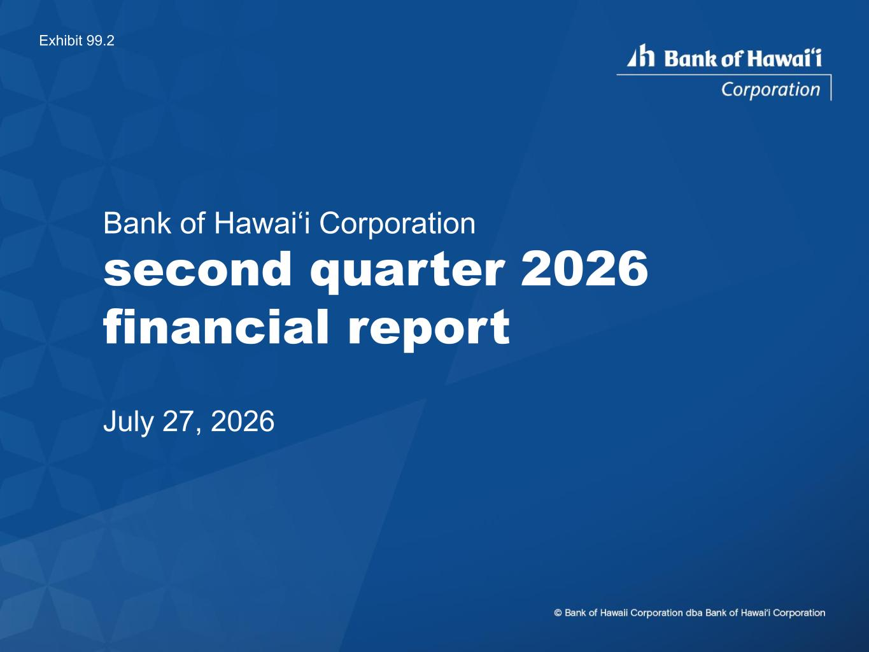

Bank of Hawai‘i Corporation second quarter 2026 financial report July 27, 2026 Exhibit 99.2

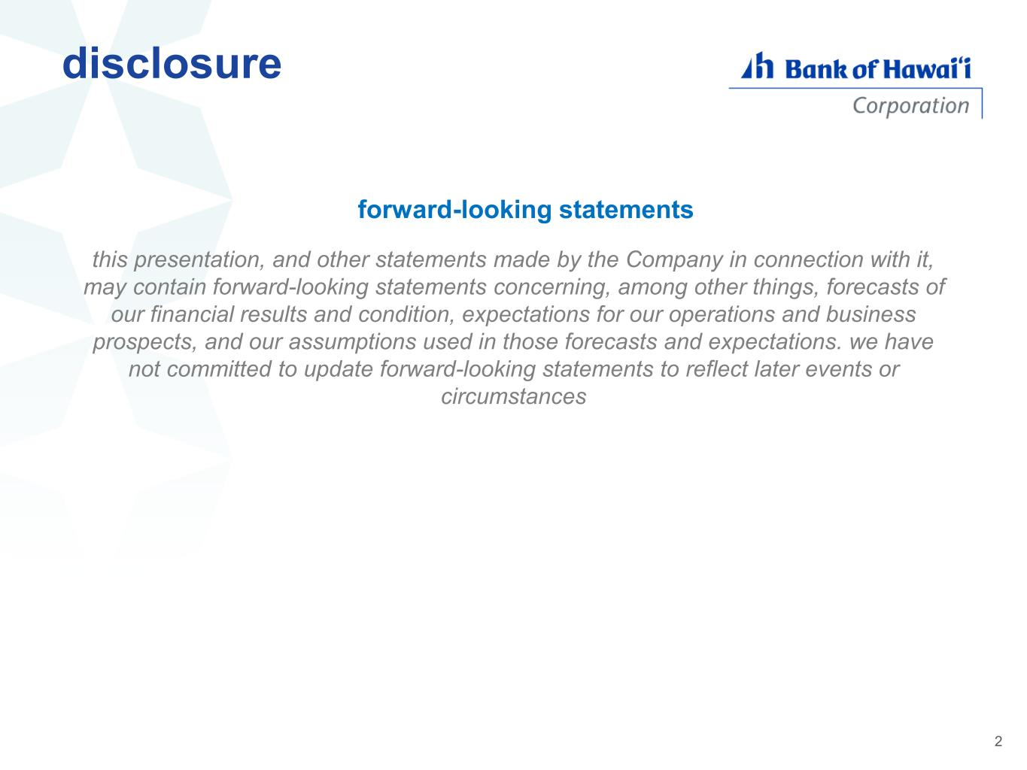
this presentation, and other statements made by the Company in connection with it, may contain forward-looking statements concerning, among other things, forecasts of our financial results and condition, expectations for our operations and business prospects, and our assumptions used in those forecasts and expectations. we have not committed to update forward-looking statements to reflect later events or circumstances disclosure 2 forward-looking statements

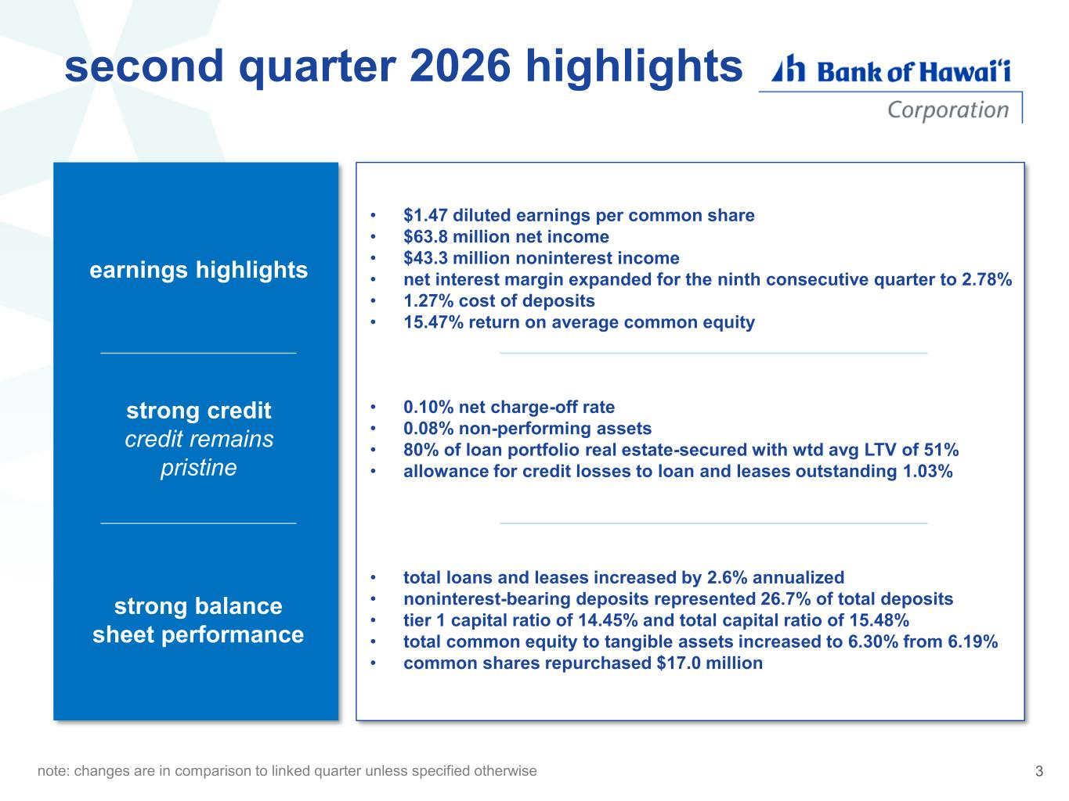
diversified, lower risk loan assets second quarter 2026 highlights broad & deep market penetration strong balance she t performance • total loans and leases increased by 2.6% annualized • noninterest-bearing deposits represented 26.7% of total deposits • tier 1 capital ratio of 14.45% and total capital ratio of 15.48% • total common equity to tangible assets increased to 6.30% from 6.19% • common shares repurchased $17.0 million earnings highlights • $1.47 diluted earnings per common share • $63.8 million net income • $43.3 million noninterest income • net interest margin expanded for the ninth consecutive quarter to 2.78% • 1.27% cost of deposits • 15.47% return on average common equity strong credit credit remains pristine • 0.10% net charge-off rate • 0.08% non-performing assets • 80% of loan portfolio real estate-secured with wtd avg LTV of 51% • allowance for credit losses to loan and leases outstanding 1.03% note: changes are in comparison to linked quarter unless specified otherwise 3

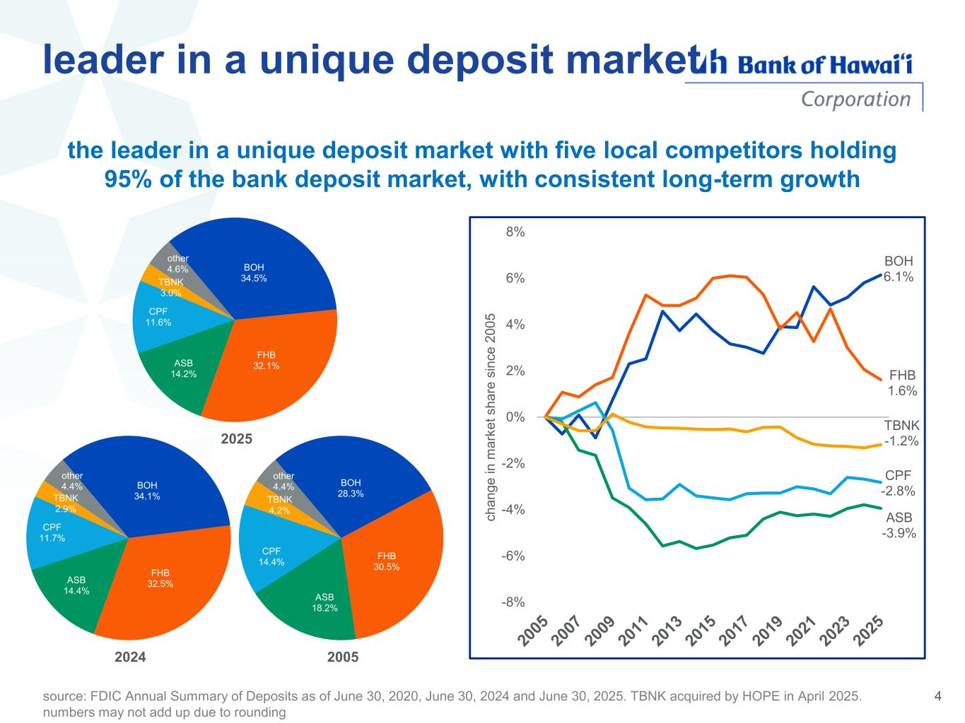
leader in a unique deposit market the leader in a unique deposit market with five local competitors holding 95% of the bank deposit market, with consistent long-term growth BOH 28.3% FHB 30.5% ASB 18.2% CPF 14.4% TBNK 4.2% other 4.4% 2005 BOH 34.1% FHB 32.5%ASB 14.4% CPF 11.7% TBNK 2.9% other 4.4% 2024 BOH 34.5% FHB 32.1%ASB 14.2% CPF 11.6% TBNK 3.0% other 4.6% 2025 BOH 6.1% FHB 1.6% CPF -2.8% ASB -3.9% TBNK -1.2% -8% -6% -4% -2% 0% 2% 4% 6% 8% c h a n g e i n m a rk e t s h a re s in c e 2 0 0 5 4source: FDIC Annual Summary of Deposits as of June 30, 2020, June 30, 2024 and June 30, 2025. TBNK acquired by HOPE in April 2025. numbers may not add up due to rounding

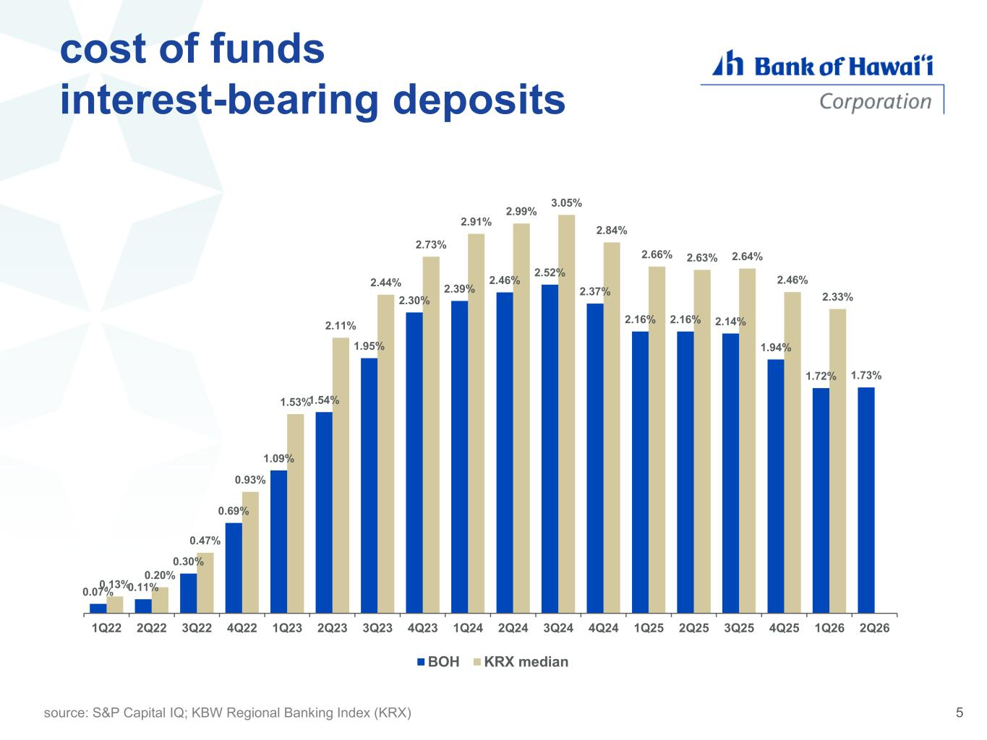
cost of funds interest-bearing deposits 0.07% 0.11% 0.30% 0.69% 1.09% 1.54% 1.95% 2.30% 2.39% 2.46% 2.52% 2.37% 2.16% 2.16% 2.14% 1.94% 1.72% 1.73% 0.13% 0.20% 0.47% 0.93% 1.53% 2.11% 2.44% 2.73% 2.91% 2.99% 3.05% 2.84% 2.66% 2.63% 2.64% 2.46% 2.33% 1Q22 2Q22 3Q22 4Q22 1Q23 2Q23 3Q23 4Q23 1Q24 2Q24 3Q24 4Q24 1Q25 2Q25 3Q25 4Q25 1Q26 2Q26 BOH KRX median source: S&P Capital IQ; KBW Regional Banking Index (KRX) 5

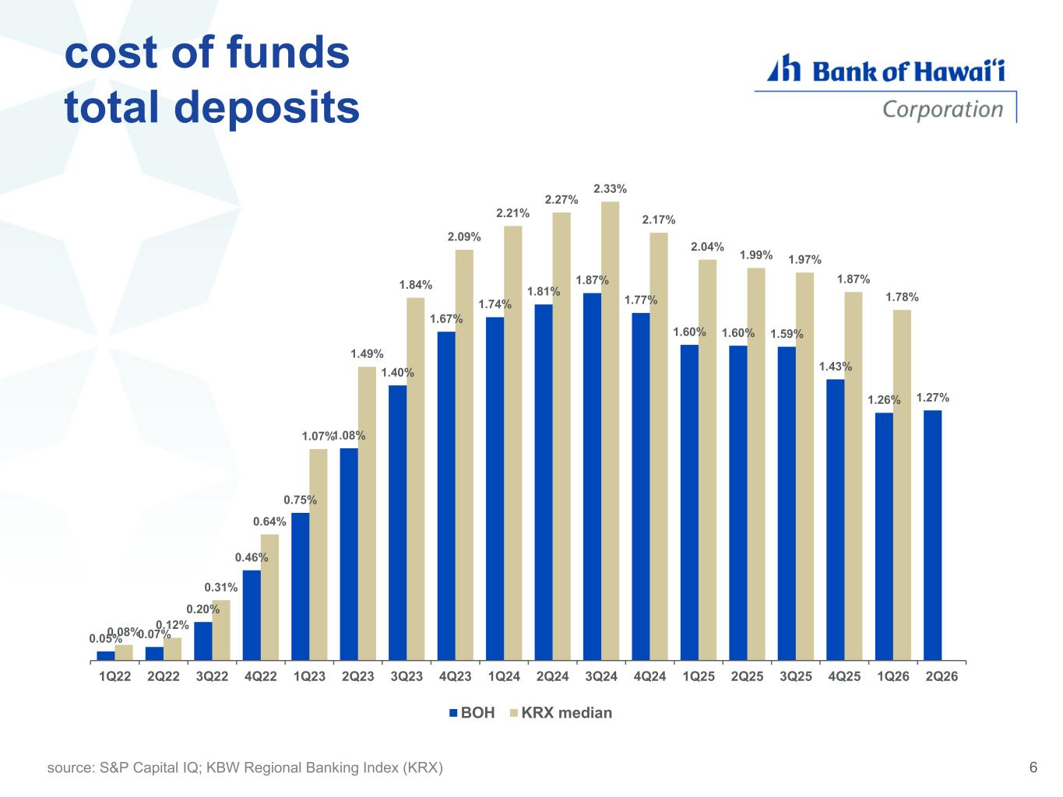
cost of funds total deposits 0.05% 0.07% 0.20% 0.46% 0.75% 1.08% 1.40% 1.67% 1.74% 1.81% 1.87% 1.77% 1.60% 1.60% 1.59% 1.43% 1.26% 1.27% 0.08% 0.12% 0.31% 0.64% 1.07% 1.49% 1.84% 2.09% 2.21% 2.27% 2.33% 2.17% 2.04% 1.99% 1.97% 1.87% 1.78% 1Q22 2Q22 3Q22 4Q22 1Q23 2Q23 3Q23 4Q23 1Q24 2Q24 3Q24 4Q24 1Q25 2Q25 3Q25 4Q25 1Q26 2Q26 BOH KRX median source: S&P Capital IQ; KBW Regional Banking Index (KRX) 6

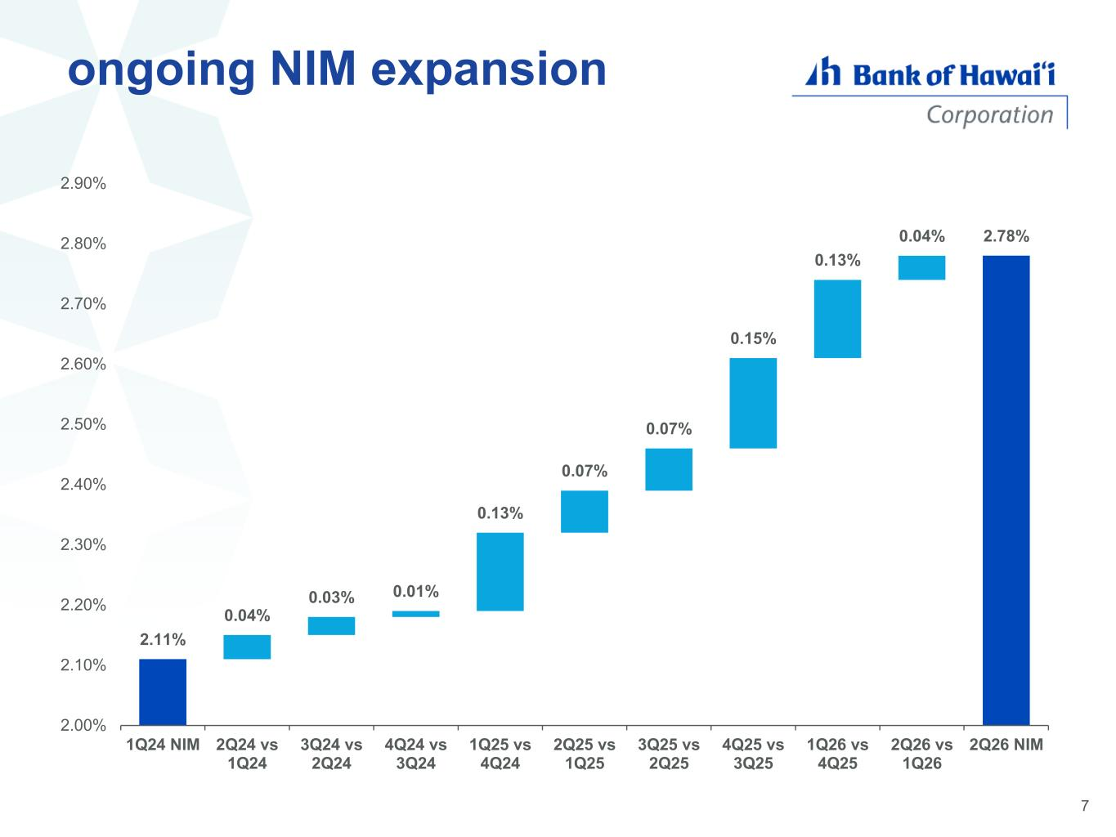
ongoing NIM expansion 2.11% 0.04% 0.03% 0.01% 0.13% 0.07% 0.07% 0.15% 0.13% 0.04% 2.78% 2.00% 2.10% 2.20% 2.30% 2.40% 2.50% 2.60% 2.70% 2.80% 2.90% 1Q24 NIM 2Q24 vs 1Q24 3Q24 vs 2Q24 4Q24 vs 3Q24 1Q25 vs 4Q24 2Q25 vs 1Q25 3Q25 vs 2Q25 4Q25 vs 3Q25 1Q26 vs 4Q25 2Q26 vs 1Q26 2Q26 NIM 7

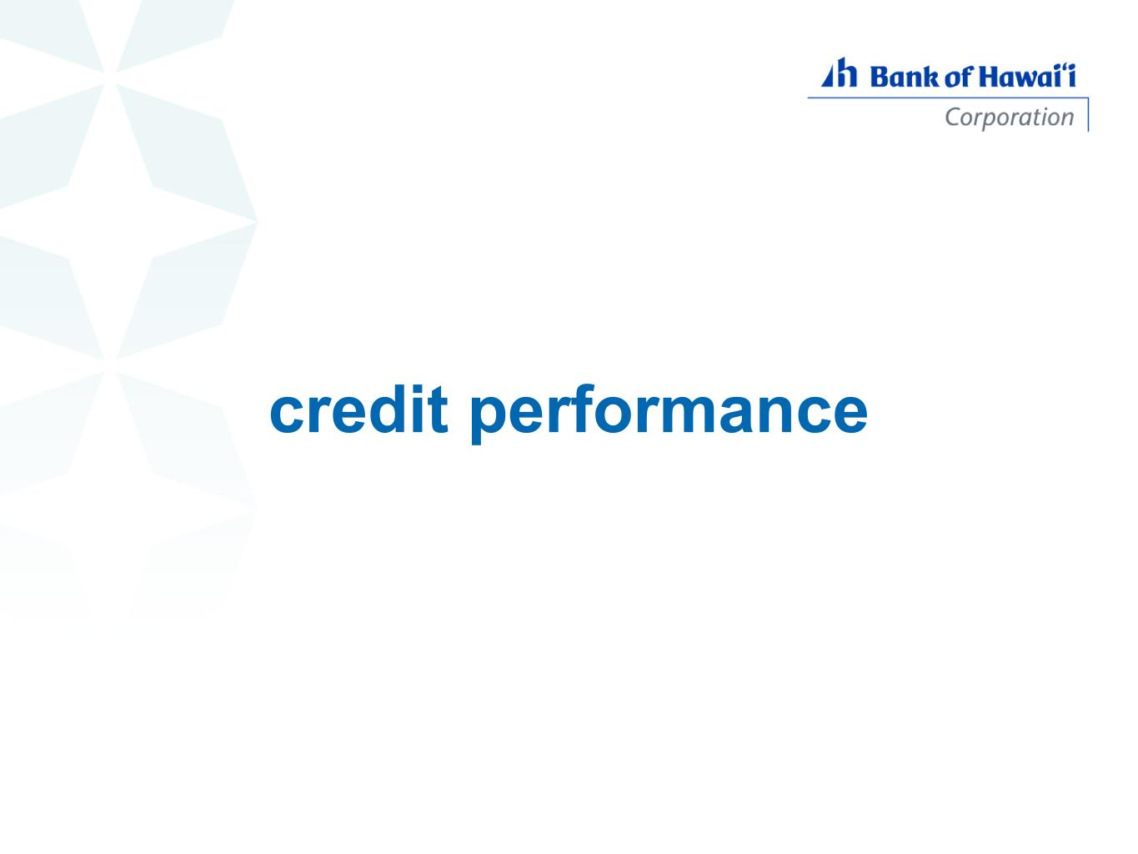
credit performance

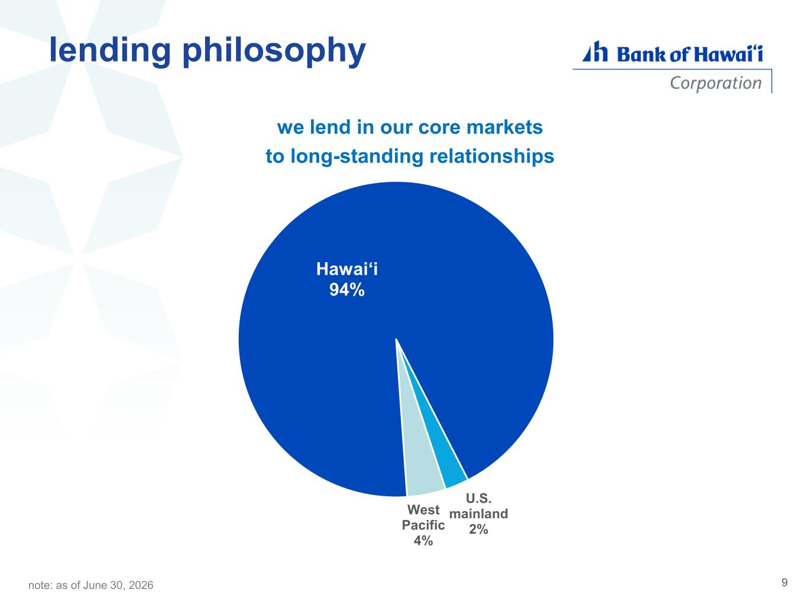
lending philosophy Hawaiʻi 94% U.S. mainland 2% West Pacific 4% we lend in our core markets to long-standing relationships note: as of June 30, 2026 9

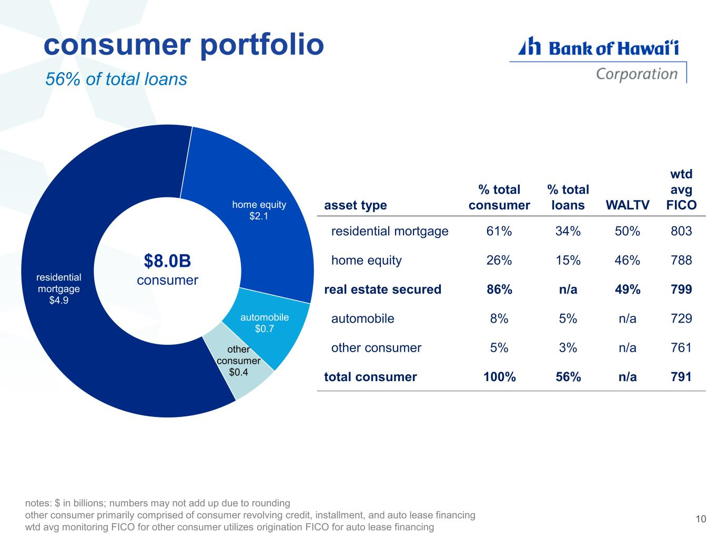
consumer portfolio asset type % total consumer % total loans WALTV wtd avg FICO residential mortgage 61% 34% 50% 803 home equity 26% 15% 46% 788 real estate secured 86% n/a 49% 799 automobile 8% 5% n/a 729 other consumer 5% 3% n/a 761 total consumer 100% 56% n/a 791 $8.0B consumer notes: $ in billions; numbers may not add up due to rounding other consumer primarily comprised of consumer revolving credit, installment, and auto lease financing wtd avg monitoring FICO for other consumer utilizes origination FICO for auto lease financing 56% of total loans 10 residential mortgage $4.9 home equity $2.1 automobile $0.7 other consumer $0.4

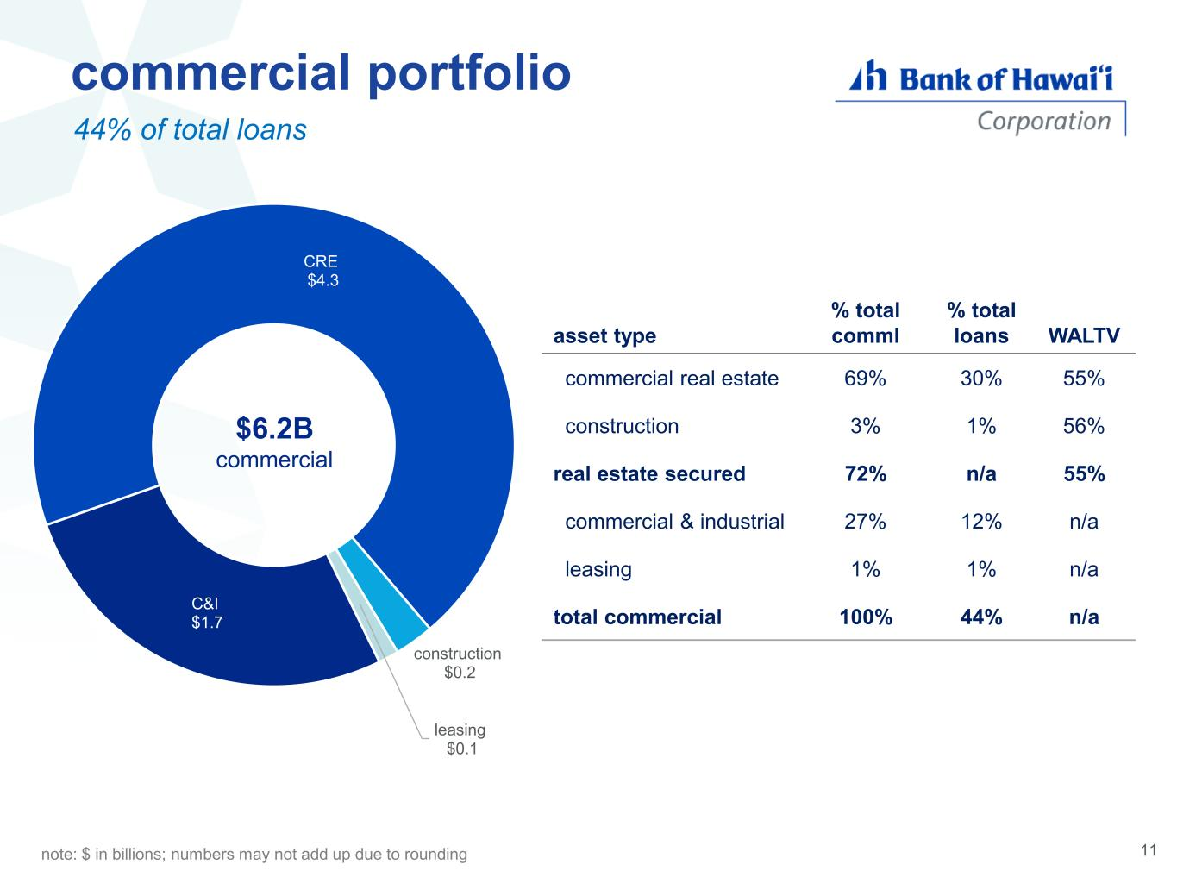
C&I $1.7 CRE $4.3 construction $0.2 leasing $0.1 commercial portfolio residential mortgage home equity $6.2B commercial asset type % total comml % total loans WALTV commercial real estate 69% 30% 55% construction 3% 1% 56% real estate secured 72% n/a 55% commercial & industrial 27% 12% n/a leasing 1% 1% n/a total commercial 100% 44% n/a note: $ in billions; numbers may not add up due to rounding 44% of total loans 11

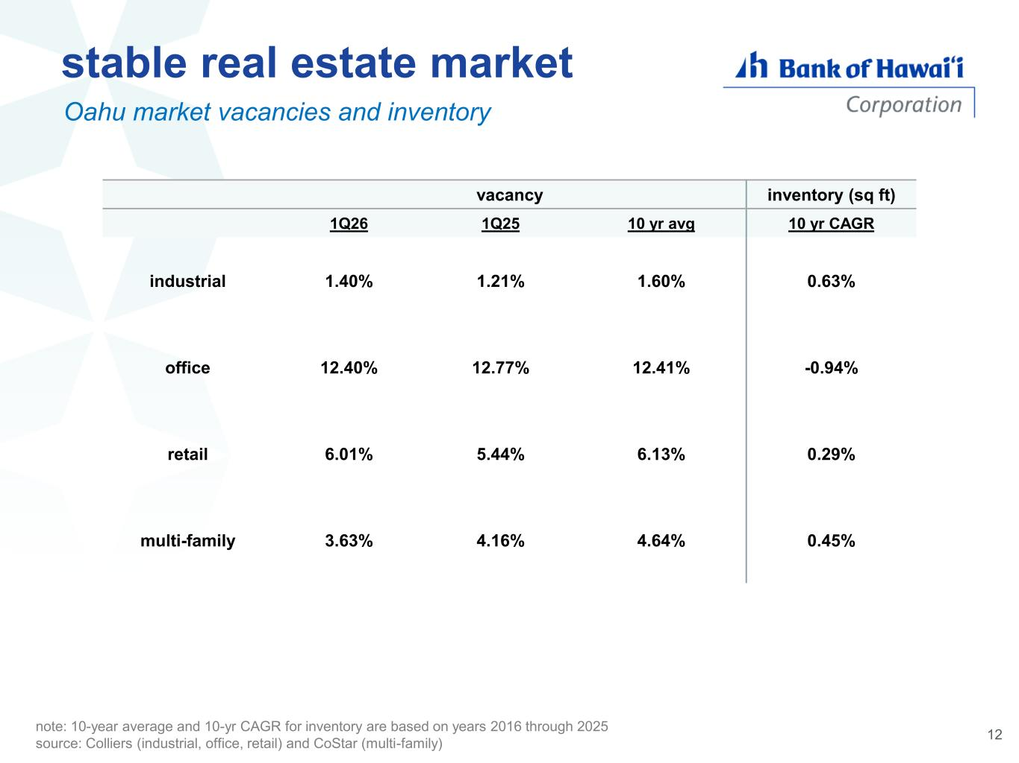
vacancy inventory (sq ft) 1Q26 1Q25 10 yr avg 10 yr CAGR industrial 1.40% 1.21% 1.60% 0.63% office 12.40% 12.77% 12.41% -0.94% retail 6.01% 5.44% 6.13% 0.29% multi-family 3.63% 4.16% 4.64% 0.45% Oahu market vacancies and inventory stable real estate market note: 10-year average and 10-yr CAGR for inventory are based on years 2016 through 2025 source: Colliers (industrial, office, retail) and CoStar (multi-family) 12

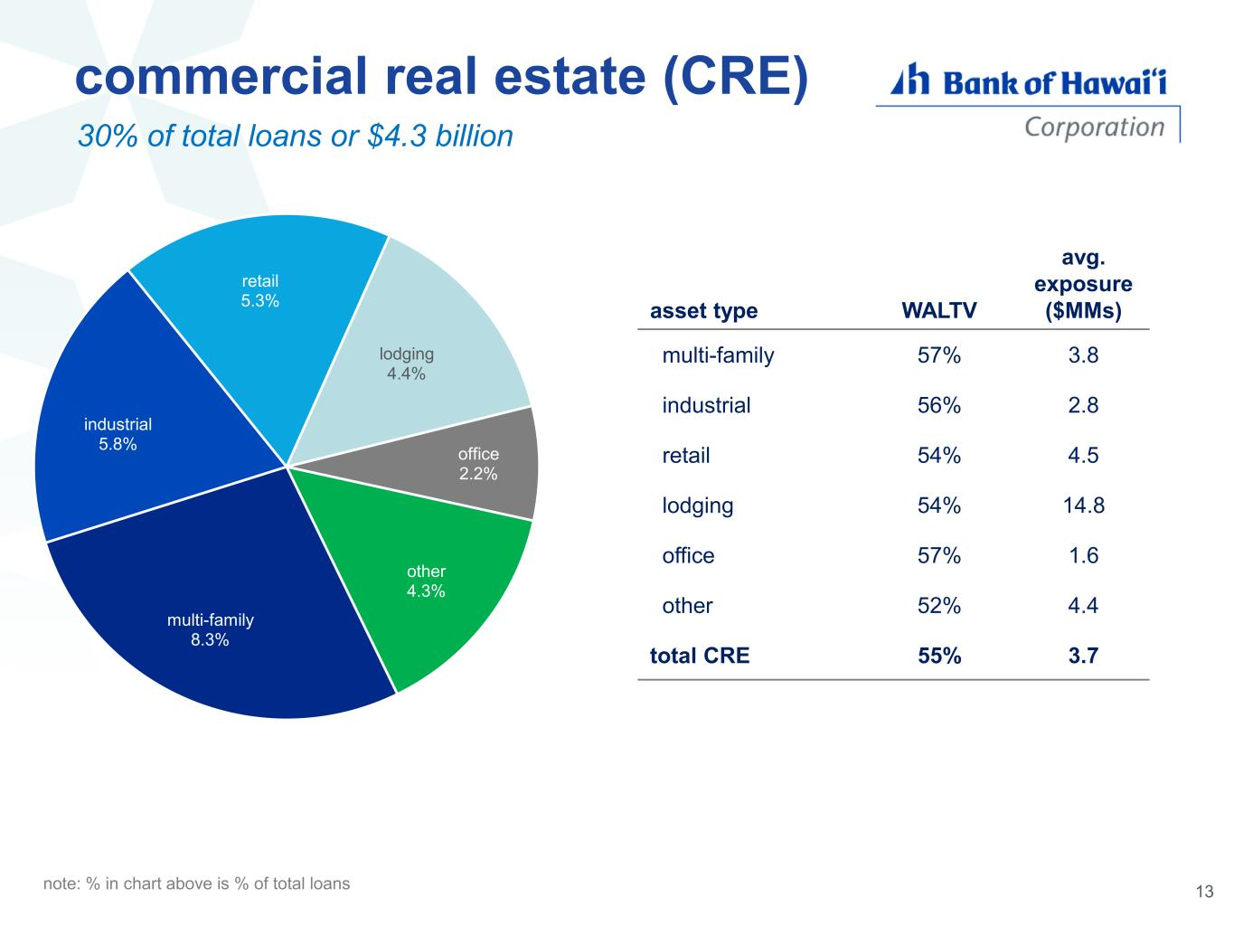
multi-family 8.3% industrial 5.8% retail 5.3% lodging 4.4% office 2.2% other 4.3% commercial real estate (CRE) residential mortgage home equity 30% of total loans or $4.3 billion asset type WALTV avg. exposure ($MMs) multi-family 57% 3.8 industrial 56% 2.8 retail 54% 4.5 lodging 54% 14.8 office 57% 1.6 other 52% 4.4 total CRE 55% 3.7 note: % in chart above is % of total loans 13

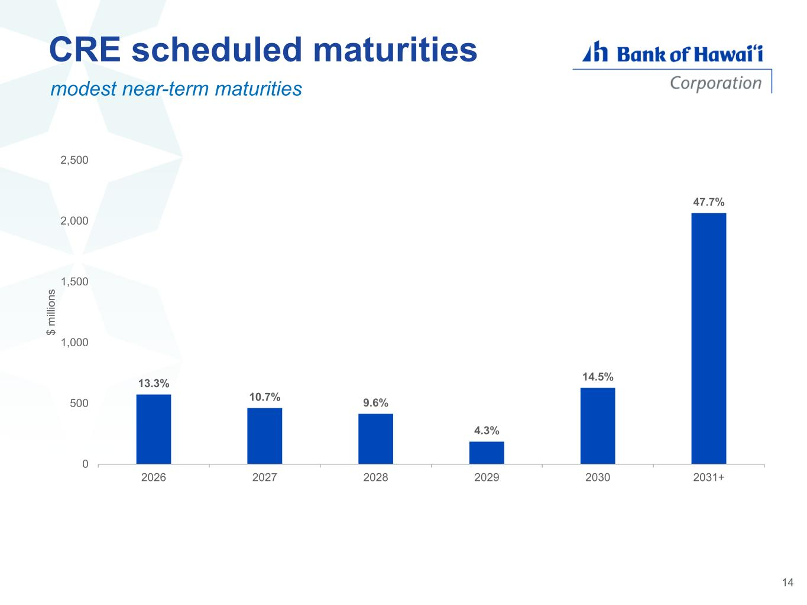
CRE scheduled maturities 13.3% 10.7% 9.6% 4.3% 14.5% 47.7% 0 500 1,000 1,500 2,000 2,500 2026 2027 2028 2029 2030 2031+ $ m ill io n s modest near-term maturities 14

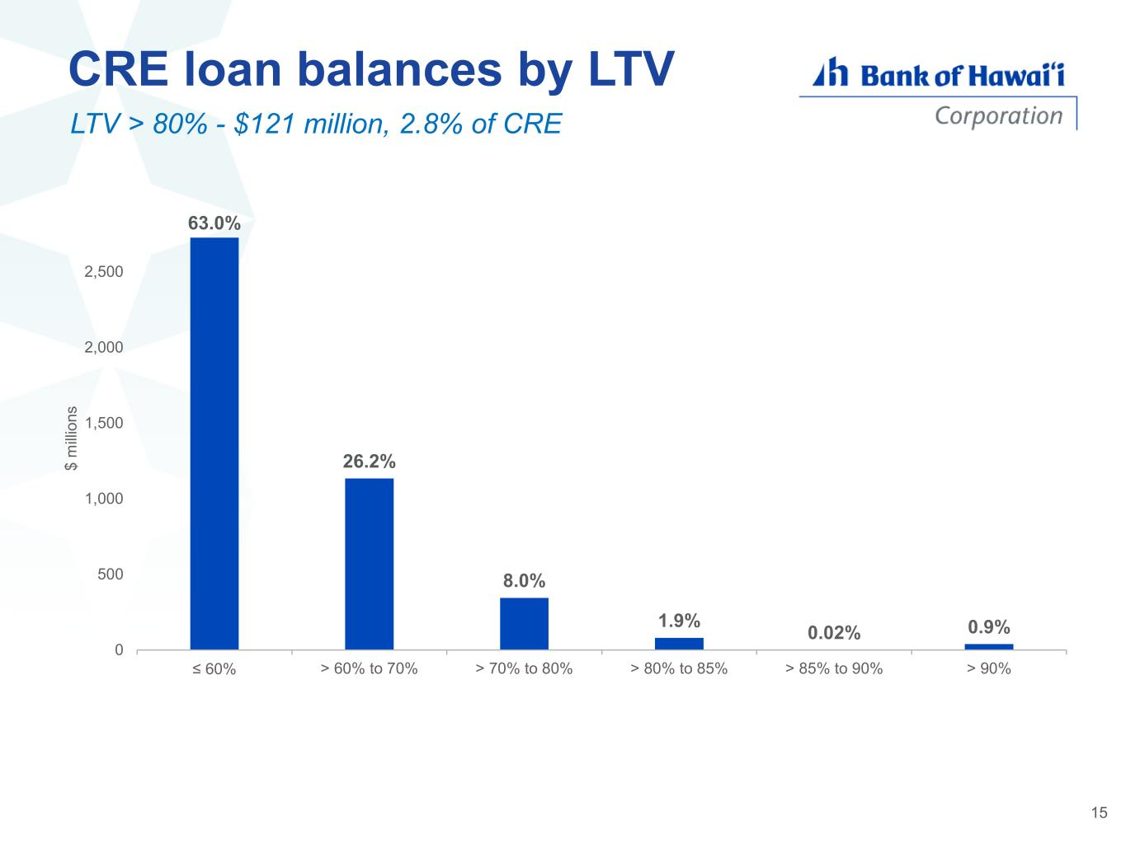
63.0% 26.2% 8.0% 1.9% 0.02% 0.9% 0 500 1,000 1,500 2,000 2,500 ≤ 60% > 60% to 70% > 70% to 80% > 80% to 85% > 85% to 90% > 90% $ m ill io n s CRE loan balances by LTV LTV > 80% - $121 million, 2.8% of CRE 15

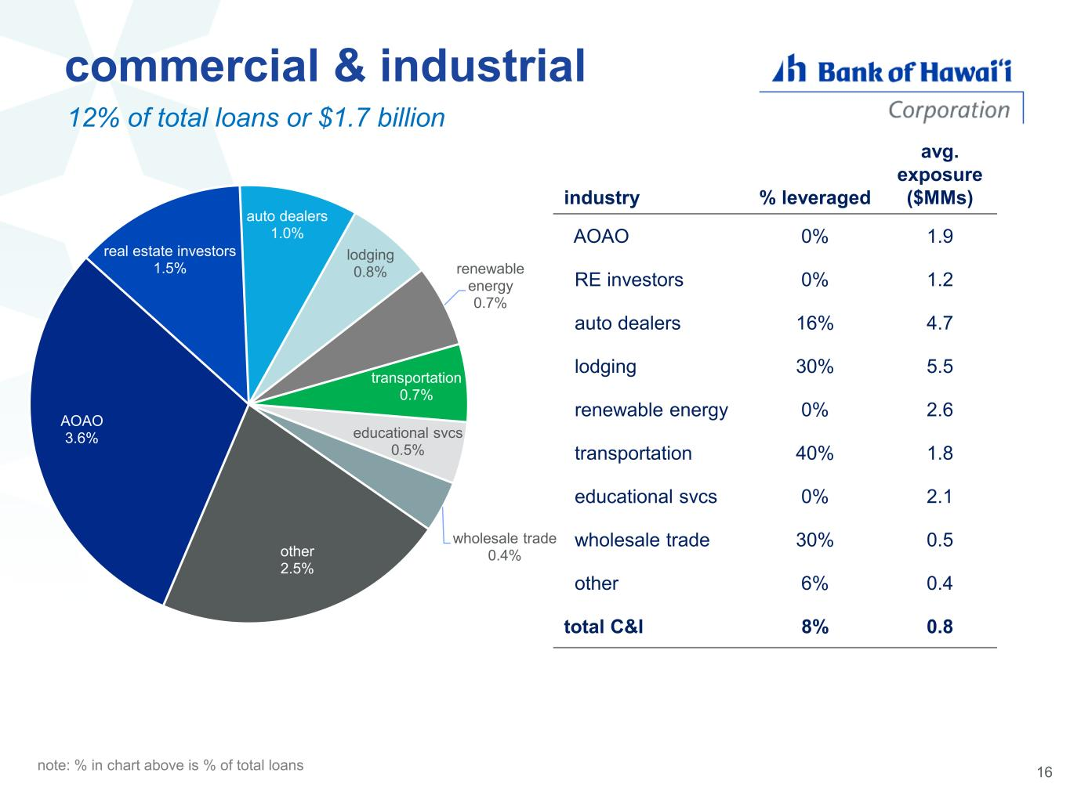
AOAO 3.6% real estate investors 1.5% auto dealers 1.0% lodging 0.8% renewable energy 0.7% transportation 0.7% educational svcs 0.5% wholesale trade 0.4%other 2.5% commercial & industrial residential mortgage home equity 12% of total loans or $1.7 billion industry % leveraged avg. exposure ($MMs) AOAO 0% 1.9 RE investors 0% 1.2 auto dealers 16% 4.7 lodging 30% 5.5 renewable energy 0% 2.6 transportation 40% 1.8 educational svcs 0% 2.1 wholesale trade 30% 0.5 other 6% 0.4 total C&I 8% 0.8 16 note: % in chart above is % of total loans

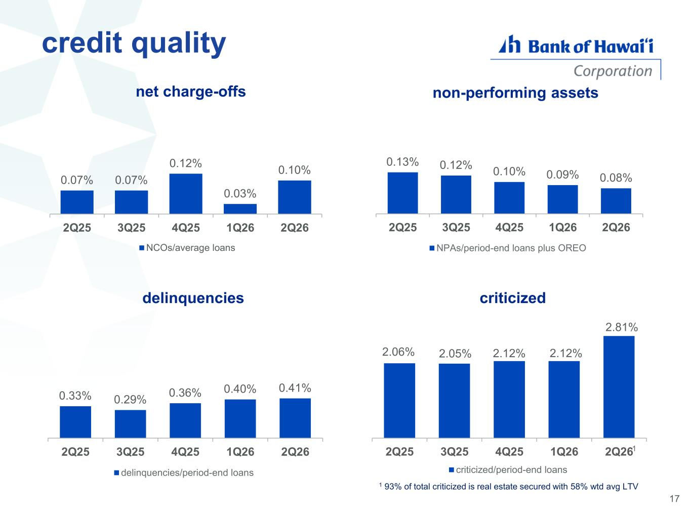
credit quality 0.07% 0.07% 0.12% 0.03% 0.10% $0 $0 $0 $0 $0 $0 $0 $0 $0 2Q25 3Q25 4Q25 1Q26 2Q26 net charge-offs NCOs/average loans 1 93% of total criticized is real estate secured with 58% wtd avg LTV 0.33% 0.29% 0.36% 0.40% 0.41% 0.00% 0.20% 0.40% 0.60% 0.80% 1.00% 1.20% 1.40% 2Q25 3Q25 4Q25 1Q26 2Q26 delinquencies delinquencies/period-end loans 2.06% 2.05% 2.12% 2.12% 2.81% 2Q25 3Q25 4Q25 1Q26 2Q26 criticized criticized/period-end loans 1 17 0.13% 0.12% 0.10% 0.09% 0.08% 0.00% 0.05% 0.10% 0.15% 0.20% 0.25% 0.30% 0.35% 0.40% 2Q25 3Q25 4Q25 1Q26 2Q26 non-performing assets NPAs/period-end loans plus OREO

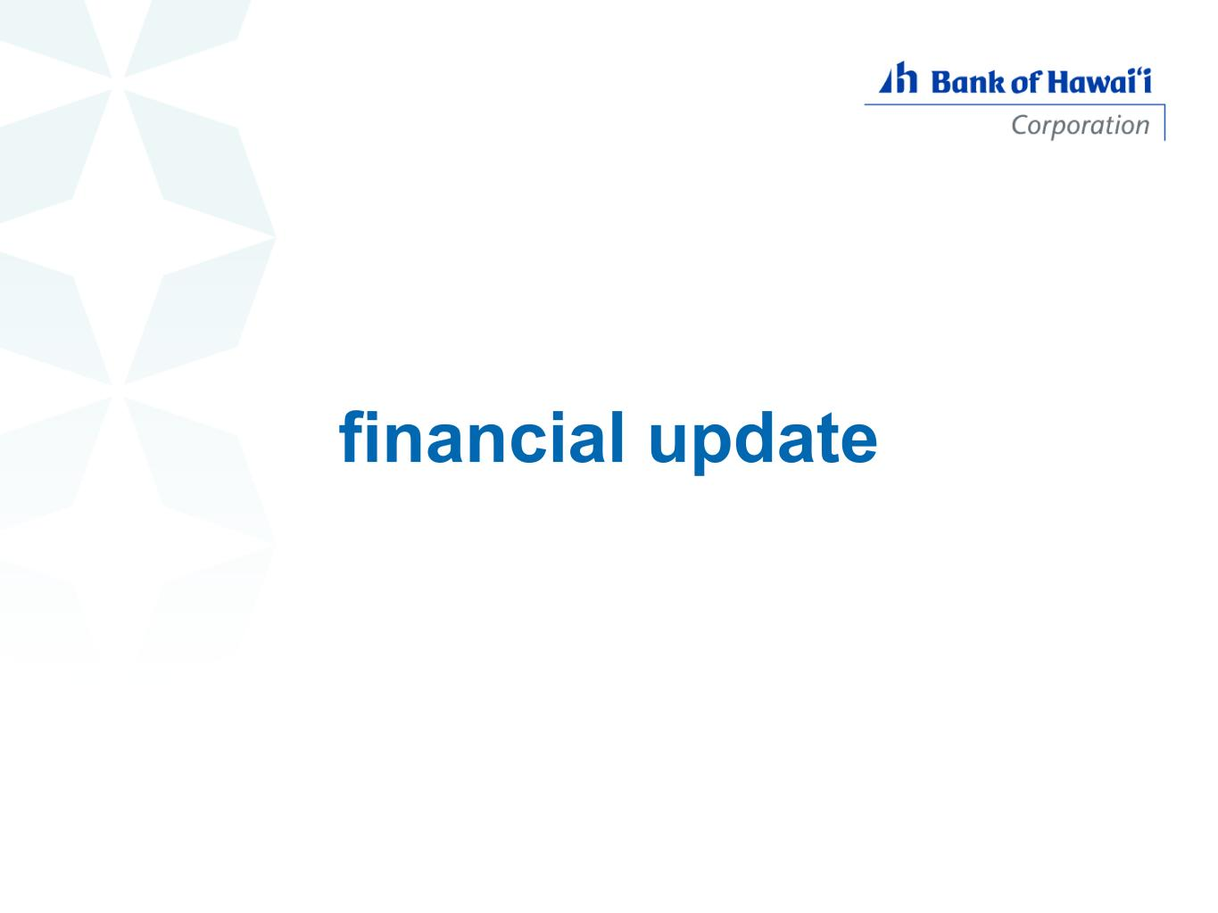
financial update

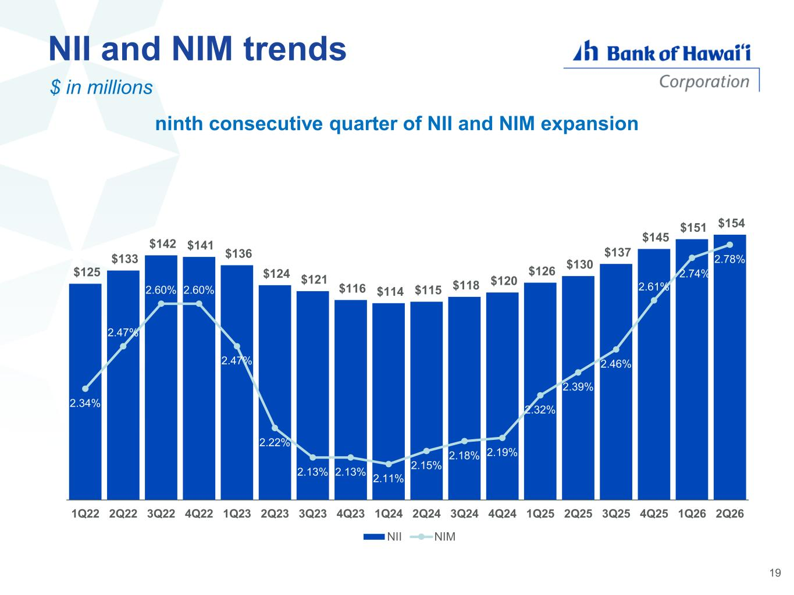
NII and NIM trends ninth consecutive quarter of NII and NIM expansion $ in millions $125 $133 $142 $141 $136 $124 $121 $116 $114 $115 $118 $120 $126 $130 $137 $145 $151 $154 2.34% 2.47% 2.60% 2.60% 2.47% 2.22% 2.13% 2.13% 2.11% 2.15% 2.18% 2.19% 2.32% 2.39% 2.46% 2.61% 2.74% 2.78% 1Q22 2Q22 3Q22 4Q22 1Q23 2Q23 3Q23 4Q23 1Q24 2Q24 3Q24 4Q24 1Q25 2Q25 3Q25 4Q25 1Q26 2Q26 NII NIM 19

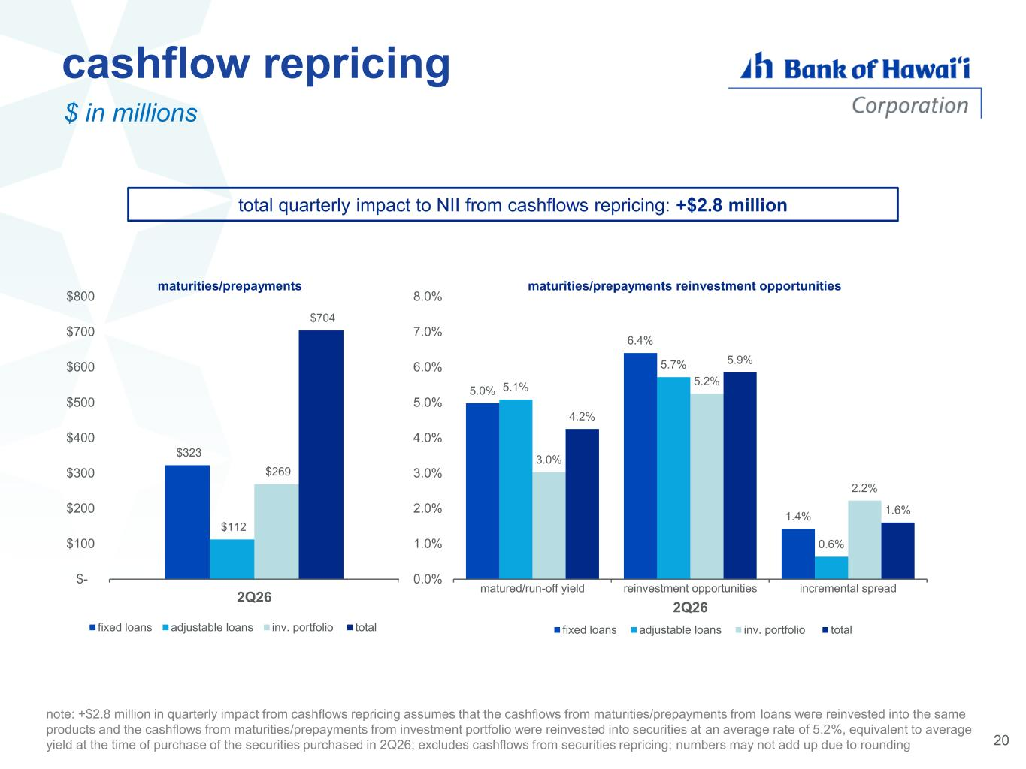
cashflow repricing total quarterly impact to NII from cashflows repricing: +$2.8 million note: +$2.8 million in quarterly impact from cashflows repricing assumes that the cashflows from maturities/prepayments from loans were reinvested into the same products and the cashflows from maturities/prepayments from investment portfolio were reinvested into securities at an average rate of 5.2%, equivalent to average yield at the time of purchase of the securities purchased in 2Q26; excludes cashflows from securities repricing; numbers may not add up due to rounding 5.0% 6.4% 1.4% 5.1% 5.7% 0.6% 3.0% 5.2% 2.2% 4.2% 5.9% 1.6% 0.0% 1.0% 2.0% 3.0% 4.0% 5.0% 6.0% 7.0% 8.0% matured/run-off yield reinvestment opportunities incremental spread 2Q26 maturities/prepayments reinvestment opportunities fixed loans adjustable loans inv. portfolio total $323 $112 $269 $704 $- $100 $200 $300 $400 $500 $600 $700 $800 2Q26 maturities/prepayments fixed loans adjustable loans inv. portfolio total 20 $ in millions

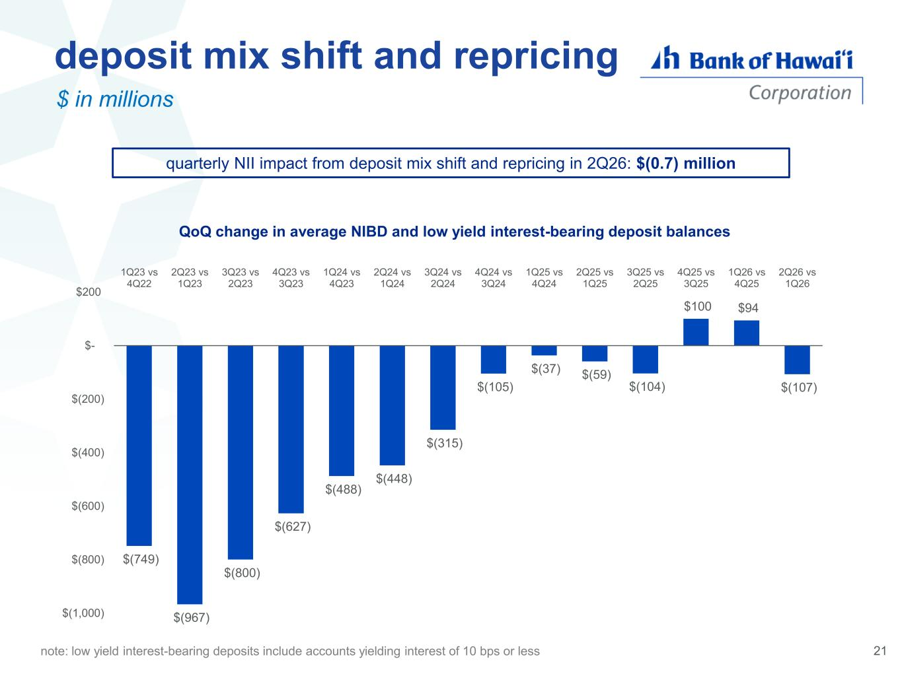
deposit mix shift and repricing quarterly NII impact from deposit mix shift and repricing in 2Q26: $(0.7) million $(749) $(967) $(800) $(627) $(488) $(448) $(315) $(105) $(37) $(59) $(104) $100 $94 $(107) $(1,000) $(800) $(600) $(400) $(200) $- $200 1Q23 vs 4Q22 2Q23 vs 1Q23 3Q23 vs 2Q23 4Q23 vs 3Q23 1Q24 vs 4Q23 2Q24 vs 1Q24 3Q24 vs 2Q24 4Q24 vs 3Q24 1Q25 vs 4Q24 2Q25 vs 1Q25 3Q25 vs 2Q25 4Q25 vs 3Q25 1Q26 vs 4Q25 2Q26 vs 1Q26 QoQ change in average NIBD and low yield interest-bearing deposit balances note: low yield interest-bearing deposits include accounts yielding interest of 10 bps or less 21 $ in millions

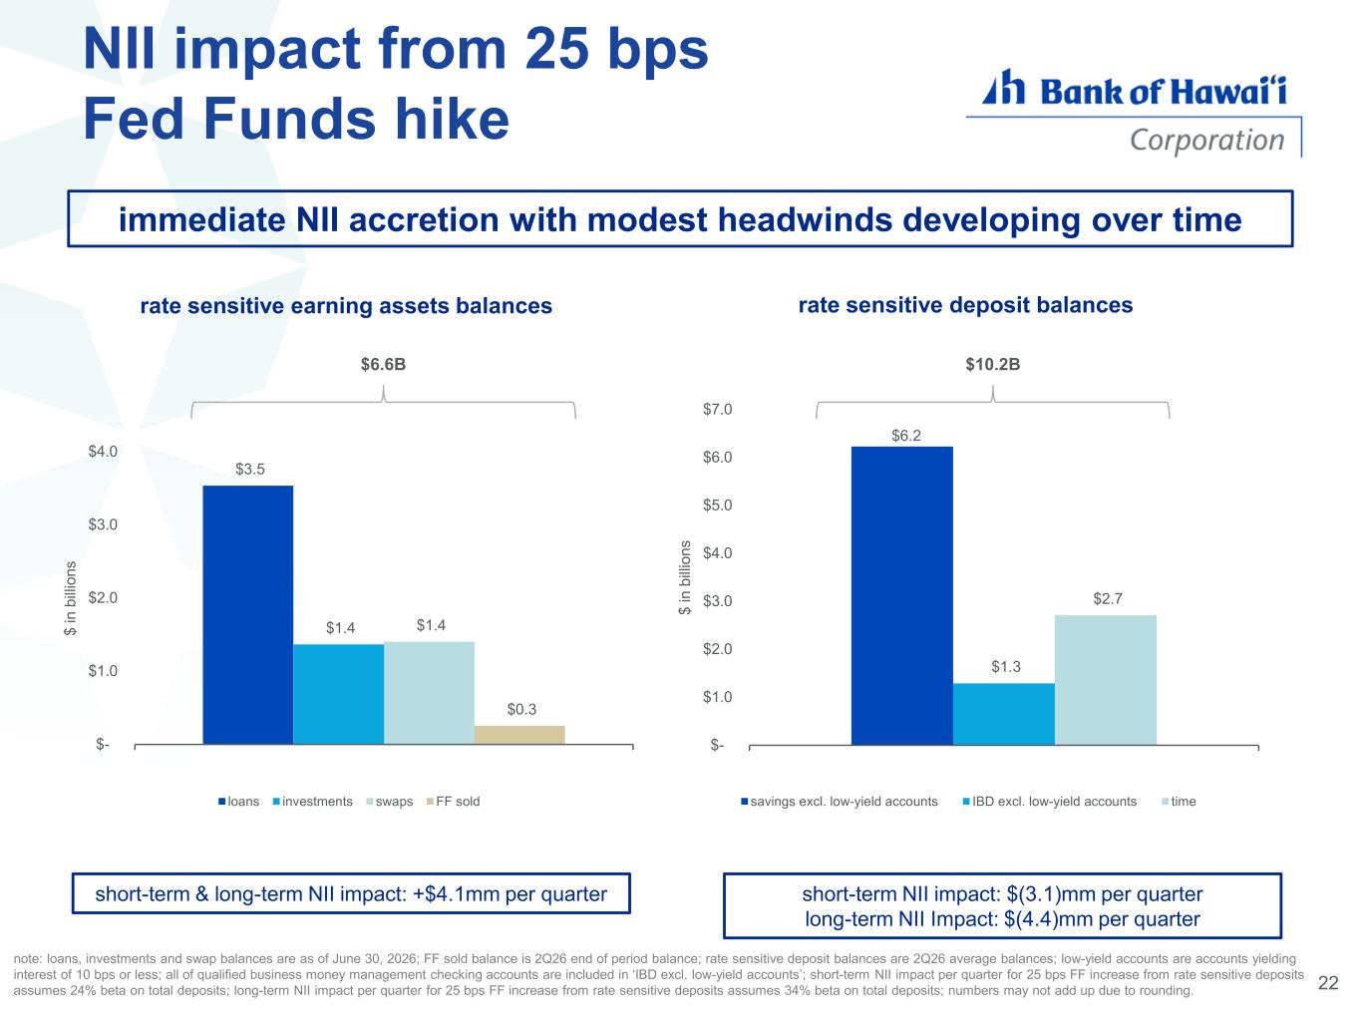
22 NII impact from 25 bps Fed Funds hike rate sensitive earning assets balances rate sensitive deposit balances $3.5 $1.4 $1.4 $0.3 $- $1.0 $2.0 $3.0 $4.0 $ i n b ill io n s loans investments swaps FF sold $6.6B short-term & long-term NII impact: +$4.1mm per quarter short-term NII impact: $(3.1)mm per quarter long-term NII Impact: $(4.4)mm per quarter note: loans, investments and swap balances are as of June 30, 2026; FF sold balance is 2Q26 end of period balance; rate sensitive deposit balances are 2Q26 average balances; low-yield accounts are accounts yielding interest of 10 bps or less; all of qualified business money management checking accounts are included in ‘IBD excl. low-yield accounts’; short-term NII impact per quarter for 25 bps FF increase from rate sensitive deposits assumes 24% beta on total deposits; long-term NII impact per quarter for 25 bps FF increase from rate sensitive deposits assumes 34% beta on total deposits; numbers may not add up due to rounding. immediate NII accretion with modest headwinds developing over time $6.2 $1.3 $2.7 $- $1.0 $2.0 $3.0 $4.0 $5.0 $6.0 $7.0 $ i n b ill io n s savings excl. low-yield accounts IBD excl. low-yield accounts time $10.2B

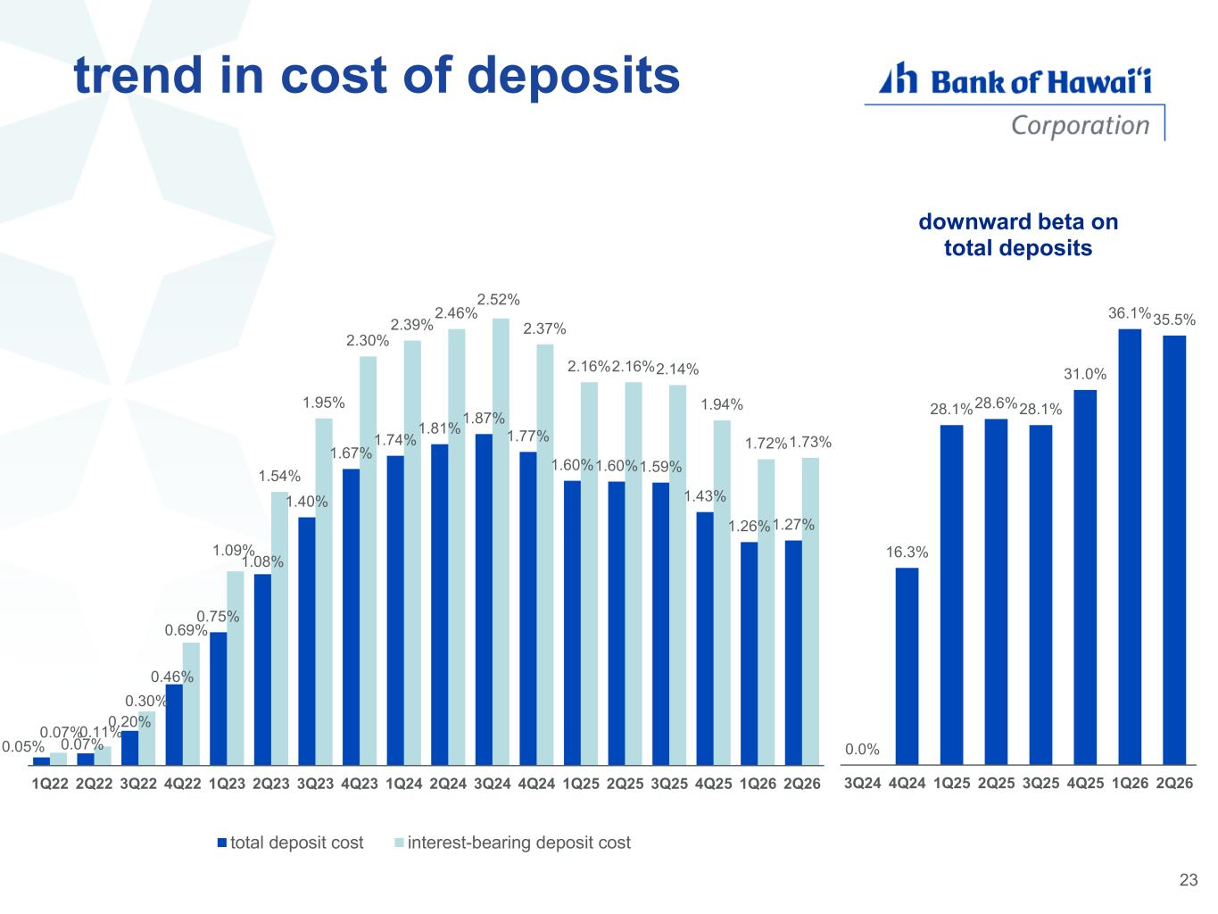
trend in cost of deposits 23 0.0% 16.3% 28.1%28.6%28.1% 31.0% 36.1%35.5% 3Q24 4Q24 1Q25 2Q25 3Q25 4Q25 1Q26 2Q26 downward beta on total deposits 0.05% 0.07% 0.20% 0.46% 0.75% 1.08% 1.40% 1.67% 1.74% 1.81% 1.87% 1.77% 1.60%1.60%1.59% 1.43% 1.26%1.27% 0.07%0.11% 0.30% 0.69% 1.09% 1.54% 1.95% 2.30% 2.39% 2.46% 2.52% 2.37% 2.16%2.16%2.14% 1.94% 1.72%1.73% 1Q22 2Q22 3Q22 4Q22 1Q23 2Q23 3Q23 4Q23 1Q24 2Q24 3Q24 4Q24 1Q25 2Q25 3Q25 4Q25 1Q26 2Q26 total deposit cost interest-bearing deposit cost

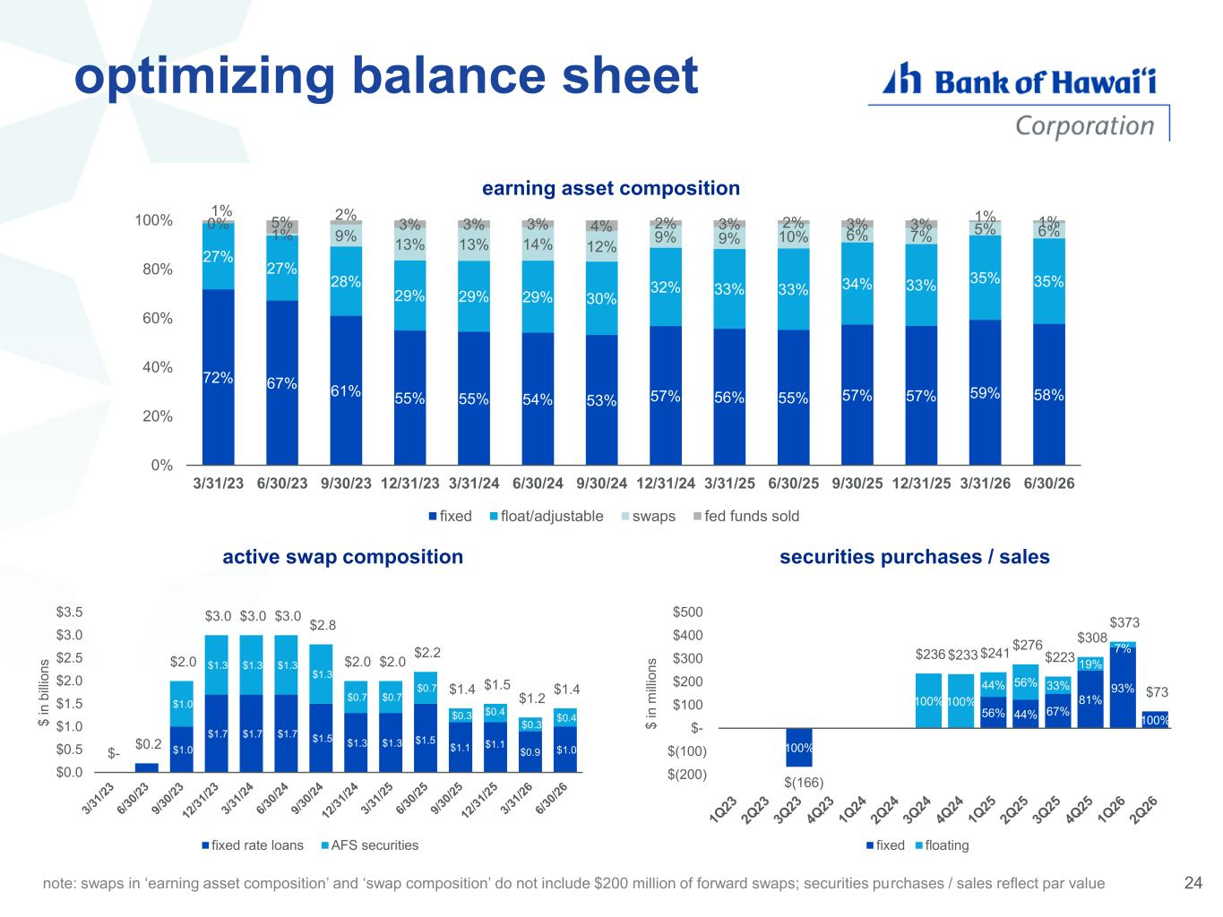
24 optimizing balance sheet $1.0 $1.7 $1.7 $1.7 $1.5 $1.3 $1.3 $1.5 $1.1 $1.1 $0.9 $1.0 $1.0 $1.3 $1.3 $1.3 $1.3 $0.7 $0.7 $0.7 $0.3 $0.4 $0.3 $0.4 $- $0.2 $2.0 $3.0 $3.0 $3.0 $2.8 $2.0 $2.0 $2.2 $1.4 $1.5 $1.2 $1.4 $0.0 $0.5 $1.0 $1.5 $2.0 $2.5 $3.0 $3.5 $ i n b ill io n s active swap composition fixed rate loans AFS securities 72% 67% 61% 55% 55% 54% 53% 57% 56% 55% 57% 57% 59% 58% 27% 27% 28% 29% 29% 29% 30% 32% 33% 33% 34% 33% 35% 35% 0% 1% 9% 13% 13% 14% 12% 9% 9% 10% 6% 7% 5% 6% 1% 5% 2% 3% 3% 3% 4% 2% 3% 2% 3% 3% 1% 1% 0% 20% 40% 60% 80% 100% 3/31/23 6/30/23 9/30/23 12/31/23 3/31/24 6/30/24 9/30/24 12/31/24 3/31/25 6/30/25 9/30/25 12/31/25 3/31/26 6/30/26 earning asset composition fixed float/adjustable swaps fed funds sold 100% 56% 44% 67% 81% 93% 100% 100% 100% 44% 56% 33% 19% 7% $(166) $236 $233 $241 $276 $223 $308 $373 $73 $(200) $(100) $- $100 $200 $300 $400 $500 $ i n m ill io n s securities purchases / sales fixed floating note: swaps in ‘earning asset composition’ and ‘swap composition’ do not include $200 million of forward swaps; securities purchases / sales reflect par value

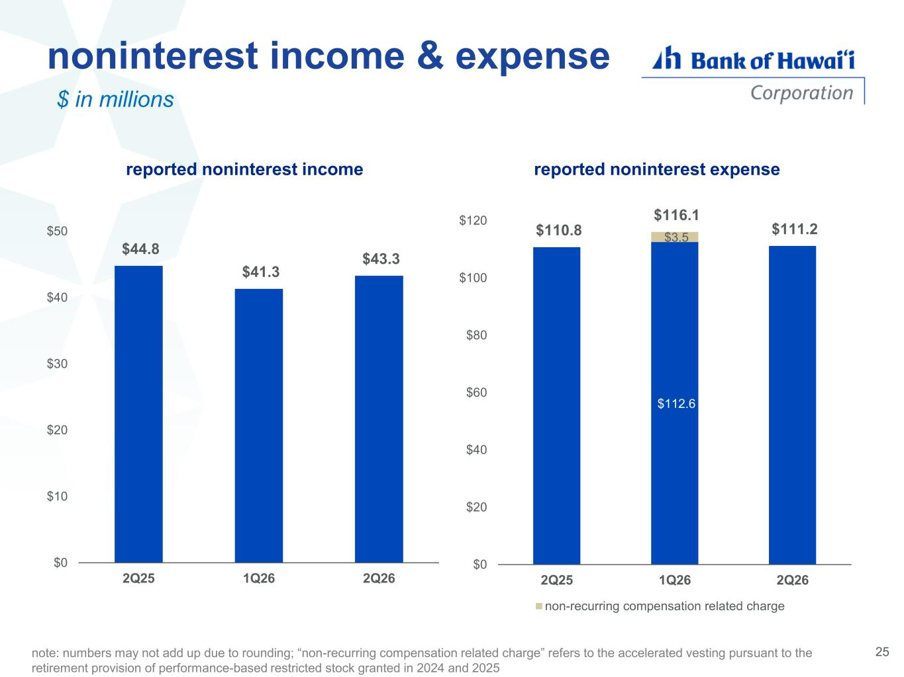
noninterest income & expense $ in millions 25note: numbers may not add up due to rounding; “non-recurring compensation related charge” refers to the accelerated vesting pursuant to the retirement provision of performance-based restricted stock granted in 2024 and 2025 $44.8 $41.3 $43.3 $0 $10 $20 $30 $40 $50 2Q25 1Q26 2Q26 $112.6 $3.5 $110.8 $116.1 $111.2 $0 $20 $40 $60 $80 $100 $120 2Q25 1Q26 2Q26 non-recurring compensation related charge reported noninterest income reported noninterest expense

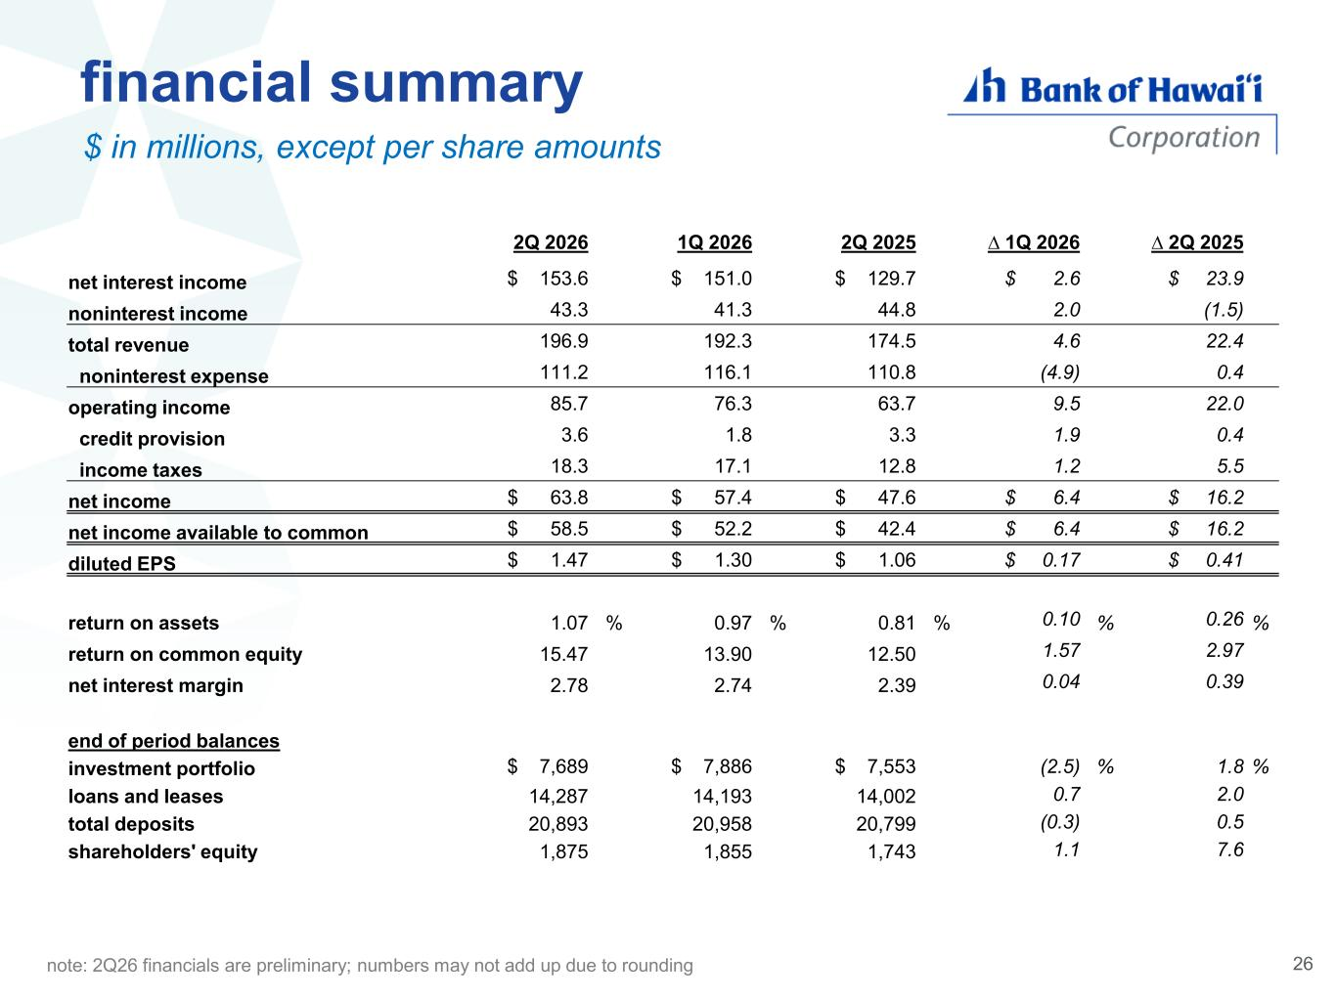
financial summary $ in millions, except per share amounts 2Q 2026 1Q 2026 2Q 2025 ∆ 1Q 2026 ∆ 2Q 2025 net interest income $ 153.6 $ 151.0 $ 129.7 $ 2.6 $ 23.9 noninterest income 43.3 41.3 44.8 2.0 (1.5) total revenue 196.9 192.3 174.5 4.6 22.4 noninterest expense 111.2 116.1 110.8 (4.9) 0.4 operating income 85.7 76.3 63.7 9.5 22.0 credit provision 3.6 1.8 3.3 1.9 0.4 income taxes 18.3 17.1 12.8 1.2 5.5 net income $ 63.8 $ 57.4 $ 47.6 $ 6.4 $ 16.2 net income available to common $ 58.5 $ 52.2 $ 42.4 $ 6.4 $ 16.2 diluted EPS $ 1.47 $ 1.30 $ 1.06 $ 0.17 $ 0.41 return on assets 1.07 % 0.97 % 0.81 % 0.10 % 0.26 % return on common equity 15.47 13.90 12.50 1.57 2.97 net interest margin 2.78 2.74 2.39 0.04 0.39 end of period balances investment portfolio $ 7,689 $ 7,886 $ 7,553 (2.5) % 1.8 % loans and leases 14,287 14,193 14,002 0.7 2.0 total deposits 20,893 20,958 20,799 (0.3) 0.5 shareholders' equity 1,875 1,855 1,743 1.1 7.6 note: 2Q26 financials are preliminary; numbers may not add up due to rounding 26

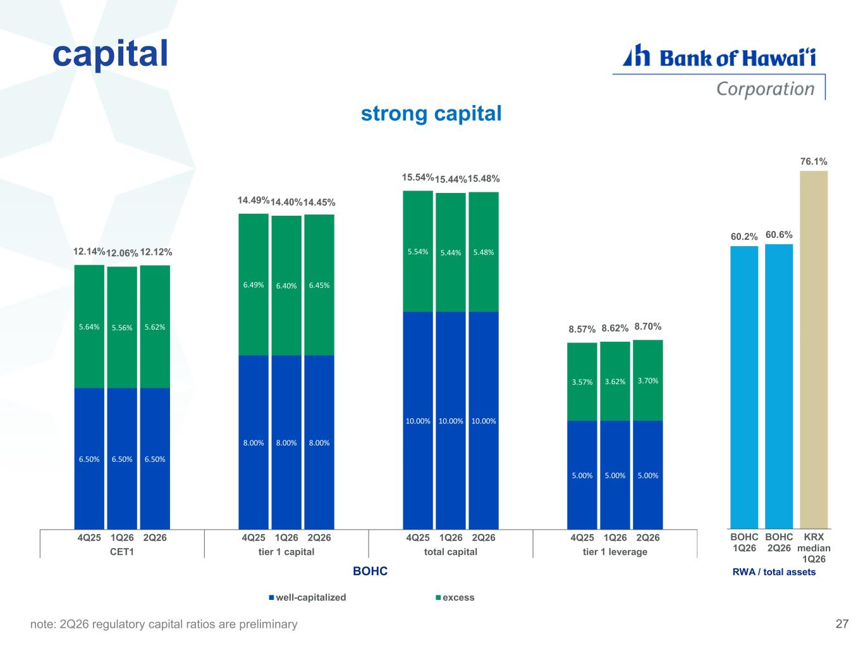
capital note: 2Q26 regulatory capital ratios are preliminary 6.50% 6.50% 6.50% 8.00% 8.00% 8.00% 10.00% 10.00% 10.00% 5.00% 5.00% 5.00% 5.64% 5.56% 5.62% 6.49% 6.40% 6.45% 5.54% 5.44% 5.48% 3.57% 3.62% 3.70% 12.14%12.06% 12.12% 14.49%14.40%14.45% 15.54%15.44%15.48% 8.57% 8.62% 8.70% 4Q25 1Q26 2Q26 4Q25 1Q26 2Q26 4Q25 1Q26 2Q26 4Q25 1Q26 2Q26 CET1 tier 1 capital total capital tier 1 leverage well-capitalized excess 13.6% BOHC strong capital 27 60.2% 60.6% 76.1% BOHC 1Q26 BOHC 2Q26 KRX median 1Q26 1 RWA / total assets

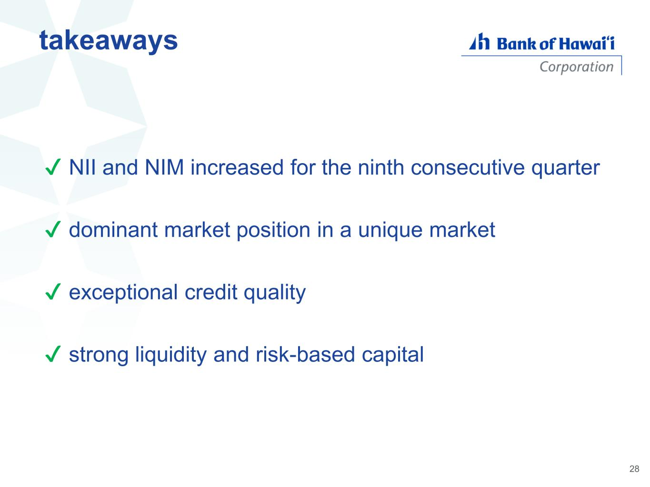
✔ NII and NIM increased for the ninth consecutive quarter ✔ dominant market position in a unique market ✔ exceptional credit quality ✔ strong liquidity and risk-based capital takeaways 28

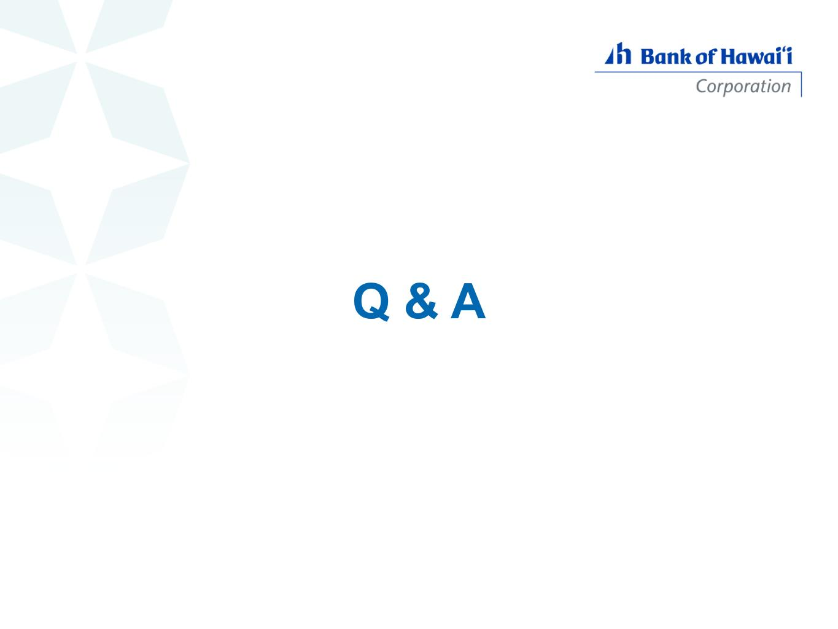
Q & A

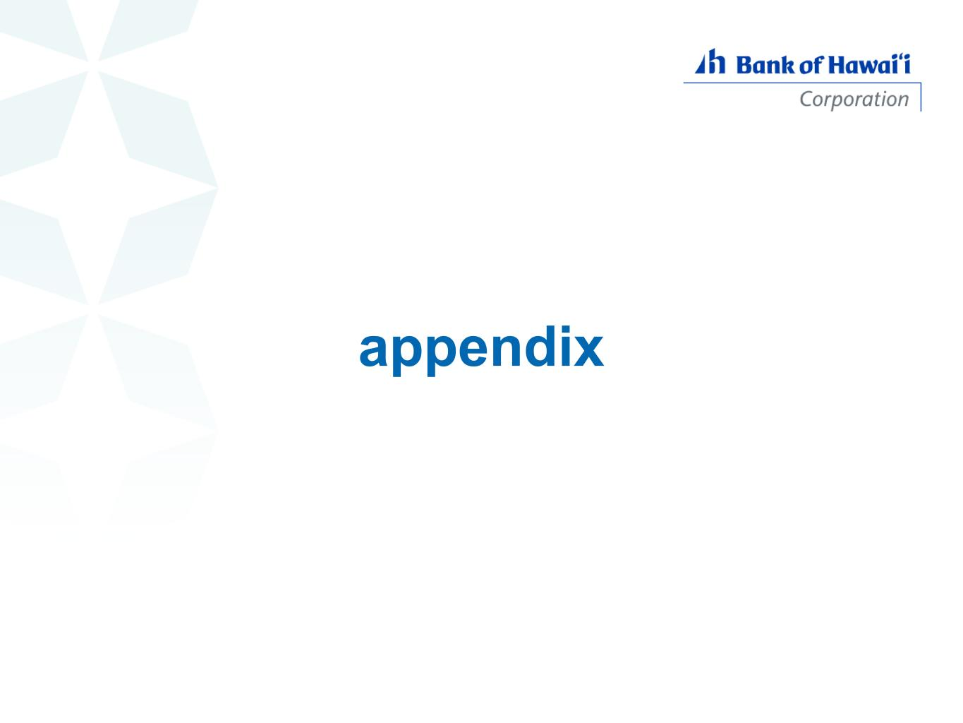
appendix

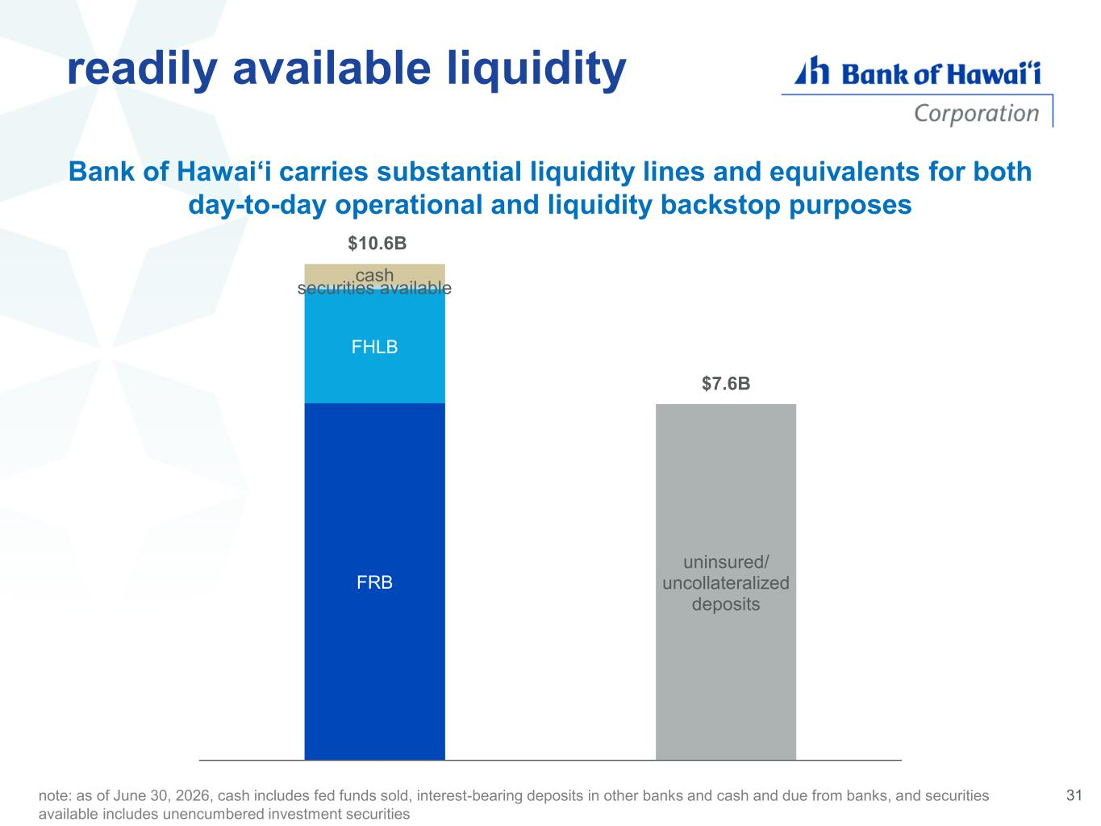
note: as of June 30, 2026, cash includes fed funds sold, interest-bearing deposits in other banks and cash and due from banks, and securities available includes unencumbered investment securities Bank of Hawai‘i carries substantial liquidity lines and equivalents for both day-to-day operational and liquidity backstop purposes FRB FHLB securities available cash uninsured/ uncollateralized deposits $10.6B $7.6B readily available liquidity 31

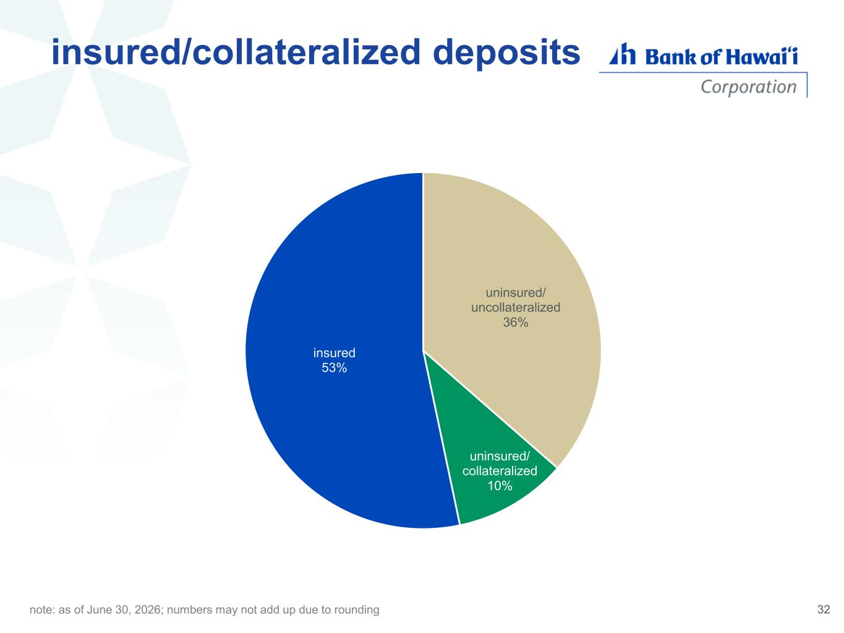
insured/collateralized deposits uninsured/ uncollateralized 36% uninsured/ collateralized 10% insured 53% note: as of June 30, 2026; numbers may not add up due to rounding 32

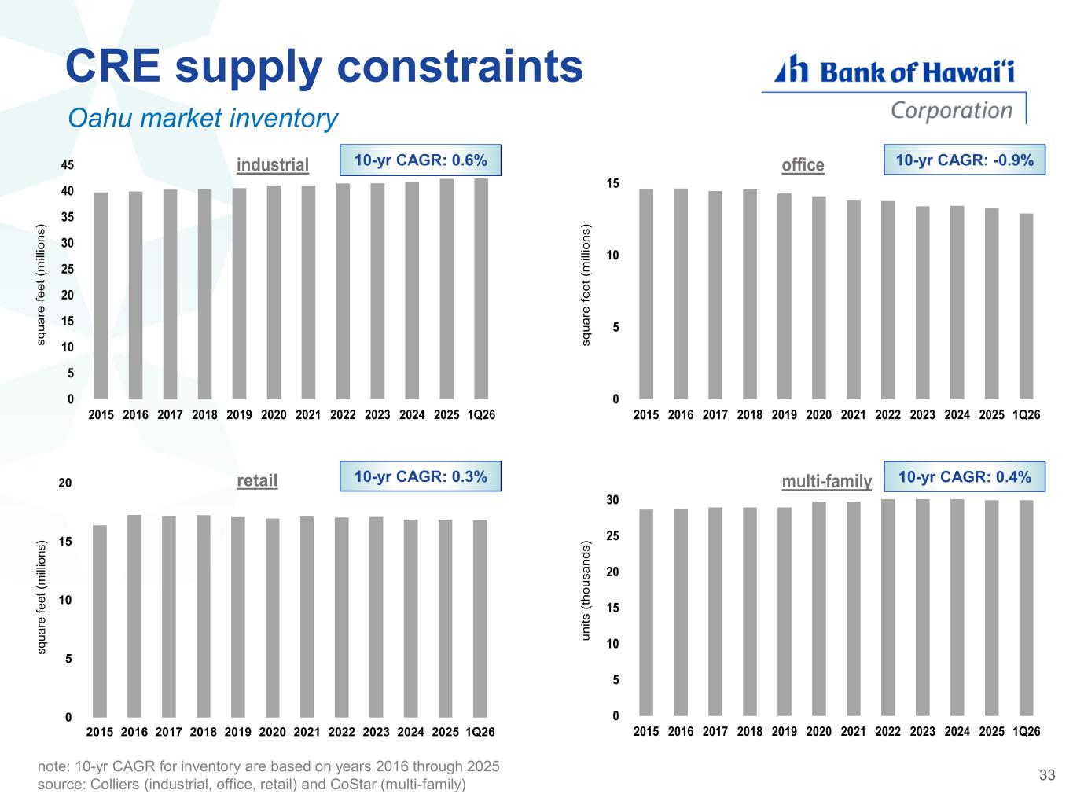
Oahu market inventory 33 CRE supply constraints 10-yr CAGR: 0.6% 10-yr CAGR: -0.9% 10-yr CAGR: 0.3% 10-yr CAGR: 0.4% note: 10-yr CAGR for inventory are based on years 2016 through 2025 source: Colliers (industrial, office, retail) and CoStar (multi-family) 0 5 10 15 20 25 30 35 40 45 2015 2016 2017 2018 2019 2020 2021 2022 2023 2024 2025 1Q26 s q u a re f e e t (m il li o n s ) industrial 0 5 10 15 2015 2016 2017 2018 2019 2020 2021 2022 2023 2024 2025 1Q26 s q u a re f e e t (m il li o n s ) office 0 5 10 15 20 25 30 2015 2016 2017 2018 2019 2020 2021 2022 2023 2024 2025 1Q26 u n it s ( th o u s a n d s ) multi-family 0 5 10 15 20 2015 2016 2017 2018 2019 2020 2021 2022 2023 2024 2025 1Q26 s q u a re f e e t (m ill io n s ) retail

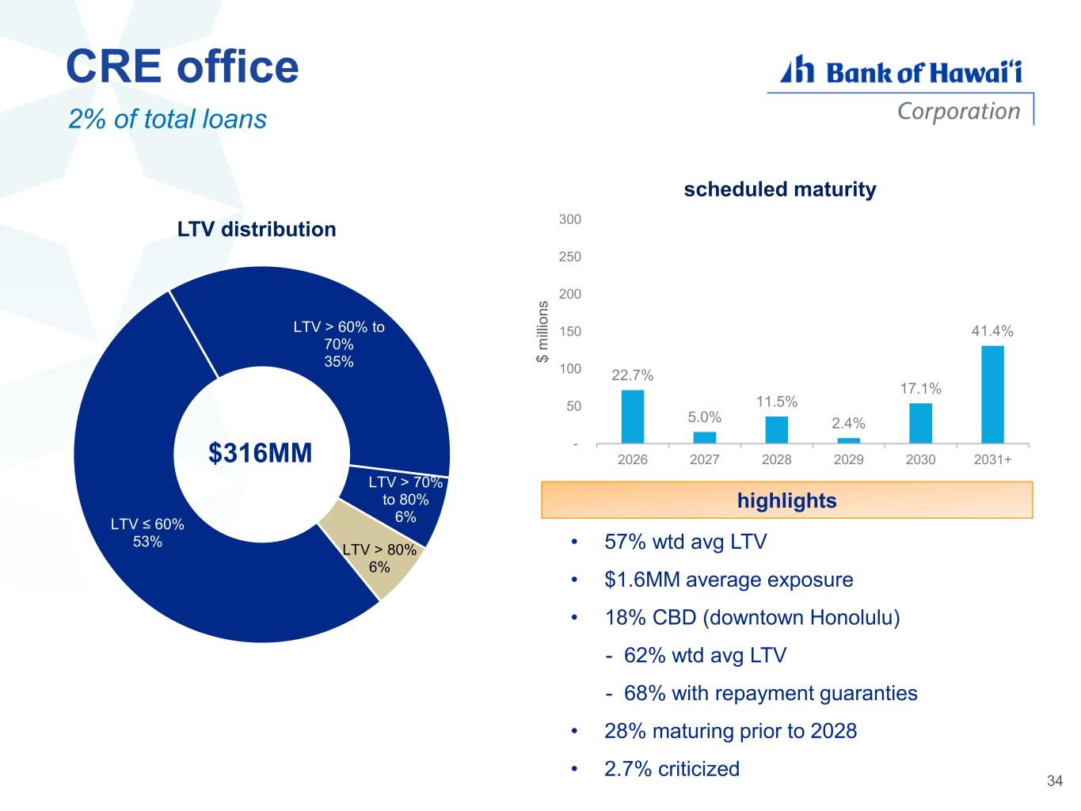
CRE office 2% of total loans • 57% wtd avg LTV • $1.6MM average exposure • 18% CBD (downtown Honolulu) - 62% wtd avg LTV - 68% with repayment guaranties • 28% maturing prior to 2028 • 2.7% criticized highlights LTV ≤ 60% 53% LTV > 60% to 70% 35% LTV > 70% to 80% 6% LTV > 80% 6% LTV distribution $316MM 34 22.7% 5.0% 11.5% 2.4% 17.1% 41.4% - 50 100 150 200 250 300 2026 2027 2028 2029 2030 2031+ $ m ill io n s scheduled maturity

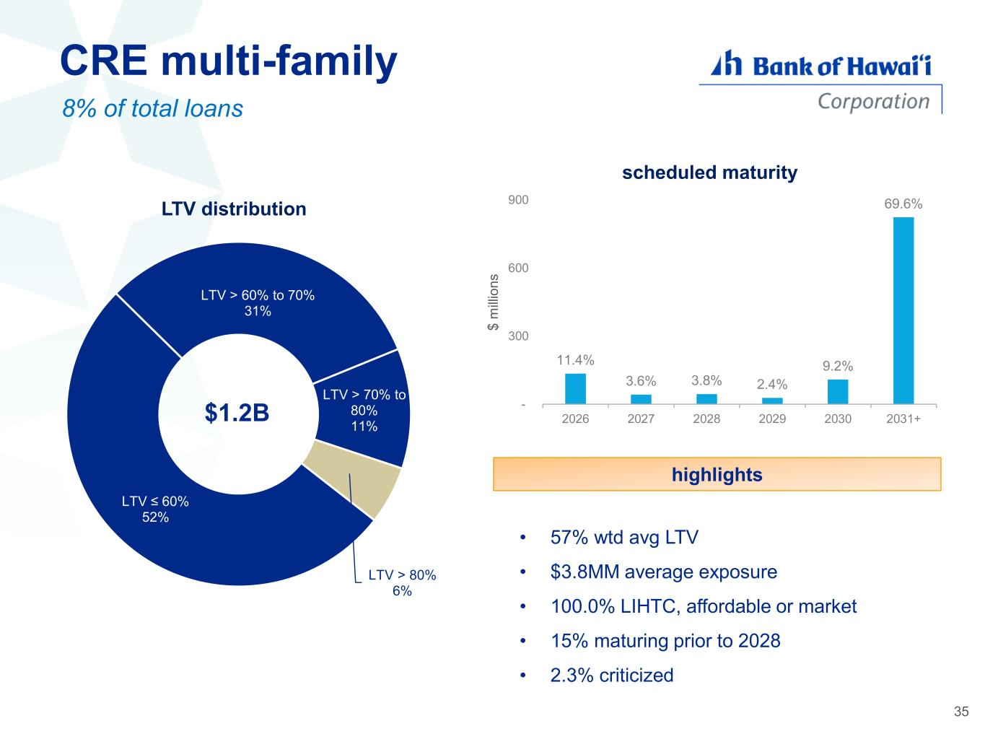
CRE multi-family 8% of total loans • 57% wtd avg LTV • $3.8MM average exposure • 100.0% LIHTC, affordable or market • 15% maturing prior to 2028 • 2.3% criticized highlights LTV ≤ 60% 52% LTV > 60% to 70% 31% LTV > 70% to 80% 11% LTV > 80% 6% LTV distribution 11.4% 3.6% 3.8% 2.4% 9.2% 69.6% - 300 600 900 2026 2027 2028 2029 2030 2031+ $ m ill io n s scheduled maturity $1.2B 35

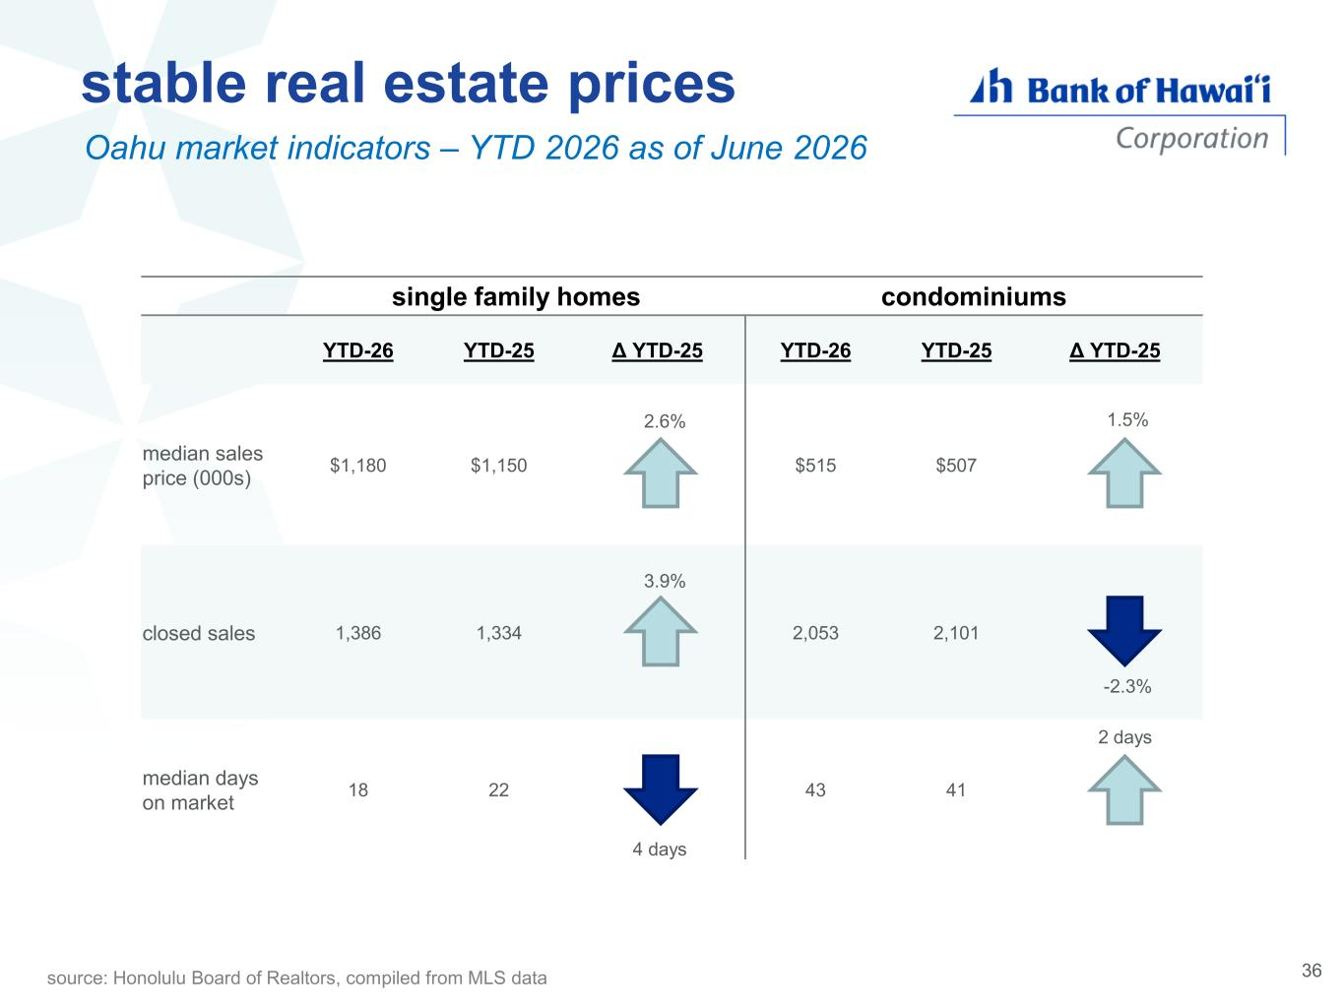
single family homes condominiums YTD-26 YTD-25 Δ YTD-25 YTD-26 YTD-25 Δ YTD-25 median sales price (000s) $1,180 $1,150 2.6% $515 $507 1.5% closed sales 1,386 1,334 3.9% 2,053 2,101 -2.3% median days on market 18 22 4 days 43 41 2 days stable real estate prices Oahu market indicators – YTD 2026 as of June 2026 source: Honolulu Board of Realtors, compiled from MLS data 36

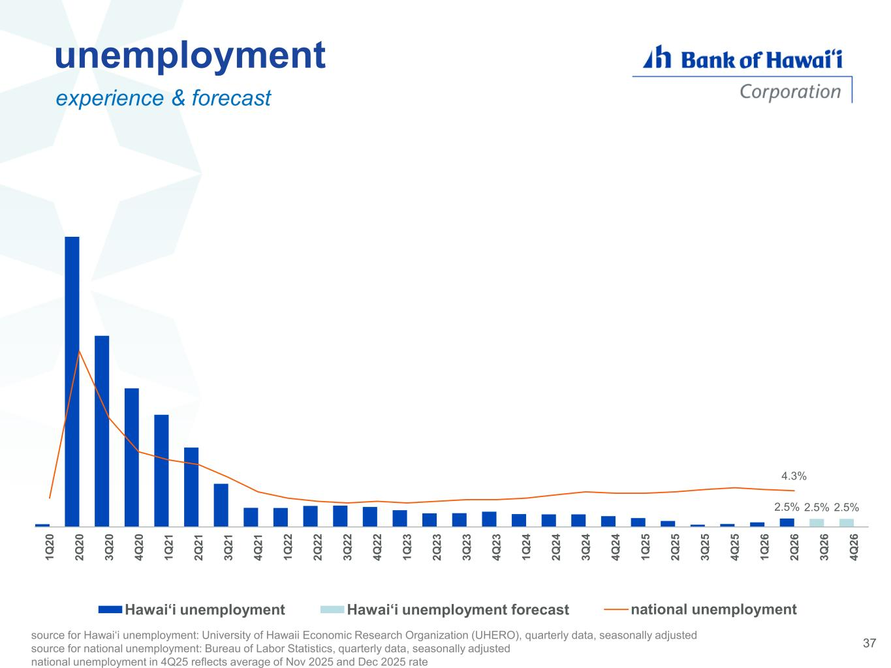
2.5% 2.5% 2.5% 4.3% 1 Q 2 0 2 Q 2 0 3 Q 2 0 4 Q 2 0 1 Q 2 1 2 Q 2 1 3 Q 2 1 4 Q 2 1 1 Q 2 2 2 Q 2 2 3 Q 2 2 4 Q 2 2 1 Q 2 3 2 Q 2 3 3 Q 2 3 4 Q 2 3 1 Q 2 4 2 Q 2 4 3 Q 2 4 4 Q 2 4 1 Q 2 5 2 Q 2 5 3 Q 2 5 4 Q 2 5 1 Q 2 6 2 Q 2 6 3 Q 2 6 4 Q 2 6 Hawai‘i unemployment Hawai‘i unemployment forecast national unemployment unemployment experience & forecast source for Hawai‘i unemployment: University of Hawaii Economic Research Organization (UHERO), quarterly data, seasonally adjusted source for national unemployment: Bureau of Labor Statistics, quarterly data, seasonally adjusted national unemployment in 4Q25 reflects average of Nov 2025 and Dec 2025 rate 37

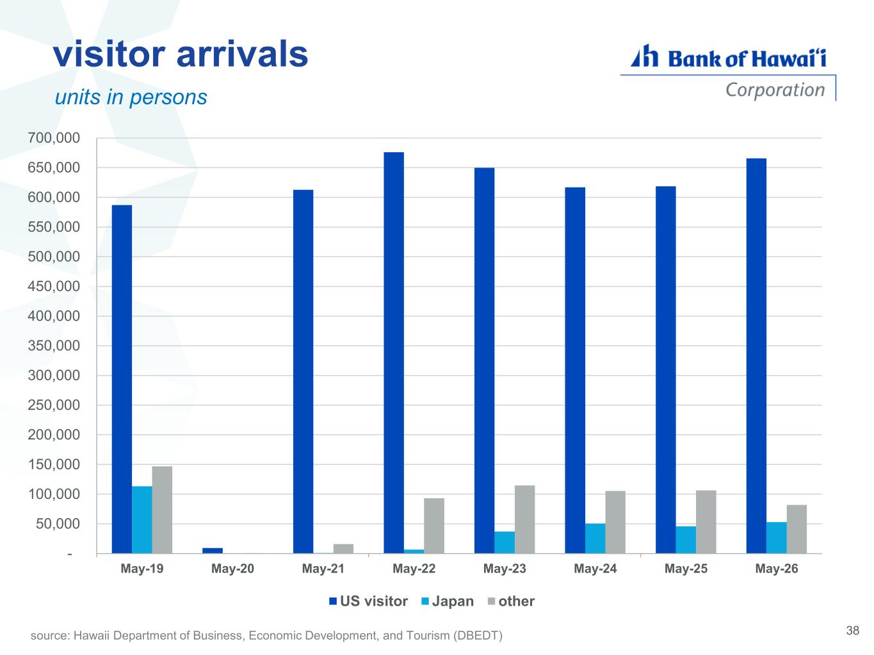
38 visitor arrivals units in persons source: Hawaii Department of Business, Economic Development, and Tourism (DBEDT) - 50,000 100,000 150,000 200,000 250,000 300,000 350,000 400,000 450,000 500,000 550,000 600,000 650,000 700,000 May-19 May-20 May-21 May-22 May-23 May-24 May-25 May-26 US visitor Japan other

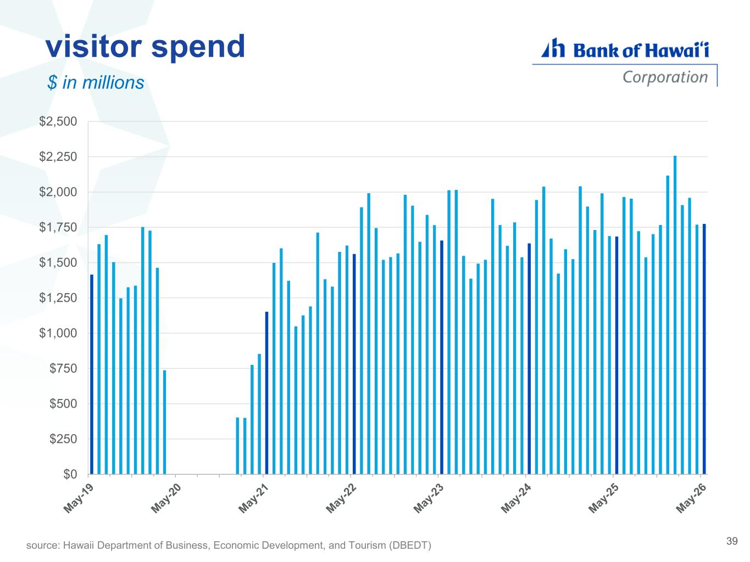
visitor spend $ in millions 39source: Hawaii Department of Business, Economic Development, and Tourism (DBEDT) $0 $250 $500 $750 $1,000 $1,250 $1,500 $1,750 $2,000 $2,250 $2,500

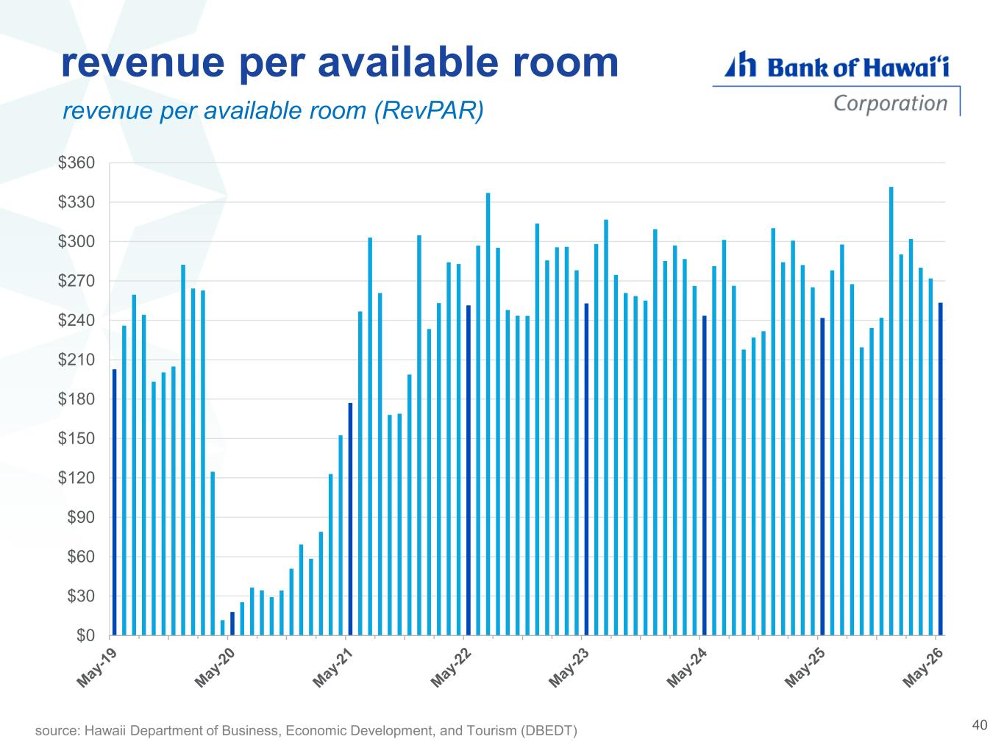
revenue per available room revenue per available room (RevPAR) 40source: Hawaii Department of Business, Economic Development, and Tourism (DBEDT) $0 $30 $60 $90 $120 $150 $180 $210 $240 $270 $300 $330 $360

